BEFORE
THE PUBLIC UTILITIES COMMISSION OF OHIO

In the Matter of the Application of the Dayton Power and Light Company to Increase its Rates for Electric Distribution.  In the Matter of the Application of the Dayton Power and Light Company for Accounting Authority.  In the Matter of the Application of Dayton Power and Light Company for Approval of Revised Tariffs. | )  )  )  )  )  )  )  )  ) | Case No. 20-1651-EL-AIR  Case No. 20-1652-EL-AAM  Case No. 20-1653-EL-ATA

MOTION TO ALLOW DAYTON-AREA CONSUMERS TO PARTICIPATE VIRTUALLY DURING THE PANDEMIC IN THE PUCO’S LOCAL PUBLIC HEARING ON AES’S PROPOSED RATE INCREASE
AND
REQUEST FOR EXPEDITED RULING
BY
OFFICE OF THE OHIO CONSUMERS’ COUNSEL

It is important that the public have their voices heard by their state government (the PUCO). As required by R.C. 4903.083, consumers are to be invited to participate in the PUCO’s rate increase process by having local public hearings.
Unfortunately, the state, country, and world are in a once-in-a-century pandemic. The first of the two scheduled local public hearings in Dayton on AES’s $120 million rate increase request has been held (on September 17, 2021). There, only a single person attended the hearing. That person supported the utility’s request for higher rates and represented the Dayton Area Chamber of Commerce, of which AES Ohio is a member, and appears to have been invited by the utility.
We note that the PUCO itself has decided that the evidentiary hearing in this case, where lawyers and expert witnesses attend, will be held remotely and not in person, given the City of Columbus’s mask mandate and general concerns about the pandemic. Ohio consumers should be given no less courtesy and consideration for their safety by the PUCO, than that allowed for AES and other parties who are allowed by the PUCO to attend the evidentiary hearing virtually. Consumers should be allowed to provide oral testimony remotely.
The Office of the Ohio Consumers’ Counsel (“OCC”) is concerned that, given the current state of the coronavirus pandemic, consumers might feel at risk appearing in person at a local public hearing to voice their concerns about AES’s request to increase the rates that they pay. Accordingly, OCC requests that the PUCO allow consumers to also remotely testify at the next local public hearing, currently scheduled for September 28, 2021 at 6:00 p.m. in the City of Dayton. Allowing remote testimony would help satisfy the intent of R.C. 4903.083, which is to provide for a local public hearing allowing consumers to be heard.
Further, under O.A.C. 4901-1-12(C), OCC asks that the PUCO issue an expedited ruling because the upcoming local public hearing is scheduled for September 28, 2021, which is only one week away.
For these reasons, as explained more fully in the attached memorandum in support, OCC respectfully requests that the PUCO allow Dayton-area consumers to remotely participate (via WebEx, Microsoft Teams, Zoom, or a similar platform) at the September 28, 2021 local public hearing.

Bruce Weston (0016973)
Ohio Consumers’ Counsel

/s/ Christopher Healey
Christopher Healey (0086027)
Counsel of Record
Ambrosia E. Wilson (0096598)
John Finnigan (0018689)
Assistant Consumers’ Counsel

Office of the Ohio Consumers’ Counsel
65 East State Street, 7th Floor
Columbus, Ohio 43215
Telephone [Healey]: (614)-466-9571
Telephone [Wilson]: (614)-466-1292
Telephone [Finnigan]: (614) 466-9585
christopher.healey@occ.ohio.gov
ambrosia.wilson@occ.ohio.gov
john.finnigan@occ.ohio.gov
(willing to accept service by e-mail)
BEFORE
THE PUBLIC UTILITIES COMMISSION OF OHIO

In the Matter of the Application of the Dayton Power and Light Company to Increase its Rates for Electric Distribution.  In the Matter of the Application of the Dayton Power and Light Company for Accounting Authority.  In the Matter of the Application of Dayton Power and Light Company for Approval of Revised Tariffs. | )  )  )  )  )  )  )  )  ) | Case No. 20-1651-EL-AIR  Case No. 20-1652-EL-AAM  Case No. 20-1653-EL-ATA

MEMORANDUM IN SUPPORT
BY
OFFICE OF THE OHIO CONSUMERS’ COUNSEL

R.C. 4903.083 requires the PUCO to hold at least one local public hearing in a base distribution rate case so that consumers have an opportunity to directly interact with the PUCO and share their opinions regarding the utility’s proposal. In the past, consumers have demonstrated interest in participating. In DP&L’s 2018 base distribution rate case, for example, nine consumers testified at the first local public hearing, and another ten consumers testified at the second local public hearing—each hearing lasting at least an hour for consumer testimony.
In contrast, only a single person attended DP&L’s September 17, 2021 local public hearing. That individual supported the utility’s request for higher rights and represented the Dayton Area Chamber of Commerce, of which AES Ohio is a member, and appears to have been invited by the utility. No residential consumers attended the hearing to express their opinions regarding the application.
OCC is concerned that the lack of participation could reflect concerns among Ohioans about attending public gatherings in person, in light of the ongoing coronavirus pandemic. Coronavirus cases, hospitalizations, and deaths have steadily risen since July, as shown in the following data provided by the Ohio Department of Health—and as Governor DeWine has expressed concern about:
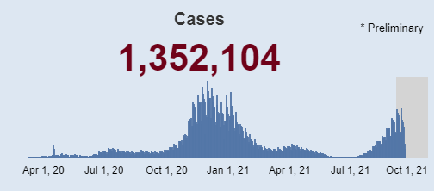
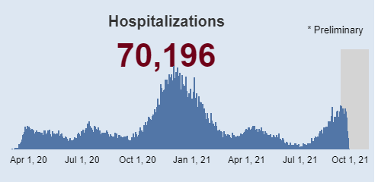
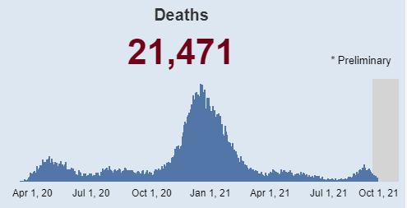
Recognizing the concern about rising coronavirus cases, the City of Dayton reissued its mask mandate for all public indoor spaces, shortly before the September 18, 2021 local public hearing.
We note that the PUCO itself has decided that the evidentiary hearing in this case, where lawyers and expert witnesses attend, will be held remotely and not in person, given the City of Columbus’s mask mandate and general concerns about the pandemic. Ohio consumer witnesses should be given no less courtesy and consideration for their safety by the PUCO, than that allowed for AES and other parties who are allowed by the PUCO to attend the evidentiary hearing virtually. Consumers should be allowed to provide oral testimony remotely
It is true that consumers have other ways to express their opinions regarding the case. They can call the PUCO, write the PUCO by mail, or submit comments on the PUCO’s website. But these are not a substitute for personally appearing before PUCO commissioners and attorney examiners to present sworn testimony. Requiring consumers to appear in person without any remote option is unreasonable under the current circumstances. This is especially so where other business—including much of the PUCO’s business—is proceeding remotely to protect people’s health.
Finally, because the next local public hearing will occur very soon—September 28, 2021—there is good cause to grant this motion on an expedited basis under O.A.C. 4901-1-12(C). OCC cannot certify that no party opposes the request for expedited treatment.
For the reasons set forth herein, OCC respectfully requests that the PUCO grant this motion.
Respectfully submitted,
Bruce Weston (0016973)
Ohio Consumers’ Counsel

/s/ Christopher Healey
Christopher Healey (0086027)
Counsel of Record
Ambrosia E. Wilson (0096598)
John Finnigan (0018689)
Assistant Consumers’ Counsel

Office of the Ohio Consumers’ Counsel
65 East State Street, 7th Floor
Columbus, Ohio 43215
Telephone [Healey]: (614)-466-9571
Telephone [Wilson]: (614)-466-1292
Telephone [Finnigan]: (614) 466-9585
christopher.healey@occ.ohio.gov
ambrosia.wilson@occ.ohio.gov
john.finnigan@occ.ohio.gov

CERTIFICATE OF SERVICE
I hereby certify that a copy of this Motion was served on the persons stated below via electronic transmission, this 22nd day of September 2021.

/s/ Christopher Healey
Christopher Healey
Assistant Consumers’ Counsel

The PUCO’s e-filing system will electronically serve notice of the filing of this document on the following parties:

SERVICE LIST

jodi.bair@ohioAGO.gov  kyle.kern@ohioAGO.gov  chelsea.fletcher@ohioAGO.gov  bmckenney@mcneeslaw.com  mjsettineri@vorys.com  glpetrucci@vorys.com  dromig@armadapower.com  dparram@bricker.com  rmains@bricker.com  ccox@elpc.org  khernstein@bricker.com  mwarnock@bricker.com  little@litohio.com  hogan@litohio.com  ktreadway@oneenergyllc.com  jdunn@oneenergyllc.com  whitt@whitt-sturtevant.com  fykes@whitt-sturtevant.com  rhartley@fbtlaw.com  cwieg@fbtlaw.com  talexander@beneschlaw.com  khehmeyer@beneschlaw.com  ssiewe@beneschlaw.com  Attorney Examiners:  patricia.schabo@puco.ohio.gov  Michael.williams@puco.ohio.gov | bojko@carpenterlipps.com  paul@carpenterlipps.com  michael.schuler@aes.com  jsharkey@ficlaw.com  djireland@ficlaw.com  chollon@ficlaw.com  mkurtz@BKLlawfirm.com  kboehm@BKLlawfirm.com  jkylercohn@BKLlawfirm.com  bethany.allen@igs.com  Joe.oliker@igs.com  Michael.nugent@igs.com  Evan.betterton@igs.com  Stephanie.chmiel@thompsonhine.com  Kevin.oles@thompsonhine.com  Fdarr2019@gmail.com  rdove@keglerbrown.com  cgrundmann@spilmanlaw.com  dwilliamson@spilmanlaw.com  mpritchard@mcneeslaw.com  rglover@mcneeslaw.com  mleppla@theOEC.org  tdougherty@theOEC.org  ctavenor@theOEC.org

Parties were informed of this sua sponte decision at a prehearing conference on September 16, 2021. OCC understands that this decision will be memorialized in a forthcoming Entry.
In re Application of the Dayton Power & Light Co. for an Increase in Elec. Distrib. Rates, Case No. 15-1830-EL-AIR, Transcript (May 8, 2018 local public hearing, transcript filed May 16, 2018); Transcript (May 10, 2018 local public hearing, transcript filed June 12, 2018).
See City of Dayton restarts mask mandate, Dayton Daily News (Sept. 15, 2021), available at https://www.daytondailynews.com/local/city-of-dayton-restarts-mask-mandate/GEFKO2AN6VAKBHPIHIRVY3EUSE/
Parties were informed of this sua sponte decision at a prehearing conference on September 16, 2021. OCC understands that this decision will be memorialized in a forthcoming Entry.

