Before
The Public Utilities Commission of Ohio

In the Matter of the Application of )
The Dayton Power and Light Company ) Case No. 12-426-EL-SSO
for Approval of Its Market Rate Offer. )

In the Matter of the Application of )
The Dayton Power and Light Company ) Case No. 12-427-EL-ATA
for Approval of Revised Tariffs. )

In the Matter of the Application of )
The Dayton Power and Light Company ) Case No. 12-428-EL-AAM
for Approval of Certain Accounting )
Authority. )

In the Matter of the Application of )
The Dayton Power and Light Company ) Case No. 12-429-EL-WVR
for Waiver of Certain Commission Rules. )

In the Matter of the Application of )
The Dayton Power and Light Company ) Case No. 12-672-EL-RDR
to Establish Tariff Riders. )

Motion to Take Administrative Notice or in the Alternative to
Reopen this Proceeding or in the Alternative to Supplement the Record
and Request for Expedited Treatment and Memorandum in Support of
Industrial Energy Users-Ohio

Samuel C. Randazzo (Counsel of Record)
Frank P. Darr
Joseph E. Oliker
Matthew R. Pritchard
McNees Wallace & Nurick LLC
21 East State Street, 17TH Floor
Columbus, OH 43215
Telephone: (614) 469-8000
Telecopier: (614) 469-4653
sam@mwncmh.com
fdarr@mwncmh.com
joliker@mwncmh.com
mpritchard@mwncmh.com

May 20, 2013 Attorneys for Industrial Energy Users-Ohio

Before
The Public Utilities Commission of Ohio

In the Matter of the Application of )
The Dayton Power and Light Company ) Case No. 12-426-EL-SSO
for Approval of Its Market Rate Offer. )

In the Matter of the Application of )
The Dayton Power and Light Company ) Case No. 12-427-EL-ATA
for Approval of Revised Tariffs. )

In the Matter of the Application of )
The Dayton Power and Light Company ) Case No. 12-428-EL-AAM
for Approval of Certain Accounting )
Authority. )

In the Matter of the Application of )
The Dayton Power and Light Company ) Case No. 12-429-EL-WVR
for Waiver of Certain Commission Rules. )

In the Matter of the Application of )
The Dayton Power and Light Company ) Case No. 12-672-EL-RDR
to Establish Tariff Riders. )

Motion to Take Administrative Notice or in the Alternative to
Reopen this Proceeding or in the Alternative to Supplement the Record
and Request for Expedited Treatment of Industrial Energy Users-Ohio

The Industrial Energy Users-Ohio (“IEU-Ohio”) hereby moves the Public Utilities Commission of Ohio (“Commission”) to take administrative notice or in the alternative to reopen this proceeding or in the alternative to supplement the record to include the data described in IEU-Ohio Supplemental Exhibit 1 (“Exhibit 1”). Exhibit 1 contains excerpted pages from a May 9, 2013 AES Corporation Investor Day presentation (“Investor Day Presentation”).
Although IEU-Ohio maintains that issues related to The Dayton Power & Light Company’s (“DP&L”) credit rating and financial integrity are not relevant to the resolution of DP&L’s electric security plan (“ESP”) Application, these issues are central to DP&L’s claim that it is entitled to non-bypassable charges in the form of the Service Stability Rider (“SSR”) and the Switching Tracker (“ST”). Specifically, DP&L has claimed that credit rating agencies are monitoring this case, in part, because it will impact DP&L’s ability to refinance long-term debt that will come due in the latter half of 2013.
The information contained in Exhibit 1 demonstrates that DP&L’s claim is unfounded. In its Investor Day Presentation, AES indicated that DP&L and DPL Inc. intend to complete efforts to refinance and reduce $700 million in debt by the end of May 2013, pushing these refinanced debt maturities out until 2016.
The purpose of taking administrative notice, reopening the proceeding, or supplementing the record is to provide accurate information regarding the impact of this proceeding on DP&L’s ability to refinance its long-term debt. Contrary to DP&L’s assertions, this proceeding will have no impact on DP&L’s ability to refinance the long-term debt that would come due in 2013—DP&L is able and plans to refinance such debt prior to the Commission issuing an Opinion and Order in this proceeding.
Exhibit 1 is publicly available on the AES Corporation website and Exhibit 1 contains information that AES has held out to the investment community as being reliable. At the time of the hearing in this proceeding in March 2013, the information contained in Exhibit 1 was not available, thus Exhibit 1 could not have, with reasonable diligence, been presented during the hearing.
For the reasons stated in this Motion and more fully in the Memorandum in Support, IEU-Ohio requests that the Commission take administrative notice of Exhibit 1 or in the alternative, reopen the proceeding to receive additional evidence or in the alternative, supplement the record. IEU-Ohio requests expedited treatment of this Motion.
Respectfully submitted,
/s/ Joseph E. Oliker
Samuel C. Randazzo
(Counsel of Record)
Frank P. Darr
Joseph E. Oliker
Matthew R. Pritchard
McNees Wallace & Nurick LLC
21 East State Street, 17TH Floor
Columbus, OH 43215
Telephone: (614) 469-8000
Telecopier: (614) 469-4653
sam@mwncmh.com
fdarr@mwncmh.com
joliker@mwncmh.com
mpritchard@mwncmh.com

Attorneys for Industrial Energy Users-Ohio

Before
The Public Utilities Commission of Ohio

In the Matter of the Application of )
The Dayton Power and Light Company ) Case No. 12-426-EL-SSO
for Approval of Its Market Rate Offer. )

In the Matter of the Application of )
The Dayton Power and Light Company ) Case No. 12-427-EL-ATA
for Approval of Revised Tariffs. )

In the Matter of the Application of )
The Dayton Power and Light Company ) Case No. 12-428-EL-AAM
for Approval of Certain Accounting )
Authority. )

In the Matter of the Application of )
The Dayton Power and Light Company ) Case No. 12-429-EL-WVR
for Waiver of Certain Commission Rules. )

In the Matter of the Application of )
The Dayton Power and Light Company ) Case No. 12-672-EL-RDR
to Establish Tariff Riders. )

Memorandum in Support

DP&L has claimed that it is entitled to a non-bypassable charge in the form of the SSR and the ST to support its financial integrity. Specifically, DP&L has claimed that any deterioration to its financial integrity will impact its credit rating and thus its ability to refinance long-term debt that will come due in the latter half of 2013.
The information contained in Exhibit 1 demonstrates that DP&L’s claim is unfounded. In its Investor Day Presentation, AES indicated that DP&L and DPL Inc. intend to complete efforts to refinance and reduce $700 million in debt by the end of May 2013, extending these debt maturities until 2016.
Because the record in this matter is incomplete, dated, and inaccurate, the Commission should take administrative notice of Exhibit 1 or in the alternative reopen this proceeding or supplement the record to include the information contained in Exhibit 1.
Initially, the Commission should take administrative notice of information contained in Exhibit 1. The practice and the rules of evidence shall be the same as in civil actions. Evidence Rule 201 pertaining to judicial notice, states:
(A) Scope of rule. This rule governs only judicial notice of adjudicative facts; i.e., the facts of the case.
(B) Kinds of facts. A judicially noticed fact must be one not subject to reasonable dispute in that it is either (1) generally known within the territorial jurisdiction of the trial court or (2) capable of accurate and ready determination by resort to sources whose accuracy cannot reasonably be questioned.
(C) When discretionary. A court may take judicial notice, whether requested or not.
(D) When mandatory. A court shall take judicial notice if requested by a party and supplied with the necessary information.
(E) Opportunity to be heard. A party is entitled upon timely request to an opportunity to be heard as to the propriety of taking judicial notice and the tenor of the matter noticed. In the absence of prior notification, the request may be made after judicial notice has been taken.
(F) Time of taking notice. Judicial notice may be taken at any stage of the proceeding.
(G) Instructing jury. In a civil action or proceeding, the court shall instruct the jury to accept as conclusive any fact judicially noticed. In a criminal case, the court shall instruct the jury that it may, but is not required to, accept as conclusive any fact judicially noticed.
(Emphasis added).

The information contained in Exhibit 1 satisfies the standard for judicial notice; thus, the Commission should take administrative notice of Exhibit 1. The information contained in Exhibit 1 is capable of verification and cannot be disputed because Exhibit 1 is viewable on AES Corporation’s website. Finally, administrative notice may be taken at any time during the proceeding. Under these circumstances, administrative notice is mandatory.
The Commission’s rules and precedent also support reopening this proceeding or, in the alternative, permitting IEU-Ohio to supplement the record. Rule 4901-1-34, Ohio Administrative Code (“OAC”), allows the Commission to reopen a proceeding for good cause at any time before the issuance of a final order:
(A) The commission, the legal director, the deputy legal director, or an attorney examiner may, upon their own motion or upon motion of any person for good cause shown, reopen a proceeding at any time prior to the issuance of a final order.
(B) A motion to reopen a proceeding shall specifically set forth the purpose of the requested reopening. If the purpose is to permit the presentation of additional evidence, the motion shall specifically describe the nature and purpose of such evidence, and shall set forth facts showing why such evidence could not, with reasonable diligence, have been presented earlier in the proceeding.
The Commission recently permitted AEP-Ohio to file Supplemental Reply Comments related to its gridSMART application, out-of-time, over the objections of the Office of the Ohio Consumers’ Counsel ("OCC"), because AEP-Ohio had provided the Commission with more comprehensive and up-to-date information:
The Commission grants AEP-Ohio's requests to supplement its reply comments and the request for expedited ruling in this case. Although the supplemental reply comments are not timely, the additional information contradicts a claim of the Staff and, in point of fact, substantiates the comments of OCC as to the CES program. We note that the Staff does not oppose the claims made by the Company in its supplemental reply comments. The additional information presented by the Company facilitates a Commission decision based on the latest and best information available.

Thus, the Commission has reopened proceedings to accept additional evidence when the evidence provides valuable information relevant to the Commission’s determination. Moreover, the Commission has granted motions to supplement the record when necessary information was not available at the time of the hearing.
The purpose of reopening this proceeding or supplementing the record is to provide the Commission with accurate information regarding the status of DP&L’s long-term debt refinancing. That process will be completed prior to the resolution of this proceeding; thus, contrary to DP&L’s claim, this proceeding will have no impact on its ability to refinance the long-term debt that will come due in 2013.
The hearing occurred in March of 2013. Exhibit 1 provides updated information that could not have been provided, with reasonable diligence, during the hearing. Good cause exists for granting the Motion because Exhibit 1 is relevant to DP&L’s claims, and it provides the most up-to-date evidence with respect to the current status of DP&L’s long-term debt. IEU-Ohio requests that the Commission reopen the record in this proceeding or in the alternative supplement the record to accept the evidence contained in Exhibit 1 into the record.
For the reasons stated herein, IEU-Ohio requests that the Commission grant the relief requested in this Motion.
Respectfully submitted,

/s/ Joseph E. Oliker
Samuel C. Randazzo
(Counsel of Record)
Frank P. Darr
Joseph E. Oliker
Matthew R. Pritchard
McNees Wallace & Nurick LLC
21 East State Street, 17TH Floor
Columbus, OH 43215
Telephone: (614) 469-8000
Telecopier: (614) 469-4653
sam@mwncmh.com
fdarr@mwncmh.com
joliker@mwncmh.com
mpritchard@mwncmh.com

Attorneys for Industrial Energy Users-Ohio

IEU-OHIO SUPPLEMENTAL exhibit 1

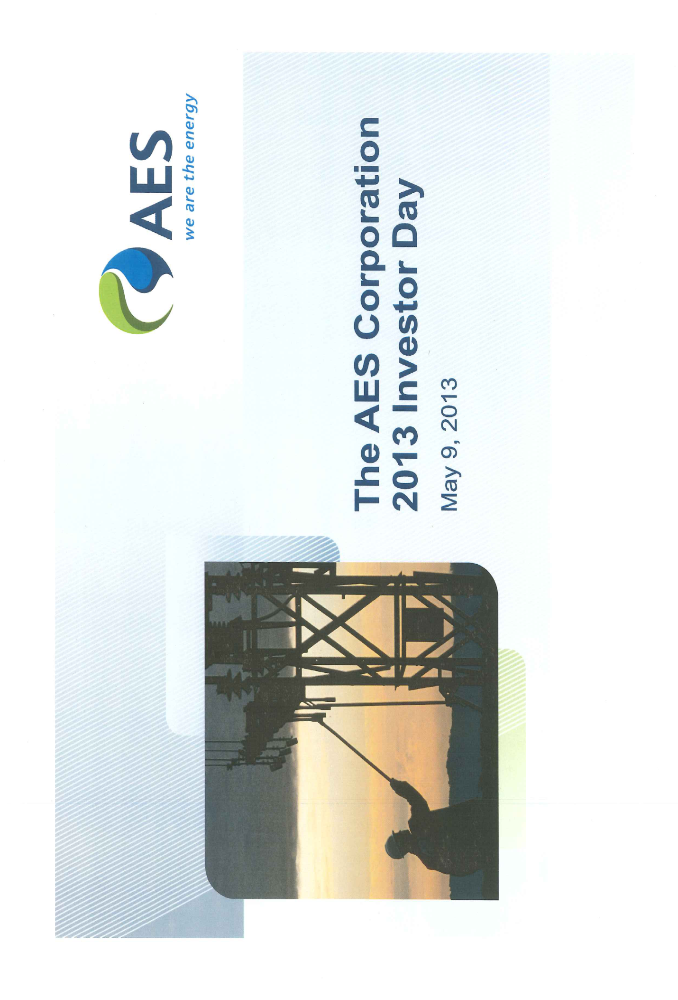
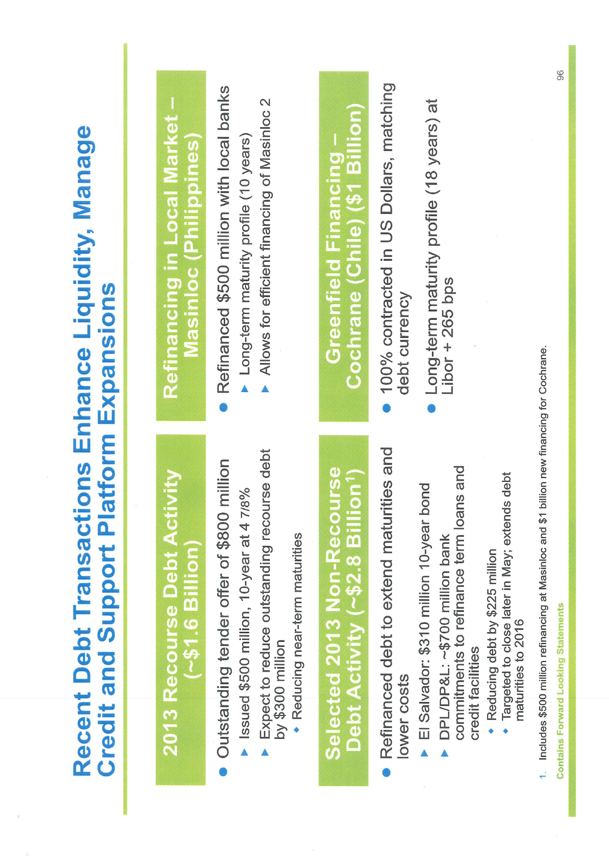
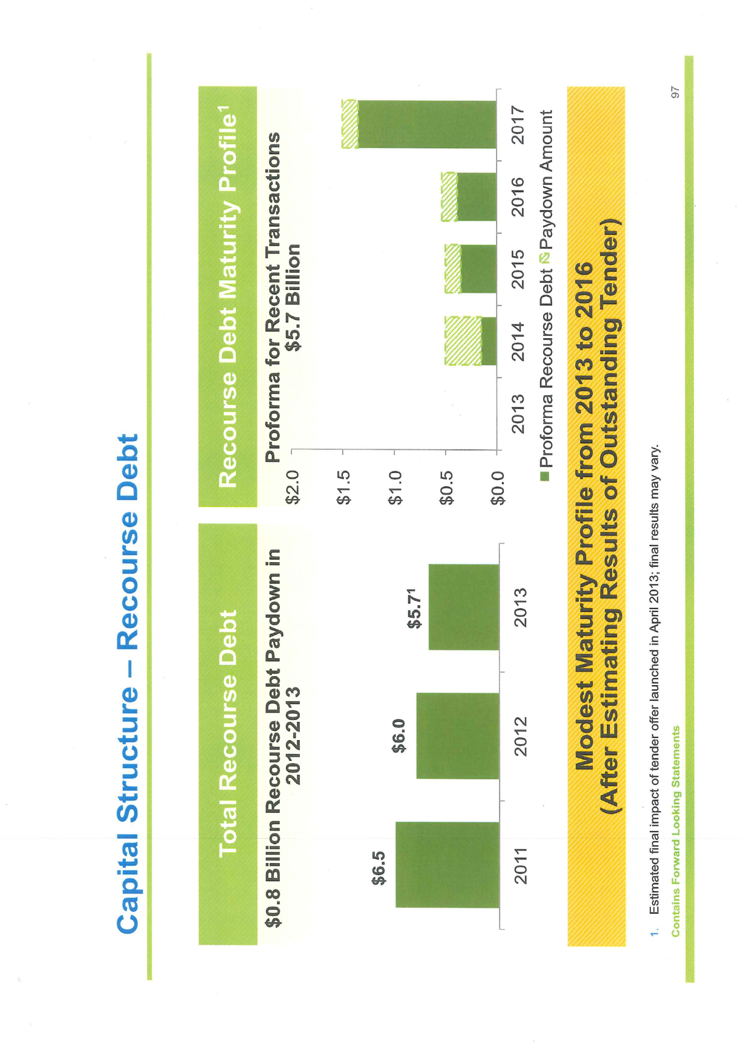
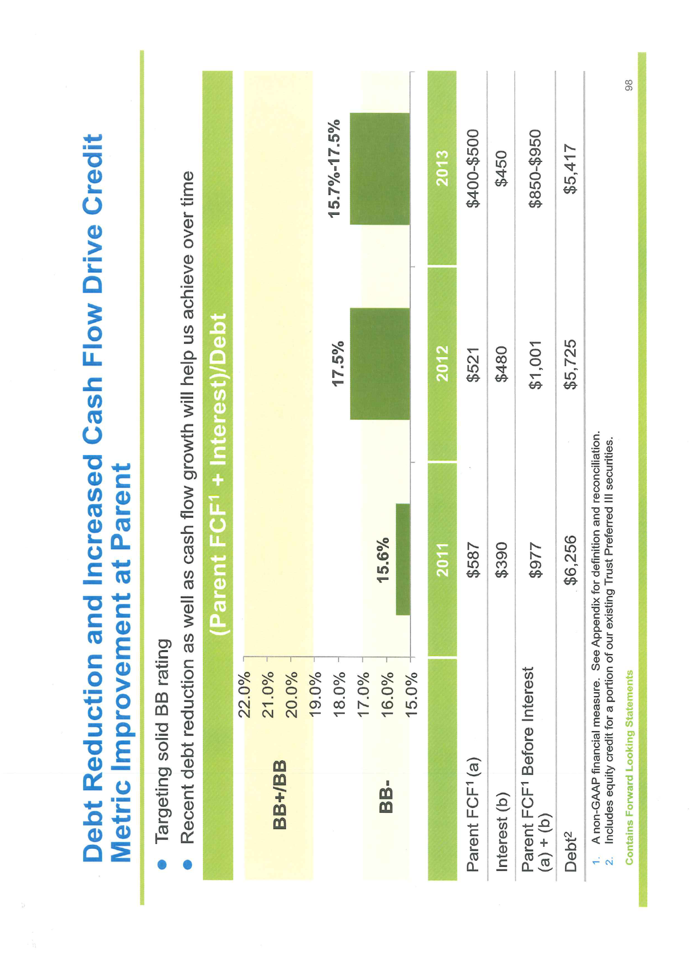
Certificate of Service

I hereby certify that a copy of the foregoing Motion for Administrative Notice or in the Alternative to Reopen this Proceeding or in the Alternative to Supplement the Record of Industrial Energy Users-Ohio and Request for Expedited Treatment and Memorandum in Support was served upon the following parties of record this 20th day of May 2013, via electronic transmission, hand-delivery or first class U.S. mail, postage prepaid.
/s/ Joseph E. Oliker
Joseph E. Oliker

judi.sobecki@dplinc.com
randall.griffin@dplinc.com
cfaruki@ficlaw.com
jsharkey@ficlaw.com
arthur.meyer@dplinc.com
dboehm@BKLlawfirm.com
mkurtz@BKLlawfirm.com
etter@occ.state.oh.us
serio@occ.state.oh.us
yost@occ.state.oh.us
gerger@occ.state.oh.us
amy.spiller@duke-energy.com
jeanne.kingery@duke-energy.com
philip.sineneng@ThompsonHine.com
bmcmahon@emh-law.com
elizabeth.watts@duke-energy.com
rocco.d’ascenzo@duke-energy.com
ricks@ohanet.org
tobrien@bricker.com
barth.royer@aol.com
gary.a.jeffries@dom.com
drinebolt@ohiopartners.org
cmooney2@columbus.rr.com
whitt@whitt-sturtevant.com
campbell@whitt-sturtevant.com
vparisi@igsenergy.com
barthroyer@aol.com
nolan@theoec.org
trent@theoec.org
cathy@theoec.org
williams.toddm@gmail.com
ejacobs@ablelaw.org
tobrien@bricker.com
mwarnock@bricker.com
tsiwo@bricker.com
mhpetricoff@vorys.com
smhoward@vorys.com
david.fein@constellation.com
cynthia.a.fonner@constellation.com
Tasha.hamilton@constellation.com
myurick@taftlaw.com
zkravitz@taftlaw.com
mhpetricoff@vorys.com
smhoward@vorys.com
Tony_Long@ham.honda.com
Stephen.bennett@exeloncorp.com
Cynthia.b.fonner@constellation.com
LGearhardt@ofbf.org
dconway@porterwright.com
aemerson@porterwright.com
haydenm@firstenergycorp.com
coneil@calfee.comk
shannon@calfee.com
jlang@calfee.com
lmcbride@calfee.com
talexander@calfee.com
dakutik@jonesday.com
aehaedt@jonesday.com
jejadwin@aep.com
Thomas.Melone@AllcoUS.com
joseph.clark@directenergy.com
christopher.miller@icemiller.com
gregory.dunn@icemiller.com
alan.starkoff@icemiller.com
ssolberg@EimerStahl.com
stephanie.Chmiel@ThompsonHine.com
michael.Dillard@ThompsonHine.com
philip.sineneng@ThompsonHine.com
mjsatterwhite@aep.com
stnourse@aep.com
bojko@carpenterlipps.com
sechler@carpenterlipps.com
matt@matthewcoxlaw.com
gpoulos@enernoc.com
ssherman@kdlegal.com
jhague@kdlegal.com
william.wright@puc.state.oh.us
thomas.lindgren@puc.state.oh.us
thomas.mcnamee@puc.state.oh.us
steven.beeler@puc.state.oh.us
devin.parram@puc.state.oh.us
gregory.price@puc.state.oh.us
mandy.willey@puc.state.oh.us
bryce.mckenney@puc.state.oh.us
henryeckhart@aol.com
Wis29@yahoo.com
berger@occ.state.oh.us
bill.wells@wpafb.af.mil
chris.thompson.2@tyndall.af.mil
mchristensen@columbuslaw.org
chris.michael@icemiller.com
williams@whitt-sturtevant.com
asim_haque@ham.honda.com
mohler@carpenterlipps.com

DP&L Ex. 4 at 28; Tr. Vol. II at 562-563. A more detailed discussion of DP&L’s claims can be found in confidential portions of DP&L’s testimony. See DP&L Ex. 4A at 52.
http://media.corporate-ir.net/media_files/IROL/76/76149/05-08 13_2013_Investor_Day.pdf (last viewed on May 17, 2013).
DP&L Ex. 4 at 28; Tr. Vol. II at 562-563. A more detailed discussion of DP&L’s claims can be found in confidential portions of DP&L’s testimony. See DP&L Ex. 4A at 52.
Section 4903.22, Revised Code.
The Commission’s rules are based upon the Ohio Rules of Evidence; thus, the standard for taking administrative notice parallels the standard for taking judicial notice.
http://media.corporate-ir.net/media_files/IROL/76/76149/05-08 13_2013_Investor_Day.pdf (last viewed on May 17, 2013).
The Supreme Court of Ohio has held that administrative notice may be taken even on rehearing so long as no party is prejudiced. Cincinnati Bell Telephone v. Pub. Util. Comm., 12 Ohio St. 3d 280, 284-285 (1984).
In the event that DP&L opposes the Motion and claims it is entitled to an “opportunity to be heard.” IEU-Ohio does not oppose such an opportunity. DP&L cannot demonstrate that taking administrative notice of Exhibit 1 would cause prejudice because the information is not disputed and Exhibit 1 merely provides up-to-date information.
In the Matter of the Application of Ohio Power Company to Update its gridSMART Rider, Case No. 12-509-EL-RDR, Finding and Order at 9 (Oct. 3, 2012) (emphasis added); see also In the Matter of the Application of Duke Energy Ohio, Inc. for an Energy Efficiency Cost Recovery Mechanism and for Approval of Additional Programs for Inclusion in its Existing Portfolio. Case No. 11-4393-EL-RDR, Entry at 2 (Mar. 21, 2012) (reopening the record for the limited purpose of receiving additional information).
In the Matter of the Petition of Al Shomaker and Numerous Other Subscribers of the Utica-Homer Exchange of United Telephone Co., Case No. 85-1283-TP-PEX, Supplemental Opinion and Order at 5 (Jul. 6, 1988); see also In the Matter of the Petition of Duane M. Miller, Judith Holmes, and Numerous Other Subscribers of the Kidron Exchange of United Telephone Company of Ohio, Case No. 95-252-TP-PEX, Entry (Nov. 16, 1995).

