May 25, 2022

Docketing Division
Public Utilities Commission of Ohio
180 East Broad Street
Columbus, OH 43215

RE: In the Matter of the Application of Water and Sewer LLC Seeking to Cancel its Certificate of Public Convenience and Necessity No. 39 (Sewer) and Substitute Service, Case No. 22-330-WS-UNC

Dear Docketing Division:

Enclosed please find the Staff’s Review and Recommendations in regard to the application filed by Water and Sewer LLC Seeking to Cancel its Certificate of Public Convenience and Necessity No. 39 (Sewer) and Substitute Service, Case No. 22-330-WS-UNC.

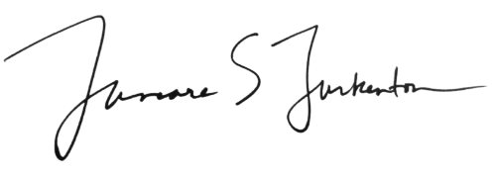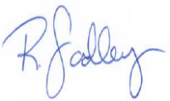
____________________________________ __________________________________

Tamara Turkenton Robert Fadley
Director, Rates and Analysis Department Director, Service Monitoring and Enforcement Public Utilities Commission of Ohio Department
Public Utilities Commission of Ohio

BEFORE
THE PUBLIC UTILITIES COMMISSION OF OHIO

In the Matter of the Application of Water and Sewer LLC Seeking to Cancel its Certificate of Public Convenience and Necessity No. 39 (Sewer) and Substitute Service | )  )  )  ) | Case No. 22-330-WS-UNC

Staff Review and Recommendation

APPLICATION DESCRIPTION

On April 5, 2022, Water and Sewer LLC (“W&S”) filed an application with exhibits (“Application”) with the Public Utilities Commission of Ohio (“Commission”) seeking authority to cancel its Certificate of Public Convenience and Necessity No. 39 and substitute service.

W&S is a public utility and a sewage disposal company that currently serves approximately 76 customers in the village of Richfield, Ohio in Summit County. Founded in 1998, W&S originally was a water and sewer company. On December 18, 2009, W&S transferred the water service to the City of Cleveland.

The application requests to substitute sewer services to Richfield Village, Ohio (“Village”) and cancel its Certificate of Public Convenience and Necessity No. 39 and authorize the withdrawal of its current sewer tariff, PUCO No. 3. The Village has committed to constructing new sanitary system to serve W&S customers as well as new subdivision (up to an additional 130 customers) scheduled for completion in May of 2022. W&S and Village have agreed to a donation agreement regarding the transfer of facilities.

REVIEW AND RECOMMENDATION

Staff has conducted a review of the Application. As a result of its investigation, Staff finds that the details surrounding the proposed transfer of service and facilities to Village should not adversely impact customers of W&S or the public interest in general. The Village Sewer Division provides services to over 1,000 customers in seven sanitary districts including 150 commercial customers. Village employs three field personnel and has invested in its capacity to provide service to W&S customers. Village has the managerial, technical, and financial capability to provide sewer services to W&S customers.

Rates for W&S customers are currently $300.19 bimonthly. Initial Village rates for W&S customers located in Richfield Township will be $153.21 per quarter and for those located in Richfield Village will be $135.13 per quarter with no planned increase in the next year. Thus, rates for W&S customers will decline after the transfer of service. W&S customers will not be charged a deposit or application fees during the transfer but will be charged a $300 tap-in fee. W&S does not have any customer deposits but does have customers with outstanding balances which will be due upon the transfer of service.

Therefore, Staff concludes that the Application appears to be reasonable and recommends its approval.

