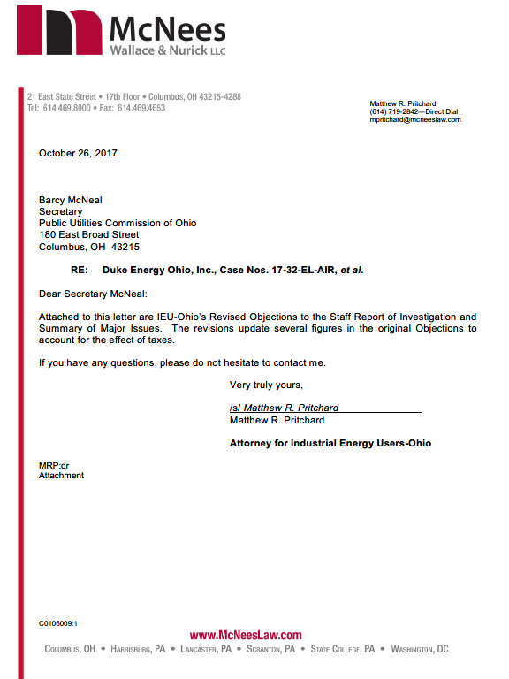
Before
The Public Utilities Commission of Ohio

In the Matter of the Application of )
Duke Energy Ohio, Inc. for an Increase ) Case No. 17-32-EL-AIR
in its Electric Distribution Rates. )

In the Matter of the Application of )
Duke Energy Ohio, Inc. for Tariff ) Case No. 17-33-EL-ATA
Approval. )

In the Matter of the Application of )
Duke Energy Ohio, Inc. for Approval to ) Case No. 17-34-EL-AAM
Change Accounting Methods. )

______________________________________________________________________

Revised Objections to the Staff Report of Investigation and Summary of Major Issues of Industrial Energy Users-Ohio

Frank P. Darr (Reg. No. 0025469)
(Counsel of Record)
Matthew R. Pritchard (Reg. No. 0088070)
McNees Wallace & Nurick LLC
21 East State Street, 17th Floor
Columbus, OH 43215
Telephone: (614) 469-8000
Facsimile: (614) 469-4653
fdarr@mwncmh.com
(willing to accept service via email)
mpritchard@mwncmh.com
(willing to accept service via email)

October 26, 2017 Counsel for Industrial Energy Users-Ohio

Before
The Public Utilities Commission of Ohio

In the Matter of the Application of )
Duke Energy Ohio, Inc. for an Increase ) Case No. 17-32-EL-AIR
in its Electric Distribution Rates. )

In the Matter of the Application of )
Duke Energy Ohio, Inc. for Tariff ) Case No. 17-33-EL-ATA
Approval. )

In the Matter of the Application of )
Duke Energy Ohio, Inc. for Approval to ) Case No. 17-34-EL-AAM
Change Accounting Methods. )

______________________________________________________________________

Revised Objections to the Staff Report of Investigation and
Summary of Major Issues of Industrial Energy Users-Ohio

Pursuant to R.C. 4909.19, Rule 4901-1-28(B), Ohio Administrative Code (“OAC”), and the Attorney Examiner’s Entry dated September 28, 2017, Industrial Energy Users-Ohio (“IEU-Ohio”) hereby files its Objections to the Staff Report of Investigation (“Staff Report”) in the above-captioned matters. The Staff Report was filed with the Public Utilities Commission of Ohio (“Commission”) on September 26, 2017. It provides the Commission Staff’s (“Staff”) findings regarding the application for authority to increase rates for distribution service filed by Duke Energy Ohio, Inc. (“Duke”) on March 2, 2017. In submitting the Objections listed below, IEU-Ohio specifically reserves the right to contest, through presentation of documentary evidence, testimony, or cross examination, issues on which Staff’s position changes, or which are newly raised, between the issuance of the Staff Report and the closing of the record.
- Objections to the Staff Report oN Duke
Revenue Requirement
- The range of Staff’s recommended revenue decrease of $18,357,786 to $28,932,684, as set out in Schedule A-1 of the Staff Report, is understated because the decrease is not sufficient to yield just and reasonable rates in accordance with Ohio law and proper ratemaking practices. The just and reasonable range of the revenue reduction should be $21,963,234 to $32,538,132 if the Commission rejects the recommendations of the Staff Report concerning energy efficiency labor expenses and net metering costs that are identified in the remaining objections.
Operating Income
- The Staff’s recommendation to increase test year expenses by $2,241,365 for energy efficiency labor expenses to be collected through base rates, as shown on page 15 and Schedule C-3.14a of the Staff Report, violates Ohio law and proper ratemaking practices. As provided by R.C. 4928.66, an electric distribution utility must implement energy efficiency and peak demand reduction programs. It may secure cost recovery through a rate adjustment mechanism. Rule 4901:1-39-07, OAC. The Commission has authorized cost recovery for Duke under Rider EE-PDR. That rider is conditionally bypassable by certain eligible customers. Under R.C. 4928.6611 and 4928.6612, eligible customers may opt out of the opportunity and ability to obtain direct benefits from the utility’s portfolio plan by providing notice of an election to opt out. If a customer elects to opt out, no account properly identified in the customer’s notice shall be subject to any cost recovery mechanism under R.C. 4928.66 or eligible to participate in, or directly benefit from, programs arising under the approved portfolio plan. R.C. 4928.6613.
The Staff Report recommends that energy efficiency labor costs be recovered through base rates. By reassigning those costs from Rider EE-PDR to base rates, eligible customers would be required, in violation of R.C. 4928.6613, to pay a portion of the portfolio program costs that they would otherwise avoid as a result of the opt-out election. Accordingly, the Commission should reject the recommendation of the Staff Report to recover energy efficiency labor costs in base distribution rates. If the Commission rejects the recommendation of the Staff Report, the revenue reduction should be adjusted to a range of $21,857,393 to $32,432,291, all other things being equal.
If the Commission accepts this Staff Report recommendation, the Commission should direct Duke to modify its billing system to exempt customers that opt out from paying the portion of their base distribution rates that is associated with the energy efficiency labor costs.
- The Staff Report’s recommendation to increase test year expenses by $67,787, as shown on page 17 and Schedule C-3.26 of the Staff Report, to reflect net metering costs violates Ohio Law and proper ratemaking practices. Net metering costs are generation-related costs. Although the General Assembly has provided express terms for the billing treatment of positive and negative net metering positions, it has not provided for the “cashing out” of net credits. By tariff, Duke provides that a customer may “cash out” net credits on an annual basis. According to Duke, cashing out net credits creates a cost for which it does not currently have a mechanism for cost recovery. In this proceeding, Duke initially sought recovery of these costs but has withdrawn that request. Because the costs of net metering are related to generation, which has been declared a competitive service and fully separated from noncompetitive distribution services, it is unlawful and unreasonable to recover these costs on a nonbypassable basis through base distribution rates. R.C. 4928.03; R.C. 4928.05; R.C. 4928.02(H). Further, Duke’s decision to withdraw its request for authorization of the recovery of net metering costs in this proceeding removes this item from proper consideration in this case. As shown on Schedule C-3.26 of the Staff Report, net metering costs during the test year total $67,787. If the Commission rejects the recommendation of the Staff Report to recover net metering costs through base distribution rates, the Staff Report’s recommended rate decrease should be modified to a range of $18,463,627 to $29,038,525, all other things being equal.
- Statement of Major Issues
- In light of the objections to the recommendations of the Staff Report concerning the recovery of energy efficiency labor expense and net metering expense, is the Staff Report’s recommendation that base distribution revenue should be decreased $18,357,786 to $28,932,684 lawful and reasonable?
- Is the recommendation of the Staff Report that Duke should be authorized to recover energy efficiency labor expenses of an energy efficiency portfolio program through base distribution rates lawful and reasonable when authorization would violate the right of an eligible customer to opt out of the benefits and costs of the portfolio program?
- Is the recommendation of the Staff Report that Duke should be authorized to recover net metering expenses through base distribution rates lawful and reasonable when authorization would violate R.C. 4928.03, R.C. 4928.05, and R.C. 4928.02(H) and the request for an authorization of recovery in this case has been withdrawn by Duke?
Respectfully submitted,

/s/ Matthew R. Pritchard
Frank P. Darr (Reg. No. 0025469)
(Counsel of Record)
Matthew R. Pritchard (Reg. No. 0088070)
McNees Wallace & Nurick LLC
21 East State Street, 17TH Floor
Columbus, OH 43215
fdarr@mwncmh.com
mpritchard@mwncmh.com

Counsel for Industrial Energy Users-Ohio
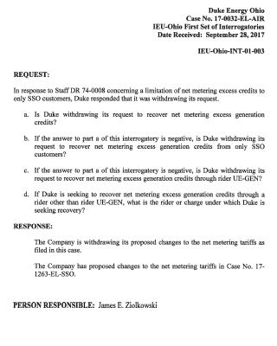
Certificate of Service

In accordance with Rule 4901-1-05, Ohio Administrative Code, the PUCO’s e-filing system will electronically serve notice of the filing of this document upon the following parties. In addition, I hereby certify that a service copy of the foregoing Revised Objections to the Staff Report of Investigation and Summary of Major Issues of Industrial Energy Users-Ohio was sent by, or on behalf of, the undersigned counsel for IEU-Ohio, to the following parties of record this 26th day of October 2017, via electronic transmission.
/s/ Matthew R. Pritchard
Matthew R. Pritchard

Amy B. Spiller (Reg. No. 0047277)
(Counsel of Record)
Deputy General Counsel
Jeanne W. Kingery (Reg. No. 0012172)
Associate General Counsel
Elizabeth H. Watts (Reg. No. 0031092)
Associate General Counsel
Rocco O. D’Ascenzo (Reg. No. 0077651)
Duke Energy Business Services LLC
139 E. Fourth Street, 1303-Main
PO Box 961
Cincinnati, OH 45201-0960
Amy.Spiller@duke-energy.com
Jeanne.Kingery@duke-energy.com
Elizabeth.Watts@duke-energy.com
Rocco.D’Ascenzo@duke-energy.com

Counsel for Duke Energy Ohio, Inc. (Duke)

Michael L. Kurtz
Jody Kyler Cohn
Boehm, Kurtz & Lowry
36 East Seventh Street, Suite 1510
Cincinnati, OH 45202
mkurtz@BKLlawfirm.com
jkylercohn@BKLlawfirm.com

Counsel for the Ohio Energy Group (OEG)

Colleen L. Mooney
Ohio Partners for Affordable Energy
PO Box 12451
Columbus, OH 43212-2451
cmooney@ohiopartners.org

Counsel for Ohio Partners for Affordable Energy (OPAE)

BRUCE WESTON (0016973)
OHIO CONSUMERS’ COUNSEL

William J. Michael (Reg. No. 0070921)
(Counsel of Record)
Christopher Healey (Reg. No. 0086027)
Assistant Consumers’ Counsel
Office of the Ohio Consumers’ Counsel
10 W. Broad Street, Suite 1800
Columbus, OH 43215-3485
William.michael@occ.ohio.gov
Christopher.healey@occ.ohio.gov

Dane Stinson (0019101)
Bricker & Eckler LLP
100 South Third Street
Columbus, OH 43215
dstinson@bricker.com

Counsel for Office of the Ohio Consumers’ Counsel (OCC)
Madeline Fleisher
Environmental Law & Policy Center
21 W. Broad St., Suite 500
Columbus, OH 43215
mfleisher@elpc.org

Counsel for Environmental Law & Policy Center (ELPC)

Angela Paul Whitfield (Reg. No. 0068774)
Carpenter Lipps & Leland LLP
280 North High Street, Suite 1300
Columbus, OH 43215
paul@carpenterlipps.com

Counsel for The Kroger Co.

Kurt J. Boehm
Boehm, Kurtz & Lowry
36 East Seventh Street, Suite 1510
Cincinnati, OH 45202
kboehm@BKLlawfirm.com

Counsel for the City of Cincinnati

Miranda Leppla (Reg. No. 0086351)
(Counsel of Record)
Trent Dougherty (Reg. No. 0079817)
1145 Chesapeake Avenue, Suite I
Columbus, OH 43212-3449
mleppla@theOEC.org
tdougherty@theOEC.org

Counsel for the Ohio Environmental Council (OEC) and Environmental Defense Fund (EDF)

Joseph Oliker (Reg. No. 0086088)
(Counsel of Record)
Michael Nugent (Reg. No. 0090408)
IGS Energy
6100 Emerald Parkway
Dublin, OH 43016
joliker@igsenergy.com
mnugent@igsenergy.com

Counsel for IGS Energy (IGS)

Elyse Akhbari (Reg. No. 0090701)
(Counsel of Record)
Bricker & Eckler LLP
100 South Third Street
Columbus, OH 43215
eakhbari@bricker.com

Counsel for People Working
Cooperatively, Inc. (PWC)

Michael D. Dortch (Reg. No. 0043897)
Richard R. Parsons (Reg. No. 0082270)
Justin M. Dortch (Reg. No. 0090048)
Kravitz, Brown & Dortch, LLC
65 East State Street, Suite 200
Columbus, OH 43215
mdortch@kravitzllc.com
rparsons@kravitzllc.com
jdortch@kravitzllc.com

Counsel for Calpine Energy Solutions, LLC

Richard L. Sites
Regulatory Counsel
Ohio Hospital Association
155 East Broad Street, 3rd Floor
Columbus, OH 43215-3620
Rick.sites@ohiohospitals.org

Dylan F. Borchers
Devin D. Parram
Bricker & Eckler LLP
100 South Third Street
Columbus, OH 43215
dborchers@bricker.com
dparram@bricker.com

Counsel for the Ohio Hospital Association (OHA)

Kimberly W. Bojko (Reg. No. 0069402)
(Counsel of Record)
James D. Perko, Jr. (Reg. No. 0093312)
Carpenter Lipps & Leland LLP
280 North High Street, Suite 1300
Columbus, OH 43215
Bojko@carpenterlipps.com
Perko@carpenterlipps.com

Counsel for the Ohio Manufacturers’ Association Energy Group (OMAEG)

Mark A. Whitt (Reg. No. 0067996)
Andrew J. Campbell (Reg. No. 0081485)
Rebekah J. Glover (Reg. No. 0088798)
Whitt Sturtevant LLP
The KeyBank Building, Suite 1590
88 East Broad Street
Columbus, OH 43215
whitt@whitt-sturtevant.com
campbell@whitt-sturtevant.com
glover@whitt-sturtevant.com

Counsel for Retail Energy Supply Association (RESA)

Samantha Williams
Staff Attorney
Natural Resources Defense Council
20 N. Wacker Drive, Suite 1600
Chicago, IL 60606
swilliams@nrdc.org

Counsel for Natural Resources Defense Council

D. David Altman (Reg. No. 0021457)
(Counsel of Record)
Justin D. Newman (Reg. No. 0080968)
J. Michael Weber (Reg. No. 0093983)
D. DAVID ALTMAN CO., L.P.A.
15 East 8th Street, Suite 200W
Cincinnati, OH 45202
daltman@environlaw.com
jnewman@environlaw.com
jweber@environlaw.com

Counsel for Cincinnati Clean Energy Foundation

Mark A. Whitt (Reg. No. 0067996)
Andrew J. Campbell (Reg. No. 0081485)
Rebekah J. Glover (Reg. No. 0088798)
Whitt Sturtevant LLP
The KeyBank Building, Suite 1590
88 East Broad Street
Columbus, OH 43215
whitt@whitt-sturtevant.com
campbell@whitt-sturtevant.com
glover@whitt-sturtevant.com

Counsel for Direct Energy Services, LLC, Direct Energy Business, LLC and Direct Energy Business Marketing, LLC

Steven Beeler
Robert Eubanks
Assistant Attorneys General
Public Utilities Section
Office of the Ohio Attorney General
30 East Broad Street, 16th Floor
Columbus, OH 43215-3414
Steven.Beeler@ohioattorneygeneral.gov
Robert.Eubanks@ohioattorneygeneral.gov

Counsel for the Staff of the Public Utilities Commission of Ohio (PUCO)

Nicholas Walstra
Attorney Examiner
Legal Department
Public Utilities Commission of Ohio
180 East Broad Street, 12th Floor
Columbus OH 43215
Nicholas.Walstra@puc.state.oh.us

Attorney Examiner

R.C. 4928.6610(A) provides: As used in sections 4928.6611 to 4928.6616 of the Revised Code: (A) “Customer” means any customer of an electric distribution utility to which either of the following applies: (1) The customer receives service above the primary voltage level as determined by the utility’s tariff classification. (2) The customer is a commercial or industrial customer to which both of the following apply: (a) The customer receives electricity through a meter of an end user or through more than one meter at a single location in a quantity that exceeds forty-five million kilowatt hours of electricity for the preceding calendar year. (b) The customer has made a written request for registration as a self-assessing purchaser pursuant to section 5727.81 of the Revised Code.
R.C. 4928.67(B)(3)(b) provides, “If the electricity supplied by the electric utility exceeds the electricity generated by the customer-generator and fed back to the utility during the billing period, the customer-generator shall be billed for the net electricity supplied by the utility, in accordance with normal metering practices. If electricity is provided to the utility, the credits for that electricity shall appear in the next billing cycle.”
See Duke’s Response to IEU-Ohio Interrogatory 1-003 (Oct. 18, 2017) (copy attached).

