BEFORE
THE PUBLIC UTILITIES COMMISSION OF OHIO

In the Matter of the Application of Columbia Gas of Ohio, Inc. for Authority to Amend its Filed Tariffs to Increase the Rates and Charges for Gas Services and Related Matters. |  | Case No. 21-637-GA-AIR
In the Matter of the Application of Columbia Gas of Ohio, Inc. for Approval of an Alternative Form of Regulation. |  | Case No. 21-638-GA-ALT
In the Matter of the Application of Columbia Gas of Ohio, Inc. for Approval of a Demand Side Management Program for its Residential and Commercial Customers. |  | Case No. 21-639-GA-UNC
In the Matter of the Application of Columbia Gas of Ohio, Inc. for Approval to Change Accounting Methods |  | Case No. 21-640-GA-AAM

Direct Testimony of PAUL LEANZA
on Behalf of Interstate Gas Supply, Inc.

May 13, 2022

TABLE OF CONTENTS
I. Introduction……………………………………………………… 3
II. Standard Choice Offer………………………………………….. 4
III. Natural Gas Volatility………………………………………….. 8
IV. Natural Gas Trends and the Standard Choice Offer………… 18
Certificate of Service …………………………………………………….. 22
Appendix…………………………………………………………………… 25

I. INRODUCTION
Q. Please introduce yourself.
A. My name is Paul Leanza. I am employed by Interstate Gas Supply, Inc. (“IGS” or “IGS Energy”) as Gas Supply Director. My business address is 6100 Emerald Parkway, Dublin, Ohio 43016.
Q. Please describe your educational background and work history.
A. I received a BSBA degree from The Ohio State University in 1989 and have worked exclusively in the energy industry since 1991. My experience includes positions on both the regulated utility side of the business and non-regulated side including wholesale, retail, and trading for both natural gas and power. I am well versed in futures, swaps, and options and currently execute or oversee all NYMEX future and swap transactions and manage the fixed price position for Interstate Gas Supply, Inc. As the Director for the Northeast Desk at Enron Energy Services I was responsible for purchasing and selling physical supplies under short and long term contractual arrangements including fixed and floating pricing for fixed and variable volumes. The position also included the management of storage contracts and supply peaking arrangements. My experience also includes power and gas trading at AEP Energy Services where I traded power in the NYISO region and traded natural gas in the Northeast region.
Q. Are you familiar with natural gas markets?
A. Yes, I’ve worked in the gas industry for 30 years, my experience includes positions on both the regulated utility side of the business and non-regulated side including wholesale, retail, and trading for both natural gas and power. I am currently the Director of Gas Supply for IGS Energy where my duties include managing our natural gas NYMEX book of business that includes futures, swaps, and options.
Q. What is the purpose of your testimony?
A. My testimony provides context regarding changes in the wholesale natural gas market that will impact all customers of Columbia Gas of Ohio. In the past two years, we have experienced significant wholesale market volatility. As I discuss in my testimony, volatile wholesale natural gas prices have translated into volatile and recently high Standard Choice Offer prices. My testimony discusses the current wholesale market fundamentals driving these changes and provides factual support for recommendations contained in the testimony of Matthew White.
II. Standard Choice Offer
Q. Are you familiar with the Standard Choice Offer (SCO)?
A. Yes, I am familiar with the Standard Choice Offer.
Q. How is the SCO established?
A. In a nutshell, the SCO is a monthly variable rate tied to the Henry Hub NYMEX clearing price plus an adder established by an online auction. Ohio SCO auctions are typically held mid-winter for the upcoming gas year starting in April. Prior to the auction utilities post information related to tranche size, asset allocation, customer usage forecasts, and any year over year changes in the program. From this information, suppliers build up a NYMEX plus price adder that includes locational supply basis costs, fixed and variable transportation costs, storage fees that include fixed and variable injection and withdrawal costs, BTU and fuel estimates, pooling or behind the city-gate fees charged by the utility, and the potential for any peak demand asset short falls. Once the auction starts, the auction manager generally starts the first bid cycle on the higher end of expectations which should attract more bidders than the number of tranches that the utility has available. The auction manager continues this process until the number of bidders equals the number of tranches available.
Q. Is it true that the SCO is established based upon the NYMEX clearing price?
A. Yes, in fact, the NYMEX component of the SCO price is based upon the last monthly settlement price for the prompt month. That price is based upon the last 30 minutes of trading for that day.
Q. What is your understanding of the natural gas and SCO trends over the past 10 years?
A. While there have been price movements, in general, we experienced a decade of depressed and relatively stable natural gas prices. We’ve witnessed the advent of shale drilling technology which has transformed the energy industry especially in the Appalachian region that includes Ohio, Pennsylvania, and West Virginia. From 2014 to 2016 natural gas and oil producers tested and refined the new drilling process and by the start of 2017, they gained sufficient experience and became comfortable with the new extraction processes. As you can see from the US Production chart, figure 1, the US saw unprecedented gains in production. According to data from the US Energy Information Administration (EIA), US natural gas production increased from 75 BCF/day to recent highs of over 94 BCF/day. Due to the unprecedented growth, supply tended to outpace demand which muted natural gas prices and decreased price volatility.

Figure 1
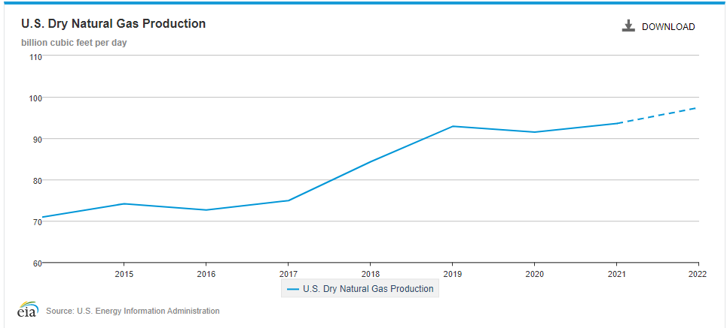
The decrease in natural gas prices put pressure on competing energy fuels such as coal generating power facilities. Figure 2 from the EIA shows US electricity by fuel source. The figure indicates that coal generation, as a percentage of all electric generation, has fallen from 40% in 2014 to 20% by 2020. At the same time, natural gas generating facilities have increased from slightly over 25% to a high of 40% for the same period.

Figure 2
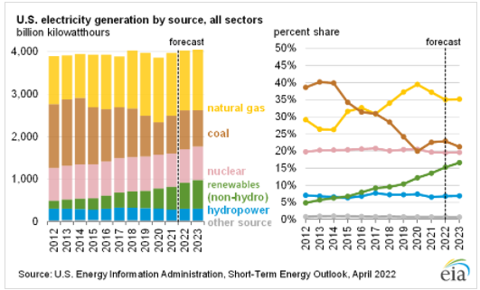
It’s also worth noting, as shown in figure 3, that the EIA expects 85% of all electric generating capacity retirements this year to come from coal which further increases the dependency on natural gas power generation until renewable and battery technologies catch up.
Figure 3
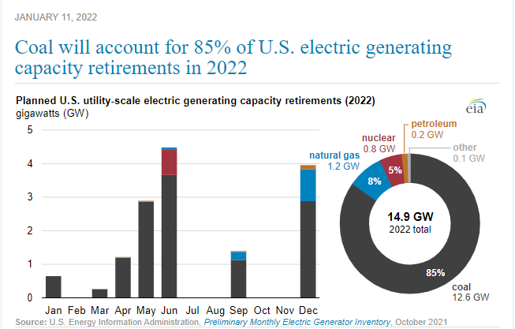
Another noticeable trend in the past 10 years, as shown in figure 4, is the unprecedented growth in gas exports via LNG and exports to Mexico. In 2015, the US exported zero gas via LNG but due to significantly lower US natural gas prices compared to Asia, Europe, and South America, LNG liquefaction facilities were built and now the US exports roughly 12 BCF/day of LNG. At the same time pipelines to Mexico were approved by the US government and built, and the US has seen exports to Mexico increase from 4 BCF/day in 2014 to over 7 BCF/day currently. When added together, LNG exports and deliveries to Mexico account for roughly 20% of all US natural gas production. The expectation is that new LNG facilities will continue to be built and that Mexico, over time, will become more reliant on US natural gas.
Figure 4
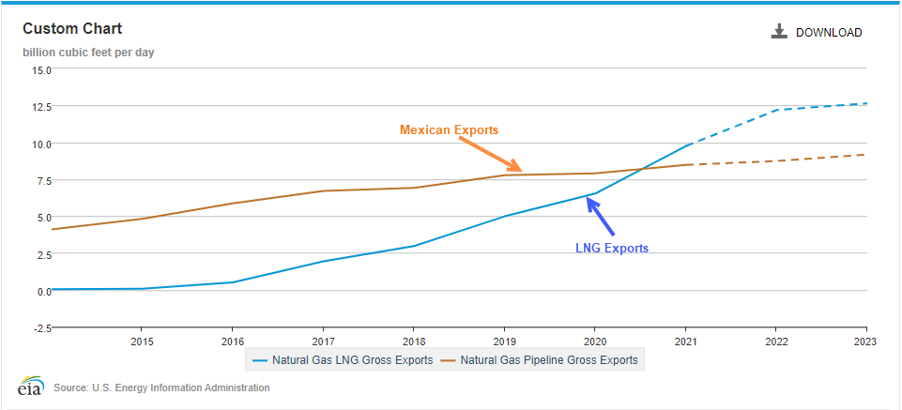
III. Natural Gas Volatility
Q. How have natural gas pricing trends changed?
A. Between 2000 and 2010 (Period 1 in figure 5), natural gas prices were higher along with relatively high levels of price volatility. Natural gas prompt month New York Mercantile Exchange (NYMEX) prices traded anywhere between $2.00 on the low side to almost $16.00 on the high side. During this period, total US production was approximately 50 BCF/day and demand was strong as you can see from figure 6. In fact, demand during this period outpaced supply by roughly 9.2 BCF/day which means imports were needed to make up for the lack of supply. This shortfall in supply led to an increase in both US natural gas prices and an increase in price volatility whenever the weather dictated.
Between 2010 and 2020 (Period 2 in figure 5), US natural gas production increased which reduced natural gas imports and reduced US natural gas prices. In 2015, US supply and US demand started to balance out which greatly reduced the impact of price volatility. Between 2010 and 2020, prices, as shown in figure 5, range from $1.50 on the low side to $6.50 on the high side
Since 2020, the US energy industry has seen increased volatility due to Covid, the recent invasion of Ukraine by Russia, and the economic gains seen in the US. The supply/demand balance for many commodities struggled early in the Pandemic as industries across the globe shutdown completely or scaled back operations. In the US, we are now in a cycle where the supply/demand balance has shifted and many on the supply side of commodities struggle to keep up with demand which increases the price of that commodity

Figure 5
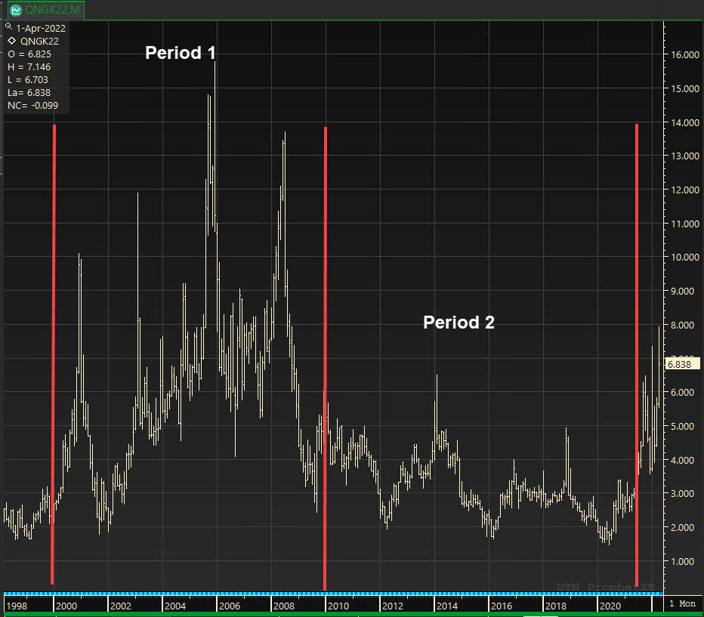
Figure 6
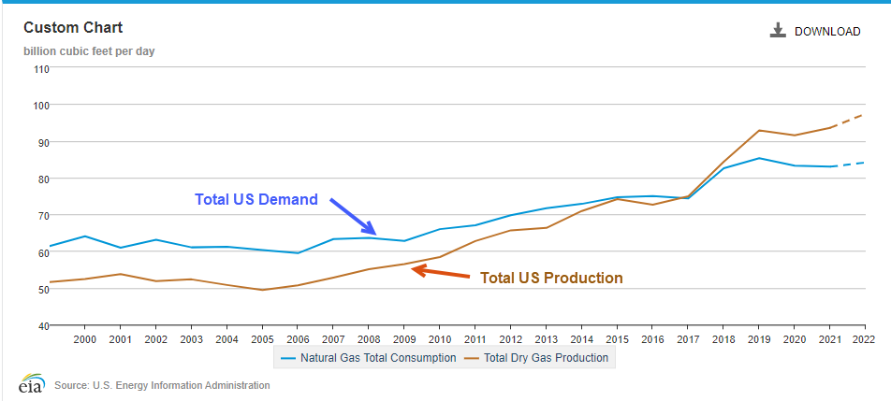
Q. Do you believe natural gas prices will be volatile in the future?
A. Yes, as explained earlier, the natural gas market witnessed a period of high volatility from 2000 to 2010, and a period of somewhat low volatility from 2010 to 2020, but recent history would suggest that the US is entering another period of increased volatility as explained below.
Q. What factors do you believe will lead to the volatility you described above?
A. Given the global nature of natural gas pricing that I have described, I expect that natural gas volatility will be driven by domestic and international production trends, demand for natural gas, and energy policy.
Q. Please elaborate on the production trends you describe above which you believe will lead to natural gas volatility.
A. As shown in figure 6, production started trending up steeply in 2017 at a time when US prices were low as seen in figure 5. Unfortunately, this led to an increased amount of oil and gas exploration and producing company bankruptcies. According to data collected by Haynes Boones, (chart below that shows the quarterly and cumulative bankruptcies, figure 7) over the past seven years, there have been 274 oil and gas producer bankruptcies. In the same period, 330 oilfield services and midstream companies have filed for bankruptcy, bringing the combined North American industry total to more than 600 industry bankruptcies involving over $321 billion in secured and unsecured debt

Figure 7
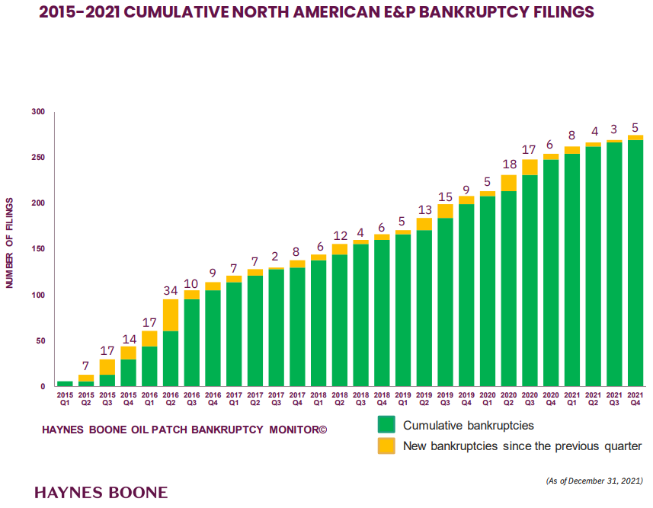
During this seven-year period the industry witnessed a consolidation of producing companies and the associated acreage and now the drilling actions are in the hands of fewer companies who have made it clear that they intend to increase investor returns. During the early stages of the Covid pandemic, both gas and oil demand greatly decreased and on April 20, 2020, we witnessed the first time that US oil prices went negative and settled at -$37.63 on the New York Mercantile Exchange. Based on the pandemic and historically low prices, producers cut costs, budgets, and experienced employees to weather the financial storm. Two years later, at a time when US producers should be ramping up supplies, they are running into a lack of qualified employees to hire along with all the issues experienced by many other companies including supply chain problems, cost increases and product unavailability. While the latter can be considered a short-term (under 18 months) consideration, there are reasons to believe that both gas and oil producers will stick to their longer-term goals of debt reduction, controlled capital expenditures, stock buy-back programs when the opportunity exists, a strong cash position, and increased shareholder value.
Q. Please elaborate on the demand trends you describe above which you believe will lead to natural gas volatility.
A. Demand for natural gas has been stronger than anticipated and is expected to get stronger throughout the year as new LNG facilities, specifically Calcasieu Pass in LA, come on-line. Once completed the EIA, as shown in figure 8, suggests that Calcasieu Pass will add a combined 1.6 BCF/day of LNG capacity to the demand side of the equation. On top of this, a new facility called Golden Pass is expected to be completed by the end of 2025, which according to its website, has the potential to increase US natural gas demand by an additional 2.6 BCF/day.

Figure 8
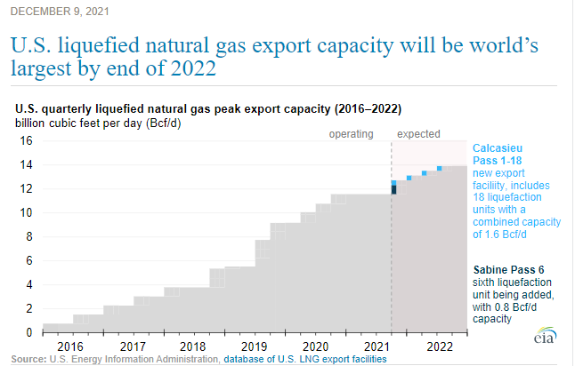
Outside of LNG, winter 20-21 over 21-22 winter demand continues to exceed expectations as shown in figure 9 from RBN Energy. According to Maxar Weather, the US temperatures associated to the winter of 2020-2021 compared to the winter of 2021-2022 were virtually identical, 3,537.7 and 3,552.3 weighted average heating degree days, respectively. With very similar weather, gas fired power generation increased by 2.4 BCF/day due to coal plant retirements and increased reliance on natural gas in the power stack. Residential and commercial demand increased by almost ½ BCF/day at a time when the weather was basically identical. Industrial demand was higher by almost 1 BCF/day as the US entered a better economic cycle. Lastly, LNG deliveries increased as expected due to the build out of that export industry.

Figure 9
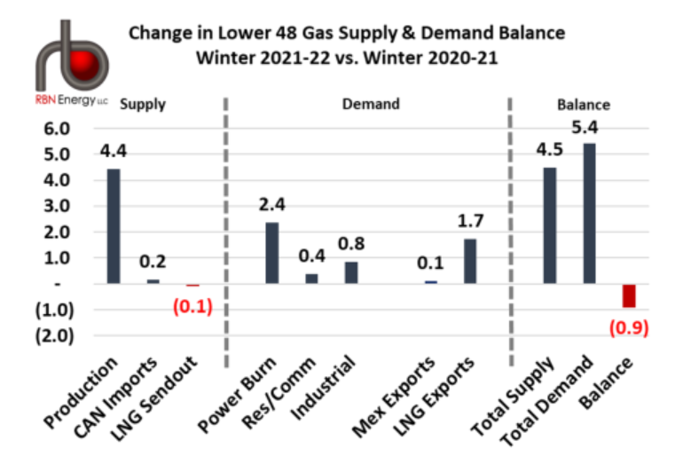
Q. Please elaborate on the energy policy trends you describe above which you believe will lead to natural gas volatility.
A. Given recent energy policy decisions, the energy landscape for natural gas and oil producers has become cloudy. Many infrastructure projects necessary to move gas, oil, and products from the supply areas to the demand areas have been delayed or cancelled. Some of these projects include the well-publicized Keystone Pipeline cancelled on June 9, 2021, the 1.1 BCF/day PennEast natural gas pipeline cancelled in September 2021, the 1.5 BCF/day Atlantic Coast Pipeline cancelled in July 2020, and the .6 BCF/day Constitution Pipeline cancelled in February 2020. The 304 mile, 2 BCF/day Mountain Valley Pipeline which runs from West Virginia to Virginia is 90% complete after 7 years but faces an uphill battle to get completed. If producers are not confident that pipeline expansions will be readily available in the future, they will be reluctant to increase supply as there is nowhere for the new supply to go. Finally, the FERC recently released a notice of proposed rulemaking that indicates a higher level of scrutiny with respect to the construction of green field pipelines. This is a signal to the market that it will be more challenging to drill for and move natural gas. The pipeline cancelations or delays and FERC rulemaking mentioned above stifle supply. At the same time, however, recent announcements by President Biden to provide Europe with US LNG tend to increase LNG demand. Based on the White House Fact Sheet, the US will work with international partners to ensure additional volumes of at least 15 billion tons of LNG for the remainder of 2022. The agreement also envisions a mechanism that ensures at least 50 billion cubic tons of LNG until 2030.
Q. Please summarize how the three factors outlined above will work together and lead to a volatile natural gas market in the future.
A. We are currently in an environment with increasing demand, especially via exports, compared to a supply side that, for reasons mentioned above, is having trouble responding after years of oversupply and a low revenue stream. The natural gas market has recently responded to this imbalance by raising both the short-term price and volatility. In fact, when looking at prompt month pricing since the beginning of the year, we see prices move from a low of $3.53 to a high of $8.99 for a low price to high price difference of $5.46. In just a four-month period we’ve seen natural gas prompt month prices move $5.46 while in the 10-year period from 2010 to 2020, prices moved from a low of $1.50 to a high of $6.50 which is only a total move of $5.00.
While it’s impossible to tell just how high or low prices can get this year, the EIA along with other analysts, suggest that prices could reach almost $30 in January and February 2023 under certain conditions. Figure 10 from the EIA’s most recent Short-Term Energy Outlook suggests, with 95% confidence, that February 2023 NYMEX prices could range anywhere from roughly $2.00 to $30.00. If we compare this to what the EIA suggested one year ago in its April 2021 report (figure 11), the upcoming February was projected to fall somewhere between $1.75 and $6.00 within a 95% confidence level. It is noticeable that the EIA expects increased volatility, by a factor of three, for the next 12 months.
Figure 10
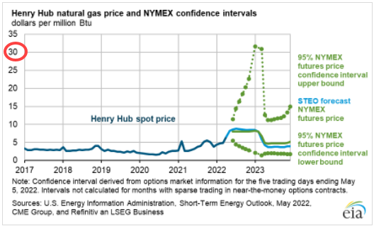
Figure 11
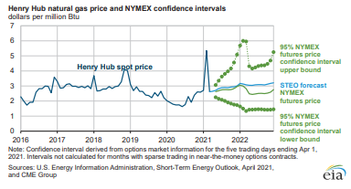
IV. Natural Gas trends and the Standard Choice Offer
Q. Have natural gas trends impacted SCO prices?
A. Yes. It directly affects the price of the SCO ( Figures 12 and 13 SCO prices 2019-present). The total commodity price to the SCO customer is made up of two components, the NYMEX monthly natural gas settlement price and the SCO adder determined by the auction. For example, for COH, the SCO auction price for the period April 2021 to March of 2022 was $1.70 and the SCO auction price for the current period of April 2022 to March 2023 is $1.65. This SCO price adder is added to the monthly NYMEX natural gas settlement to make up the total SCO commodity price. The natural gas NYMEX settlement price makes up most of the total SCO cost seen on the SCO customer bill. The SCO price adder is fixed and offers no volatility to SCO customers, but the underlying commodity cost or NYMEX price is variable and subject to the market conditions explained above. In fact, for April 2022 the total COH SCO commodity price was $6.986 where the NYMEX portion of the total price was three times the SCO adder price.
Figure 12
Columbia Gas of Ohio's SCO rates
DATES | SCO rates ($)
May 2018 - June 2018 | 0.39
June 2018 - July 2018 | 0.41
July 2018 - August 2018 | 0.42
August 2018 - September 2018 | 0.41
September 2018 - October 2018 | 0.41
October 2018 - November 2018 | 0.43
November 2018 - December 2018 | 0.44
December 2018 - January 2019 | 0.59
January 2019 - February 2019 | 0.49
February 2019- March 2019 | 0.42
March 2019 - April 2019 | 0.41
April 2019 - May 2019 | 0.39
May 2019 - June 2019 | 0.37
May 2019 - June 2019 | 0.38
July 2019 - August 2019 | 0.35
August 2019 - September 2019 | 0.33
September 2019 - October 2019 | 0.34
October 2019 - November 2019 | 0.36
November 2019 - December 2019 | 0.38
December 2019 - January 2020 | 0.37
January 2020 - February 2020 | 0.33
February 2020 - March 2020 | 0.31
March 2020 - April 2020 | 0.30
April 2020 - May 2020 | 0.27
May 2020 - June 2020 | 0.29
June 2020 - July 2020 | 0.28
July 2020 - August 2020 | 0.26
August 2020 - September 2020 | 0.29
September 2020 - October 2020 | 0.36
October 2020 - November 2020 | 0.32
November 2020 - December 2020 | 0.41
December 2020 - January 2021 | 0.40
January 2021 - February 2021 | 0.35
February 2021 - March 2021 | 0.38
March 2021 - April 2021 | 0.39
April 2021 - May 2021 | 0.43
May 2021 - June 2021 | 0.46
June 2021 - July 2021 | 0.47
July 2021 - August 2021 | 0.53
August 2021 - September 2021 | 0.61
September 2021 - October 2021 | 0.75
October 2021 - November 2021 | 0.79
November 2021 - December 2021 | 0.71
December 2021 - January 2022 | 0.57
January 2022 - February 2022 | 0.77
February 2022 - March 2022 | 0.80
March 2022 - April 2022 | 0.63
April 2022 - May 2022 | 0.70
May 2022 - Present | 0.89

Figure 13
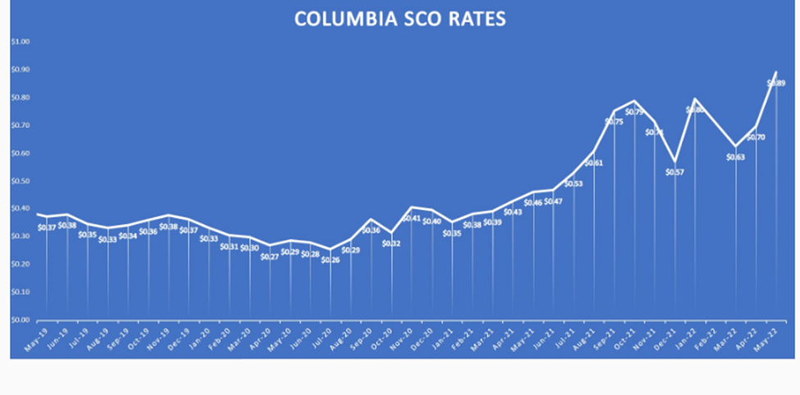
Q. Could customers have avoided price increases by entering a fixed long-term contract?
A. Companies enter fixed price contracts for many reasons. It could be as a hedge against sales, it could be that the current price fits within the budget, it could be that the price is attractive to the company, or it could be that companies want to take away the potential for a blowout in winter prices when system usage is highest. For whatever reason, companies enter into fixed contracts by locking in gas when the price meets the criteria set out by the decision makers within the company. In times of low-price volatility, customers tend to put off decisions and are content with whatever happens in the market. In times of higher volatility, customer decisions become much more important, contract timing becomes more important, and the length of contract commitment becomes much more important. Longer term fixed price agreements entered into during the past couple years would have avoided the current high price situation.
Q. Does this conclude your testimony?
A. Yes.

Certificate of Service

I hereby certify that a true copy of the foregoing Direct Testimony of Paul Leanza on Behalf of Interstate Gas Supply, Inc. was filed electronically through the Docketing Information System of the Public Utilities Commission of Ohio on May 13, 2022. The Commission’s e-filing system will electronically serve notice of the filing of this document upon the following parties listed below.

/s/ Stacie Cathcart
Stacie Cathcart

Service List

Citizens’ Utility Board of Ohio | Trent Dougherty trent@hubaydougherty.com
Environmental Law & Policy Center | Janean R. Weber jweber@elpc.org
Columbia Gas of Ohio | Joseph M. Clark  John R. Ryan  Melissa L. Thompson  josephclark@nisource.com  johnryan@nisource.com  mlthompson@nisource.com  Eric B. Gallon  Mark Stemm  L. Bradfield Hughes  Devan K. Flahive  Porter, Wright, Morris & Arthur LLP  egallon@porterwright.com  mstemm@porterwright.com  bhughes@porterwright.com  dflahive@porterwright.com
The Kroger Company | Angela Paul Whitfield Carpenter Lipps & Leland LLP paul@carpenterlipps.com
Northeast Ohio Public Energy Council | Devin D. Parram BRICKER & ECKLER LLP  dparram@bricker.com  Glenn S. Krassen gkrassen@nopec.org
Office of the Ohio Consumers’ Counsel | Angela D. O’Brien William J. Michael  Assistant Consumers’ Counsel angela.obrien@occ.ohio.gov william.michael@occ.ohio.gov
Ohio Energy Group (OEG) | Michael L. Kurtz, Esq. Kurt J. Boehm, Esq.  Jody Kyler Cohn, Esq. BOEHM, KURTZ & LOWRY  mkurtz@BKLlawfirm.com kboehm@BKLlawfirm.com jkylercohn@BKLlawfirm.com
Ohio Manufacturers’ Association Energy Group | Kimberly W. Bojko Jonathan Wygonski  Carpenter Lipps & Leland LLP Bojko@carpenterlipps.com Wygonski@carpenterlipps.com
Ohio Partners for Affordable Energy | Robert Dove  Kegler Brown Hill + Ritter Co., L.P.A. rdove@keglerbrown.com
Ohio School Council | Glenn S. Krassen BRICKER & ECKLER LLP  gkrassen@bricker.com Dane Stinson  BRICKER & ECKLER LLP  dstinson@bricker.com
Retail Energy Supply Association | Michael J. Settineri Gretchen L. Petrucci  Vorys, Sater, Seymour and Pease LLP mjsettineri@vorys.com glpetrucci@vorys.com
IEU-Ohio | Matthew Pritchard  Bryce Mckenney  MCNEES WALLACE & NURICK LLC  mpritchard@mcneeslaw.com  bmckenney@mcneeslaw.com

APPENDIX

Figure 1: U.S. Dry Natural Gas Production; Source: U.S. Energy Information Administration (page 6).
Figure 2: U.S. Electricity Generation by Source, all Sectors; Source U.S. Energy Information Administration, Short Term Energy Outlook, April 2022 (Page 7).
Figure 3: Coal will account for 85% of U.S. electric generating capacity retirements in 2022; Source U.S. Energy Information Administration, Preliminary Monthly Electric Generation Inventory, October 2021. (Page 7).
Figure 4: Gas Exports to Mexico; Source: U.S. Energy Information Administration (Page 8).
Figure 5: Natural Gas Prices between 1998-2020 (Page 10).
Figure 6: U.S. Production and Demand Natural Gas 2000-2022; Source U.S. Energy Information Administration (Page 10).
Figure 7: 2015-2021 Cumulative North American E&P Bankruptcy Filings; Source Haynes Boone Oil Patch Bankruptcy Monitor December 31, 2021. (Page 12)
Figure 8 :U.S. Liquefied Natural Gas Export Capacity Will be World’s Largest by End of 2022; Source: U.S. Energy Information Administration, database of U.S. LNG Export Facilities (Page 14).
Figure 9: Changes in Lower 48 Gas Supply & Demand Balance Winter 2021-22 vs. Winter 2020-21; Source RBN Energy (Page 15).
Figure 10 Henry Hub Natural Gas Price and NYMEX Confidence Intervals; Sources U.S. Energy Information Administrative, Short Term Energy Outlook, May 2022, CME Group, and Refinitiv an LSEG Business (Page 17).
Figure 11: Henry Hub Natural Gas Price and NYMEX Confidence Intervals; Sources: U.S. Energy Information Administrative, Short Term Energy Outlook, April 2021, and CME Group (Page 17).
Figure 12: Columbia Gas of Ohio’s SCO Rates May 2018-Present (Page 18-20).
Figure 13: Columbia Gas of Ohio’s SCO Rates May 2018-Present (Page 21).

