March 21, 2022

Docketing Division
Public Utilities Commission of Ohio
180 East Broad Street
Columbus OH 43215

RE: In the Matter of the Application of Ohio Power Company for Approval of a Change in Bill Format, Case No. 22-0222-EL-UNC.

Dear Docketing Division:

Enclosed please find Staff Comments in the Matter of the Application of Ohio Power Company for Approval of a Change in Bill Format, Case No. 22-0222-EL-UNC.

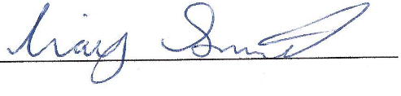
Craig Smith
Manager, Reliability and Service Analysis Division
Service Monitoring and Enforcement Department
Public Utilities Commission of Ohio

Enclosure

Cc: Parties of Record

COMMENTS

OF THE STAFF OF THE PUBLIC UTLITIES COMMISSION OF OHIO

I. BACKGROUND

On March 16, 2022, Ohio Power Company (hereinafter, “Company”) filed an application seeking expedited approval of a new bill format. In Case No. 20-585-EL-AIR, the Public Utilities Commission of Ohio (“the Commission”) approved a Delayed Payment Charge to apply to all residential customer bills, including consolidated bills, beginning April 1, 2022. The Delayed Payment Charge (i.e., late payment charge) establishes that residential accounts not paid with seven days after the due date will be charged an additional 1.5% of the total AEP Ohio amount billed.
The Company’s application proposes to add new language on Page 1 under “Amount due” at the top of the bill as well as to the pay stub showing a “Pay $X.XX after DATE”, to update the definition of late charge on Page 2 and to add a bill message to the “Notes from AEP Ohio” section on Page 3 informing customers of a possible late payment charge beginning with bills issued on May 1, 2022.
II. COMMENTS
Staff reviewed the Company’s application limited to the changes requested and has no concern with the proposed language or the request for an accelerated timeline.
III. RECOMMENDATIONS
Staff recommends the Commission approve the Company’s new bill format on an expedited basis.

