OCC EXHIBIT NO._______

BEFORE
THE PUBLIC UTILITIES COMMISSION OF OHIO

In the Matter of the Application of  Duke Energy Ohio, Inc., for an  Increase in Electric Distribution Rates.  In the Matter of the Application of  Duke Energy Ohio, Inc., for Tariff  Approval.  In the Matter of the Application of  Duke Energy Ohio, Inc., for Approval  To Change Accounting Methods. | )  )  )  )  )  )  )  )  ) | Case No. 21-887-EL-AIR  Case No. 21-888-EL-ATA  Case No. 21-889-EL-AAM

SUPPLEMENTAL TESTIMONY IN OPPOSITION TO THE SETTLEMENT
OF
J. RANDALL WOOLRIDGE, Ph.D.

On Behalf of
Office of the Ohio Consumers' Counsel
65 East State Street, Suite 700
Columbus, Ohio 43215

September 29, 2022
TABLE OF CONTENTS

PAGE

I. INTRODUCTION 1
II. Response to Duke’s testimony in support of the
settlement 3
A. OCC’s ROE recommendation of 8.84 percent is not out of line
with the average authorized ROE for electric distribution companies. 3
B. The proposed capital structure ignores the fact that Duke Energy,
Inc. is leveraging its returns using “double leverage” and Duke
Energy Ohio’s customers are paying the price. 4
C. Duke Energy Ohio’s investment risk is similar to other electric
utility companies. 6
D. Inflation and interest rates are up in 2022, but authorized ROEs
never reflected the historically low interest rates associated with
the coronavirus pandemic, and expected long-term inflation is
only 2.5 percent. 7
E. Despite the increase in interest rates in 2022, interest rates are
still at historically low levels. 8
F. Utility stocks have outperformed the S&P 500 by a large margin
in 2022 and utility betas are on the way down. 10
G. Ohio authorized ROEs have been out of step with national ROEs
over the past decade. 12
III. THE PUCO SHOULD REJECT THE SETTLEMENT TO PROTECT
DUKE’S CONSUMERS. 14
IV. CONCLUSION 15

I. INTRODUCTION

Q1. PLEASE STATE YOUR FULL NAME, ADDRESS, AND OCCUPATION.
A1. My name is J. Randall Woolridge, and my business address is 120 Haymaker Circle, State College, PA 16801. I am a professor of finance and the Goldman, Sachs & Co. and Frank P. Smeal Endowed University Fellow in Business Administration at the University Park Campus of the Pennsylvania State University. I filed testimony in this case on behalf of the Office of the Ohio Consumers’ Counsel (“OCC”) on the appropriate rate of return or cost of capital for Duke Energy Ohio (“Duke”).

Q2. DID YOU PREVIOUSLY FILE DIRECT TESTIMONY ON BEHALF OF OCC IN THIS CASE?

A2. Yes. I prepared direct testimony in support of OCC’s Objections to the Staff Report in this case that was filed on September 2, 2022. In my direct testimony, which is incorporated here by reference, I explain and provide extensive support for my recommendations for an appropriate Return on Equity (“ROE”) and capital structure for Duke.

Q3. WHAT IS THE PURPOSE OF YOUR SUPPLEMENTAL TESTIMONY?
A3. I am addressing the Supplemental Testimony of Duke witnesses Mr. Christopher R. Bauer and the Second Supplemental Testimony of Dylan W. D’Ascendis regarding the Corrected Stipulation and Recommendation (“Settlement”) filed in this proceeding on September 19, 2022. I review these testimonies in the context of the Public Utilities Commission of Ohio’s (“PUCO”) three-prong test whereby it evaluates a regulatory settlement under the following criteria: (1) is the settlement a product of serious bargaining among capable, knowledgeable parties; (2) whether the settlement, as a package, benefits customers and the public interest; and (3) whether the settlement violates any important regulatory principles or practices. With respect to these tests, I am addressing the capital structure, return on equity, and overall cost of capital agreed to in the Settlement.

Q4. IN YOUR OPINION, DOES THE SETTLEMENT VIOLATE THE PUCO’S TEST FOR EVALUATING SETTLEMENTS?

A4. Yes. The Settlement includes a ROE of 9.50 percent and a capital structure that includes 49.5 percent long-term debt and 50.5 percent common equity. I believe the agreed to ROE and settled capital structure violates prongs two and three of the PUCO’s three-part settlement test. Specifically, I believe that the Settlement, which includes an inflated ROE and a capital structure with excessive equity, does not benefit consumers and the public interest (prong two). The Settlement also violates regulatory principles (prong three) because it results in rates to consumers that are not just and reasonable.

II. Response to Duke’s testimony in support of the settlement

A. OCC’s ROE recommendation of 8.84 percent is not out of line with the average authorized ROE for electric distribution companies.

Q5. DUKE WITNESS D’ASCENDIS CRITICIZES YOUR PROPOSAL FOR DUKE’S ROE. IS YOUR PROPOSED ROE OF 8.84% OUT OF LINE WITH THE AVERAGE AUTHORIZED ROEs OF ELECTRIC DISTRIBUTION COMPANIES?

A5. No. Mr. D’Ascendis tries to make the point that the Settlement ROE of 9.50 percent is not significantly different than those approved by state commissions for electric distribution companies. However, Mr. D’Ascendis’ analysis is dated. As I noted in my direct testimony, the authorized ROEs for electric delivery companies have been 30 to 50 basis points below those of vertically integrated electric utilities in recent years. In addition, the average authorized ROEs for electric distribution companies in 2020 and 2021 were 9.10% and 9.04%, and 9.13% in the first half of 2022. As such, my ROE recommendation of 8.84 percent is closer to the national average than the settlement ROE of 9.50 percent. Charging consumers an outdated and excessive ROE is in the best interest of the utility, not the consumer and fails the second prong of the Commission’s test.

B. The proposed capital structure ignores the fact that Duke Energy, Inc. is leveraging its returns using “double leverage” and Duke Energy Ohio’s customers are paying the price.

Q6. PLEASE DISCUSS THE CAPITAL STRUCTURE IN THE SETTLEMENT.
A6. The Settlement adopts Duke’s proposed capital structure consisting of 49.50 percent long-term debt and 50.50 percent common equity. In my direct testimony, I showed that Duke’s proposed capital structure includes a common equity ratio that is higher than the average common equity ratios employed by the proxy groups and Duke Energy, Inc., the parent of the Company. Therefore, the proposed capital structure has more common equity and less financial risk than the capital structures of other electric utility companies. Furthermore, I highlighted the fact that the parent company has more debt than proposed for Duke which is evidence of double leverage. Moody’s published an article on the use of low-cost debt financing by public utility holding companies to increase their ROEs.
U.S. utilities use leverage at the holding-company level to invest in other businesses, make acquisitions and earn higher returns on equity. In some cases, an increase in leverage at the parent can hurt the credit profiles of its regulated subsidiaries.
The Moody’s article identifies this financial strategy “double leverage.” Noting that “double leverage” results in a consolidated debt-to-capitalization ratio that is higher at the parent than at the subsidiary because of the additional debt at the parent, Moody’s defined double leverage as follows:
Double leverage is a financial strategy whereby the parent raises debt but downstreams the proceeds to its operating subsidiary, likely in the form of an equity investment. Therefore, the subsidiary’s operations are financed by debt raised at the subsidiary level and by debt financed at the holding-company level. In this way, the subsidiary’s equity is leveraged twice, once with the subsidiary debt and once with the holding-company debt. In a simple operating-company/holding-company structure, this practice results in a consolidated debt-to-capitalization ratio that is higher at the parent than at the subsidiary because of the additional debt at the parent.

Moody’s goes on to discuss the potential risk “down the road” to utilities of this financing corporate strategy if regulators were to ascribe the debt at the parent level to the subsidiaries or adjust the authorized return on capital:
“Double leverage” drives returns for some utilities but could pose risks down the road. The use of double leverage, a long-standing practice whereby a holding company takes on debt and downstreams the proceeds to an operating subsidiary as equity, could pose risks down the road if regulators were to ascribe the debt at the parent level to the subsidiaries or adjust the authorized return on capital.

As I discussed in my initial testimony, when a regulated electric utility company’s actual capital structure contains a high equity ratio, the options to benefit consumers (prong 2) are to: (1) to impute a more reasonable capital structure and reflect the imputed capital structure in revenue requirements or (2) recognize the downward impact that an unusually high equity ratio will have on the financial risk of a utility and authorize a lower common equity cost rate. Given these two alternatives, I proposed using a capital structure with an imputed common equity ratio of 50.0 percent. In my opinion, this is a very modest adjustment to recognize the double leverage being used Duke Energy, Inc. at the expense of Duke Energy Ohio customers. This simple change would bring the Settlement more in line with regulatory principles and practices.

C. Duke Energy Ohio’s investment risk is similar to other electric utility companies.

Q7. IS DUKE’S INVESTMENT RISK LEVEL SIMILAR TO OTHER ELECTRIC UTILITIES?

A7. Yes. Mr. Bauer discusses the riskiness of Duke. In my direct testimony, I highlighted that Duke’s S&P and Moody’s issuer credit ratings of BBB+ and Baa1 are identical to the average of the three proxy groups. As a result, I have concluded that Duke’s investment risk is very similar to the average of the proxy groups. Therefore, the risk assessment used to justify the unreasonable ROE and capital structure agreed to in the Settlement harms consumers and is contrary to the regulatory principle that consumers pay only just and reasonable rates, in violation of prongs two and three of the PUCO’s settlement test.

D. Inflation and interest rates are up in 2022, but authorized ROEs never reflected the historically low interest rates associated with the coronavirus pandemic, and expected long-term inflation is only 2.5 percent.

Q8. PLEASE ADDRESS THE COMPANY’S ASSESSMENT OF CAPITAL MARKET CONDITIONS AND AUTHORIZED ROES.

A8. Mr. D’Ascendis has addressed current capital market conditions and authorized ROEs. However, while authorized ROEs for utilities also reached record low levels in in 2020 and 2021, they did not decline as much as the record low interest rates. Figure 1 and Table 1 show the average annual 30-year Treasury yields and authorized ROEs for electric utilities and gas distribution companies. As shown, the average daily 30-year Treasury yield declined from 3.11% in 2018 to 1.56% in 2020, a decrease of 155 basis points. However, the average authorized ROE for electric utilities declined only from 9.60% in 2018, and 9.66% in 2019, to 9.44% in 2020, and 9.38% in 2021. As such, authorized electric ROEs declined by about 20 basis points, while the 30-year Treasury yield decreased by over 150 basis points. Likewise, the average authorized ROE for gas distribution companies declined from 9.60% in 2018 and 9.71% in 2019, to 9.46% in 2021 and 9.56% in 2021. So utility authorized gas ROEs declined by 10-15 basis points, while the 30-year Treasury yield decreased by over 150 basis points. Accordingly, the ROE agreed to in the Settlement harms consumers and is contrary to regulatory principles that consumers pay just and reasonable rates in violation of prongs two and three of the PUCO’s three-prong test.
Figure 1
Authorized ROEs for Electric Utilities and 30-Year Treasury Yields
2007–2021
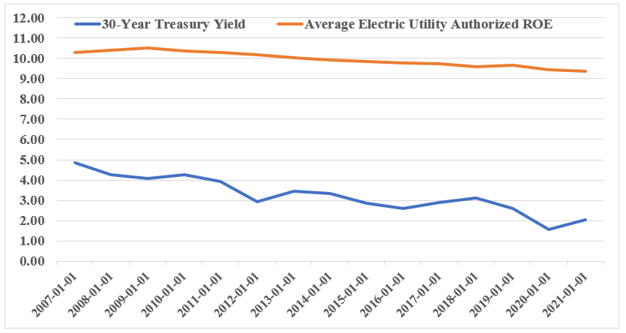

Table 1
Average Annual 30-Year Treasury Yields and Authorized ROEs
for Electric Utility and Gas Distribution Companies
2018–2021
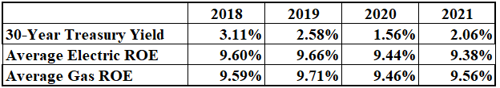

E. Despite the increase in interest rates in 2022, interest rates are still at historically low levels.

Q9. IN HIS SECOND SUPPLEMENTAL TESTIMONY, MR. D’ASCENDIS REFUTES YOUR STATEMENT THAT DESPITE THE INCREASE IN INTEREST RATES IN 2022, THEY ARE STILL AT HISTORICALLY LOW LEVELS. PLEASE RESPOND.
A9. Mr. D’Ascendis disputes my statement that interest rates are still at historically low levels by noting that interest rates are at levels not seen since 2014. In Figure 2, I show the yields on 10-year Treasury yields since 1953. The average monthly 10-year yield over this time frame is 5.60 percent. As shown in the figure, prior to the decline in interest rates over the past decade, the 10-year Treasury yield had not been as low as 3.30 percent since the 1950s. Hence, I stand by my statement that interest rates, despite the increase in 2022, are still at historically low levels. And the unreasonable interest rate used to justify the ROE agreed to in the Settlement harms consumers and is contrary to regulatory principles that consumers pay just and reasonable rates in violation of prongs two and three of the PUCO’s three-prong test.
Figure 2
10-Year Treasury Yields
1953–2022
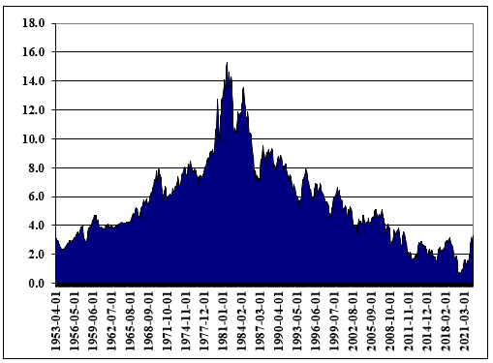

F. Utility stocks have outperformed the S&P 500 by a large margin in 2022 and utility betas are on the way down.

Q10. IN HIS SECOND SUPPLEMENTAL TESTIMONY, MR. D’ASCENDIS ALSO DOWNPLAYS THE RECENT PERFORMANCE OF UTILITY STOCKS. PLEASE RESPOND.

A10. Mr. D’Ascendis downplays the 2022 performance of utility stocks by going back and assessing utility stock performance since before the pandemic. His analysis is outdated and does not reflect the risk and return of utility stocks in 2022. In Figure 3, I show the performance of the S&P Utilities vs. the S&P 500 in 2022. While the S&P 500 is down 22.51 percent in 2022, the S&P Utilities stocks are up 0.26 percent. The bottom line is that investors are flocking to utility stocks due to their favorable risk and return attributes. Accordingly, Duke’s failure to acknowledge the strong demand for utility stocks since the pandemic harms the justification for the ROE agreed to in the Settlement, which harms consumers and is contrary to regulatory principles that consumers pay just and reasonable rates in violation of prongs two and three of the PUCO’s three-prong test.
Figure 3
S&P Utility Stocks vs. the S&P 500
2022
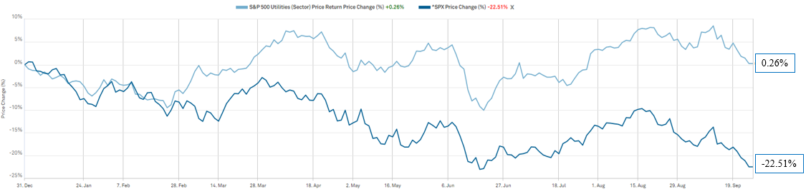

Q11. HAVE ANY ATTRIBUTES OF UTILITY STOCK CHANGED THAT MIGHT BE ASSOCIATED WITH THE UTILITY STOCK OUTPERFORMANCE?

A11. Yes. A significant change has been the decline in utility betas in the last two years. Wells Fargo recently highlighted the decline in utility betas in an equity investment publication. The results are highlighted in Figure 4. In the figure, you can see that utility betas have declined from the 0.95 range in 2020 to about 0.60. As such, the investment risk of utility stocks is on the decline. Lower risk and higher returns are very attractive to investors. This is clearly an attribute that Mr. D’Ascendis missed in his analysis and presumably a reason for the utility stock performance in 2022. Accordingly, Duke’s failure to acknowledge the lower risk and higher returns currently being experienced by the utility industry harms the justification for the ROE agreed to in the Settlement, which harms consumers and is contrary to regulatory principles that consumers pay just and reasonable rates in violation of prongs two and three of the PUCO’s three-prong test.
Figure 4
Utility Betas Decline Below Betas of Other Defensive Sectors
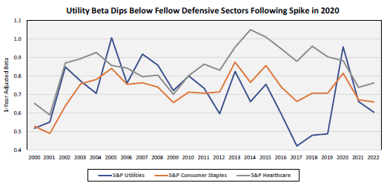
Source: Wells Fargo Equity Research, “Figure of the Week: Utility 1-Year Beta Continues Downward Trajectory.” July 15, 2022.

G. Ohio authorized ROEs have been out of step with national ROEs over the past decade.

Q12. IN HIS SECOND SUPPLEMENTAL TESTIMONY, MR. D’ASCENDIS HAS FOCUSSED ON AUTHORIZED ROEs. YOU DISCUSSED AUTHORIZED ROEs FOR DISTRIBUTION ELECTRIC UTILITIES ABOVE. DO YOU HAVE ANY OTHER OBSERVATIONS REGARDING THE AUTHORIZED ROE?

A12. Yes. One other issue are the authorized ROEs in Ohio. In Figure 5, I have compared the authorized ROEs for electric delivery utilities in Ohio and nationally over the past decade. While authorized ROEs in Ohio were in the 10.0% range a decade ago, which was in-line with national averages, these authorized ROEs have only declined to the 9.70%-10.00% range since that time, while national average delivery-only authorized ROEs have declined to 9.0%. Clearly, authorized ROEs in Ohio have not reflected the lower interest rates and capital costs in the U.S. and have remained at much higher levels than U.S. national averages. Simply put, Ohio utilities have been charging consumers for ROEs above the national average. That harms consumers and is not in the public interest (second prong). It is also contrary to regulatory principles that consumers pay only just and reasonable rates.
Figure 5
Authorized ROEs for Ohio Electric Utilities vs.
National Average Delivery-Only Authorized ROEs
2010–2022
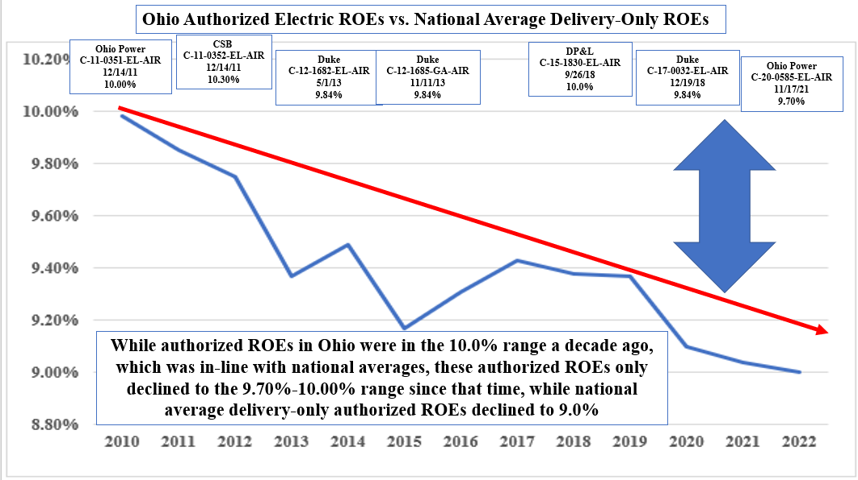

Q13. ONE FINAL ISSUE - DO YOU BELIEVE THAT YOUR ROE RECOMMENDATION MEETS HOPE AND BLUEFIELD STANDARDS?

A13. Yes, I do. According to the Hope and Bluefield decisions, returns on capital should be: (1) comparable to returns investors expect to earn on other investments of similar risk; (2) sufficient to assure confidence in the company’s financial integrity; and (3) adequate to maintain and support the company’s credit and to attract capital. As shown on page 3 of Exhibit JRW-3 in my direct testimony, I show that electric utilities and gas distribution companies have been earning ROEs in the range of 8.0% to 10.0% in recent years. With such an ROE, electric utilities such as those in the proxy group have strong investment grade credit ratings, their stocks have been selling above book value, and they have been raising abundant amounts of capital. While my recommendation is a little below the average authorized ROE for electric distribution companies, it reflects the relatively low levels of interest rates and capital costs and the outstanding performance of utility stocks. Therefore, I believe that my ROE recommendation meets the criteria established in Hope and Bluefield, which are the basis for established regulatory principles. My recommendations also are to benefit consumers and the public interest.

III. THE PUCO SHOULD REJECT THE SETTLEMENT TO PROTECT DUKE’S CONSUMERS.

Q14. ABOVE YOU MENTIONED THE THREE PRONG TEST THE PUCO USES TO EVALUATE SETTLEMENTS. IN YOUR OPINION, DOES THE STIPULATION VIOLATE THE THREE PRONG TEST?

A14. Yes. For the reasons explained above and in my direct testimony, a ROE of 8.84% represents a proper balance of protecting consumers from paying unjust and unreasonable rates and the recent increase in interest rates in the financial market. The ROE agreed to in the Settlement is significantly above average and it will be imposed on residential consumers who will be forced to pay for the majority of the rate increase. Thus, the Settlement does not benefit consumers and

is not in the public interest in violation of the second prong of the PUCO’s three prong test.

The ROE and capital structure agreed to in the Settlement also violate regulatory principles and practices (prong three) because it results in unjust and unreasonable rates to consumers. For the reasons explained above and in my direct testimony, the PUCO should reject the Settlement in in its current form.

IV. CONCLUSION

Q15. DOES THIS COMPETE YOUR SUPPLEMENTAL TESTIMONY?
A15. Yes. However, I reserve the right to incorporate new information that may subsequently become available. I also reserve the right to supplement my testimony in the event Duke, the PUCO Staff, or other parties submit new or corrected information in connection with this proceeding.
CERTIFICATE OF SERVICE
I hereby certify that a copy of the foregoing Supplemental Testimony in Opposition to the Settlement of J. Randall Woolridge, Ph.D. on behalf of Office of the Ohio Consumers’ Counsel has been served upon those persons listed below via electronic service this 29th day of September 2022.
/s/ Angela D. O’Brien
Angela D. O’Brien
Assistant Consumers’ Counsel

The PUCO’s e-filing system will electronically serve notice of the filing of this document on the following parties:

SERVICE LIST
robert.eubanks@ohioAGO.gov  shaun.lyons@ohioAGO.gov  werner.margard@ohioAGO.gov  mkurtz@BKLlawfirm.com  kboehm@BKLlawfirm.com  jkylercohn@BKLlawfirm.com  mwarnock@bricker.com  kherrnstein@bricker.com  ktreadway@oneenergyllc.com  jdunn@oneenergyllc.com  dborchers@bricker.com  kherrnstein@bricker.com  Fdarr2019@gmail.com  paul@carpenterlipps.com  rdove@keglerbrown.com  nbobb@keglerbrown.com  trent@hubaydougherty.com  Attorney Examiners:  matthew.sandor@puco.ohio.gov  nicholas.walstra@puco.ohio.gov | Rocco.dascenzo@duke-energy.com  Jeanne.kingery@duke-energy.com  Larisa.vaysman@duke-energy.com  elyse.akhbari@duke-energy.com  ebrama@taftlaw.com  kverhalen@taftlaw.com  Bethany.allen@igs.com  Joe.oliker@igs.com  Evan.betterton@igs.com  Stacie.cathcart@igs.com  michael.nugent@igs.com  jlang@calfee.com  gjewell@calfee.com  gwhaling@calfee.com  sfranson@calfee.com  dromig@nationwideenergypartners.com  Bojko@carpenterlipps.com  Wygonski@carpenterlipps.com  cgrundmann@spilmanlaw.com  dwilliamson@spilmanlaw.com  cpirik@dickinsonwright.com  todonnell@dickinsonwright.com  mmcdonnell@dickinsonwright.com

D’Ascendis Second Supplemental Testimony, at 7-8.
Woolridge Direct Testimony, at 20.
Woolridge Direct Testimony, at 29-34.
Id., at 28-30.
High Leverage at the Parent Often Hurts the Whole Family, Moody’s Investors’ Service, May 1, 2015, at 1.
Id. at 5.
Id. at 1.
D’Ascendis Second Supplemental Testimony, at 10-14.
D’Ascendis Second Supplemental Testimony, at 11.
Id., at 13.
Wells Fargo Equity Research, “Figure of the Week: Utility 1-Year Beta Continues Downward Trajectory,” July 15, 2022.

