OCC EXHIBIT _______

BEFORE
THE PUBLIC UTILITIES COMMISSION OF OHIO

In the Matter of the Application of  The Dayton Power and Light Company for Approval of Its Electric Security Plan. | )  )  ) | Case No. 16-0395-EL-SSO
In the Matter of the Application of  The Dayton Power and Light Company for Approval of Revised Tariffs.  In the Matter of the Application of  The Dayton Power and Light Company for Approval of Certain Accounting Authority Pursuant to Ohio Rev. Code § 4905.13. | )  )  )  )  )  )  )  ) | Case No. 16-0396-EL-ATA  Case No. 16-0397-EL-AAM

SUPPLEMENTAL DIRECT TESTIMONY
OF
JAMES D. WILLIAMS

On Behalf of
The Office of the Ohio Consumers’ Counsel
10 West Broad Street, Suite 1800
Columbus, Ohio 43215-3485

MARCH 29, 2017

TABLE OF CONTENTS
Page

I. INTRODUCTION 1
II. PURPOSE 1
III. EVALUATION OF THE STIPULATION REGARDING THE THREE-PRONG TEST USED BY THE PUCO FOR JUDGING SETTLEMENTS 5

ATTACHMENTS

JDW-1 DP&L Response to OCC INT-485
JDW-2 DP&L Response to OCC INT-487
JDW-3 DP&L Response to OCC INT-488
JDW-4 DP&L Response to OCC INT-348
JDW-5 DP&L Response to OCC INT-338
JDW-6 DP&L Response to OCC INT-363
JDW-7 DP&L Response to OCC INT-366
JDW-8 DP&L Response to OCC INT-491
JDW-9 DP&L Response to OCC INT-492
JDW-10 DP&L Response to OCC INT-369
JDW-11 DP&L Response to OCC INT-370

INTRODUCTION

Q1. PLEASE STATE YOUR NAME AND BUSINESS ADDRESS.
A1. My name is James D. Williams. My business address is 10 W. Broad Street, Suite 1800, Columbus, Ohio 43215.

Q2. HAVE YOU PREVIOUSLY SUBMITTED DIRECT TESTIMONY IN THIS CASE?
A2. Yes. I submitted Direct Testimony on November 21, 2016. My qualifications and experience are included with that Direct Testimony.

PURPOSE

Q3. WHAT IS THE PURPOSE OF YOUR SUPPLEMENTAL TESTIMONY?
A3. On March 14, 2017, The Dayton Power and Light Company (“DP&L” or “Utility”) filed a proposed Amended Stipulation and Recommendation (“Settlement”) covering issues presented in this proceeding. The purpose of my supplemental testimony is to review the Settlement reached among DP&L and the signatory parties related to the Application of DP&L for approval of its third Electric Security Plan (ESP III). That purpose includes providing my opinion on whether the Amended Settlement meets the three-prong test used by the PUCO in determining whether a settlement should be approved.
Q4. PLEASE DESCRIBE THE SETTLEMENT BETWEEN DP&L AND SOME SIGNATORY PARTIES
A4. This Settlement, if approved by the PUCO, would enable DP&L to impose multiple new and additional charges on customers:
- The Settlement includes a Distribution Modernization Rider (“DMR”) that collects $105 million annually through additional charges to customers. The $105 million collected from customers annually would continue for three years. The total cost to customers would be at least $315 million because there is an option for DP&L to extend the duration of the rider for two additional years.
- The Settlement enables DP&L to create a Distribution Investment Rider (“DIR”), which can collect an uncapped and unspecified amount of money from customers for certain investments categorized as incremental distribution capital investments.
- The Settlement establishes a Smart Grid Rider (“SGR”) that will enable DP&L to collect an undetermined amount of money from customers for an unspecified period of time regarding a Distribution Infrastructure Modernization Plan that has yet to be developed by the Utility.
- The Settlement enables DP&L to increase the bills for residential customers who heat their homes using electricity.
- The Settlement enables DP&L to establish an Economic Development Rider (“EDR”) that collects from customers an unspecified amount of money to subsidize economic development incentives offered to large customers that are signatory parties or Non-opposing parties to the Settlement.
- The Settlement results in DP&L providing preferential treatment to certain customers in the form of economic development grant payments that ultimately impact the cost of electricity for other customers.
- The Settlement enables DP&L to defer unspecified costs for later collection from customers that are associated with the Utility OVEC commitments.
- The Settlement enables DP&L to implement a Decoupling Rider for collection of an uncapped amount of money from customers related to lost revenues associated with energy efficiency.
- The Settlement enables DP&L to establish a Regulatory Compliance Rider (“RCR”), which ultimately results in customers paying up to $20 million over the term of the ESP for different deferral balances and expansion of supplier billing options.
- The Settlement enables DP&L to collect an unspecified and undetermined amount of money from customers annually for costs associated with restoring service following major storms through a Storm Cost Recovery Rider (“SCRR”).
- The Settlement enables DP&L to collect from customers an unspecified and undetermined amount of money associated with unpaid bills through an Uncollectible Rider.

Q5. PLEASE SUMMARIZE YOUR RECOMMENDATIONS.
A5. I recommend that the PUCO reject the Settlement signed by DP&L and a group of other parties to this case because it violates all three prongs of the test that the PUCO has used in evaluating settlements. More specifically, and fully consistent with the intent of my original testimony, the Settlement if approved by the PUCO could result in DIR charges that are unreasonable, unlawful, and contrary to sound Ohio regulatory policy. DP&L’s obligation to continue providing customers with safe and reliable service is not contingent on the establishment of new revenue streams through DIR or the DMR riders.
In addition, the Settlement if approved by the PUCO results in establishment of multiple riders that unnecessarily increase the electric charges that customers are ultimately required to pay. Some of the new riders can result in duplicative charges with costs customers are already paying in base electric rates. Other ill-conceived riders like the DMR and the SGR are premature because the Settlement provides for a cost recovery mechanism that will collect hundreds of millions of dollars from customers before the PUCO even defines the smart grid initiative and what the ultimate costs will be. Under the smart grid rider, DP&L converts its customers into shareholders by shifting the risks associated with financial decisions that may be unsound involving smart grid onto customers. Such risks should be borne by shareholders not customers.

EVALUATION OF THE STIPULATION REGARDING THE THREE-PRONG TEST USED BY THE PUCO FOR JUDGING SETTLEMENTS

Q6. WHAT CRITERIA DOES THE PUCO USUALLY RELY UPON FOR CONSIDERING WHETHER TO ADOPT A STIPULATION?
A6. The PUCO will adopt a stipulation only if it meets all three of the criteria below. The PUCO must analyze the Settlement and decide the following:
1. Is the settlement a product of serious bargaining among capable, knowledgeable parties?
2. Does the settlement, as a package, benefit customers and the public interest?
3. Does the settlement package violate any important regulatory principle or practice?

Q7. DOES THE SETTLEMENT FILED IN THIS PROCEEDING MEET ALL THREE CRITERIA?
A7 No. The proposed Settlement fails to meet the three-prong test as I elaborate below.

Q8. IS THE STIPULATION A PRODUCT OF SERIOUS BARGAINING AMONG CAPABLE, KNOWLEDGEABLE PARTIES REPRESENTING DIVERSE INTERESTS?
A8. No. The settlement is not a product of serious bargaining between capable and knowledgeable parties representing a diversity of interests. The Settlement focuses on serving the self-interests of a few signatory parties and not the diverse interests of customers, including residential customers, as a whole. But the residential customers must bear the burden of paying a significant portion of the unjust and unreasonable charges associated with the Settlement. A review of the signatory parties to the Settlement reveals there is not a single signatory party that represents the exclusive interests of all residential customers across DP&L’s service territory.
Even the testimony of DP&L Witness Schroder demonstrates the lack of diversity of interests in this Settlement. In her testimony, she states that a diverse group of parties signed the Settlement. She then describes this diverse group of parties as including PUCO Staff, DP&L, three groups representing some low-income consumers, the largest municipality in the DP&L service territory, an industrial customer, a manufacturing association, a supermarket chain, an organization representing hospitals, a retail supplier association, and an individual supplier. There is hardly a diversity of interests represented in this Settlement when the interests of the vast majority of customers who pay DP&L electric bills are not supporting the Settlement.

Q9. DOES THE SETTLEMENT BENEFIT CUSTOMERS AND THE PUBLIC INTEREST?
A9. No. Under the Settlement, DP&L customers will be charged an additional $105 million annually, or $315 million over three years, for the DMR to allegedly pay down debt. Also under the Settlement, DP&L customers could be charged hundreds of millions of dollars over an additional two years as an extension to the DMR for repayment of debt. A Settlement that provides no certainty in customer benefits and that costs customers hundreds of millions of dollars over five years for credit support and another untold amount of money for unnecessary investments is clearly not in the public interest.

Moreover, the Settlement enables DP&L to collect from customers an uncapped and unspecified amount of money for distribution capital investments through the DIR. DP&L claims that the DIR would be used to address known threats to the distribution system including replacing high failure rate equipment and replacement of underground cable. But consistent with my previous testimony, DP&L has not justified the need for collecting additional money from customers for a DIR. In addition, while the Settlement enables DP&L to collect more money from customers for the DIR, there is no commitment from the Utility that consumers will receive tangible benefits derived from money collected through the DIR.

Q10. ARE THERE OTHER REASONS WHY THE SETTLEMENT DOES NOT BENEFIT CUSTOMERS AND THE PUBLIC INTEREST?
A10. Yes. According to the testimony of DP&L Witness Schroder, the Settlement will establish a new Smart Grid Rider (“SGR”). The purpose of the new rider is to enable DP&L to collect from customers the costs associated with preparing a Distribution Grid Modernization Plan and eventually grid modernization investments. Based on the DP&L response to OCC INT-485 (attached herein as JDW-1), the Distribution Grid Modernization Plan is based on a PUCO statewide PowerForward grid modernization initiative. And according to JDW-1, at this time DP&L has no understanding about the PUCO’s PowerForward grid modernization initiative.

According to the DP&L response to OCC INT-487 (attached herein as JDW-2), the Utility claims it will seek collection of the costs associated with preparing the Distribution Infrastructure Modernization Plan through the smart grid rider. And these costs are unknown and subject to no limitations in the Settlement. Furthermore, the smart grid rider will be used to collect costs from customers associated with deploying the DP&L Distribution Infrastructure Modernization Plan consistent with the PowerForward grid modernization initiative.

These costs are unknown and not subject to limitations in the Settlement although they could easily be hundreds of millions of dollars. In fact, the Settlement creates a smart grid rider by name only and then defers all other matters related to the rider to some future proceeding involving approval of the modernization plan, DP&L has not considered other alternatives than a smart grid rider for collecting these investment costs from consumers. Other alternatives like recovery of the costs in future base rate proceedings may be more appropriate for consumers.

The PUCO should not permit customers to be converted into investors by being asked to shoulder the risks for investments that DP&L makes that are not supported through sound financial analysis (including quantifiable cost/benefit analysis). DP&L should consider future enhancements to its distribution system in the normal course of business without the need for a rider to collect the costs for preparing the distribution modernization plan. Furthermore, DP&L has the opportunity to seek cost recovery for investments that it makes in its distribution system through traditional base rate cases. Approval of the smart grid rider circumvents consideration of alternatives like future base rate cases for collecting smart grid costs. Furthermore, to the extent that grid modernization initiatives are being used by the Stipulating parties as support for the DMR, there has been no demonstration that the grid modernization initiative or the Settlement benefits customers or is in the public interest.

Before the PUCO authorizes DP&L to spend any customer money on future smart grid programs, the PUCO should first complete the PowerForward initiative and establish clear requirements for future smart grid deployments. The Smart grid programs that have been implemented in Ohio should be evaluated to ensure that customers are obtaining all of the benefits that are supposed to be provided through smart grid technology. This evaluation should include an assessment of whether the investments are cost effective and providing sufficient benefit to customers. Without this evaluation, it appears that the smart grid rider in the Settlement benefits neither customers nor the public interest.

Q11. ARE THERE OTHER REASONS WHY THE SETTLEMENT DOES NOT BENEFIT CUSTOMERS AND THE PUBLIC INTEREST?
A11. Yes. DP&L Witness Schroder testifies that the Settlement results in a monthly bill impact of $(0.25) per month for a typical residential customer using 1,000 kWh per month. She further states that DP&L has “had among the lowest residential rates of electric distribution rates in the state.”

But DP&L Witness Schroder did not include the full bill impact including the pending base rate case, DIR, SGR, and the many other riders that DP&L and others agreed upon under the Settlement. Without the Settlement, there can be no doubt that bills would indeed be lower. For example, according to DP&L Witness Schroeder, customers who use 1,000 kWh should receive a $5.97 credit to their monthly bill through the standard service offer competitive auction process. DP&L bills are lower today because DP&L is finally providing customers with some of the benefits of lower priced energy from competitive auctions even though these benefits are 16 years after Ohio restructured the electric industry. Also, the rate impact is understated considering that DP&L is collecting $73 million in unlawful stability charges from customers. Customers should be able to finally enjoy the benefits of lower energy prices that were contemplated by lawmakers sixteen years ago before DP&L again unnecessarily raises the costs of electric bills through unwarranted and unnecessary charges.

DP&L Witness Jeffery Malinak’s description of the economic condition of customers in DP&L’s service territory is not accurate. His testimony minimizes the affordability impact that the Settlement will have on residential customers. But as explained earlier, the bill impacts provided by DP&L Witness Schroder are not all inclusive. Mr. Malinak fails to mention that 31,805 residential customers were disconnected last year. And of those 31,805 customers who DP&L disconnected, only 23,814 (or approximately 75 percent) were able to afford to have services reconnected. Also, Mr. Malinak does not testify regarding the approximately 30,000 low-income DP&L customers who are on the Percentage of Income Payment Plan (“PIPP”) program. Furthermore, his testimony does not mention the roughly additional 187,000 DP&L customers who were unable to pay their electric bill last year and were required to be on a PUCO-ordered payment plan to prevent loss of service.

PUCO approval of the Settlement will result in unnecessary increases in the cost of electric bills paid by all DP&L customers that provides little benefits to consumers and is not in the public interest. DP&L Witness Schroder testifies that a benefit of the Settlement is the three quarters of a million dollars that DP&L is making available to benefit consumers at or below 200 percent of the poverty guidelines at risk of losing service. But three quarters of a million dollars does not address the needs of all at-risk consumers across the entire DP&L service territory, and it pales in comparison with the vast amount of money DP&L will collect from customers under the Settlement. Updating poverty data from my previous testimony, the poverty level in Dayton is now 35.5 percent. And the Settlement, if approved by the PUCO, adds to the cost of electric bills for all customers, including the same at-risk customers who DP&L Witness Schroder claims benefit from the Settlement. Consequently, the Settlement benefits neither customers nor the public interest.
Q12. ARE THERE OTHER REASONS WHY THE SETTLEMENT DOES NOT BENEFIT CUSTOMERS AND THE PUBLIC INTEREST?
A12. Yes. I consider the large number of new riders created under the Settlement to be counter to the public interest. This Settlement creates riders that ultimately enable DP&L to collect additional charges from customers without undergoing the scrutiny of a traditional base rate case.

In a traditional base rate case, there is an opportunity for a thorough examination of DP&L’s cost of service and other financial records to verify that customers are ultimately being charged just and reasonable rates for their electric service. Most of the riders identified in the Settlement enable automatic collection of costs and there is less regulatory oversight than would exist otherwise in a traditional base rate case. Given the assurance that practically all costs will be collected through the riders, there is less incentive for DP&L to control costs or to avoid making unsound financial decisions. This is a far cry from the traditional use of riders where collection of costs are limited to costs that are large, volatile, and outside the control of the Utility such as statutory mandates for taxes.

The Settlement is especially troubling because DP&L has filed an application to increase base distribution rates in Case No. 15-1830-EL-AIR. There is no evidence that these riders are necessary given the opportunity that DP&L has right now to support and justify changes in proposed base rates. Yet the Settlement appears to circumvent the rate case process by recommending that the PUCO approve riders like the DIR and SGR in name only, and then to defer all matters related to the mechanics of how the riders function and what charges will be included to some undefined future process. The Commission should not approve a Settlement that includes unsupported riders that ultimately result in financial harm to customers. As I explain throughout this testimony, this complicated and convoluted Settlement ultimately increases the cost of electric, fails to benefit all consumers, and is not in the public interest. The Commission should reject the Settlement.

Q13. ARE THERE OTHER REASONS WHY THE SETTLEMENT DOES NOT BENEFIT CUSTOMERS AND THE PUBLIC INTEREST?
A13. Yes. The new riders created under the Settlement are an Economic Development Grant Fund that appears to be used for the sole purpose of providing economic incentives to some customers, but not all. DP&L claims that it will contribute $1,000,000 annually for energy programs and infrastructure, $2,000,000 to benefit Adams County, and an unspecified benefit for offsetting payments to certain large employers. The Settlement also provides specific payments to parties to “partially offset the costs of this Stipulation.” R.C.4905.33 prohibits utilities from providing rebates, special rates, or the provision of free service. Furthermore, offsetting the financial impact of the Settlement though preferential deals with only some customers is inconsistent with state policy. The policy of the state requires all consumers to be provided with adequate, reliable, safe, efficient, nondiscriminatory, and reasonably priced retail electric service.

Q14. DOES THE SETTLEMENT VIOLATE IMPORTANT REGULATORY PRINCIPLES OR PRACTICES?
A14. Yes. Consistent with my original testimony, the Settlement results in customers paying unjust and unreasonable charges for electric service that are contrary to Ohio law and the PUCO rules. The DIR and the DMR are not necessary in order for DP&L to continue providing the safe and reliable service that it is responsible for providing. The DIR is contrary to state law to the extent that any investments are not specifically related to distribution infrastructure modernization. Expenses associated with maintaining the distribution system may be considered ordinary and necessary expenses that may be requested in an application to increase rates. Such requests are governed by statutory provisions in Ohio Revised Code 4909. Under the Settlement, DIR would collect incremental distribution capital investments recorded in Account 101 Plant in Service related to FERC Plant Accounts 360-374. These are the same plant accounts that exist today where customers pay for the normal; and routine investments that DP&L has made to its rate base through distribution rates. In other words, these riders could collect money from customers for investments that have nothing to do with infrastructure modernization. There are no conditions attached, DP&L is free to use the revenues collected from customers as they desire, including subsidizing uneconomic generation and/or buying down the debt of an unregulated affiliate company.

DP&L Witness Schroder claims that a benefit of the Settlement is that it “allows DP&L to continue to provide safe and reliable service” and to “make investments to address issues on its system.” But this statement should not be interpreted as a conclusion that the safety or reliability of the DP&L distribution system is currently in jeopardy, or that the funds will be used to prevent system jeopardy in the future if the Settlement is not approved. The Settlement is not necessary because the traditional ratemaking process in Ohio provides DP&L with sufficient resources through base rates to prevent any potential degradation of its distribution system. In fact, the DP&L response to OCC INT-348 (attached herein as JDW-4) clarifies that the intent of plant additions and projects associated with DIR is to mitigate potential degradation of the reliability of the DP&L distribution system.

The Settlement reflects that DMR is necessary to position DP&L to make capital expenditures to modernize and/or maintain DP&L’s transmission and distribution infrastructure. Single-issue ratemaking in the context of R.C. 4928.143 applies to distribution infrastructure - - not transmission. And the costs associated with maintaining the distribution system are (or should be) included in base distribution rates. The PUCO does not establish rates associated with investments or maintenance of DP&L’s transmission system. DIR and DMR should not provide a means for DP&L to collect money from customers for services that are already (or should be) included in transmission or distribution base rates. DP&L’s on-going rate case 15-1830-EL-AIR is the proper venue for DP&L to address matters related to the distribution system - - not a Settlement that attempts to circumvent the results of the pending rate case. For these reasons, the Settlement violates important regulatory policies and practices.

Q15. CAN YOU PROVIDE A BRIEF SUMMARY OF THE RELIABILITY PERFORMANCE OF THE DP&L DISTRIBUTION SYSTEM INCLUDING WHY YOU DO NOT BELIEVE THE SETTLEMENT IS NECESSARY FOR DP&L TO CONTINUE PROVIDING RELIABLE SERVICE?
A15. Certainly. As addressed in my original testimony, the current reliability of the DP&L distribution system is well within the reliability standards prescribed by the PUCO. The DP&L SAIFI standard that measures the average number of sustained outages that customers incur in a year is 0.88. The DP&L five-year average SAIFI performance between 2011 and 2015 is 0.8 (well within the standard). Also of interest, the DP&L SAIFI reliability standard changed from 1.07 in 2011/2012 to the current 0.8 standard in 2013 because the performance was so much better than the standard. In addition, the CAIDI reliability standard that measures the average duration of a sustained outage is 125.04 minutes. The DP&L five-year average CAIDI performance between 2011 and 2015 is 118.36 minutes (6.68 minutes on average better than the standard). The CAIDI standard also changed in 2013 because the reliability performance was better than the standard. My experience with the DP&L reliability standards is that DP&L reliability performance is getting better - - not worse. Therefore, DP&L Witness Schroder’s statement that the Settlement is necessary to allow DP&L to continue providing safe and reliable service is at odds with the current distribution system reliability measures. As detailed below, DP&L has to meet specific standards for reliability so DP&L Witness Schroder’s claims have no merit. DP&L is required to file the annual reliability performance report for 2016 on March 31, 2017. This report provides yet another opportunity to evaluate DP&L’s current performance in providing safe and reliable service.
Q16. DOESN’T THE PUCO HAVE SPECIFIC RULES IN PLACE TO PREVENT THE DETERIORATION OF UTILITY SERVICE?
A16. Absolutely. The Electric Service and Safety Standards enumerated in Ohio Adm. Code 4901:1-10 provide sufficient safeguards to prevent the deterioration of utility services including the distribution reliability. DP&L has recognized these important safeguards in the past and has argued that there is no direct relationship between the downgrade of a utility or an affiliate and how a downgrade would affect the service reliability. It is disingenuous for DP&L and the Parties to the Settlement to now claim that without the Settlement, the Utility is unable to continue to provide safe and reliable service or to make investments to address local distribution reliability issues.

DP&L has specific reporting requirements that guarantee the PUCO is advised should there be a change in the reliability performance of the DP&L distribution system. For example, if DP&L failed to meet either its SAIFI or CAIDI standards in a given year, the Utility would be required to submit an action plan to the PUCO by March 31st of the following year. The action plan would explain factors contributing to the performance and a proposal for improving performance. DP&L would have to fail meeting the same performance standard for two consecutive years before the Utility could potentially be in violation of the PUCO rules. And during this time, there would be plenty of opportunity for DP&L to work with Staff and others to address the specific issues that are contributing to the change in reliability performance.

Q17. DOESN’T THE PUCO HAVE SPECIFIC RULES IN PLACE THAT REQUIRE DP&L TO REPORT THE DISTRIBUTION CAPITAL EXPENDITURES THAT IT MAKES IN RELIABILITY SPECIFIC PROGRAMS ON AN ANNUAL BASIS?
A17. Yes. Ohio Adm. Code 4901:1-10-26(B)(3)(d) requires each electric utility to include within its annual system improvement plan report information about the capital expenditures it makes on an annual basis.

Q18. CAN YOU SUMMARIZE THE RESULTS OF YOUR REVIEW OF THE ANNUAL SYSTEM IMPROVEMENT PLAN REPORTS?
A18. Yes. I routinely review the annual system improvement plan reports and have not observed any major change in the capital expenditure levels that DP&L is investing in its distribution system. Attached is a table that provides a summary of the capital expenditures that DP&L claims to have made in reliability specific programs between 2012 and 2016.
Table 1: DP&L Capital Expenditures in Reliability Specific Programs (2012-2016)
2012 | 2013 | 2014 | 2015 | 2016
$53,943,000 | $43,632,000 | $41,637,000 | $47,056,075 | $47,712,000

Q19. DO YOU HAVE AN OPINION CONCERNING THE VALIDITY OF DP&L WITNESS SCHRODER’S CLAIM THAT THE STIPULATION IS NEEDED FOR DP&L TO MAKE INVESTMENTS TO ADDRESS RELIABILITY ISSUES ON ITS SYSTEM?
A19. Yes. My opinion is that there is no validity to this claim. The level of local distribution investment that DP&L has made in reliability-specific programs appears to be relatively consistent over the last several years. DP&L Witness Schroder has provided no evidence that DP&L has reliability issues that are not being addressed because the Utility has insufficient financial resources. There is no indication that DP&L is unable to make sufficient investments in the future to continue providing the safe and reliable distribution service that it is required under Ohio law.

There are differences though in having sufficient financial resources to maintain the reliability of the distribution system and the financial resources that could be needed for implementation of grid modernization. In fact, there is no definition for grid modernization. In the DP&L response to OCC INT-363 (attached herein as JDW-6), the Utility affirmed its understanding that the PUCO’s grid modernization initiative involves Staff gaining an understanding of smart grid capabilities across Ohio and then establishing a long-term vision for grid modernization across Ohio. In the deposition of DP&L Witness Craig Jackson, he agreed that grid modernization is not a prerequisite for maintaining reliability. Based on my analysis, I can only conclude that the Settlement is not necessary for DP&L to continue to provide safe and reliable service. DP&L should plan the financial resources necessary to implement grid modernization when (and if) the PUCO establishes a long-term vision for grid modernization across Ohio. Until then, the Settlement results in customers being billed unjust and unreasonable charges for services that are not necessary and that are not supported by Ohio law. For these reasons, the Settlement violates important regulatory principles and practices. And, the Settlement benefits neither customers nor the public interest.

Q20. DOES THE SETTLEMENT VIOLATE OTHER IMPORTANT REGULATORY PRINCIPLES OR PRACTICES?
A20. Yes. Consistent with my previous testimony, the Settlement, if approved by the PUCO, results in the imposition of new riders that ultimately increase the cost of electric service to customers. At least three of the new riders (the Regulatory Compliance Rider, the Storm Cost Recovery Rider, and the Uncollectible Rider) were part of the DP&L rate case application (15-1830-EL-AIR) and are included in the Settlement. If the PUCO were to approve the Settlement, there is the possibility that customers could double pay for the same services through charges in base rates and also through charges collected through these riders.

Q21. WHY IS IT IMPORTANT THAT THE COSTS ASSOCIATED WITH THESE RIDERS BE ADDRESSED AS PART OF THE RESOLUTION OF THE BASE RATE CASE NO. 15-1830-EL-AIR?
A21. Ohio law requires that a distribution base rate case follow certain prescribed processes and procedures. The purpose of the base rate case is to ensure that a complete and thorough review and analysis of Utility business and financial records are undertaken to ensure that customers are ultimately charged just and reasonable rates. The regulatory process includes an investigation of the Utility application performed by the PUCO Staff and memorialized in the form of a Staff Report. DP&L made the initial pre-filing notice for the rate case (Case No. 15-1830-EL-AIR, et al.) on October 30, 2015. However, there has been no Staff Report issued to date. Furthermore, there is no certainty when a Staff Report will be produced. The unprecedented amount of time that has lapsed since DP&L filed its rate case with no indication as to when a Staff Report will be issued leads me to conclude that there are serious issues with DP&L’s rate case.
Interestingly, the PUCO is now seeking a consultant to perform a forensic review of the DP&L jurisdictional rate base in the same case where the Utility is seeking to increase rates. This “forensic review” of plant accounts for the rate case is precisely the same accounts where the Settlement enables DP&L to collect money from customers through the DIR. Without completion of the forensic review of DP&L’s rate base, and the analysis and investigation contained in a Staff Report, parties to the case do not have an opportunity to object to the reasonableness of any of the cost components included in DP&L’s proposed base rates or, for that matter, those charges to consumers included in the Settlement.

In the instant case, the Settlement, if approved by the PUCO, would permit DP&L to circumvent the rate case process including establishing a DIR, a Regulatory Compliance Rider, a Storm Cost Recovery Rider, and Uncollectible Rider. Each of these riders contains cost components that are currently included in DP&L base rates. And until a Staff Report is issued and ultimate resolution of the base rate case, there is no certainty that customers will not be charged twice for the same services through base rates that are also being charged through the riders. Issues that are related to each rider is included as follows:
- For the regulatory compliance rider, the Staff Report provides for a review of any cost deferrals that were authorized by the PUCO, and a recommendation concerning costs that should reasonably be collected from customers. In the DP&L response to OCC INT-366 (attached herein as JDW-7), the Utility objected to providing any information to OCC regarding deferral authorities. Quite possibly, DP&L is seeking to collect from customers previous costs that were not even authorized by the PUCO. Without a Staff Report, there is no review of DP&L accounting to ensure that all costs were prudently incurred. In the DP&L response to OCC INT-491 (attached herein as JDW-8), the Utility verified having no first-hand knowledge if the PUCO Staff reviewed the costs and performed a prudence review. Until that review is completed and documented in a Staff Report, there is no basis to assume that any of these charges are just and reasonable and appropriate for collection from customers. The regulatory compliance rider is just an attempt by DP&L to circumvent the rate case process and to potentially over charge customers for service.

- For the Storm Cost Recovery Rider, the Staff Report is critical in determining with certainty the level of expenses that DP&L incurs restoring services following major storms. Yet in the DP&L response to OCC INT-492 (attached herein as JDW-9), the Utility claims that its distribution rates were set in a black box settlement in Case 91-414-EL-AIR and that no specific amount is allocated to major storm restoration. With no baseline identified that relates to how much storm recovery costs are currently being collected from customers, there can be no assurance that the Storm Cost Recovery Rider will not be double collecting costs from customers.

The Settlement even recognizes the potential for double collecting costs from consumers if a baseline for major storm expenses is not determined in base rates. The Settlement also recognizes that the major storm expenses may not be resolvable in the distribution rate case. Nonetheless, the Settlement allows DP&L to circumvent the rate case process by using a three-year average of major storm expenses as a surrogate amount for what customers are supposedly already paying for in base rates.

- For the Uncollectible Rider, there is no definition for what costs will be collected from customers through the rider. In addition, the DP&L response to OCC INT-369 (attached herein as JDW-10), the Utility was unwilling to provide information related to any costs that were deferred for later collection through the rider. Finally, in the DP&L response to OCC INT-370 (attached herein as JDW-11), the Utility claims that its distribution rates were set in a black box settlement in Case 91-414-EL-AIR and that “no specific amount was allocated to recover any specific amount.” The Staff Report is essential in reasonably determining the uncollectible expenses that are included in base rates. Without this determination, the PUCO cannot be certain that customers are not being double charged in base rates and through collection of charges in the rider. The Settlement even recognizes that uncollectible expenses exist now in base distribution rates. Supposedly, the amount that is being collected from customers will be addressed in annual true-up filings for the rider. But there is no justification for creating an uncollectible rider when DP&L has failed to demonstrate the need for the rider. The Uncollectible Rider is just another ill-disguised attempt to circumvent the rate case process.

Q22. DOES THIS CONCLUDE YOUR SUPPLEMENTAL DIRECT TESTIMONY?
A22. Yes. For all the reasons identified herein, the Settlement fails to meet all three prongs of the test used by the PUCO in judging Settlements. The Settlement should be rejected. I also reserve the right to incorporate new information that may subsequently become available.

CERTIFICATE OF SERVICE
It is hereby certified that a true copy of the foregoing Supplemental Direct Testimony of James D. Williams on Behalf of the Ohio Consumers’ Counsel was served via electronic transmission this 29th day of March 2017.
/s/ William J. Michael
William J. Michael
Assistant Consumers’ Counsel

SERVICE LIST

william.wright@ohioattorneygeneral.gov  dboehm@bkllawfirm.com  mkurtz@bkllawfirm.com  jkylercohn@bkllawfirm.com  kboehm@bkllawfirm.com  fdarr@mwncmh.com  mpritchard@mwncmh.com  mjsettineri@vorys.com  smhoward@vorys.com  glpetrucci@vorys.com  ibatikov@vorys.com  wasieck@vorys.com  tdougherty@theOEC.org  cmooney@ohiopartners.org  joliker@igsenergy.com  mswhite@igsenergy.com  ebetterton@igsenergy.com  Slesser@calfee.com  jlang@calfee.com  talexander@calfee.com  mkeaney@calfee.com  slesser@calfee.com  jlang@calfee.com  amy.spiller@duke-energy.com  elizabeth.watts@duke-energy.com  jeanne.kingery@duke-energy.com  gthomas@gtpowergroup.com  stheodore@epsa.org  laurac@chappelleconsulting.net  todonnell@dickinsonwright.com  jdoll@djflawfirm.com  Attorney Examiners:  gregory.price@puc.state.oh.us  nicholas.walstra@puc.state.oh.us | michael.schuler@aes.com  cfaruki@ficlaw.com  djireland@ficlaw.com  jsharkey@ficlaw.com  mfleisher@elpc.org  kfield@elpc.org  jeffrey.mayes@monitoringanalytics.com  evelyn.robinson@pjm.com  schmidt@sppgrp.com  rsahli@columbus.rr.com  tony.mendoza@sierraclub.org  kristin.henry@sierraclub.org  gpoulos@enernoc.com  mdortch@kravitzllc.com  rparsons@kravitzllc.com  Bojko@carpenterlipps.com  perko@carpenterlipps.com  Ghiloni@carpenterlipps.com  paul@carpenterlipps.com  sechler@carpenterlipps.com  rick.sites@ohiohospitals.org  mwarnock@bricker.com  dparram@bricker.com  dborchers@bricker.com  lhawrot@spilmanlaw.com  dwilliamson@spilmanlaw.com  charris@spilmanlaw.com  ejacobs@ablelaw.org  rseiler@dickinsonwright.com  cpirik@dickinsonwright.com  wvorys@dickinsonwright.com  mcrawford@djflawfirm.com

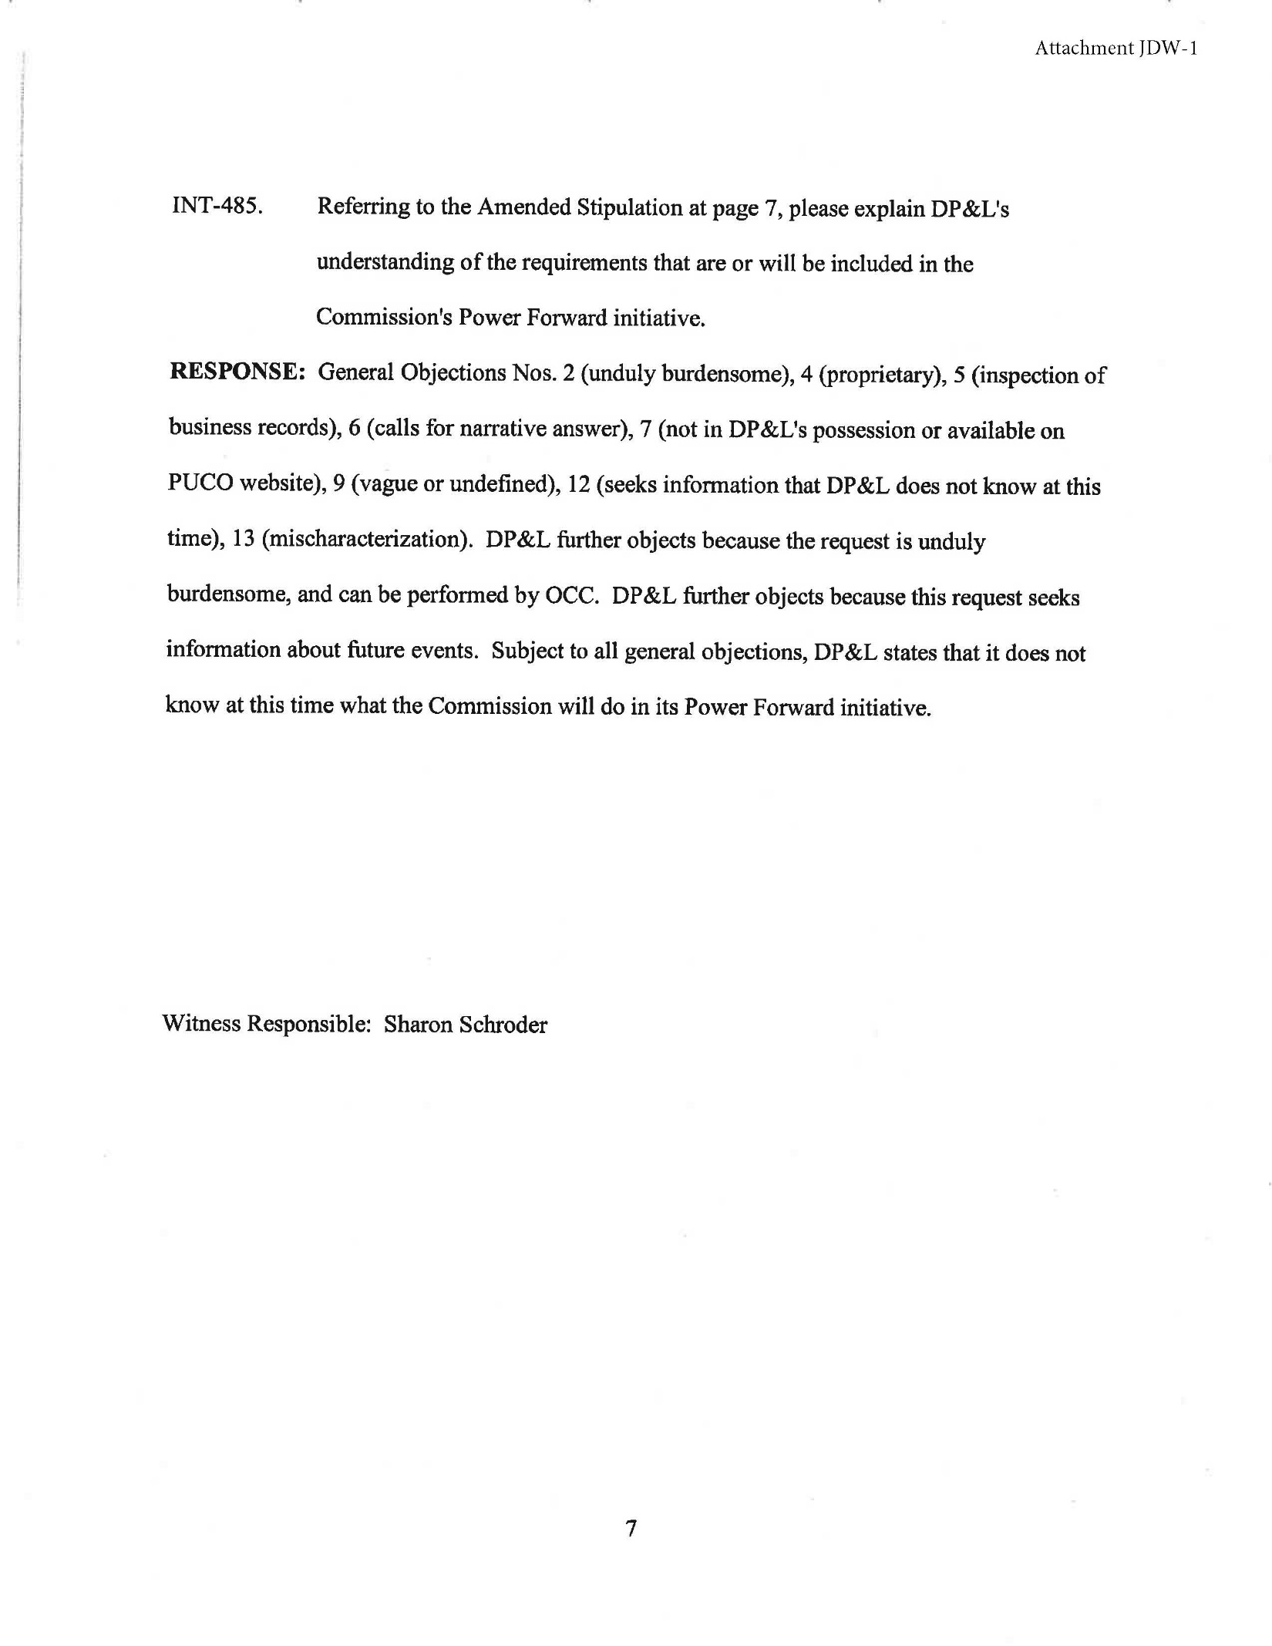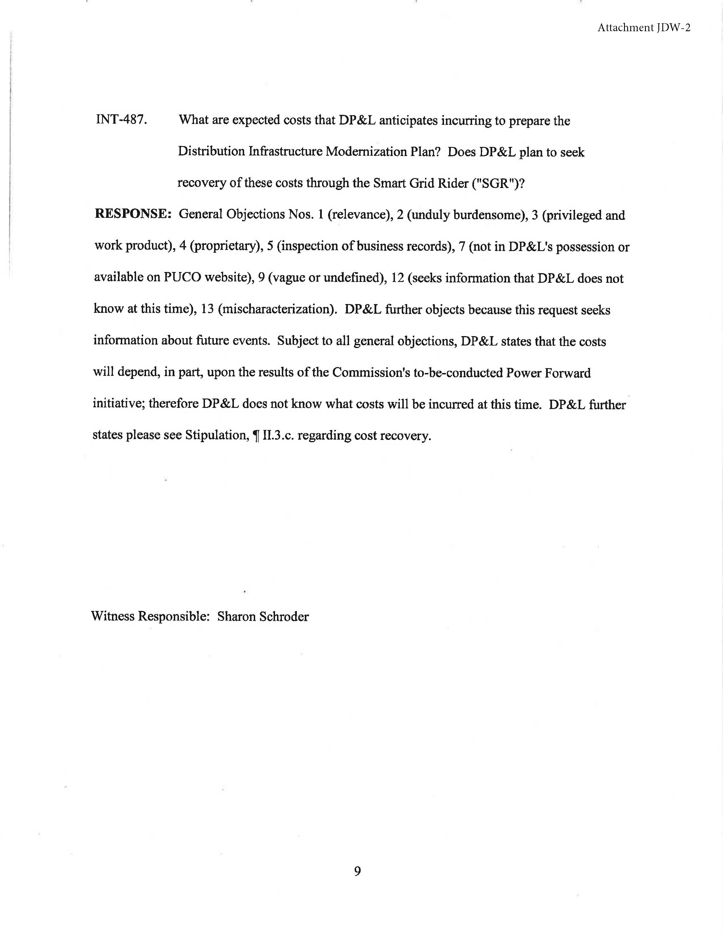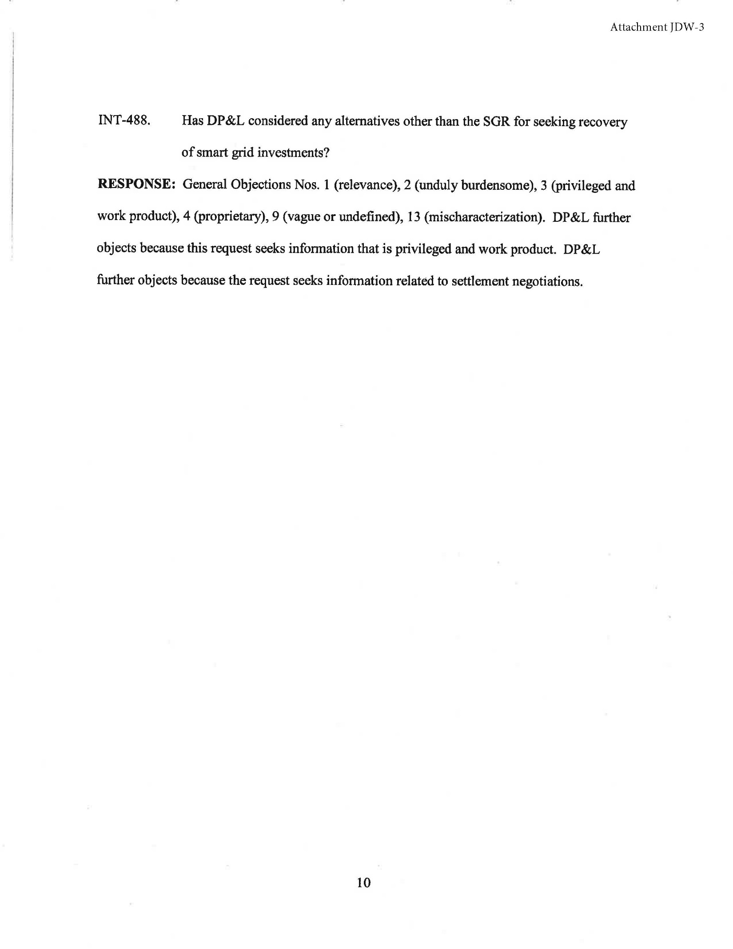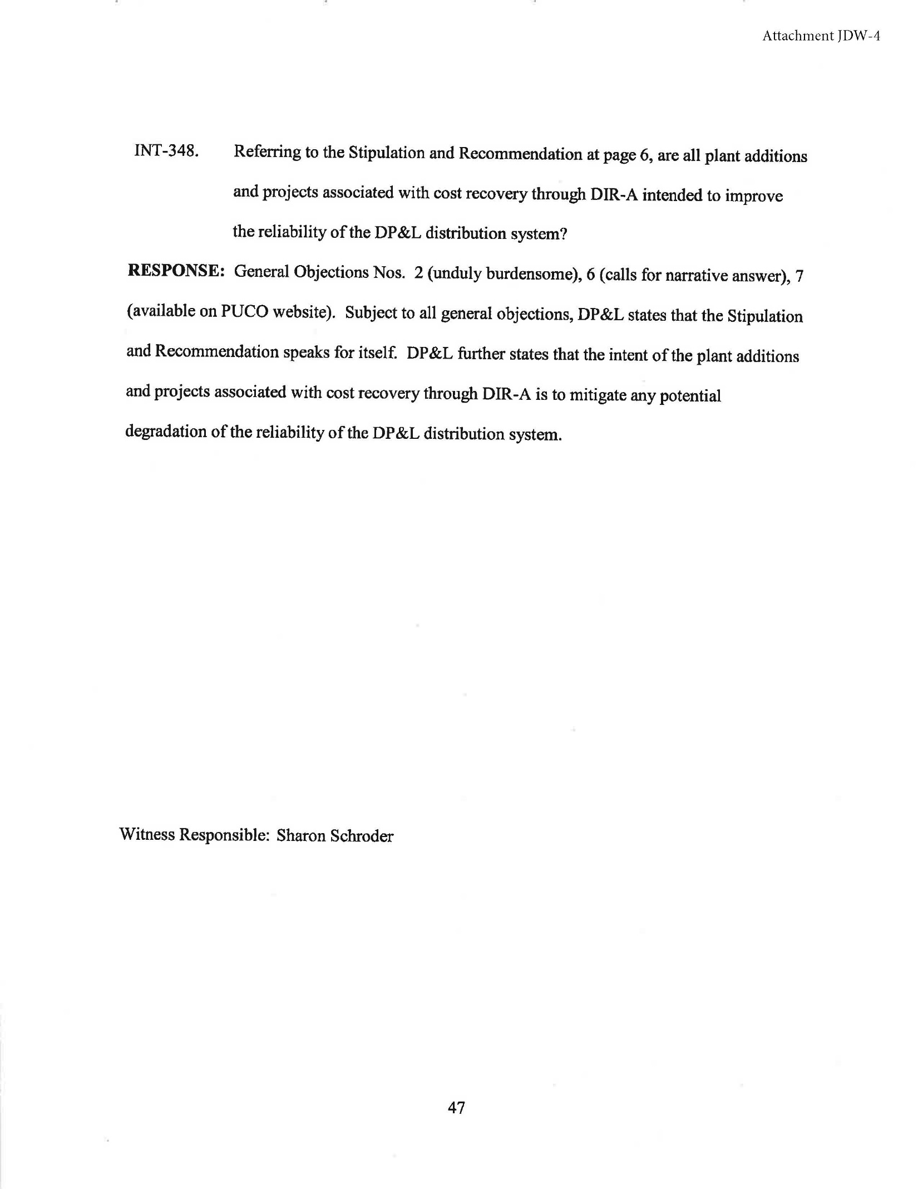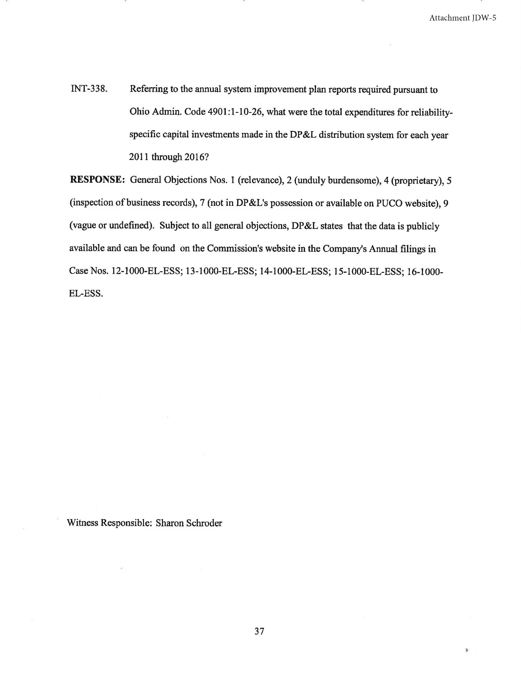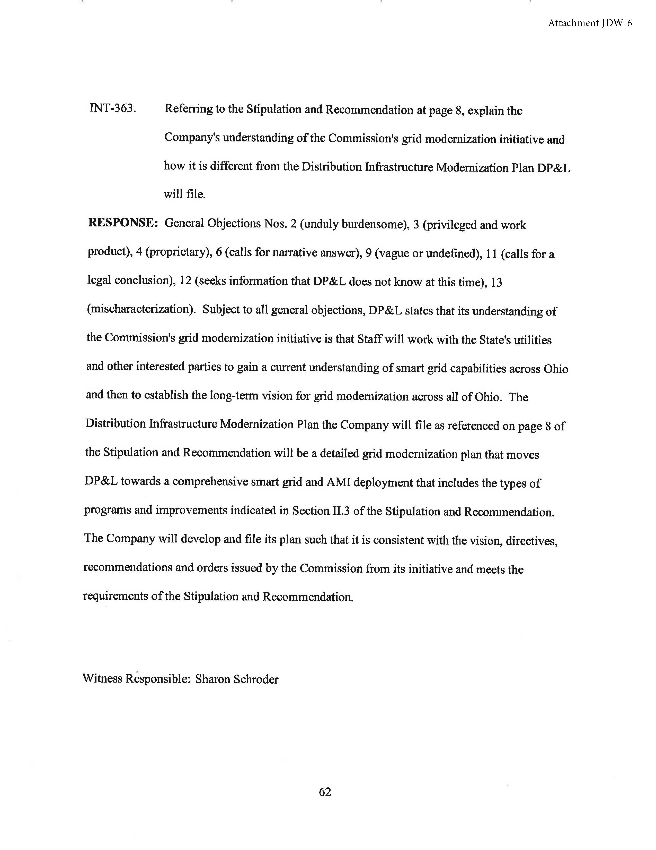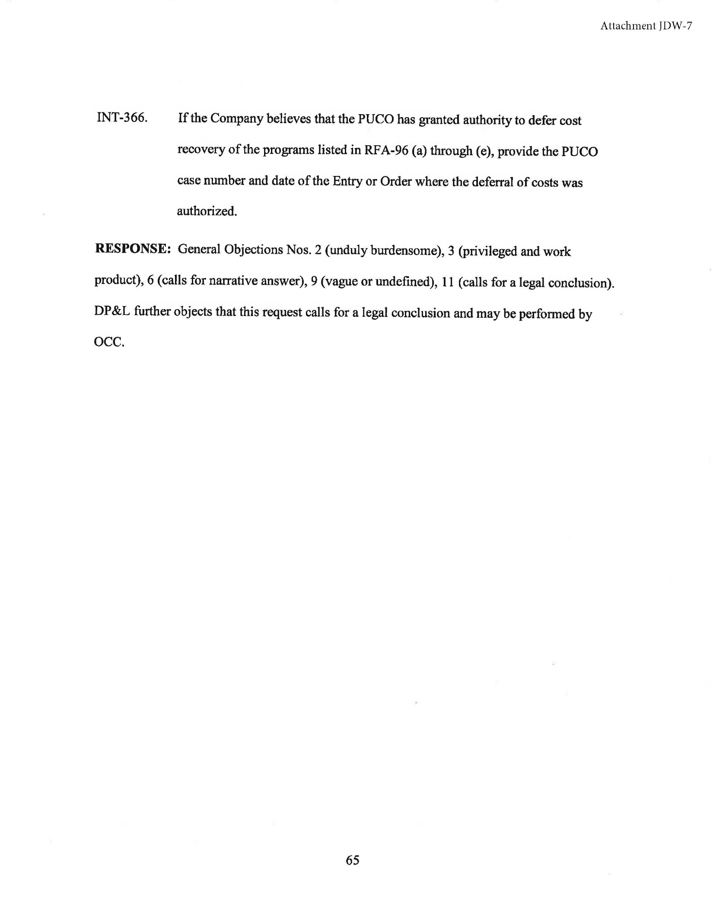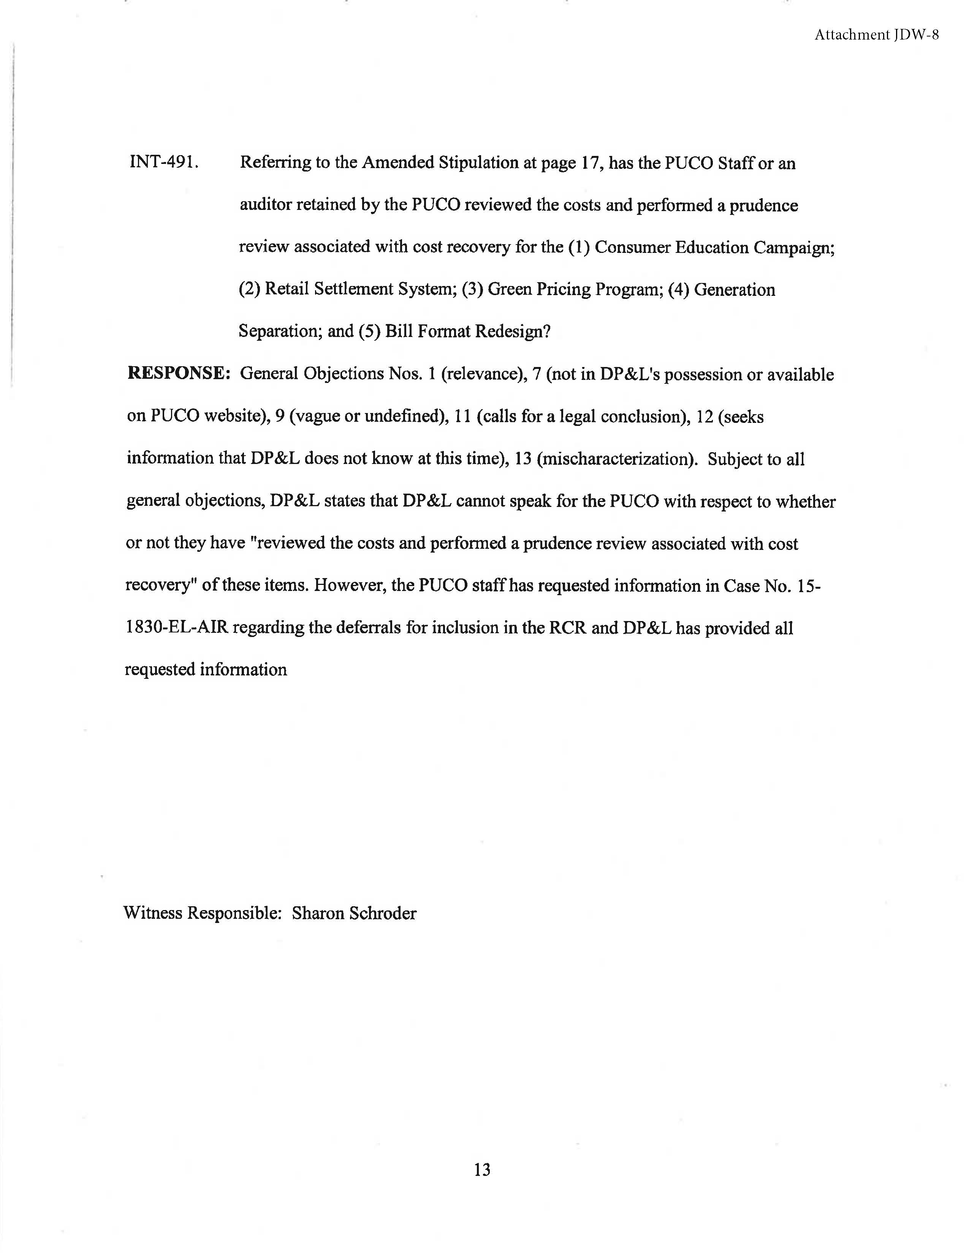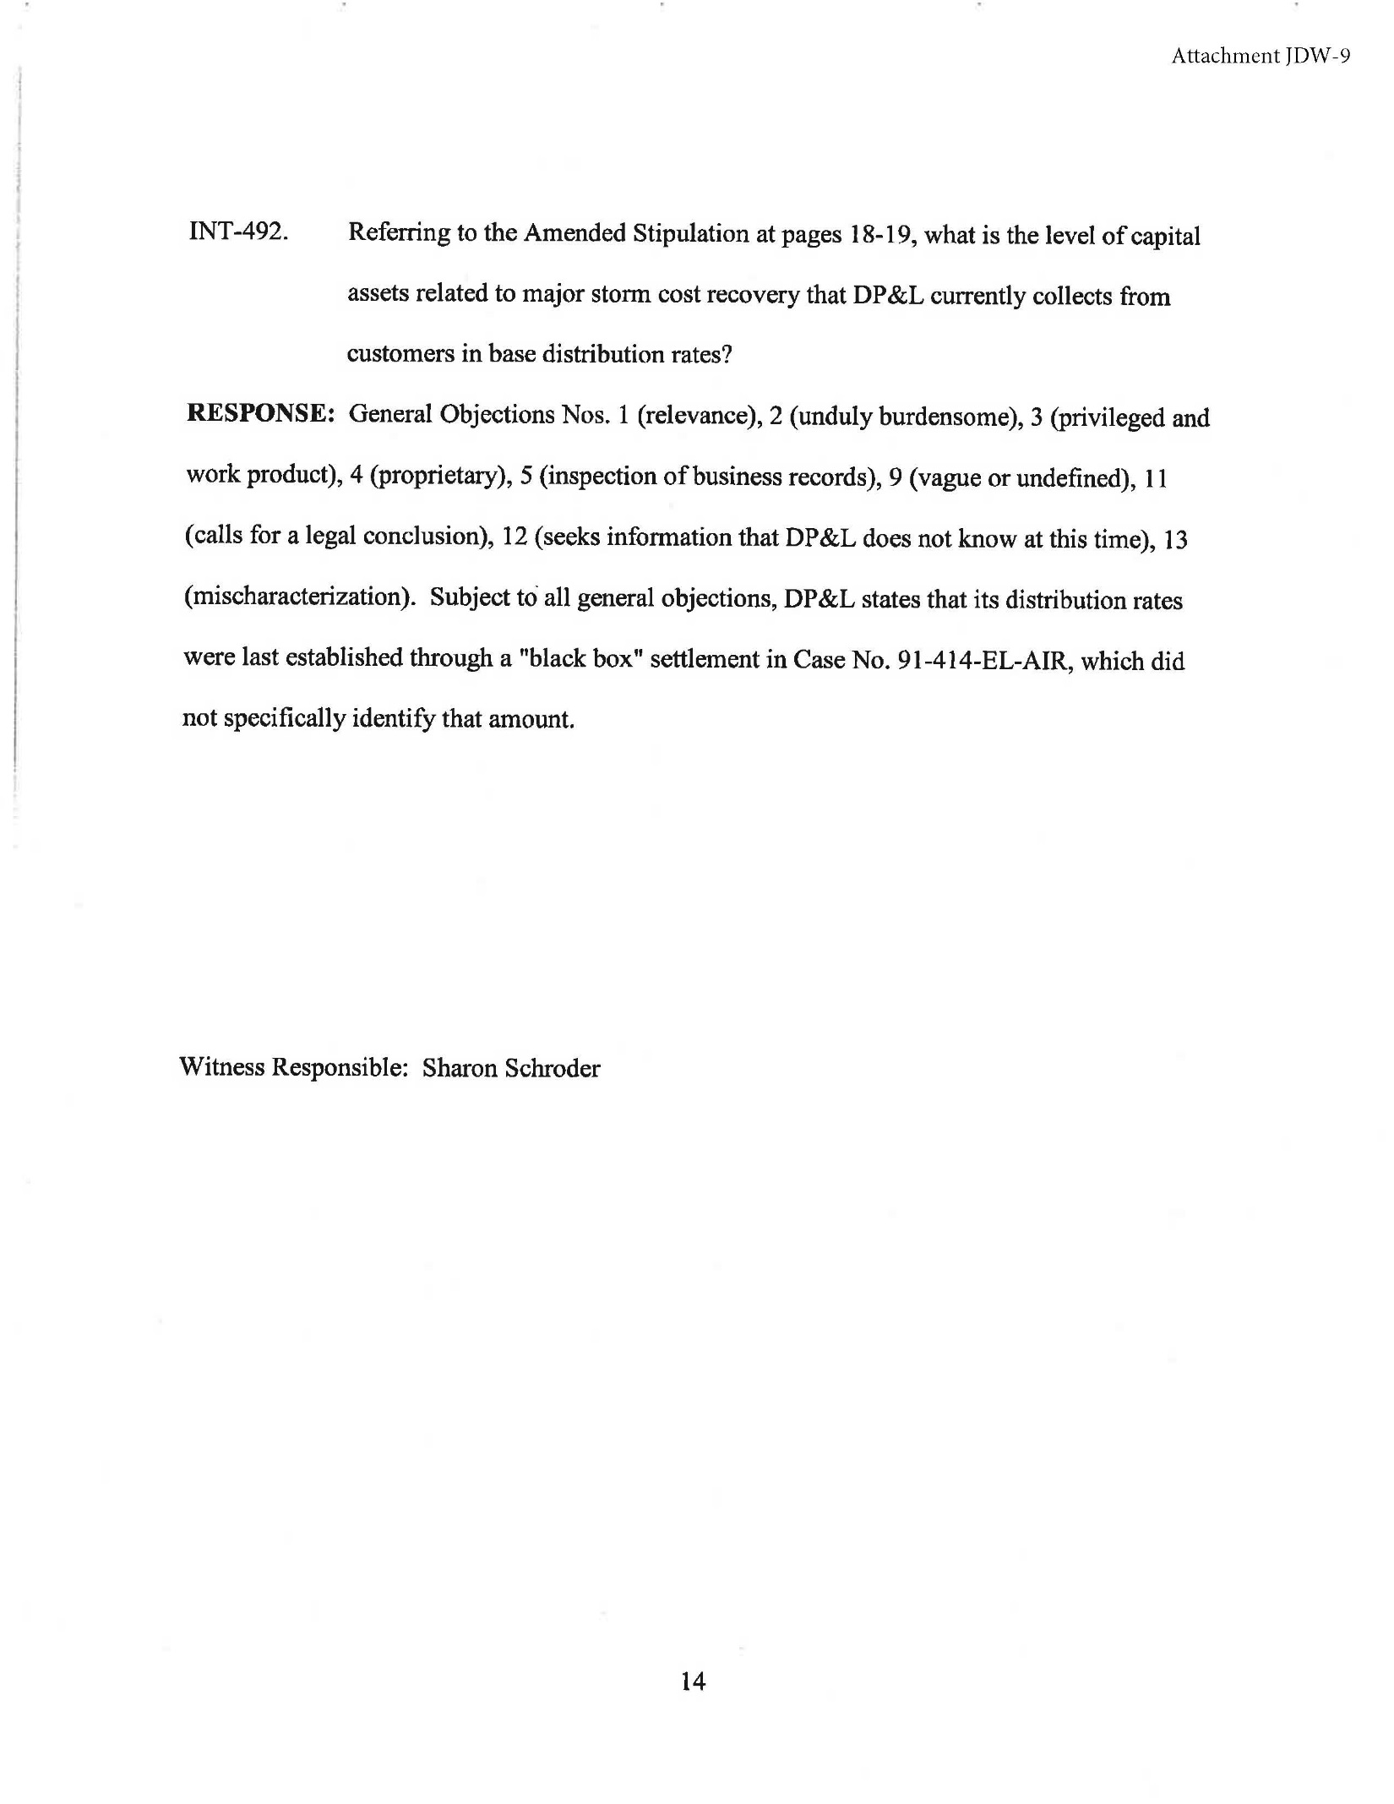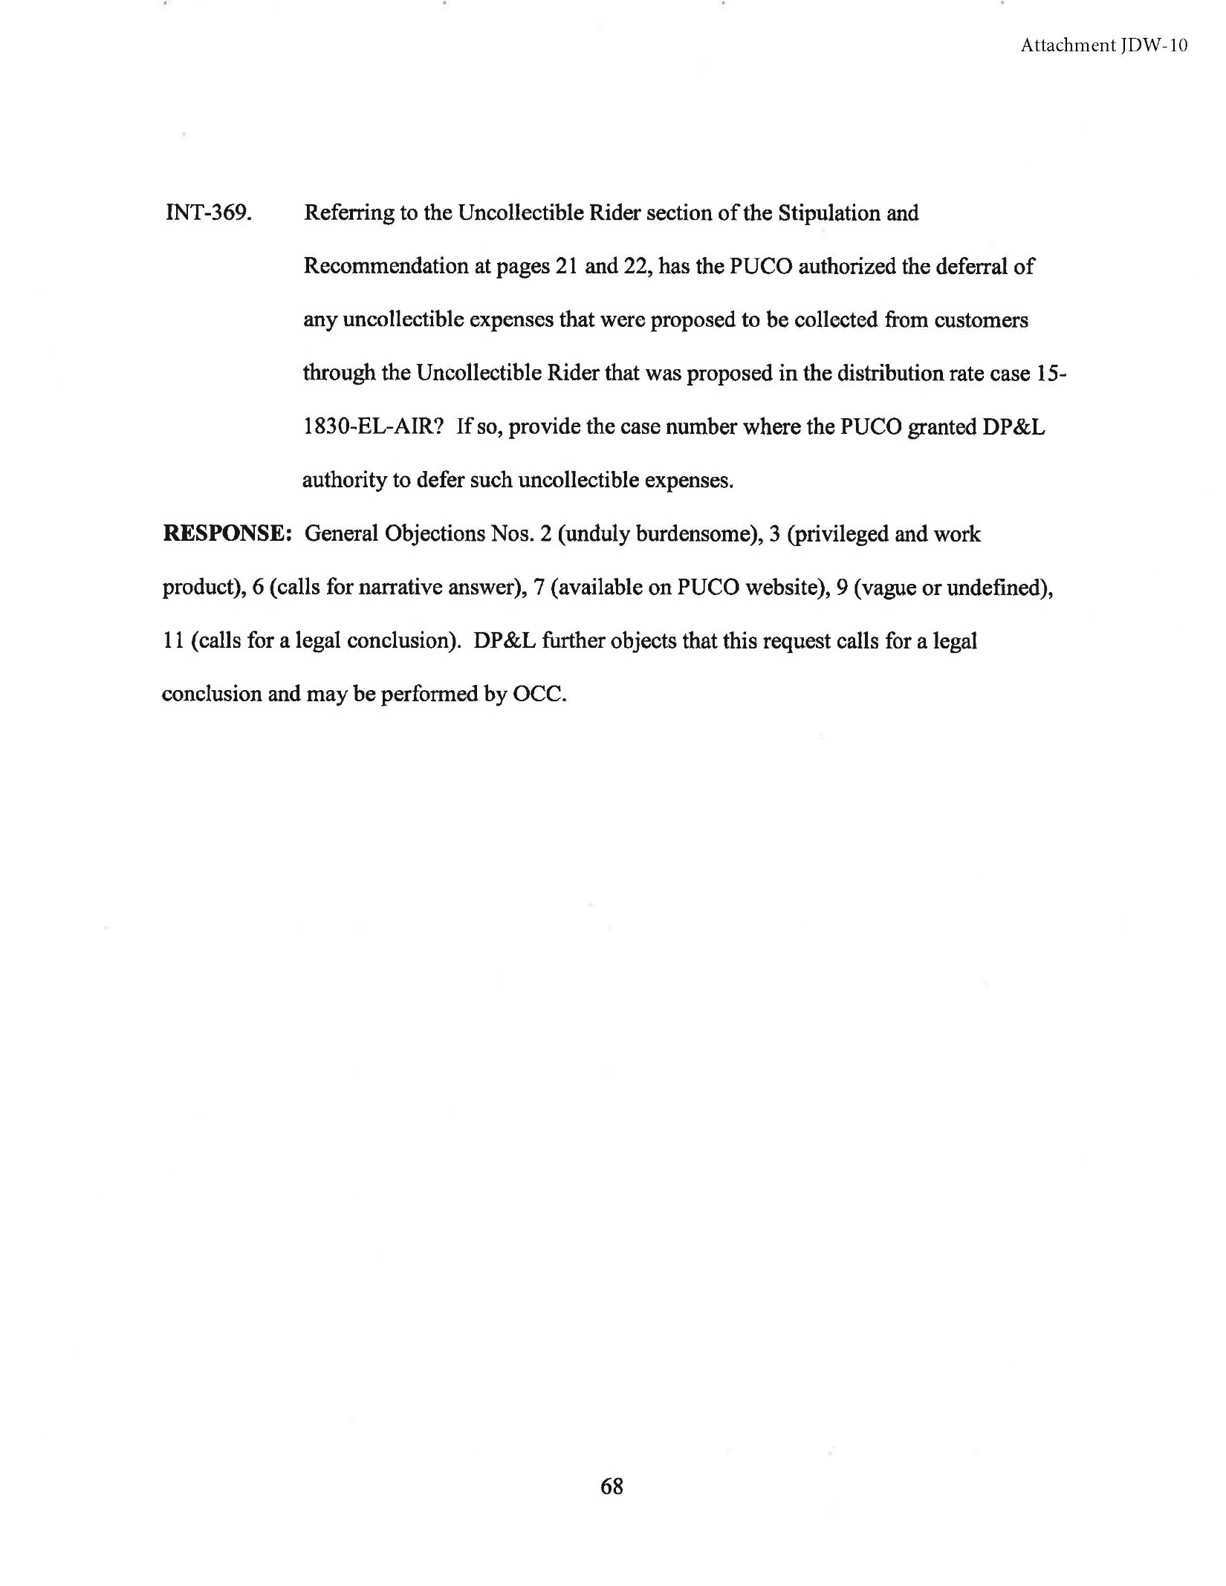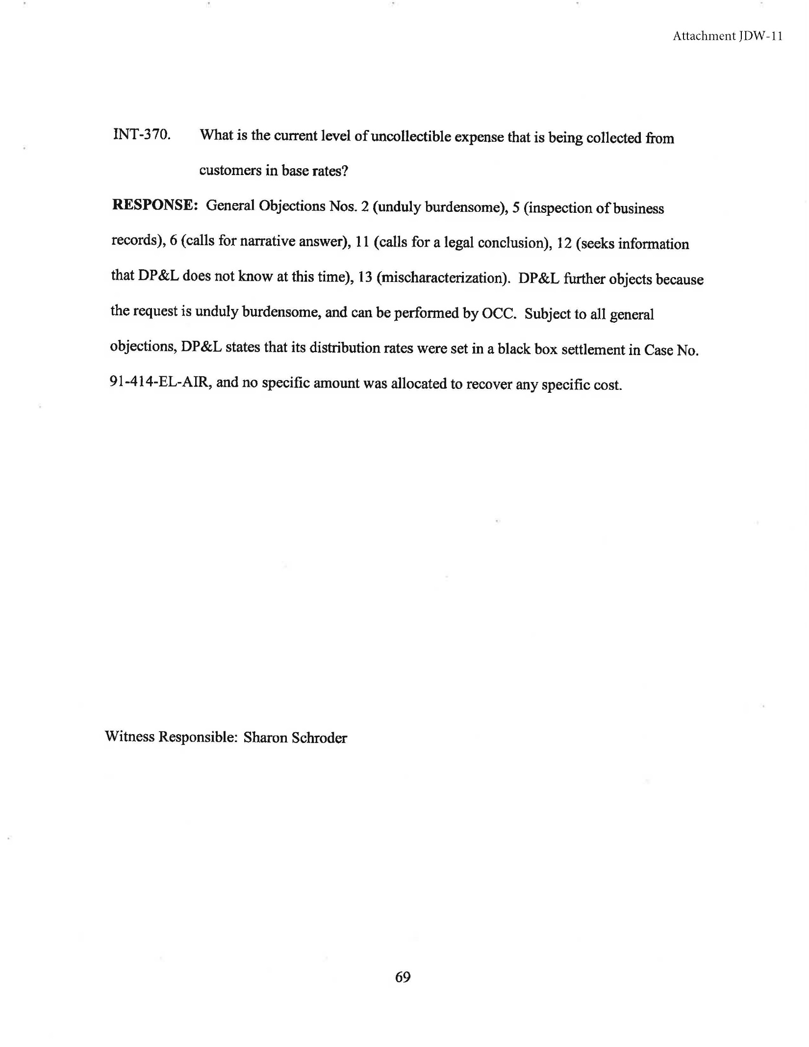

Amended Stipulation and Recommendation at 4-5 (March 13, 2017).
Id.
Id. at 7.
Id. at 9.
Id. at 10-12.
Id. at 13.
Id. at 14.
Id. at 17.
Id. at 18-19.
Id. at 19-20.
Consumers’ Counsel v. Pub. Util. Comm’n. (1992), 64 Ohio St.3d 123, 126.
The PUCO takes into account the “diversity of interests” as part of the first part of the stipulation assessment. See In the Matter of the Application of Ohio Edison Company, The Cleveland Electric Illuminating Company, and The Toledo Edison Company for Authority to Establish a Standard Service Offer, Case No. 10-388-EL-SSO, Opinion and Order at 48 (August 25, 2010).
Schroder at page 8.
Id.
There are approximately 515,000 DP&L customers of which 456,000 (or approximately 89 percent) are residential customers.
Testimony of Sharon Schroder in Support of the Amended Stipulation and Recommendation at 10.
Amended Stipulation and Recommendation at 5.
Schroeder at 11.
Id.
Schroder at 11.
Id.
Schroder at 11.
Schroder at 7-8.
DP&L response to OCC INT-488 (attached herein as JDW-3).
Schroder at 20.
Id. at 21.
Schroder at Exhibit A, page 1 of 36.
In the Matter of the Application of The Dayton Power and Light Company for Approval of its Electric Security Plan, Case No. 17-0241, Notice of Appeal to the Supreme Court of Ohio by The Office of the Ohio Consumers' Counsel at 1 (Feb. 17, 2017).
DP&L Witness Malinak at 37-38.
Id.
In the Matter of the Annual Report of Service Disconnections for Nonpayment Required by Section 4933.123, Revised Code, Case No. 16-1224-GE-UNC, June 30, 2016.
Id.
PIPP Plus Metrics Data provided to the PUCO Staff and the OCC.
Direct Testimony of DP&L Witness Schroder at page 16.
Ohio Poverty Report, Ohio Development Services Agency, February 2017, at Table A6.
Direct Testimony of DP&L Witness Schroder at page 13.
Amended Stipulation and Recommendation at 11-12.
R.C. 4928.02(A).
R.C. 4928.143(B)(2)(h).
Ohio Revised Code 4909.15.
Amended Stipulation and Recommendation at 6.
DP&L Witness Schroder at page 9.
Amended Stipulation and Recommendation at 5.
Ohio Adm. Code 4901:1-10-10.
Case 16-395-EL-SSO, Direct Testimony of James D. Williams (November 21, 2016 at 18).
Id.
In the Matter of the Application of The Dayton Power and Light Company for Establishing New Reliability Standards. Case No. 12-1832-EL-ESS, Opinion and Order at 3.
Case No. 16-395-EL-SSO, Direct Testimony of James D. Williams (November 21, 2016 at 19).
Id.
Case No. 12-1832-EL-ESS, Opinion and Order at 3.
Testimony of Sharon R. Schroder in Support of the Amended Stipulation and Recommendation at 9 (March 22, 2017).
In the Matter of the Commission Investigation of the Financial Condition of Ohio’s Regulated Public Utilities, Case No. 02-2627-AU-COI, Reply Comments of The Dayton Power and Light Company, November 22, 2002 at 3.
Ohio Adm. Code 4901:1-10-10(D).
Id.
The DP&L response to OCC INT-338 (attached herein as JDW-5) confirmed that the total expenditures for reliability specific capital investments are included in the annual system improvement plan report filed with the PUCO in Case Nos. 13-1000-EL-ESS, 14-1000-EL-ESS, 15-1000-EL-ESS, and 16-1000-EL-ESS. The actual level of investments will be included in the annual system improvement plan report that will be filed March 31, 2017.
Deposition of DP&L Witness Craig Jackson at page 48.
R.C. 4909.19.
In the Matter of the Application of the Dayton Power and Light Company for an Increase in its Electric Distribution Rates, Case No. 15-1830-EL-AIR, Entry (March 22, 2017 at 1).

