BEFORE
THE PUBLIC UTILITIES COMMISSION OF OHIO

In the Matter of the Review of the Distribution )
Modernization Rider of Ohio Edison Company, ) Case No. 17-2474-GA-ALT
the Cleveland Electric Illuminating Company )
and the Toledo Edison Company. )

OHIO PARTNERS FOR AFFORDABLE ENERGY’S
NOTICE OF ADDITIONAL COUNSEL

Ohio Partners for Affordable Energy (“OPAE”) hereby respectfully gives notice to the Public Utilities Commission of Ohio (“Commission”) that David C. Rinebolt should be added as counsel for OPAE in these proceedings.

/S/ Robert Dove_______________
Robert Dove (0092109)
Kegler Brown Hill + Ritter Co., L.P.A.
65 E State St., Ste. 1800
Columbus, OH 432115-4295
rdover@keglerbrown.com
Office: 614-462-5443

David C. Rinebolt (0073178)
Ohio Partners for Affordable Energy
PO Box 1793
Findlay, OH 45849-1793
Office: 614-975-8692
drinebolt@opae.org

Counsel for Ohio Partners for Affordable Energy

(Willing to accept service by email.)

CERTIFICATE OF SERVICE

In accordance with Rule 4901-1-05, Ohio Administrative Code, I hereby certify that a copy of the foregoing Notice of Additional Counsel of Ohio Partners for Affordable Energy will be served by the Commission’s Docketing Division on these parties on this 24th day of March, 2021.

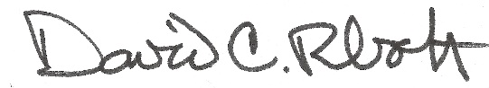
David C. Rinebolt

