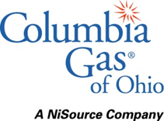
October 27, 2021

Ms. Tanowa Troupe
Secretary, Office of Administration
Public Utilities Commission of Ohio
180 East Broad Street
Columbus, Ohio 43215

Re: Case Number 21-121-GA-UNC

Case Number 89-8003-GA-TRF

Dear Ms. Troupe:

In compliance with the Public Utilities Commission of Ohio's rules governing Tariff Filing Procedures in Case Number 89-500-AU-TRF, Columbia Gas of Ohio, Inc. (Columbia) has enclosed for filing a copy in the above referenced dockets the following tariff sheets:

Sec.  No. | Sheet No. |  | Description
 | Three Hundred and Thirty-Fifth Revised Sheet No. 1a |  | Index
V | One Hundred and Forty-Eighth Revised Sheet No. 22 |  | Standard Choice Offer Rider (SCO)

Very truly yours,

Melissa L. Thompson
Director of Regulatory Policy

