BEFORE
THE PUBLIC UTILITIES COMMISSION OF OHIO

In the Matter of the Commission’s Review )
of Chapter 4901:1-35 of the Ohio ) Case No. 18-1188-EL-ORD
Administrative Code. )

REPLY COMMENTS
BY
THE OFFICE OF THE OHIO CONSUMERS’ COUNSEL

- INTRODUCTION
For years the Office of the Ohio Consumers’ Counsel (“OCC”) has advocated for consumer protection from the process and substance of electric security plans. The process and substance of electric security plans favor utilities and disfavor millions of Ohio consumers. The plans have been the gateway for utilities to charge Ohioans for hundreds of millions of dollars in subsidies above the market price of electricity.
As OCC wrote in comments, the PUCO should find ways to elevate the use of market rate offers instead of electric security plans. That approach should give Ohio consumers the benefits of competition without the costs of government regulation that has acquiesced to utility calls for subsidies at consumer expense. The following chart from the Legislative Service Commission shows an unfortunate trend (since the 2008 law’s enabling of electric security plans) where retail electricity prices for Ohioans have been rising despite the good result of competitive wholesale electricity prices falling:
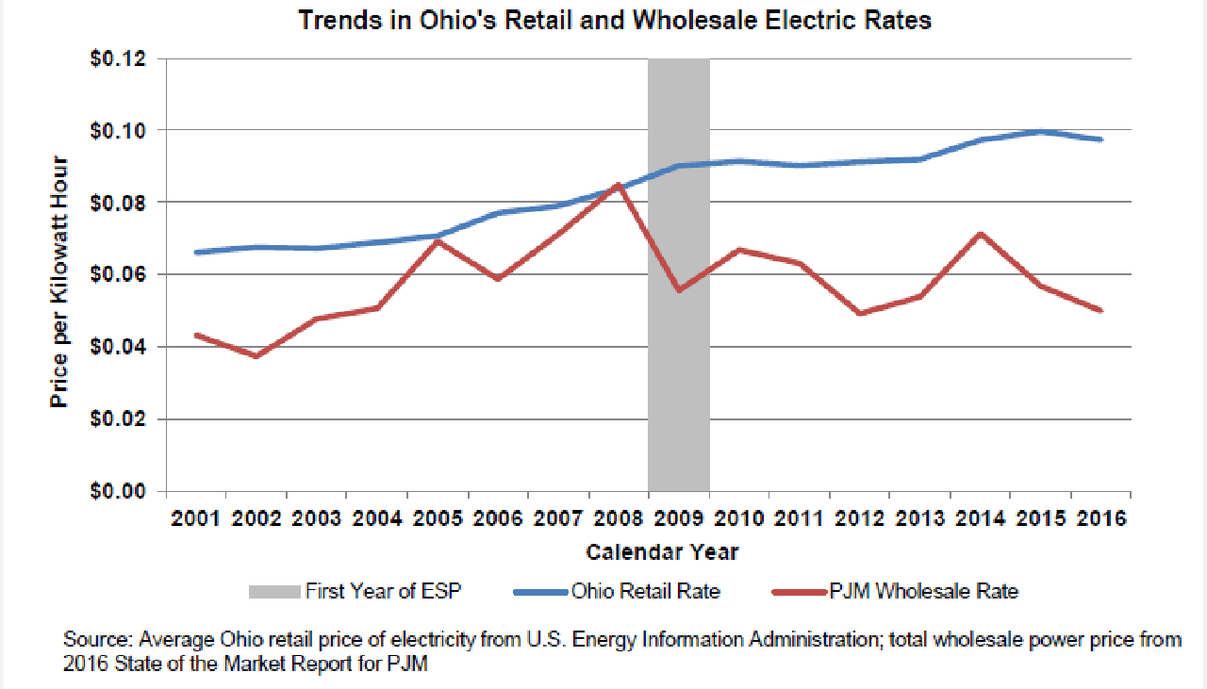

One need look no further than the electric utilities’ comments (or lack thereof) in this case to confirm that they are quite satisfied with how electric security plans serve their interests. AEP-Ohio and DP&L did not even file comments. FirstEnergy and Duke made non-substantive recommendations in their comments.
In response to comments filed in this rule-making case by Duke Energy Ohio, Inc. (“Duke”) and FirstEnergy, OCC affirms its support for adopting new or revised rules for regulatory fairness in the (due) process and in the outcomes of electric security plans for Ohio consumers. The specific proposals made by these utilities are not in the public interest and do not protect consumers. Therefore, the utility proposals should not be adopted by the Public Utilities Commission of Ohio (“PUCO”).

- RECOMMENDATIONS
- FirstEnergy’s proposals are contrary to the public interest and should not be adopted.
FirstEnergy proposed to eliminate the requirement in Ohio Adm. Code 4901:1-35-03 for an electric utility to file an original and ten copies of a standard service offer application. FirstEnergy’s proposal should be rejected. Large-sized documents or spreadsheets in an electric format, or printed from an electric format, may be hard to read or not legible. Protecting consumers’ effective access to information about an electric utility’s standard service offer application means not adopting FirstEnergy’s proposal.
FirstEnergy’s proposal of providing all schedules, tariff sheets, work papers, and other supporting documents and information on an “as soon as practical” basis and “subject to execution of such protective agreement(s) as appropriate” under Ohio Adm. Code 4901:1-35-03 should be rejected. It is ambiguous and would unnecessarily delay, in some instances significantly, providing essential information to the parties in developing a proper record. As indicated by FirstEnergy, these types of documents and information are already available and possessed by the electric utilities in electronic format. They can be transmitted easily and readily through e-mails, CDs, or other electronic formats, within two business days.
Further, there is no definition of what constitutes “as soon as possible.” And if there is any confidential or protected information involved in an electric utility’s standard service offer application, the utility can move for a protective order through the process for protection already in place. Protecting consumers’ ability to effectively and efficiently participate in standard service offer proceedings means not adopting FirstEnergy’s proposal.
FirstEnergy proposes to modify Ohio Adm. Code 4901:1-35-03(G). Under its proposal, electric utilities would be able to provide electronic copies of standard service offer applications upon request “as soon as practicable and subject to execution of such protective agreement(s) as appropriate[.]” FirstEnergy’s proposal should not be adopted for the same reasons discussed above.

B. Duke’s proposals are contrary to the public interest and should not be adopted.
- Duke’s proposals regarding O.A.C. 4901:1-35-03(B)(1) should be rejected to protect consumers.

Duke has proposed that the PUCO eliminate the requirements that electric distribution utilities belong to a Regional Transmission Organization (“RTO”) with an independent market monitor and publicly available pricing information. Duke’s proposal should be rejected. Because electric utilities are already members of an RTO with an independent market monitor and publicly available pricing information, meeting this requirement will impose minimal costs, if any, on the electric utilities.
The requirements in Ohio Adm. Code 4901:1-35-03(B)(1) are still needed and should be maintained to protect consumers. Electric utilities’ participation in an RTO with an independent market-monitor and publicly available pricing information benefits consumers with timely information and competitively set, transparent prices.
- Duke’s proposals regarding Ohio Adm. Code 4901:1-35-03(B)(2) should be rejected to protect consumers.

Duke proposed eliminating the requirements in Ohio Adm. Code. 4901:1-35-03(B)(2)(b) regarding the submission of projected generation, transmission, and distribution rate impacts under a market rate offer proposal. Duke’s proposal should be rejected. The market rate offer versus electric security plan comparison required in the electric security plan statute requires comparing all the rate impacts between an electric security plan versus a market rate offer. (In the 2008 law, the comparison was intended to be a protection to give consumers the benefit of a competitive market price. In practice, the comparison has been diluted, as a result of the PUCO considering the purported benefits of “qualitative” measures that can actually increase consumers’ electric bills.) This must necessarily include comparing the rate impacts of distribution and transmission costs of an electric security plan and a market rate offer. If the rate impacts of distribution and transmission provisions were removed from a market rate offer, the comparison between a market rate offer and an electric security plan would be incomplete, biased, and meaningless.
Further, all of the electric security plans that are now in effect use a competitive bidding process to obtain generation-related service for the electric utilities. An electric security plan should and is still required to provide projected rate impacts from generation, distribution, and transmission service. There is no reason that the same information should not be required of a market rate offer proposal (and as described above, there is good reason to require the information). And electric security plans have many generation-related provisions with (quoting Duke) “highly contingent and uninformed projections” that rely on the competitive market prices in the RTOs. So contrary to Duke’s assertions, the dynamic nature of competitive market prices for generation service is not a good cause for eliminating the need for projecting rate impacts (and potential consumer savings) of a market rate offer proposal.
The requirements in Ohio Adm. Code 4901:1-35-03(B)(2) are still needed and should be maintained. Requiring the submission of projected generation, transmission, and distribution rate impacts under a market rate offer proposal is in the public interest and protects consumers.
- Duke’s proposals regarding Ohio Adm. Code 4901:1-35-03(B)(2)(k) should be rejected to protect consumers.

Duke proposed eliminating the requirement in 4901:1-35-03(B)(2)(k) regarding utilities’ plans to comply with alternative energy portfolio requirements, energy efficiency requirements, and peak demand reduction requirements. Duke’s proposal should be rejected. Electric utilities have not committed (much less been required) to eliminate or withdraw from these programs and their associated customer charges. Eliminating an individual utility’s obligation to comply with Ohio Adm. Code 4901:1-35-03(B)(2)(k) can be considered on a case-by-case basis when the utility proposes to eliminate or withdraw from these programs.
The requirements in Ohio Adm. Code 4901:1-35-03(B)(2)(k) are still needed and should be maintained. They are in the public interest and protect consumers.
- Duke’s proposal regarding Ohio Adm. Code 4901:1-35-11 should be rejected to protect consumers.

Duke proposed to eliminate the requirement in Ohio Adm. Code 4901:1-35-11 regarding quarterly and annual filings when a utility’s competitive bidding process is subject to a price blending period. Duke’s proposal should be rejected. Although price blending requirements may not be in place for currently approved competitive bidding processes, they may be necessary in the future. If that becomes true, consumers would be protected by requiring utilities to comply with O.A.C. 4901:1-35-11.
A bigger issue to consider in this PUCO rules review case involves Duke’s admission regarding the competitive bid process (“CPB”). Duke stated: “[a]ll utilities procure generation for their standard service offer (SSO) pursuant to a CPB, which sets a market price.” If all electric utilities are providing their standard service offer through a market rate offering, there should be no further need for electric security plans. The transition to a full market rate offer has been achieved; therefore, the continued reliance on electric security plans for delivering the standard service offer is harming customers because of the resulting above-market charges and subsidy payments. There should be serious consideration given to eliminating the electric security plan option from the PUCO’s rules.
The requirements in O.A.C. 4901:1-35-11 are still needed and should be maintained. They are in the public interest and protect consumers.
- CONCLUSION
FirstEnergy and Duke propose changes to the rules that are against the public interest and would fail to protect consumers. Their proposals should be rejected.
The PUCO should adopt and revise rules in this rule-making to bring fairness and
benefit to consumers through both the process and the outcomes of utility standard service offer applications for the millions of Ohioans who pay the bill. The recommendations we made in our initial comments should be adopted.

Respectfully submitted,
Bruce Weston (0016973)
Ohio Consumers’ Counsel

/s/ William J. Michael
William J. Michael (0070921)
Counsel of Record
Assistant Consumers’ Counsel

Office of the Ohio Consumers’ Counsel
65 East State Street, 7th Floor
Columbus, Ohio 43215
Telephone: [Michael] (614) 466-1291
william.michael@occ.ohio.gov
(willing to accept service by e-mail)
CERTIFICATE OF SERVICE

It is hereby certified that a true copy of the foregoing Reply Comments were served by electronic transmission upon the parties below this 6th day of September 2019.

/s/ William J. Michael
William J. Michael
Assistant Consumers’ Counsel

The PUCO’s e-filing system will electronically serve notice of the filing of this document on the following parties:

SERVICE LIST

John.jones@ohioattorneygeneral.gov
Rocco.dascenzo@duke-energy.com
Jeanne.kingery@duke-energy.com
Larisa.vaysman@duke-energy.com
rendris@firstenergycorp.com

Attorney Examiners:

james.lynn@puco.ohio.gov

https://www.legislature.ohio.gov/download?key=8111&format=pdf
See Duke’s Comments filed August 23, 2019.
“FirstEnergy “is The Ohio Edison Company, The Cleveland Electric Illuminating Company, and The Toledo Edison Company. FirstEnergy filed its Comments on August 23, 2019.
See FirstEnergy’s Comments at 1.
See id. at 2.
See Duke’s Comments at 1-2.
See id. at 2-3.
See R.C. 4928.143(C).
See O.A.C. 4905:1-35.
Duke’s Price Stability Rider, for example.
See Duke’s comments at 3.
See id.

