Exhibit A-14 “Principle Officers, Directors & Partners”

Steven Moffitt, President  211 Carnegie Center  Princeton, NJ 08540  (609) 524-4500  Clare H. Doyle, Secretary  211 Carnegie Center  Princeton, NJ 08540  (609) 524-4500  Deborah R. Fry, Assistant Secretary  211 Carnegie Center  Princeton, NJ 08540  (609) 524-4500  Judith Tompkins, Assistant Secretary  211 Carnegie Center  Princeton, NJ 08540  (609) 524-4500  Gaetan Frottie, Treasurer  211 Carnegie Center  Princeton, NJ 08540  (609) 524-4500  David Callen, Vice President  211 Carnegie Center  Princeton, NJ 08540  (609) 524-4500 | Krisshna Koomar, Vice President  211 Carnegie Center  Princeton, NJ 08540  (609) 524-4500  Glen E. Mackey, Vice President  211 Carnegie Center  Princeton, NJ 08540  (609) 524-4500  Richard Mason, Vice President  211 Carnegie Center  Princeton, NJ 08540  (609) 524-4500

Exhibit A-15 “Company History”

REX’s commitment to making the industry better for suppliers, brokers and commercial customers started in 2006 when its founders were innovating the first web-based software solutions automating supplier back office functions and expediting energy quote turnaround.

Developers of the industry’s first “broker portals,” REX’s leadership founded Energy Choice Solutions, LLC DBA EnergyWize in 2011 with an industry wide perspective of the inefficiencies hindering suppliers and brokers and the resulting impacts on customer choice, pricing and service quality. The company attracted hundreds of brokers and 50 leading energy suppliers.

In 2015, EnergyWize was acquired by NRG Energy, Inc. and re-launched as Retail Energy Xchange, expanding its product and service offering to 21 states.

Exhibit A-16 “Articles of Incorporation and Bylaws”

NRG ENERGY, INC. CORPORATE GOVERNANCE GUIDELINES

Adopted by the Board of Directors on March 2, 2004, and as amended most recently on December 1, 2016

- ROLE AND COMPOSITION OF THE BOARD OF DIRECTORS

Role of the Board

The Board of Directors, which is elected by the Company's stockholders, oversees the management of the Company and its business. The Board monitors the performance of senior management; selects, evaluates and compensates the Chief Executive Officer and oversees CEO succession planning; provides counsel and oversight on the selection, evaluation, development and compensation of senior management; reviews, approves and monitors fundamental financial and business strategies and major corporate actions; assesses major risks facing the Company and their management; and oversees processes for maintaining the integrity of the Company.

The Board’s goals are to build long-term value for the Company’s stockholders, and to assure the vitality of the Company for its customers, suppliers, employees and other stakeholders.

Role of Directors

A director is expected to spend the time and effort necessary to properly discharge such director's responsibilities, including those specified above. Accordingly, a director is expected to regularly attend meetings of the Board and committees on which such director sits, and to review prior to meetings material distributed in advance for such meetings. A director who is unable to attend a meeting (which it is understood will occur on occasion) is expected to notify the Chairman of the Board or the Chairman of the appropriate committee in advance of such meeting.

Size, Composition and Membership Criteria

The Board is made up of a majority of independent directors. An “independent” director is a director who meets the definition of "independent director" under the listing standards of the New York Stock Exchange and is affirmatively determined to be “independent” by the Board. The Board is presently

composed of thirteen directors, and directors are elected annually at the Company’s annual meeting stockholders.

The Board membership criteria include, among other things, an individual's business experience and skills, independence, judgment, integrity, ability to commit sufficient time and attention to the activities of the Board and director tenure (as described below). The Governance and Nominating Committee of the Board considers these criteria in the context of an assessment of the perceived needs of the Board as a whole and seeks to achieve a diversity of occupational and personal backgrounds on the Board.

The Governance and Nominating Committee reviews the qualifications of director candidates in light of applicable Board membership criteria and recommends candidates to the Board for election by the stockholders at the annual meeting.

The Committee also considers nominations by stockholders who recommend candidates for election to the Board in compliance with the advance notice provisions in the Company's Bylaws, applicable Securities and Exchange Commission rules and regulations, and applicable securities market rules and regulations.

Board Leadership

The Board believes that it is in the best interests of the Company for the Board to make a determination regarding whether or not to separate the roles of Chairman of the Board and CEO based upon the circumstances. Currently, the offices of Chairman and CEO are held by two individuals.

Change in Principal Occupation

When a director's principal occupation or business association changes substantially during the director's tenure on the Board, the director should tender his or her resignation for consideration by the Governance and Nominating Committee. The Committee will recommend to the Board the action, if any, to be taken with respect to the offer of resignation.

Director Tenure

It is the general policy of the Board that non-employee directors will not stand for re-election after reaching age 75. However, the Board upon the recommendation of the Governance and Nominating Committee may waive the requirement in any particular case or change the retirement age if it is in the Company's best interest.

Director Attendance at Annual Meetings of Stockholders

Directors are invited and encouraged to attend the Company's annual meeting of stockholders. A director who is unable to attend the Company’s annual meeting of stockholders (which it is understood will occur on occasion) is expected to notify the Chairman of the Board in advance of the meeting.

Service on Other Boards

A director who also serves in the capacity of a CEO or in an equivalent position should not serve on more than two boards of public companies in addition to the Company's Board, and other directors should not serve on more than four other boards of public companies in addition to the Company's Board. Current positions in excess of these limits may be maintained unless the Board determines that doing so would impair the director's service on the Company's Board.

- FUNCTIONING OF THE BOARD AND BOARD MEETINGS

Frequency of Meetings

There shall be at least five regularly scheduled meetings of the Board each year. At least one regularly scheduled meeting of the Board shall be held quarterly.

Agendas

The Chairman, in consultation with the CEO, sets the agenda for Board meetings with the understanding that certain items pertinent to the advisory and monitoring functions of the Board be brought to it periodically by the Chairman for review and/or decision. Agenda items that fall within the scope of responsibilities of a Board committee are reviewed with the chairman of that committee. Directors are encouraged to suggest the inclusion of items on the agenda.

Distribution of Board Materials

Board materials related to agenda items are provided to directors sufficiently in advance of Board meetings to allow directors to review and prepare for discussion of the items at the meeting. In some cases, due to timing or the sensitive nature of an issue, materials are presented only at the Board meeting.

Director Access to Management and Employees

At the invitation of the Board, members of senior management recommended by the Chairman or CEO may attend Board meetings or portions of meetings for the purpose of participating in discussions.
Generally, presentations of matters to be considered by the Board are made by the manager responsible for that area of the Company's operations. Directors also have full and free access to other members of management, to employees of the Company, and to the Company’s counsel, subject to their use of judgment to assure that this access is not distracting to the business operations of the Company.

Access to Outside Advisors

The Board and its committees have the right to retain outside financial, legal or other advisors as they determine appropriate to assist them in the performance of their respective functions.

Executive Sessions of Non-Management Directors

The non-management directors meet in executive session periodically during Board meetings. It is the policy of the Board that the Chairman presides at executive sessions; provided that if the Chairman is a member of management then it is the policy of the Board to elect a non- management director to preside at executive sessions.

- DIRECTOR COMPENSATION

Non-employee directors are compensated in accordance with the Director Compensation Plan and the Directors Stock Option Plan. The Board believes that a significant portion of a director's compensation should be in equity to further the direct correlation of directors' and stockholders' interests. The Board

reviews the amount and composition of director compensation from time to time and makes changes as appropriate.

Directors that are officers or employees of the Company do not receive any additional compensation for service on the Board.

Company policy and federal law prohibits the Company from directly or indirectly making any loan to a director or executive officer of the Company.

- STOCK OWNERSHIP GUIDELINES

Because a significant ownership stake leads to a stronger alignment of interests between directors and stockholders, each director is required to own a meaningful amount of Company stock, as specified in the Director Compensation Plan and the Directors Stock Option Plan.

Exceptions to this requirement may be made by the Board under special circumstances.

- SUCCESSION AND MANAGEMENT DEVELOPMENT

The CEO reports annually to the Board on the Company's program for succession and management development. The Board, in collaboration with the CEO, plans for succession to the position of CEO as well as certain other senior management positions. The Board and the

Compensation Committee periodically review the Company's succession plans regarding the selection of individuals to fill these positions.

- FORMAL EVALUATION OF CEO AND OTHER EXECUTIVE OFFICERS

The Compensation Committee is responsible for setting annual and long-term performance goals for the CEO and for evaluating his performance against those goals. The results of the evaluation are shared with the CEO and used by the Compensation Committee in considering his compensation.

The Compensation Committee also is responsible for reviewing and approving annual and long- term performance goals for other executive officers of the Company. The Committee, with the CEO, reviews the performance of these executive officers against the goals and sets the executive officers' compensation.

- DIRECTOR ORIENTATION AND CONTINUING EDUCATION

The Company has an orientation process for Board members that includes extensive materials and meetings with key management designed to familiarize new directors with the Company's business, operations, finances, and governance practices. The Board encourages directors to participate in education programs to assist them in performing their responsibilities as directors.

- ANNUAL PERFORMANCE EVALUATION

The Board and each of its committees conduct annual self-evaluations to assess their effectiveness. Individual directors are also evaluated by the Board. In connection with its self- evaluation, each committee reviews its charter. The Governance and Nominating Committee coordinates the Board’s self-evaluation.

- STRUCTURE AND FUNCTIONING OF COMMITTEES

Number, Structure and Independence of Committees

The By-laws of the Company enable the Board of Directors, by majority vote, to form committees for any purpose and to delegate to such committees such power and authority as the Board deems appropriate. Currently the Board's standing committees are the Audit Committee, the Governance and Nominating Committee, the Compensation Committee, the Finance and Risk Management Committee, the Nuclear Oversight Committee and Nuclear Oversight Subcommittee. The Audit Committee, the Governance and Nominating and the Compensation Committee are made up solely of independent directors. In addition, directors who serve on the Audit Committee and Compensation Committee must be "independent" within the meaning of the applicable securities market independence criteria for audit committee and compensation committee members, respectively. Additionally, directors who serve on the Compensation Committee must qualify as "non-employee directors" for purposes of Rule 16b-3 under the Securities Exchange Act of 1934, as amended, and as "outside directors" for purposes of Section 162(m) of the Internal Revenue Code.

The Board may also establish and maintain other committees of the Board from time to time as it deems necessary and appropriate, with such power and authority as the Board may determine.

Assignment and Rotation of Committee Members

The Board is responsible for determining committee size, structure, composition and functioning. Committee members are appointed by the full Board. Committee chairmen are elected by the

Board. It is the policy of the Board that consideration be given to rotating committee members periodically, but the Board does not believe that rotation should be mandated as a policy.

Responsibilities

Each committee operates under a written charter that sets forth the purposes, goals and responsibilities of the committee as well as qualifications for committee membership. Committees report regularly to the full Board with respect to their activities. Each committee has the authority to retain outside advisors as it determines appropriate to assist it in the performance of its functions.

Meetings and Agendas

The chairman of each committee determines the frequency, length and agenda of the committee's meetings. Materials related to agenda items are provided to committee members sufficiently in advance of meetings where necessary to allow the members to review and prepare for discussion of the items at the meeting. In some cases, due to timing or the sensitive nature of an issue, materials are presented only at the committee's meeting.

Annual Performance Evaluation

The Audit Committee, the Governance and Nominating Committee, the Compensation Committee, the Finance and Risk Management Committee and the Nuclear Oversight Subcommittee each conduct an annual self-evaluation to assess their performance against best practices standards.

- COMMUNICATIONS WITH DIRECTORS

As noted above, the Chairman (or if the Chairman is a member of management, a designated non- management director) has responsibility for chairing executive sessions of the Company's non- management directors. Stockholders and others may communicate with the Chairman or with our directors as a group by writing to them c/o the Corporate Secretary, NRG Energy, Inc., 804 Carnegie Center, Princeton, New Jersey 08540.

- PERIODIC REVIEW OF GUIDELINES

These guidelines shall be reviewed periodically by the Governance and Nominating Committee and any amendments shall be presented to the Board for adoption.

Exhibit A-17 “Secretary of State”

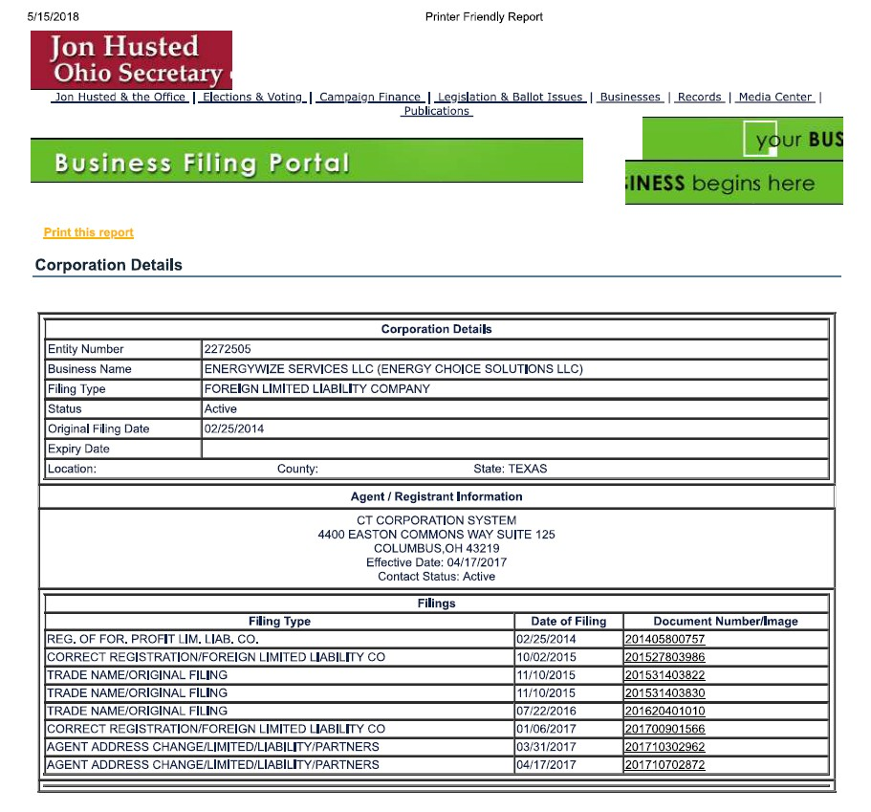

Exhibit B-1 “Jurisdictions of Operations”

 | Electric Broker License | Natural Gas Broker License
CA | Not Required | Not Required
CT | Not Required | Not Required
DC | Case #EA2014-06, Order  #17494
DE | Not Required | Not Required
IL | Order #14-0256 | Order #14-0256
MA | EB-420 | RA # 112
MD | IR-3319 | IR-3320
ME | 2016-00168 | Not Required
NH | DM 16-149 | N/A
NJ | EA-0293 | EA-0293
NY | Not Required | Not Required
OH | 17-1268E | #14-349G (1)
PA | A-2014-2425963 | A-2014-2427220
RI | D-96-6 (U6)
TX | Not Required | Not Required

Exhibit B-2 “Experience & Plans

Energy Choice Solutions LLC d/b/a Retail Energy Xchange is an energy broker that holds contracts with leading retail electricity and natural gas suppliers and provides web-based sales productivity services, making it easier for sales agents to source and sell electricity and natural gas services to businesses.

Exhibit B-3 “Summary of Experience”

Energy Choice Solutions LLC d/b/a Retail Energy Xchange agents have experience procuring gas service for businesses in Ohio and several other states. In Ohio, this experience includes procuring gas service in all utility areas including Columbia Gas of Ohio, Dominion East Ohio, Duke Energy Ohio, and Vectren Energy Delivery of Ohio. The chart below summarizes business customers by state that have signed gas contracts through agents utilizing the Energy Choice Solutions LLC d/b/a Retail Energy Xchange platform:

State | # Commercial & Industrial Customers | Annual Gas Amount in Thousand Decatherms (MDth)
IN | 1 | 19.72
IL | 3 | 192.35
MA | 5 | 87.01
NY | 1 | 42.16
OH | 5 | 15.51
PA | 1 | 60.32

Exhibit B-4 “Disclosure of Liabilities and Investigations” N/A

Exhibit B-6 “Disclosure of Certification Denial, Curtailment, Suspension, or Revocation Certificate Expired on May 8th 2018, no letter of revocation or suspension has been received.

Exhibit C -1 “Annual Reports”

NRG’s Annual Reports can be found Online: http://investors.nrg.com/phoenix.zhtml?c=121544&p=irol-reportsannual

Exhibit C -2 “SEC Fillings”

NRG’s SEC Filings can be found Online: http://investors.nrg.com/phoenix.zhtml?c=121544&p=irol-sec

Exhibit C -3 “Financial Statements”

NRG’s Financial Statements can be found Online: http://investors.nrg.com/phoenix.zhtml?c=121544&p=irol-newsEarnings&nyo=0

Exhibit C -4 “Financial Arrangements” N/A

Exhibit C -5 “Forecasted Financial Statements”
The financial forecasts that follow were prepared by: Elizabeth Melisz – (716) 906-5140
4433 Genesee St.
Suite 401
Buffalo, NY 14225 Income Projection
 | 2019 | 2020
Revenue | $ 3,186.45 | $ 2,609.60
Less : Expenses | $ 2,288.05 | $ 1,957.20
Net Income | $ 898.40 | $ 652.40

Exhibit C-6 “Credit Rating”

NRG Energy Inc’s credit ratings are as follows: S&P is BB-
Moody’s Ba3

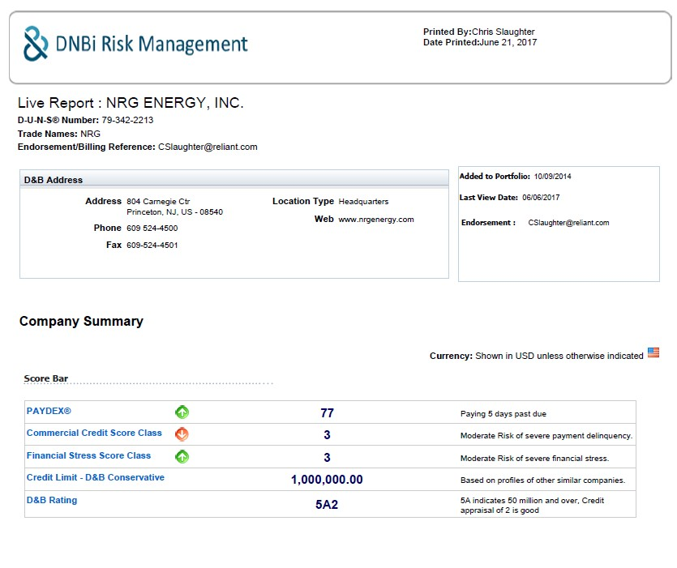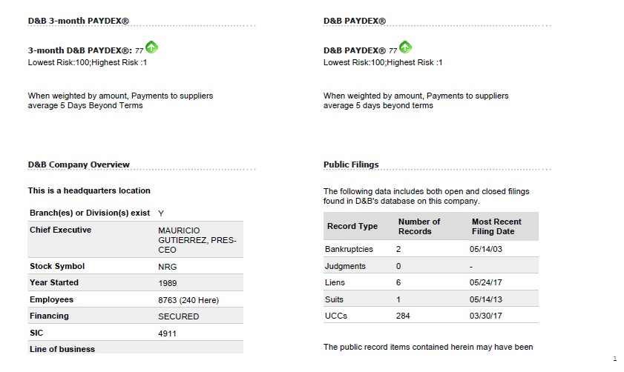Exhibit C-7 “Credit Report”

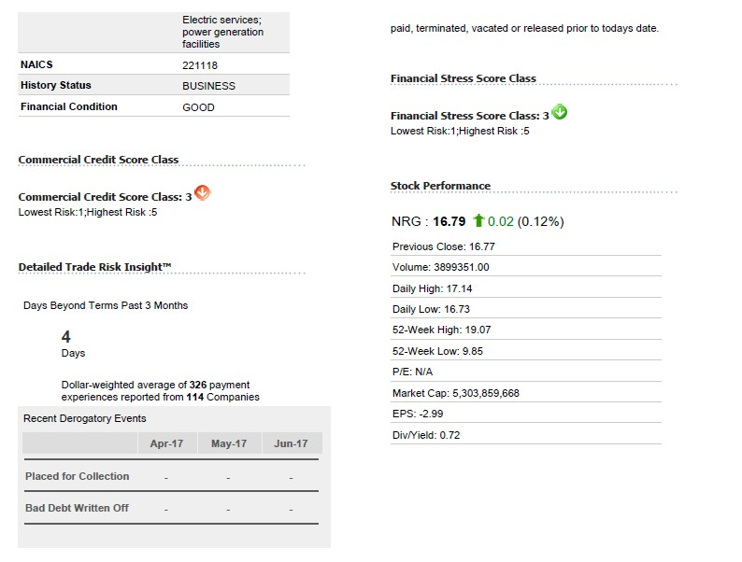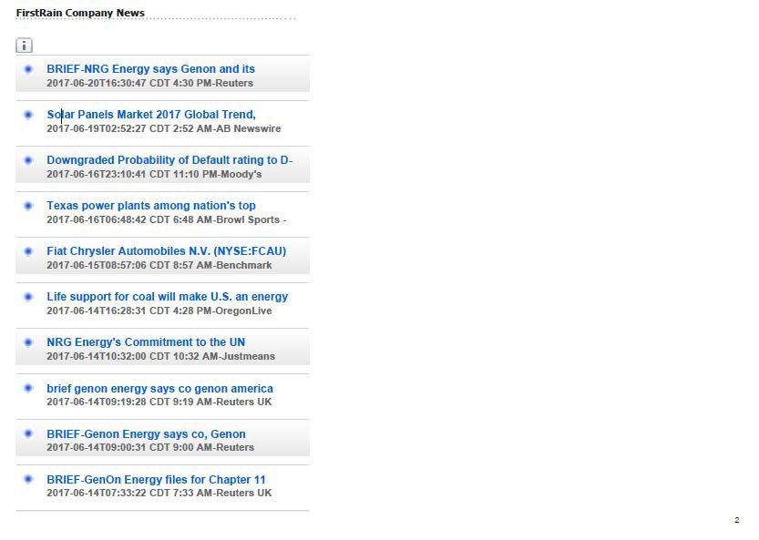

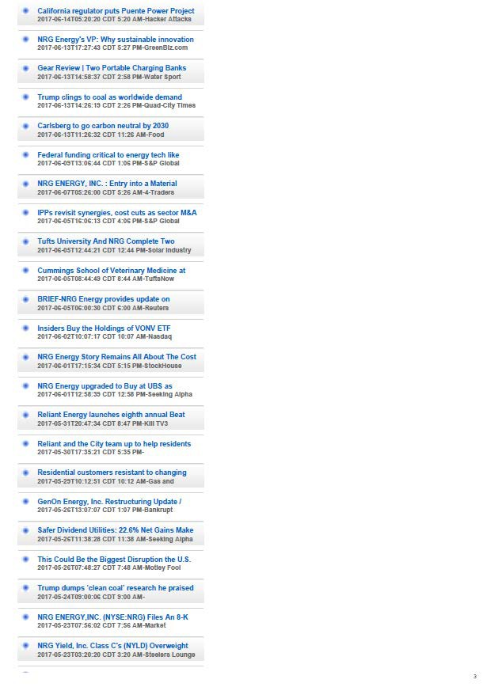

Energy Choice Solutions LLC d/b/a Retail Energy Xchange_ Ohio CRNGS Broker/Aggregator Exh

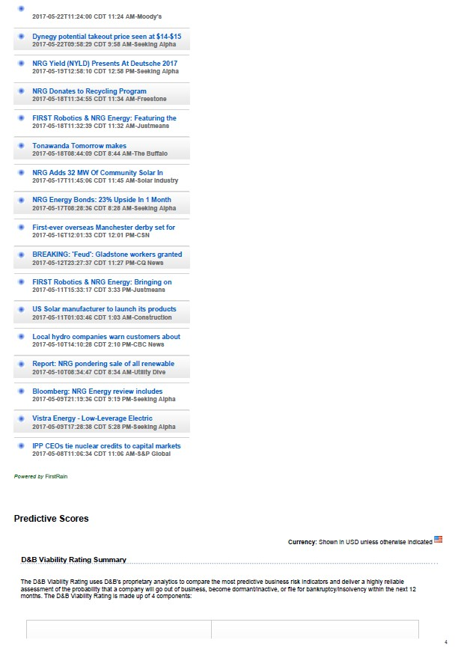

Energy Choice Solutions LLC d/b/a Retail Energy Xchange_ Ohio CRNGS Broker/Aggregator Exhib

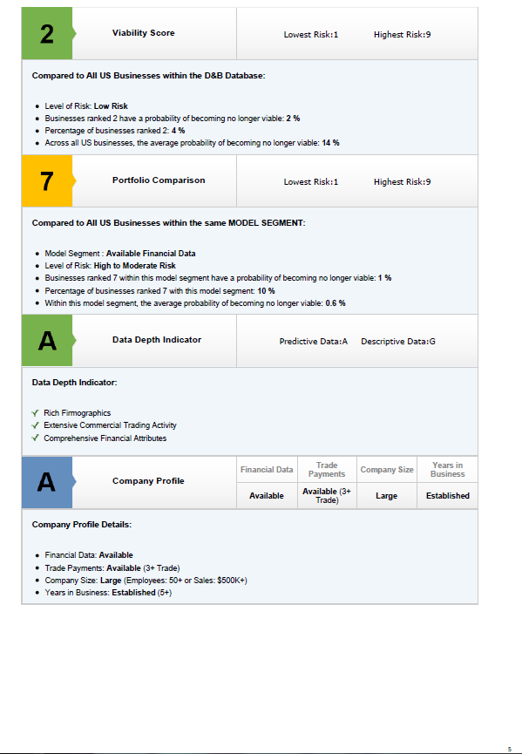

Energy Choice Solutions LLC d/b/a Retail Energy Xchange_ Ohio CRNGS Broker/Aggregator Ex

Exhibit C-8 “Bankruptcy Information”

Applicant Energy Choice Solutions, LLC, its parent and affiliates have not been the subject of any reorganizations, protection from creditors, or any other form of bankruptcy filings this year or within the past two years.

Exhibit C-9 “Merger Information”

Energy Choice Solutions was acquired by NRG Energy, Inc. on 7/17/2015.

Exhibit C-10 Corporate Structure

Energy Choice Solutions LLC d/b/a Retail Energy Xchange, a Texas limited liability company, is 100% owned by NRG Advisory Services LLC, a Delaware limited liability company. NRG Advisory Services LLC is 100% owned by NRG Energy, Inc. NRG Energy, Inc. is a publicly-held corporation traded on the New York stock exchange under the symbol NRG.

President & CEO
SVP, Business Solutions
President Distributed Energy Solutions
Director of Procurement
Development Team

REX Sales
Manager Market Operations Desk
Market Operations Desk Analyst

NRG and its subsidiary companies that supply retail or wholesale electricity or natural gas to customers in North America:

  - Reliant Energy Retail Services, LLC
  - Reliant Energy Northeast, LLC, d/b/a NRG Business Solutions
  - Green Mountain Energy Company
  - US Retailers LLC d/b/a Cirro Energy and d/b/a Pennywise Power
  - Independence Energy Alliance LLC
  - Independence Energy Natural Gas LLC
  - Energy Plus Natural Gas LLC

Exhibit D-1 “Operations”

Operating as a broker instead of a supplier or aggregator, Energy Choice Solutions LLC d/b/a Retail Energy Xchange operations consist of the following key business functions:

- Supplier Management
  - Identify qualified suppliers in the market
  - Negotiate broker agreements with selected suppliers
  - Maintain ongoing relationships with selected suppliers in terms of individual energy customers along with general processes with suppliers
- Broker Training
  - Train Energy Choice Solutions LLC d/b/a Retail Energy Xchange brokers on PUC regulations, electric and gas procurement services and processes, and use of the Energy Choice Solutions LLC d/b/a Retail Energy Xchange energy procurement system
- Broker Support
  - Support Energy Choice Solutions LLC d/b/a Retail Energy Xchange brokers in their day- to-day activities including but not limited to supplier products and information, LOA and LOE management, providing credit information to suppliers, energy contracts, and use of the Energy Choice Solutions LLC d/b/a Retail Energy Xchange energy procurement system
- Sales & Marketing
  - Programs to recruit new Energy Choice Solutions LLC d/b/a Retail Energy Xchange brokers
  - Promote Energy Choice Solutions LLC d/b/a Retail Energy Xchange at tradeshows and industry events
  - Develop and maintain sales support materials and collateral
- Finance
  - General company accounting
  - Processing and management of supplier sales commissions
- Administration
  - Recruit new Energy Choice Solutions LLC d/b/a Retail Energy Xchange employees
  - Maintain company policies and processes
  - Human resources management

Exhibit D-2 “Operations Expertise”

Energy Choice Solutions LLC d/b/a Retail Energy Xchange has demonstrated experience in all key business functions operating as an energy broker:

- Supplier Management
  - Identified and qualified dozens of suppliers across deregulated states
  - Negotiated eight (10) national supplier agreements and many other agreements with regional suppliers
  - Managed supplier activities in several states for the past 8 years as an energy broker
- Broker Training
  - In July 2013, established an industry leading web-based training platform to train Energy Choice Solutions LLC d/b/a Retail Energy Xchange brokers on PUC regulations, electric and gas procurement services and processes, and use of the Energy Choice Solutions LLC d/b/a Retail Energy Xchange energy procurement system
- Broker Support
  - Have been performing broker support activities for the past 8 years as an energy broker
- Sales & Marketing
  - Have been performing sales & marketing activities for the past 8 years as an energy broker
- Finance
  - Have been performing finance activities for the past 8 years as an energy broker
- Administration
  - Have recruited ten (10) Energy Choice Solutions LLC d/b/a Retail Energy Xchange employees to date

Exhibit D-3 “Key Technical Personnel”

Daniel Twichell - Director of Procurement 4433 Genesee St.
Suite 401
Buffalo, NY 14225
(716) 906-5327
Daniel.Twichell@nrg.com

Elizabeth Melisz – Manager Market Operations 4433 Genesee St.
Suite 401
Buffalo, NY 14225
(716) 906-5140
Elizabeth.melisz@nrg.com

Daniel Twichell, CEP, CEM Director of Procurement

The Association of Energy Engineers has certified Mr. Twichell as a Certified Energy Procurement Professional (CEP Professional®). He was a dual major (Economics and Psychology) at The University at Buffalo. As the Director of Procurement for NRG’s Energy Choice Solutions d/b/a Retail Energy Xchange, Mr. Twichell has developed comprehensive price models complete with stimulations of potential market fluctuations. He has unparalleled knowledge of individual utility tariffs, which is used to examine each of the ten to twenty cost components of an electricity supply price. His responsibilities have expanded to the oversight and direction of the most experienced team of analysts and data acquisition specialists in the industry. Mr. Twichell is also an active member of the Association of Energy Engineers.

Elizabeth Melisz, CEP, Manager Market Operations Desk

The Association of Energy Engineers has certified Mrs. Melisz as a Certified Energy Procurement Professional (CEP Professional®). Elizabeth has over 5 years of industry experience working in all deregulated electric and natural gas markets across the United States. Mrs. Melisz is directly responsible for the pricing desk team, supplier relationships and project management.

