***OCC EXHIBIT NO. ______***

**BEFORE**

**THE PUBLIC UTILITIES COMMISSION OF OHIO**

|  |  |  |
| --- | --- | --- |
| In the Matter of the Application of Aqua Ohio, Inc. to Increase Its Rates and Charges for Its Waterworks Service. | )  )  ) | Case No. 13-2124-WW-AIR |

**TESTIMONY IN OPPOSITION TO THE STIPULATION**

**AND RECOMMENDATION**

**OF**

**DANIEL J. DUANN, Ph.D.**

**On Behalf of**

**The Office of the Ohio Consumers’ Counsel**

*10 West Broad Street, Suite 1800*

*Columbus, Ohio43215-3485*

***August 4, 2014***

**TABLE OF CONTENTS**

Page

I. INTRODUCTION 1

II. PURPOSE OF TESTIMONY 1

III. OPPOSITION TO THE STIPULATION AND RECOMMENDATION 3

IV. CONCLUSION 12

**LIST OF ATTACHMENTS**

Attachment DJD-1

# I. INTRODUCTION

***Q1. PLEASE STATE YOUR NAME, BUSINESS ADDRESS AND POSITION.***

***A1.*** My name is Daniel J. Duann. My business address is 10 West Broad Street, Suite 1800, Columbus, Ohio, 43215-3485. I am a Principal Regulatory Analyst with the Office of the Ohio Consumers’ Counsel (“OCC”).

***Q2. ARE YOU THE SAME DANIEL J. DUANN WHO PREVIOUSLY FILED DIRECT TESTIMONY IN THIS PROCEEDING?***

***A2.*** Yes.

# II. PURPOSE OF TESTIMONY

***Q3. WHAT IS THE PURPOSE OF YOUR TESTIMONY IN THIS PROCEEDING?***

***A3.*** My testimony, in addition to other OCC witness testimony, explains the reasons why the Public Utilities Commission of Ohio (“PUCO”) should reject the Stipulation and Recommendation (“Stipulation” or “Settlement”) filed in this proceeding on July 21, 2014. The Stipulation is intended to resolve the requests included in the Application of Aqua Ohio, Inc. (“Aqua” or “Utility”) to increase its rates for water service.[1] My testimony explains why the rate of return (“ROR”) and return on equity (“ROE”) in the proposed Stipulation are unjust and unreasonable. As a result of the use of an unreasonable and unjust rate of return, the resulting annual revenue requirement proposed in the Stipulation is also unjust and unreasonable. If the proposed Stipulation is adopted, then the customers of Aqua will be asked to pay more than what is reasonable and justified, possibly as much as one million dollars more, every year for Aqua’s water service.

I also address one of the alleged “benefits” or advances to the “public interest” identified by the supporters of the Stipulation.[2] This alleged “public interest” of the proposed Stipulation, that is the use of a bills rendered basis for the water rate increase, will result in additional costs to the customers.

In sum, my testimony, in addition to other OCC witness testimony, shows that the proposed Stipulation does not represent a fair and reasonable compromise, does not benefit the customers and public interest, and violates important regulatory principles and practices. For these reasons, the proposed Stipulation should be rejected by the PUCO.

# III. OPPOSITION TO THE STIPULATION AND RECOMMENDATION

***Q4. WHY DO YOU RECOMMEND THAT THE PUCO REJECT THE PROPOSED STIPULATION FILED IN THIS CASE?***

***A4.*** The PUCO relies upon a three-prong test when evaluating whether to approve a stipulation. The proposed Stipulation, does not meet this standard.

***Q5.*** ***WHAT ARE THE COMPONENTS OF THE PUCO’S THREE-PRONG TEST?***

***A5.*** The components are:

1. Is the settlement a product of serious bargaining among capable, knowledgeable parties representing diverse interests?

2. Does the settlement, taken as a package, benefit customers and advance the public interest?

3. Does the settlement package violate any important regulatory principle or practice?

***Q6.*** ***DOES THE STIPULATION,*** ***AS A PACKAGE, BENEFIT CUSTOMERS AND THE PUBLIC INTEREST AS REQUIRED BY THE SECOND PRONG OF THE TEST?***

***A6.*** No.

***Q7.*** ***WHY DO YOU MAINTAIN THAT THE PROPOSED STIPULATION DOES NOT BENEFIT CUSTOMERS OR ADVANCE THE PUBLIC INTEREST?***

***A7.*** The proposed Stipulation will allow Aqua Ohio to collect $60,469,701 from customers annually for its water service.[3] This amount of annual collection is based on a rate of return of 7.47%, which is derived from a return on equity of 9.8% and Aqua Ohio’s cost of long-term debt at 4.99%.[4] This annual revenue requirement of $60,469,701 includes a net base rate increase of $3,820,000.[5]

The proposed Stipulation, if approved by the PUCO, will unreasonably and unjustly increase the financial burden of Aqua’s customers by at least $670,805 annually.[6] This amount is the difference between the annual revenue requirement of $60,469,701 agreed to in the proposed Stipulation and the annual revenue requirement of $59,798,897 associated with a lower rate of return of 7.20% and assuming no other adjustments to the proposed Stipulation. The calculation of this modified annual revenue requirement of $59,798,897 is shown in Attachment DJD-1. The net base rate increase associated with the modified annual revenue requirement based only on a lower rate of return of 7.20% will be $3,149,195,[7] not $3,820,000 as set forth in the proposed Stipulation.

Based on the current capital market condition and Aqua’s own financial metrics, a just and reasonable rate of return should be no higher than 7.20%. As discussed in my Direct Testimony, filed on June 24, 2014, the stipulated 7.47% rate of return and its underlying 9.8% return on equity far exceed what would be considered just and reasonable.[8] The lower 7.20% rate of return and 9.28% return on equity that I have recommended are based on the same methodology and data sources that the PUCO Staff has consistently applied in many electric, gas, and water rate cases.[9] In my Direct Testimony, I proposed additional adjustments to the PUCO Staff’s estimation of rate of return and return on equity, which should also be considered by the PUCO.[10] These adjustments will further reduce the rate of return to 6.99% and the return on equity to 8.84%.

In addition to a reduction in rate of return that I have recommended, OCC also proposes other adjustments in rate base, operating expenses, rate case expenses, and federal income tax expenses that collectively will further reduce the annual revenue requirement of Aqua. OCC witness Steve Hines has calculated that a just and reasonable annual revenue requirement is $58,813,286 based on other OCC adjustments (included in testimony) and a 7.20% rate of return.[11] Consequently, a just and reasonable net base rate increase should be no more than $2,163,585, which is considerably less than the $3,820,000 proposed in the Stipulation.

The proponents of the Stipulation identify several ways that the proposed Settlement “benefits customers” or “advances the public interest.”[12] But many of these so-called “benefits” are ambiguous, uncertain, and modest. At least one item will actually result in additional costs, rather than benefits, to customers. Overall, these so-called benefits or advancements to the public interest do not offset the substantial and unreasonable increase in the annual revenue requirement associated with the proposed Stipulation.

***Q8.*** ***WHY IS THE 7.47% RATE OF RETURN AGREED TO IN THE PROPOSED STIPULATION UNJUST AND UNREASONABLE?***

***A8.*** The 7.47% rate of return that the Signatory Parties agreed to in the proposed Stipulation is based on a 9.8% return on equity, a 4.99% cost of long-term debt, and Aqua’s actual capital structure that consists of 51.56% equity and 48.44% debt.[13] Because the underlying 9.8% return on equity used in calculating the rate of return is unjust and unreasonable, the resulting 7.47% rate of return agreed to in the proposed Stipulation is also unjust and unreasonable.

***Q9.*** ***WHY IS THE 9.80% RETURN ON EQUITY AGREED TO IN THE PROPOSED STIPULATION UNJUST AND UNREASONABLE?***

***A9.*** As discussed in my Direct Testimony, the 9.80% return on equity is unjust and unreasonable for various reasons.[14] First, the PUCO Staff’s proposed return on equity range (included in the Staff Report) is improper and not in accordance with past practices. Even though there is no explanation in the proposed Stipulation regarding the calculation of the 9.80% return on equity, it is clear that the 9.80% ROE is the mid-point of the PUCO Staff’s proposed range (9.29% to 10.31%) in the Staff Report.[15] This ROE range (contained in the Staff Report) is based on the average of the ROEs derived from the Capital Asset Pricing Model (“CAPM”) and the Discounted Cash Flow model (“DCF”), further adjusted upward by an equity issuing cost adjustment factor of 1.02040, and the use of a one hundred basis point range of uncertainty.[16] My main concern with the proposed ROE range is the result of the PUCO Staff’s CAPM analysis is unreasonably high at 10.08%; consequently, the 9.80% ROE midpoint used in the proposed Stipulation is also unreasonably high.

In estimating the ROE using the CAPM analysis, the PUCO Staff uses a risk-free return of 5.86%.[17] This risk-free return of 5.86% proposed by the PUCO Staff is unreasonable and not supported by the current capital market conditions for a number of reasons. First, the use of an indirectly calculated risk-free return is inconsistent with the long-established methodology used by the PUCO Staff in many previous water, electric, and gas utility rate cases.[18] The PUCO has typically used the average daily yields of 10-year and 30-year U.S. Treasury bonds over the last twelve months before the Staff Report in estimating the risk-free return.[19] In this proceeding, the PUCO Staff calculated the average daily yields of long-term government bonds from March 7, 2013 through March 7, 2014.[20] The average yield as calculated by the PUCO Staff is 3.1908%.[21] This is the risk-free return that should be used in this proceeding.

Second, the 5.86% risk-free return used by the Staff in the CAPN analysis is much higher than the many current estimates of “risk-free return” by rate of return experts including Aqua’s own witness in her direct testimony. Specifically, Aqua Ohio’s own witness, Ms. Pauline M. Ahern initially adopts a 4.31% risk-free rate in her CAPM analysis.[22] In regard to other experts, in estimating Ohio Power’s return on common equity in its most-recent electric security plan case, Dr. J. Randall Woolridge proposes a 4.0% risk-free rate using the CAPM method.[23] In the same case, Dr. William E. Avera proposes a 3.8% risk-free return.[24]

Third, the 5.86% risk-free return is unreasonable because it is higher than Aqua’s embedded cost (4.99%) of long-term debt. Such a relationship between a risk-free return and the embedded cost of debt is contradictory to basic financial theory and observed financial market data that a riskier debt (such as the debt of Aqua typically requires a higher return (interest rate or yield) than a less risky debt (such as the US government bonds).

Fourth, the data (Arithmetic Average Return and Arithmetic Average Risk Premium) reported in *Duff & Phelps Risk Premium Report 2013 (“Duff & Phelps Report)*, and used by the PUCO Staff in its CAPM analysis are the average annual rate over the fifty-year period of 1963 to 2012.[25] The average arithmetic return, the average risk premium, the implicit risk-free return (the difference between the arithmetic return and risk premium) reported in the *Duff & Phelps Report* are a long-term average. The long-term average reported in the *Duff and Phelps Report*, however, are not the most current arithmetic return – average risk premium, and risk-free return in 2013. In other words, the PUCO Staff is using the average risk-free return over a fifty-year period (1963 to 2012), instead the actual risk-free return of 2013, in estimating the current (2013 to 2014) return on equity of Aqua. This use of a long-term average rate instead of the most current one-year average is unreasonable and violates a long-standing regulatory principle.

***Q10. DO YOU AGREE WITH AQUA OHIO’S CURRENT POSITION[26] THAT THE RISK-FREE RETURN USED IN THE CAPITAL ASSET PRICING MODEL SHOULD BE 6.75%?***

***A10.*** No. Aqua’s revised position regarding the risk-free return is unreasonable. The newly proposed 6.75% risk-free return is significantly out of line with current interest rates and capital market conditions. As discussed previously, the risk-free return of 6.75% reported in the *Duff & Phelps Report* is the average annual risk-free return over the fifty-year period from 1963 to 2012. The 6.75% rate is not the risk-free return in any single year of 2012, 2013, or 2014 when the interest rates for all types of U.S. government bonds and corporate debts were at a historically low level. Therefore, the average annual risk-free return over a fifty-year period as reported in the *Duff & Phelps Report*, 6.75%, should not be used in the CAPM analysis for estimating the current ROE of Aqua.

***Q11.*** ***DOES THE USE OF A 9.80% RETURN ON EQUITY AND ITS RESULTING 7.47% RATE OF RETURN IN THE PROPOSED STIPULATION VIOLATE IMPORTANT REGULATORY PRINCIPLES AND PRACTICES?***

***A11.*** Yes. The adoption of a 9.80% return on equity (and the resulting rate of return of 7.47%) in the proposed Stipulation does violate an important regulatory principle. Specifically, the risk-free return of 5.86% used in developing the 9.80% is not based on current capital market conditions. Rather, it is based on the annual average of a much longer period of time of 1963 to 2012. This is a violation of the long-standing regulatory principle that a reasonable rate of return shall be based on the returns earned by comparable companies at the same time and in the same general part of the country. For example, in the Bluefield decision, the U.S. Supreme Court ruled that:

“A public utility is entitled to such a rates as will permit it to earn a return on the value of the property which it employs for the convenience of the public **equal to that generally made at the same time and in the same general part of the country** on investments in other business undertakings which are attended by corresponding risks and uncertainties (emphasis added);”

Based on my understanding of this regulatory principle, Aqua’s rate of return and return on equity should be set based on the current capital market conditions, not the average capital market condition over an extended period of time.

***Q12.*** ***WILL THE IMPLEMENTATION OF THE BASE RATE INCREASE ON A “BILLS RENDERED” BASIS BENEFIT CUSTOMERS AND ADVANCE THE PUBLIC INTEREST?***

***A12.*** No. The implementation of the base rate increase on a bills render basis, as proposed in the Stipulation, will not benefit customers or advance the public interest. Such a proposal allows Aqua to start collecting rate increases earlier than allowed if the rate increase is implemented under a service rendered basis. Assuming that the monthly water bills are rendered equally on each day of the month, then, on average, Aqua’s customers are required to pay the monthly water fifteen days (half-month) earlier under a bill rendered basis than under a service-rendered basis. I calculate the additional rate increase collected by Aqua under the bill-rendered basis is approximately $159,167. This is an additional cost to Aqua’s customers.[27]

# 

# IV. CONCLUSION

***Q13. DOES THIS CONCLUDE YOUR TESTIMONY?***

***A13.*** Yes.

**CERTIFICATE OF SERVICE**

I hereby certify that a copy of *Testimony in Opposition to the Stipulation of Daniel J. Duann, Ph.D. on Behalf of the Office of the Ohio Consumers’ Counsel* was provided to the persons listed below via electronic transmission this 4th day of August 2014.

*/s/ Melissa R. Yost*___________

Melissa R. Yost

Deputy Consumers’ Counsel

**SERVICE LIST**

|  |  |
| --- | --- |
| [Devin.parram@puc.state.oh.us](mailto:Devin.parram@puc.state.oh.us)  [Ryan.orourke@puc.state.oh.us](mailto:Ryan.orourke@puc.state.oh.us)  [sam@mwncmh.com](mailto:sam@mwncmh.com)  [fdarr@mwncmh.com](mailto:fdarr@mwncmh.com)  [mpritchard@mwncmh.com](mailto:mpritchard@mwncmh.com)  Attorney Examiners:  [Jay.agranoff@puc.state.oh.us](mailto:Jay.agranoff@puc.state.oh.us)  [James.lynn@puc.state.oh.us](mailto:James.lynn@puc.state.oh.us) | [whitt@whitt-sturtevant.com](mailto:whitt@whitt-sturtevant.com)  [campbell@whitt-sturtevant.com](mailto:campbell@whitt-sturtevant.com)  [williams@whitt-sturtevant.com](mailto:williams@whitt-sturtevant.com)  [brent@supancehoward.com](mailto:brent@supancehoward.com)  [law@marionohio.org](mailto:law@marionohio.org) |

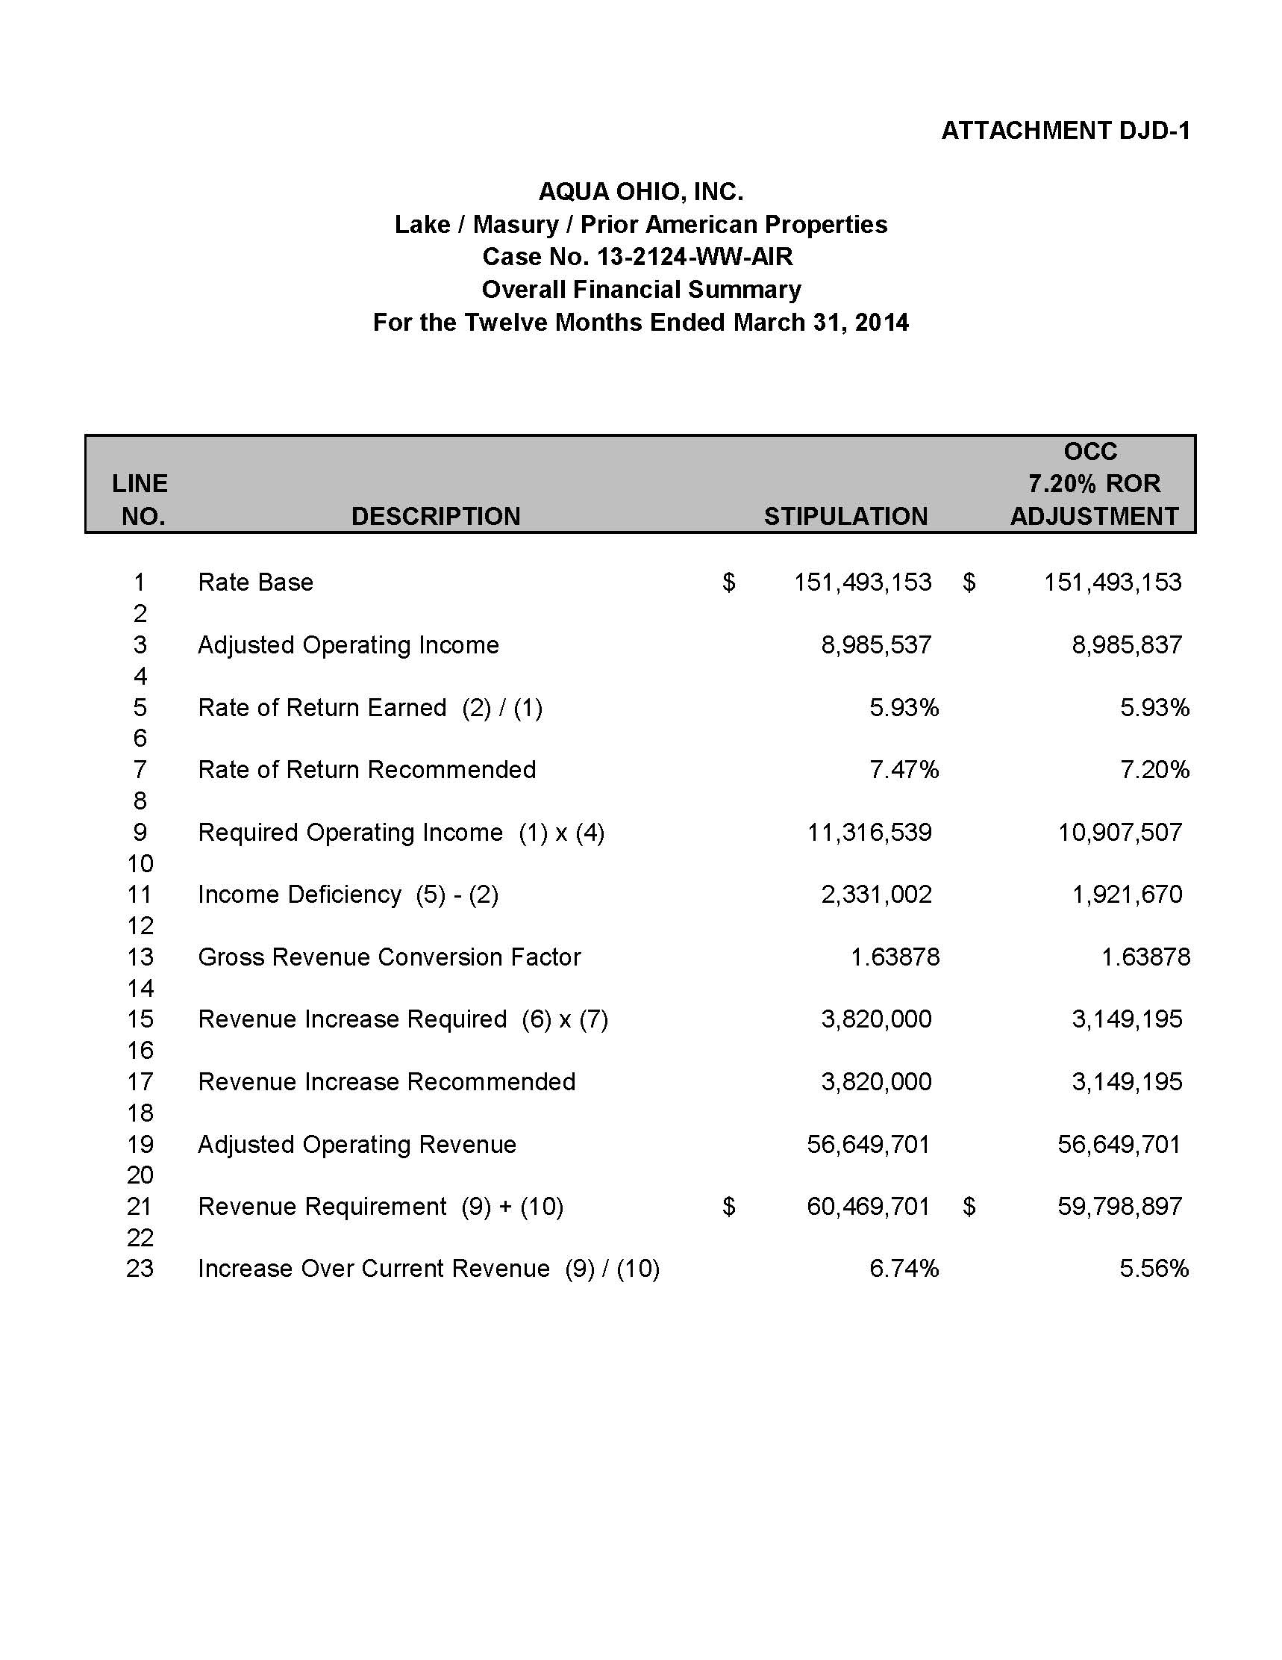

1. *In the Matter of the Application of Aqua Ohio, Inc. to Increase Its Rates for Water Service.*  Case No. 13-2124-WW-AIR, Stipulation and Recommendation (July 21, 2014).
2. See Pre-filed Testimony of WM Ross Willis (July 21, 2014) at 4.
3. See Stipulation and Recommendation, Schedule A-1.
4. See Pre-filed Testimony of WM Ross Willis (July 21, 2014) at 4.
5. See Stipulation and Recommendation, Schedule A-1.
6. $670,805 = $60,469,701 - $59,798,897.
7. $3,149,195 = $59,798,897 - $56,649,701, due to rounding.
8. See Direct Testimony of Daniel J. Duann, Ph.D. (June 24, 2014) at 10-13.
9. See Direct Testimony of Daniel J. Duann, Ph.D. (June 24, 2014) at 15.
10. Id., at 13-15.
11. Direct Testimony of Steven B. Hines, Schedule SBH-13 (August 4, 2014).
12. See Pre-filed Testimony of WM Ross Willis (July 21, 2014) at 4.
13. The rate of return is the weighted average of the return on equity and the cost of long-term debt. Specifically, 7.47% = (9.8% * 0.5146) + (4.99% *0.4844).
14. See Direct Testimony of Daniel J. Duann, Ph.D. (June 24, 2014) at 4 and 10-13.
15. See Staff Report (May 20, 2014) at 16.
16. Id.
17. See Staff Report (May 20, 2014) at 15. It was pointed out late by Aqua Ohio in its Supplemental Testimony that the 5.86% was the average annual risk premium, not the average annual risk-free return. Aqua Ohio instead proposed an annual average risk-free return of 6.75%. See Supplemental Direct Testimony of Pauline M. Ahern (June 24, 2014) at 4-5.
18. See Direct Testimony of Daniel J. Duann, Ph.D. (June 24, 2014) at 11-13.
19. See, for example, the Staff Report at 15 in PUCO Case No. 09-1044-WW-AIR.
20. See Staff Report, ScheduleD-1.3.
21. Id.
22. See Direct Testimony of Pauline M. Ahern (December 16, 2013) at 36 in PUCO Case No. 13-2124-WW-AIR.
23. See Direct Testimony of J. Randall Woolridge (May 6, 2014) at 45 in PUCO Case No. 13-2385-EL-SSO.
24. See Direct Testimony of William E. Avera (December 20, 2013) at 38 in PUCO Case No. 13-2385-EL-SSO.
25. See *Duff & Phelps Risk Premium Report 2013* at 43.
26. See Supplemental Direct Testimony of Pauline M. Ahern (June 24, 2014) at 5.
27. The rate increase collected by Aqua Ohio as a result of this half-month earlier collection is calculated this way: $159,167 = $3,820,000 / (12*2).