BEFORE
THE PUBLIC UTILITIES COMMISSION OF OHIO

In the Matter of the Application of Vectren Energy Delivery of Ohio, LLC d/b/a CenterPoint Energy Ohio for Authority to Adjust its Distribution Replacement Rider Charges. | )  )  )  )  ) | Case No. 24-720-GA-RDR

INITIAL COMMENTS
BY
OFFICE OF THE OHIO CONSUMERS’ COUNSEL

The Office of the Ohio Consumers’ Counsel (“OCC”) submits these Initial Comments to protect the 300,000 residential consumers of Vectren Energy Delivery of Ohio, LLC d/b/a CenterPoint Energy Ohio (“CenterPoint”). In this case, CenterPoint wants to raise its monthly Distribution Replacement Rider (“distribution rider charge”) charge to consumers by 29% over the increase the PUCO approved for CenterPoint just last year. If the PUCO approves CenterPoint’s request, residential consumers will pay a distribution rider charge of $12.65. This is an increase to consumers from the prior distribution rider charge of $9.85. It is unjust and unreasonable for CenterPoint to impose this increase. The increase is unaffordable, in violation of R.C. 4905.22. The PUCO should take action to protect consumers.
Many potential solutions exist. For example, CenterPoint could stretch out its main replacement program over a longer period of time. CenterPoint could phase-in the 29% increase. CenterPoint could shift some of its charges from fixed charges to usage charges, which give consumers a chance to control their bill by limiting their usage. CenterPoint could increase funding for its bill assistance programs. If CenterPoint is unwilling to put more focus on affordability for its Ohio consumers, then the PUCO must take action.
CenterPoint uses the distribution rider to charge consumers for costs to replace, retire, or improve various aspects of its distribution infrastructure. The PUCO tentatively approved this increase in the May 2023 ruling, subject to the rights of PUCO Staff and interested parties to challenge whether the increase is just and reasonable. CenterPoint’s 29% increase in the distribution rider charge is not just and reasonable, especially when viewed in light of the challenging conditions faced by CenterPoint’s 300,000 residential consumers.
CenterPoint serves 300,000 residential consumers in poverty-stricken west central Ohio with Dayton (Montgomery County) at its core. The PUCO has noted the economic hardships facing Dayton-area consumers:
The economic hardships faced by the communities in DP&L's service territory include declining population, declining employment, declining tax revenues, and increasing poverty.

The Ohio Association of Community Action Agencies’ latest available data shows that 15.2% of Montgomery County residents live in poverty, much higher than the Ohio average of 8.2%. Poverty in this region is among the highest rate in the country for mid- to large-sized urban areas.
Revised Code Section 4905.22 requires that rates must be affordable. CenterPoint has a much better focus on affordability for its Houston, Texas consumers (where its corporate headquarters is located) than in Ohio. CenterPoint’s most recent investor presentation (April 2024) has this slide about CenterPoint’s focus on affordability for its Houston Electric consumers: 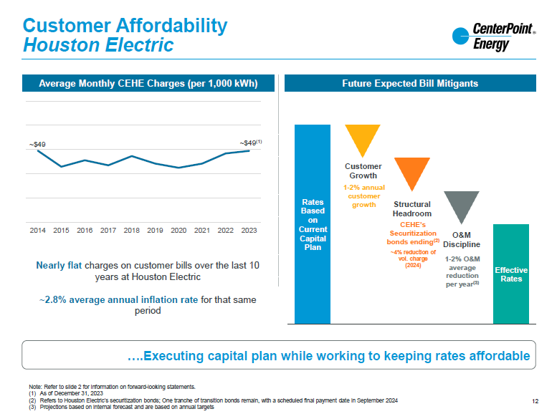

If CenterPoint can execute a ten-year spending plan to provide reliable service for its Houston, Texas consumers while keeping rates flat, why does CenterPoint need a 29% increase in its distribution rider charge for one year of spending for its Ohio consumers? CenterPoint’s Ohio consumers deserve a break just as CenterPoint has given to its Texas consumers.
Rates must be affordable under Ohio law. CenterPoint’s Ohio consumers deserve the same focus on affordability as CenterPoint’s Texas consumers. CenterPoint and the PUCO need to fix this disparate focus on affordability. Ohio consumers need a
fix. The PUCO should consider the needs of the consumers and how to justly and reasonably address those needs.

Respectfully submitted,

Maureen R. Willis (0020847)
Ohio Consumers’ Counsel

/s/ John Finnigan
John Finnigan (0018689)
Counsel of Record
Thomas J. Brodbeck (0093920)
Assistant Consumers’ Counsel

Office of the Ohio Consumers’ Counsel

65 East State Street, Suite 700

Columbus, Ohio 43215
Telephone [Finnigan]: (614) 466-9585
Telephone [Brodbeck]: (614) 466-9565
John.finnigan@occ.ohio.gov
Thomas.brodbeck@occ.ohio.gov
(Will accept service via email)

CERTIFICATE OF SERVICE
I hereby certify that a copy of the foregoing OCC Initial Comments has been served electronically upon those persons listed below this 28th day of June 2024.

/s/ John Finnigan
John Finnigan
Assistant Consumers’ Counsel

The PUCO’s e-filing system will electronically serve notice of the filing of this document on the following parties:

SERVICE LIST

John.jones@ohioattorneygeneral.gov  Attorney Examiner:  Patricia.schabo@puco.ohio.gov | whitt@whitt-sturtevant.com  kennedy@whitt-sturtevant.com

In the Matter of the Application of Vectren Energy Delivery of Ohio, LLC d/b/a CenterPoint Energy Ohio for Authority to Adjust Its Distribution Replacement Rider Charges, Case No. 23-273-GA-RDR, Finding and Order (Aug.23, 2023).
In the Matter of the Application of Vectren Energy Delivery of Ohio, LLC d/b/a CenterPoint Energy Ohio for Authority to Adjust Its Distribution Replacement Rider Charges, Case No. 23-273-GA-RDR, Application (May 1, 2023) at 90, Ex. KJT-2 at 3.
Id.
In the Matter of the Application of Vectren Energy Delivery of Ohio, LLC d/b/a CenterPoint Energy Ohio for Authority to Adjust Its Distribution Replacement Rider Charges, Case No. 23-273-GA-RDR, Revised Tariff Pages, PUCO No. 4 at 1 (Aug. 24, 2023).
In the Matter of the Application of The Dayton Power and Light Company for Approval of its Electric Security Plan. Case No. 12-426-EL-SSO, Opinion and Order at 42 (Sept. 4, 2013).
Ohio Association of Community Action Agencies, 2023 State of Poverty Report, available at: https://oacaa.org/wp-content/uploads/2023/07/State-of-Poverty-2023-web_FINAL-revision.pdf.
Id.
CenterPoint Energy First Quarter 2024 Investor Update at 12, available at: https://investors.CenterPointenergy.com/static-files/7200b76f-1481-4947-a77f-c99268a14df5.
R.C. 4905.22.

