DRAFT This document was created only for the purpose stated within it.   It is for staff discussion only and does not reflect the view of the Commission.

**Case No. 09-678-EL-REN**

**Casselman Wind Farm**

**Staff Interrogatories – Initial Set**

Question 1:  Please provide digital photographs that depict an accurate characterization of the installed system and the dates the photographs were taken.

9/3/09

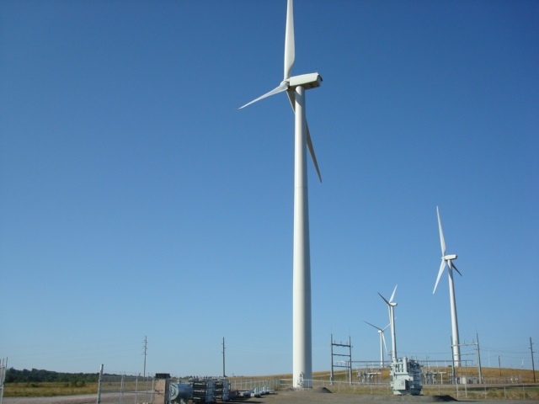

9/3/09

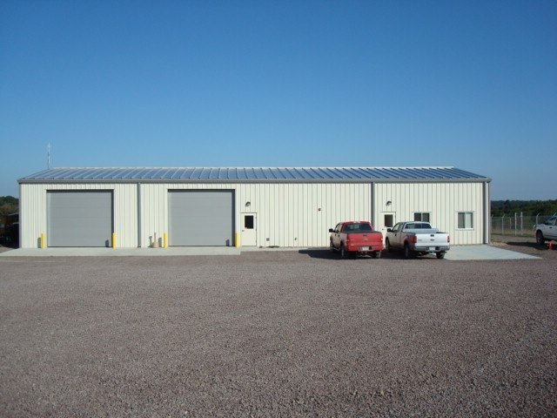

Question 2:  Please indicate whether you are or are not a mercantile customer.

Answer 2: NO

Question 3:  Please indicate whether you are a member of a regional transmission organization, and if so, specify which one.  If not, please explain why you are not a member.

Answer 3: YES - PJM

1. I am the duly authorized representative of Casselman Wind Farm.
2. I have personally examined and am familiar with all information contained in the foregoing responses, including any exhibits and attachments, and that based upon my inquiry of those persons immediately responsible for obtaining the information contained in the responses, I believe that the information is true, accurate and complete.
3. I am aware that there are significant penalties for submitting false information, including the possibility of fine and imprisonment.

__________________________________                                     ________________

                 Signature and Title                                                                                     Date