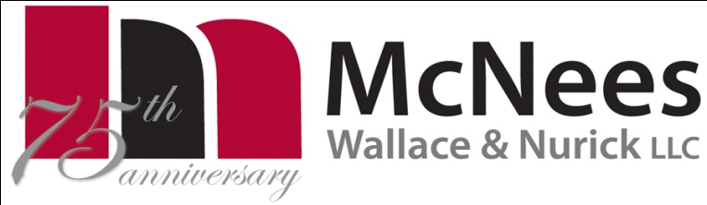

# Columbus.jpg

Lisa G. McAlister

Direct Dial (614) 719-5957

Email: lmcalister@mwncmh.com

September 15, 2010

Ms. Renee Jenkins

Secretary

Public Utilities Commission of Ohio

180 E. Broad Street, 13th Floor

Columbus, Ohio 43215

Re: In the Matter of the Application of P. H. Glatfelter Company – Chillicothe Facility Power Boiler #6 for Certification as an Eligible Ohio Renewable Energy Resource Generating Facility, Case No. 10-1060-EL-REN

Dear Secretary Jenkins:

Please find enclosed the responses to Staff’s Interrogatories – Initial Set in Case No. 10-1060-EL-REN from P. H. Glatfelter Company, Chillicothe Facility regarding the certification of its wood waste boiler #6 as an eligible Ohio renewable energy resource generating facility.

If you have any questions regarding Glatfelter’s responses, please feel free to contact me at 614-719-5957 or James F. Loder, Global Director of Energy Management, at 717-225-2887.

Very truly yours,

/s / Lisa G. McAlister

Lisa G. McAlister