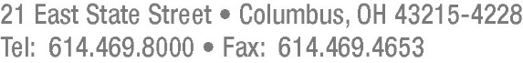

Frank P. Darr
(614) 719-2855—Direct Dial
fdarr@mwncmh.com

July 10, 2017

Barcy McNeal
Secretary, Docketing Division
Public Utilities Commission of Ohio
180 East Broad Street
Columbus, Ohio 43215

Re: Case No. 17-0420-GA-PIP and 89-8005-GA-TRF

Dear Secretary McNeal:

Pursuant to the Application filed by Vectren Energy Delivery of Ohio, Inc. (“VEDO”) in Case No. 17-0420-GA-PIP, dated May 26, 2017, VEDO hereby submits P.U.C.O. No. 3, Sheet No. 40, Seventh Revised Page 1 of 1, which replaces P.U.C.O. No. 3, Sheet No. 40, Sixth Revised Page 1 of 1.

Thank you for your kind attention to this matter.

Very truly yours,

/s/ Frank P. Darr
Frank P. Darr

Attorney for Vectren Energy Delivery
of Ohio, Inc.

Enclosure
FPD

