

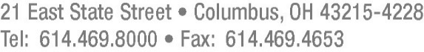

July 26, 2017

Barcy McNeal

Secretary, Docketing Division

Public Utilities Commission of Ohio

180 East Broad Street

Columbus, Ohio 43215

**RE:** **Case No. 17-0320-GA-UEX and 89-8005-GA-TRF**

Dear Secretary McNeal:

Pursuant to the Application filed by Vectren Energy Delivery of Ohio, Inc. (“Vectren”) in Case No. 17-0320-GA-UEX, Vectren hereby submits P.U.C.O. No. 3, Sheet No. 39, Ninth Revised Page 1 of 1, which replaces P.U.C.O. No. 3, Sheet No. 39, Eighth Revised Page 1 of 1. P.U.C.O. No. 3, Sheet No. 39, Ninth Revised Page 1 of 1 is being filed electronically in the case docket and in Vectren’s TRF docket.

Thank you for your kind attention to this matter.

Very truly yours,

*/s/ Frank P. Darr*

Frank P. Darr

**Attorney for Vectren Energy Delivery of Ohio, Inc.**

Enclosure

FPD

Cc: Coleen Mooney [cmooney@ohiopartners.org](mailto:cmooney@ohiopartners.org)

Ajay Kumar [Ajay.kumar@occ.ohio.gov](mailto:Ajay.kumar@occ.ohio.gov)