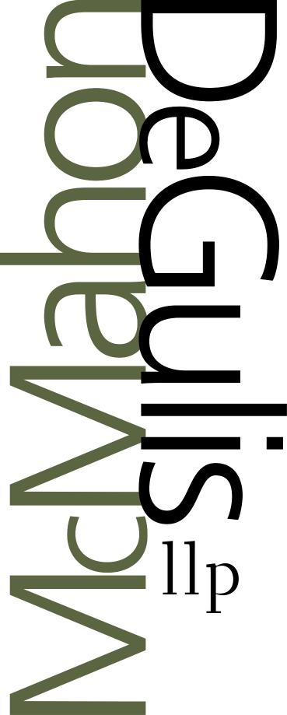asalimbene@mdllp.net

November 6, 2013

***Electronic Filing***

Todd Snitchler, Chairman

Ohio Power Siting Board

180 East Broad Street, 11th Floor

Columbus, Ohio 43215-3793

Re: Pre-Application Notification Letter

Lake Erie Energy Development Corps (LEEDCo) Project Icebreaker

Case No: 13-2033-EL-BGN

Dear Chairman Snitchler,

The Lake Erie Energy Development Corporation (LEEDCo) hereby submits its Pre-Application Notification Letter pursuant to Ohio Administrative Code (O.A.C.) 4906-5-08(A):

1. **Basic Description of the Project.** LEEDCo’s "Project Icebreaker" is funded in part by a Cooperative Agreement between LEEDCo and the U.S. Department of Energy Wind and Water Power Program for U.S. Offshore Wind Advanced Technology Demonstration Projects. Project Icebreaker is a demonstration-scale project that will consist of six Siemens SWT-3.0-113 wind turbine generators installed approximately seven to nine miles off the coast of Cleveland in Lake Erie for a total project capacity of 18 megawatts (“MW”). The southeastern most turbine will be located approximately four miles northwest of the City of Cleveland’s Water Intake Crib. A buried interconnection cable will transport power to the point of interconnection to the bulk power grid proposed at the Cleveland Public Power Lake Road Substation in Cleveland, Ohio. The turbines will have a hub height of approximately 87.5 meters; a rotor diameter of approximately 120 meters; and a surface water elevation of approximately 27.5 meters. The overall goal is that Project Icebreaker will serve as a technology innovation and validation center to reduce the levelized cost of offshore wind energy for the shallow waters of the Great Lakes.
2. **Public Informational Meeting.** LEEDCo plans to hold the public informational meeting required by O.A.C. 4906-5-08(B) on November 21, 2013 at 4 p.m. at The Cleveland Public Library, 325 Superior Avenue, NE, Room 218, Cleveland, Ohio 44114.
3. **Anticipated Waivers.** LEEDCo anticipates asserting within its application that certain requirements are not applicable because the project is located offshore, but LEEDCo does not anticipate requesting any waivers at this time.

Sincerely,

McMahon DeGulis llp

/AMS

Andrea M. Salimbene

Counsel for LEEDCo