**BEFORE**

**THE PUBLIC UTILITIES COMMISSION OF OHIO**

|  |  |  |
| --- | --- | --- |
| In the Matter of the 2014 Review of the Distribution Investment Rider Contained in the Tariff of Ohio Power Company. | :  :  : | Case No. 15-66-EL-RDR |

**COMMENTS**

SUBMITTED ON BEHALF OF THE STAFF OF

THE PUBLIC UTILITIES COMMISSION OF OHIO

**Michael DeWine**

Ohio Attorney General

**William L. Wright**

Section Chief

**Steven L. Beeler**

Assistant Attorneys General

Public Utilities Section

180 East Broad Street, 6th Floor

Columbus, OH 43215-3793

614.466.4397 (telephone)

614.644.8764 (fax)

[steven.beeler@puc.state.oh.us](mailto:steven.beeler@puc.state.oh.us)

**On behalf of the Staff of**

**The Public Utilities Commission of Ohio**

August 6, 2015

BACKGROUND 1

SCOPE AND OBJECTIVES 2

2014 COMPARED TO BASELINE YEARS 3

PROJECTION COMPARED TO ACTUAL 4

DIR EXPENDITURE TREND 5

RELIABILITY IMPROVEMENT ACHIEVED 7

SUMMARY OF RESULTS 9

PROOF OF SERVICE 11

**BEFORE**

**THE PUBLIC UTILITIES COMMISSION OF OHIO**

|  |  |  |
| --- | --- | --- |
| In the Matter of the 2014 Review of the Distribution Investment Rider Contained in the Tariff of Ohio Power Company. | :  :  : | Case No. 15-66-EL-RDR |

**COMMENTS**

SUBMITTED ON BEHALF OF THE STAFF OF

THE PUBLIC UTILITIES COMMISSION OF OHIO

# BACKGROUND

In its August 12, 2012 Opinion and Order in Case No. 11-346-EL-SSO (ESP 1 Order), the Commission approved a Distribution Investment Rider for Ohio Power Company (AEP Ohio or the Company), and ordered the Company to “work with Staff to develop a plan to emphasize proactive distribution maintenance that focuses spending on where it will have the greatest impact on maintaining and improving reliability for customers.” Accordingly, AEP Ohio has worked with Staff to develop the 2014 DIR plan, which it filed on December 16, 2013 in Case No. 13-2394-EL-UNC. During 2014, Staff monitored AEP Ohio’s implementation of that plan and will summarize the results in these Staff Comments. The purpose of this review is to determine the extent to which AEP Ohio is spending on proactive infrastructure programs and those that are expected to have a positive impact on reliability[1] and also to quantify that impact.

# SCOPE AND OBJECTIVES

The scope of Staff’s analysis is limited to AEP Ohio’s DIR performance as meas­ured by capital expenditures and reliability impact. The analysis *excludes* smart grid expenditures recovered through the Company’s gridSMART Rider as well as vegetation management expenditures recovered through base rates and the Enhanced Service Relia­bility Rider. Finally, these comments are *not* directed toward the results of the 2014 DIR Compliance Audit conducted by Baker Tilly, the consultant auditor.

The objectives of Staff’s analysis are as follows:

* To compare total 2014 DIR expenditures to baseline expenditures dur­ing the three years prior to Commission approval of the DIR Rider;
* To compare actual 2014 DIR expenditures against the Company’s 2014 projection;
* To compare historical and 2014 DIR expenditures against the 2015 DIR plan; and
* To quantify the reliability improvement achieved by implementing applicable DIR programs.

Staff has implemented each of the above analyses, and discusses the results in the sec­tions below.

# 2014 COMPARED TO BASELINE YEARS

In its ESP 1 Order, the Commission emphasized that DIR expenditures should exceed “recent spending levels.” Subsequently in its May 29, 2013 Finding and Order in Case No. 12-3129-EL-UNC, the Commission directed Staff to verify, as part of its review of AEP Ohio’s compliance with the DIR plan, that the Company’s actual DIR spending exceeded the levels achieved in recent years. Staff understands these Commission expectations to mean not that DIR spending should be ever increasing, but rather that DIR spending levels should exceed what the Company spent on comparable projects pri­or to the Commission’s approval of the DIR cost recovery mechanism. Staff selected the years 2009 through 2011 to use as the baseline for such a comparison, the results of which appear in Table 1 below.

|  |  |  |  |  |
| --- | --- | --- | --- | --- |
| **Table 1** | | | | |
| **Actual DIR Expenditures** | | | | |
| **2014 Compared to Three-year Average Prior to DIR Approval** | | | | |
| **Expenditures** | **Baseline Average 2009-2011** | **2014** | **Above Baseline** | **% Above Baseline** |
| Total | $ 122,848,667 | $ 223,868,654 | $ 101,019,987 | 82% |
| Proactive/Reliability | $ 27,406,000 | $ 109,107,018 | $ 81,701,018 | 298% |

Table 1 shows that total 2014 DIR expenditures were 82 percent higher than comparable expenditures during the baseline years, and that 2014 DIR expenditures on pro­active/reliability programs were 298 percent higher than the baseline. Staff believes the higher spending on proactive/reliability programs is consistent with the Commission’s expectations that DIR spending exceed that of recent years and that the DIR plan should focus on proactive programs that maintain and improve reliability.

# PROJECTION COMPARED TO ACTUAL

Staff also compared AEP Ohio’s actual 2014 DIR expenditures against the Company’s projection for that year, and the results of that comparison appear in Table 2 below.

|  |  |  |  |  |
| --- | --- | --- | --- | --- |
| **Table 2**  **2014 DIR Expenditures -- Projection Compared to Actual** | | | | |
| **Expenditures** | **2014 Projection** | **2014 Actual** | **Above/(Below) Projection** | **% Above/(Below) Projection** |
| Total | $ 214,872,000 | $ 223,868,654 | $ 8,996,654 | 4.2% |
| Proactive/Reliability | $ 108,872,000 | $ 109,107,018 | $ 235,018 | 0.2% |

Table 2 indicates that total DIR expenditures were 4.2 percent above projection and that proactive/reliability expenditures exceeded projection by 0.2 percent. These results show that the Company is doing a good job of keeping overall DIR spending in line with planned amounts. There were, however, some significant program variances, including two spending shortfalls in certain proactive/reliability programs that merit discussion. The first involved a 67 percent under-spend on distribution asset improvements associat­ed with transmission work. The Company attributed this shortfall to the DIR Plan’s de­pendence on “the Transmission organization’s construction schedule.” The second short­fall involved a 64 percent under-spend on station regulator replacements, which the Company similarly attributed to the DIR Plan’s dependence on “the Station organiza­tion’s engineering and construction schedules.” Staff believes the Company should use this situation as an opportunity to improve planning coordination between its Distribu­tion, Transmission, and Station organizations. Staff therefore recommends that AEP Ohio work to improve such coordination and describe, within its 2016 DIR plan, the actions it took in 2015 to implement such process improvements

# DIR EXPENDITURE TREND

Table 3 compares: (1) average DIR-related expenditures during the three-year baseline period 2009 through 2011; (2) actual DIR expenditures during each of the years 2012 through 2014; and (3) DIR expenditures projected for 2015. These expenditures are further categorized for proactive/reliability programs, non-proactive/non-reliability pro­grams, and the total amount for all DIR expenditures.

|  |  |  |  |  |  |
| --- | --- | --- | --- | --- | --- |
| **Table 3**  **DIR Expenditures - Historical Comparison ($Millions)** | | | | | |
| **Expenditures** | **Averages 2009-2011** | **2012** | **2013** | **2014** | **2015**  **Projection** |
| Proactive/Reliability | $ 27.406 | $ 34.055 | $ 79.726 | $ 109.107 | $ 89.020 |
| Non-proactive/Non-Reliability | $ 95.443 | $ 106.978 | $ 108.829 | $ 114.762 | $ 103.050 |
| Total | $ 122.849 | $ 141,033 | $ 188.555 | $ 223.869 | $ 192.070 |

The dollar amounts in Table 3 are graphically displayed in Chart 1, which depicts a slight upward trend for non-proactive/non-reliability expenditures through 2014 and a slight decline projected for 2015. By contrast, the chart shows a stronger upward trend for pro­active/reliability expenditures through 2014 with a pronounced decline projected for 2015.

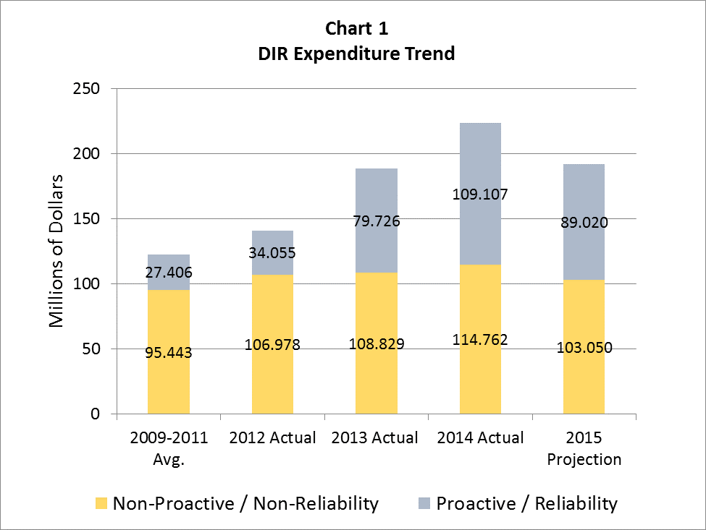

Staff is not concerned about such declines as long as total DIR spending, and especially that on proactive/reliability programs, remains significantly higher than spending levels during the (2009-2011) baseline years prior to the onset of the DIR. Staff is concerned, however, by the potential for non-proactive/non-reliability expenditures to increase while proactive/reliability expenditures continue decreasing in future years. Accordingly, Staff plans to closely monitor the Company’s DIR expenditure trends for these two broad spending categories.

# RELIABILITY IMPROVEMENT ACHIEVED

In its May 29, 2013 Finding and Order (F&O) in Case No. 12-3129-EL-UNC, the Commission directed the Company to quantify actual reliability improvements achieved for any program that is expected to reduce the frequency and/or duration of outages (reli­ability programs); and to quantify the outages avoided for any program that is expected to maintain reliability (proactive programs). The Commission also required the Company to provide such quantification to Staff. The reported reliability impact quantifications are summarized in Tables 4 and 5 below.

|  |  |
| --- | --- |
| **Table 4**  **Quantification of 2014 Reliability Impact for Proactive Programs** | |
| **Program Name** | **Avoided Outages \*** |
| Distribution Circuit Asset Improvement | 8,600 |
| Cutout and Arrester Program | 7,166 |
| Distribution Asset Improvement Associated with Transmission Work | 45 |
| Station Breaker Replacement | 30 |
| Pole Replacement | 4,320 |
| Line Recloser Maintenance | 634 |
| Underground Residential Distribution Inspection | 69 |
| Network Rehabilitation | 74 |
| Station Regulator Replacements | 15 |
| Forestry – Emerald Ash Borer Mitigation | 20,815 |
| Pole Reinforcement | 165 |
| Underground Duct and Manhole Program | 10 |
| Station Rebuild/Rehabilitation | 7 |
| **Total** | **41,950** |
| * Note that one outage represents up to 2,100 customer interruptions | |

Table 4 above indicates that the Company’s proactive DIR programs avoided a total of 41,950 outages, which represents a 35 percent improvement compared to outages avoided in 2013.

|  |  |  |
| --- | --- | --- |
| **Table 5**  **Quantification of 2014 Reliability Impact for Reliability Programs** | | |
| **Program Name** | **Reduction in Outages \*** | **Reduction in Customer Outage Minutes** |
| Animal Mitigation Station | 5 | N/A |
| Lightning Mitigation | 62 | N/A |
| Underground Cable Replacement | 23 | N/A |
| Overhead Circuit Inspection and Repair | 726 | N/A |
| Sectionalizing Program | N/A | 31,200 |
| **Total** | **816** | **31,200** |
| * Note that one outage represents up to 2,100 customer interruptions | | |

Table 5 above indicates that the Company’s DIR-related reliability programs caused a total reduction of 816 outages, which represents a 167 percent improvement compared to such outage reduction in 2013. Similarly, the Company’s Sectionalizing program caused a reduction of 31,200 customer outage minutes, which represents a 53 percent improve­ment compared to 2013 performance.

Staff asked AEP Ohio to explain what caused the improved performance discussed above with respect to Tables 4 and 5. In response, the Company attributed the improved performance to a higher level of spending on reliability-related construction projects.

# SUMMARY OF RESULTS

The results of Staff’s review is summarized as follows.

* Consistent with Commission expectations, DIR spending for 2014 is significantly higher than during the (2009–2011) baseline of comparable expenditures prior to the Commission’s approval of the DIR.
* Although the Company kept total DIR spending close to planned amounts, particular programs showed significant spending shortfalls due to constraints imposed by other parts of the larger AEP Ohio organiza­tion. Staff sees an opportunity to improve planning coordination between AEP Ohio’s Distribution, Transmission, and Station organiza­tions, and recommends that the Company describe, as part of the 2016 DIR Plan, its efforts to improve such planning coordination.
* Although planned 2015 DIR expenditures are less than actual 2014 expenditures, they remain substantially higher than expenditure levels during the (2009-2011) baseline years, and therefore meet the staff’s expectations in this respect.
* During 2014, the Company substantially increased the quantitative impact of the DIR’s proactive/reliability programs as compared with that achieved in 2013. Staff believes this improved performance shows that the Company is focusing DIR spending on maintaining and improv­ing reliability for its customers

Respectfully submitted,

**Michael DeWine**

Ohio Attorney General

**William L. Wright**

Section Chief

/s/ Steven L. Beeler

**Steven L. Beeler**

Assistant Attorney General

Public Utilities Section

180 East Broad Street, 6th Floor

Columbus, OH 43215-3793

614.466.4397 (telephone)

614.644.8764 (fax)

[steven.beeler@puc.state.oh.us](mailto:steven.beeler@puc.state.oh.us)

**On behalf of the Staff of**

**The Public Utilities Commission of Ohio**

# PROOF OF SERVICE

I hereby certify that a true copy of the foregoing **Comments** submitted on behalf of the Staff of the Public Utilities Commis­sion of Ohio,was served by regular U.S. mail, postage pre­paid, or hand-delivered, upon the following Parties of Record, this 6th day of August, 2015.

/s/ Steven L. Beeler

**Steven L. Beeler**

Assistant Attorney General

**Parties of Record:**

|  |  |
| --- | --- |
| Steve T. Nourse  American Electric Power Service Corp.  1 Riverside Plaza, 29th Floor  Columbus, OH 43215  [stnourse@aep.com](mailto:stnourse@aep.com)  Jodi J. Bair  Joseph P. Serio  Assistant Consumers’ Counsel  Office of the Ohio Consumers’ Counsel  10 West Broad Street  Suite 1800  Columbus, OH 43215  [jodi.bair@occ.ohio.gov](mailto:jodi.bair@occ.ohio.gov)  [joseph.serio@occ.ohio.gov](mailto:joseph.serio@occ.ohio.gov) | Mark S. Yurick  Devin D. Parram  Taft Stettinius & Hollister  65 East State Street, Suite 1000  Columbus, OH 43215  [myurick@taftlaw.com](mailto:myurick@taftlaw.com)  [dparram@taftlaw.com](mailto:dparram@taftlaw.com) |

1. In these comments, DIR programs that are proactive in nature or are expected to have a positive impact on reliability will be referred to collectively as “proactive/reliability programs”.