**09-1083-EL-REN** - Twenhofel Middle School - Staff Interrogatory

1. As the Twenhofel Middle School facility is not registered in GATS, please provide a methodology and documentation which will support the specific generation output that would be reported to GATS for the period January 6, 2009 through January 27, 2010 (the date the facility had a utility grade meter installed).  The documentation might include any dated photographs of the inverter and utility grade meters, written documentation of meter readings or inverter and utility grade meter measures, or entries of meter readings in a spreadsheet.

Inverter readings and photos were taken on 1/6/2009. They were again taken on 7/30/2009 and 1/5/2010. We intend to use exact inverter readings beginning on 1/6/2009. There are four inverters at the Twenhofel Middle School. The aggregate of all four inverters as of 1/5/2010 is 21,476 kWh. For a monthly output to report to GATS, we will just divide the 21,476 by 12 months to report 1,790 kWh per month for each month in 2009 to GATS.

The Twenhofel Middle School had a utility grade meter installed on 1/27/2010. From this date going forward, the output of the facility will be measured with this utility grade meter and reported to GATS.

Below are the inverter photos and readings from each time period.

1/6/2009

Inverter # 2000098047

Reading 18,477 kWh

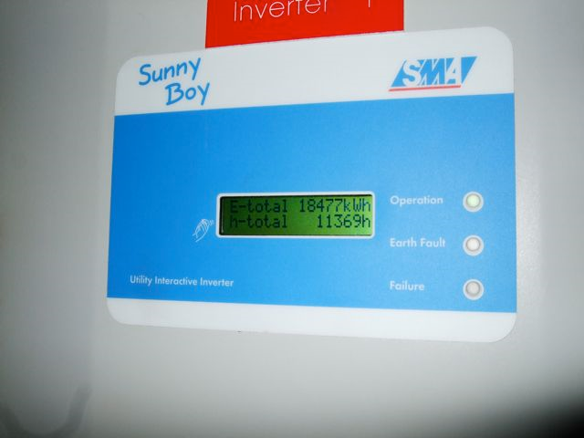

Inverter # 2000108302

Reading 21,086 kWh

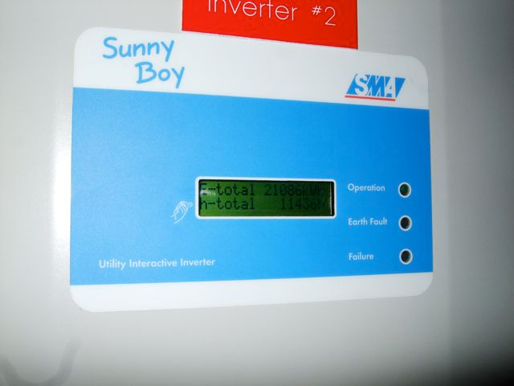

Inverter # 2000106126

Reading 18,042 kWh

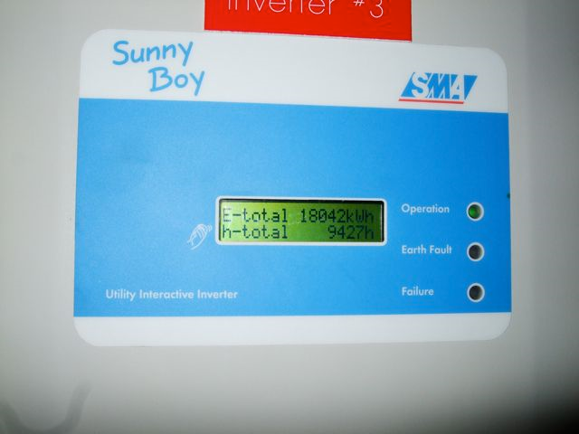

Inverter # 2000103524

Reading 7,869 kWh

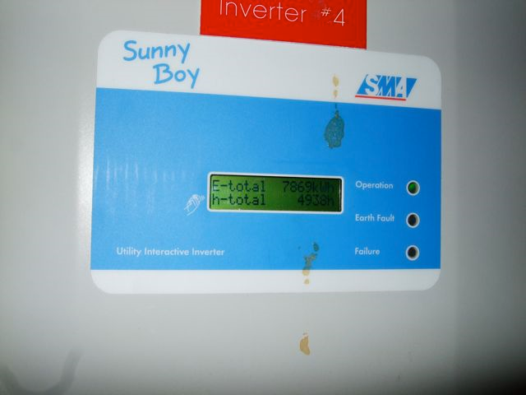

7/30/2009

Inverter # 2000098047

Reading 21,183 kWh

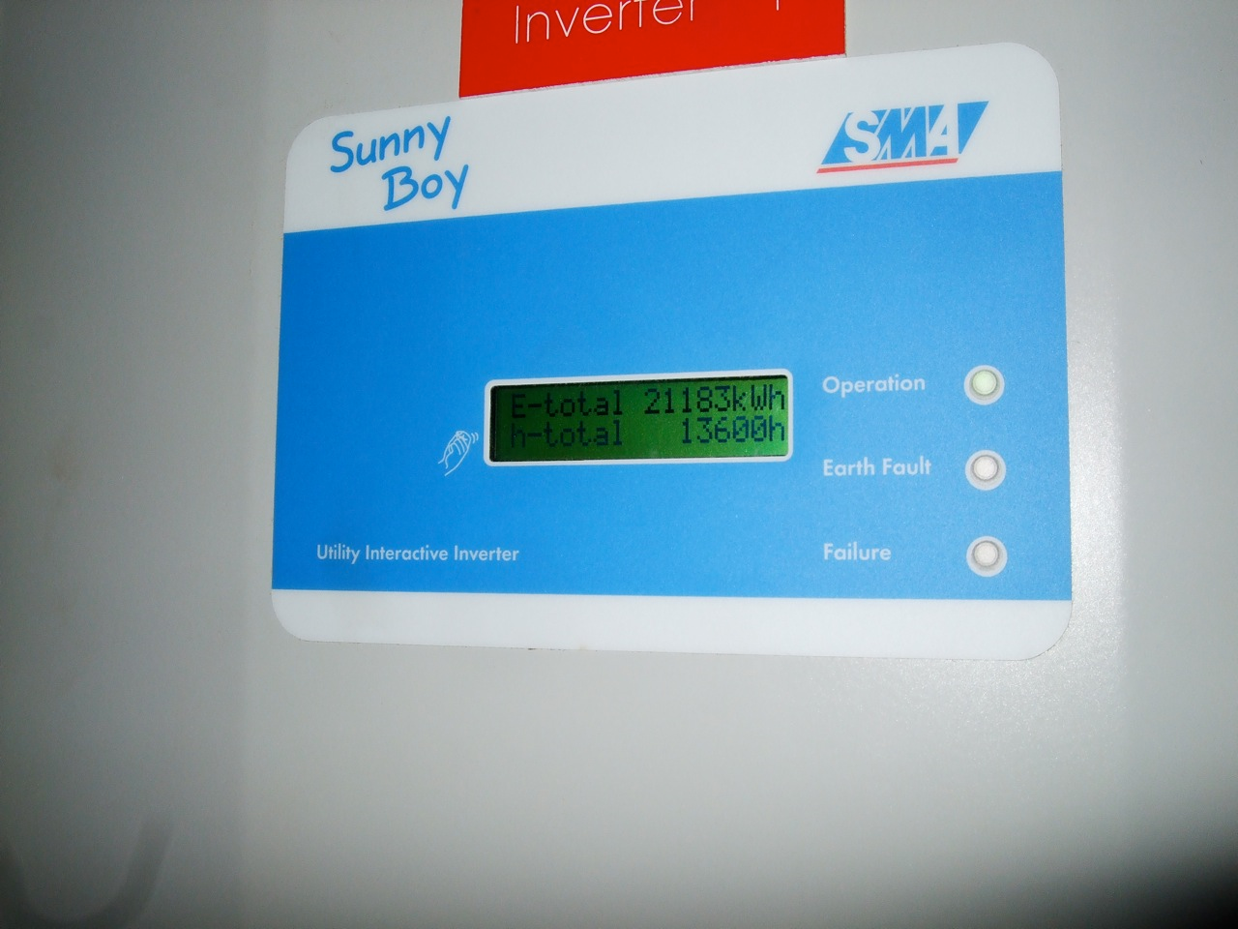

Inverter # 2000108302

Reading 25,114 kWh

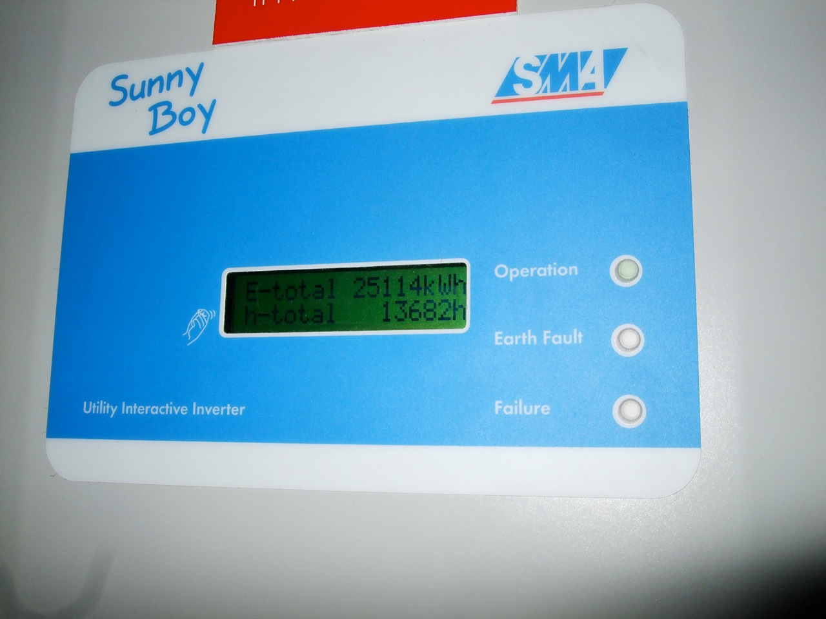

Inverter # 2000106126

Reading 22,162 kWh

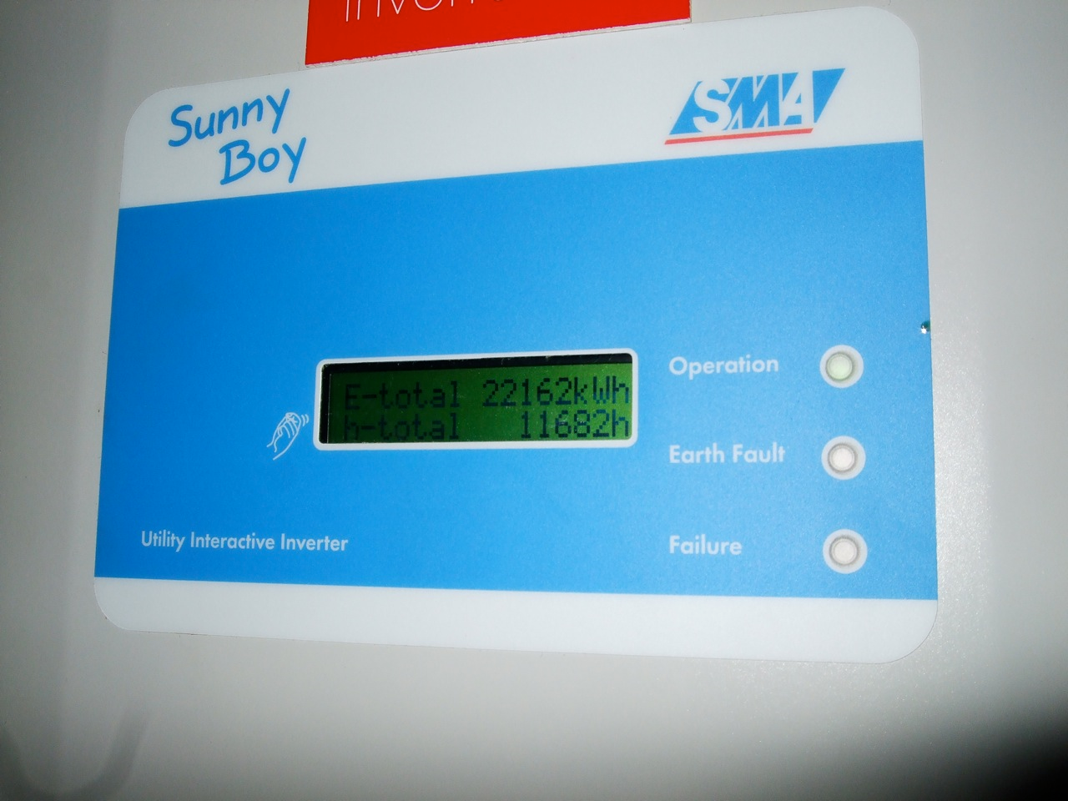

Inverter # 2000103524

Reading 10,349 kWh

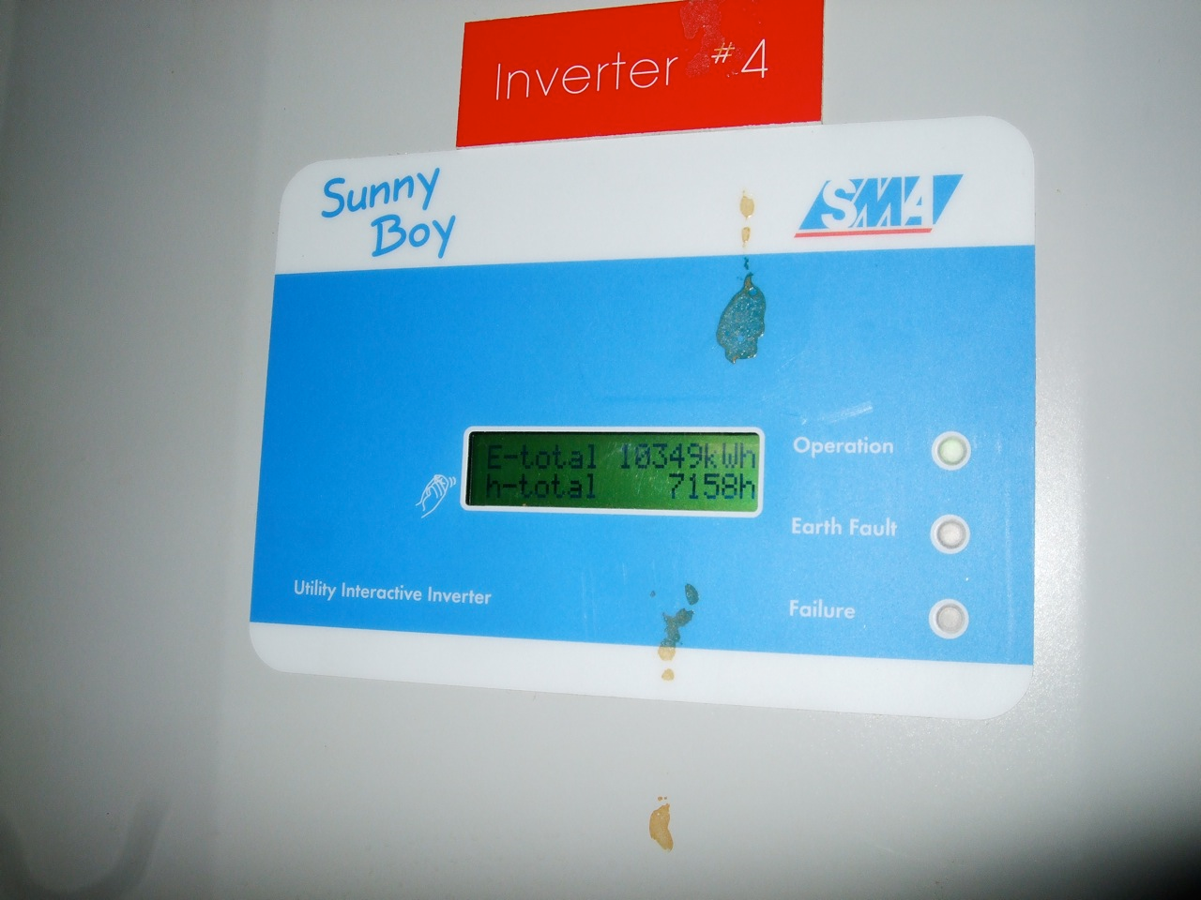

7/30/2009

Inverter # 2000098047

Reading 22,954 kWh

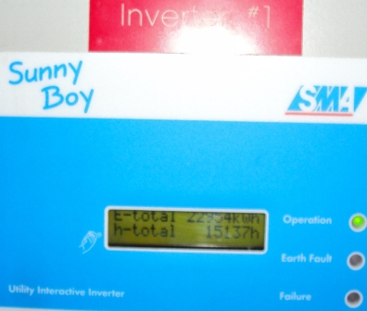

Inverter # 2000108302

Reading 27,791 kWh

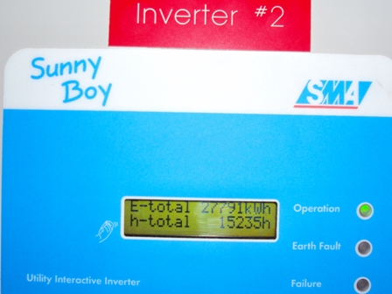

Inverter # 2000106126

Reading 24,893 kWh

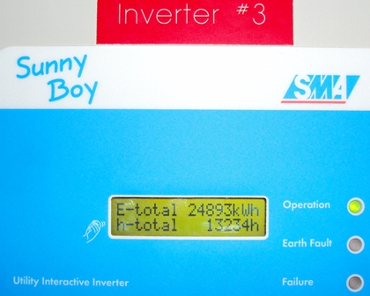

Inverter # 2000103524

Reading 11,312 kWh

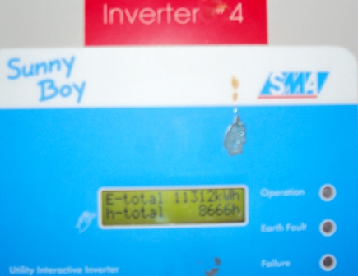

2. Also in the Commission’s Entry on Rehearing, the Commission explained that consistent with its policy on double counting, the Commission will not retroactively recognize any past RECs which have been sold or otherwise consumed (page 34).   Please confirm that none of the generation that the Twenhofel Middle School facility will report from before January 27, 2010 has been tracked as RECS that have been sold or otherwise consumed.

We confirm that none of the generation that the Twenhofel Middle School facility will report from before January 27, 2010 has been tracked as RECs that have been sold or otherwise consumed.