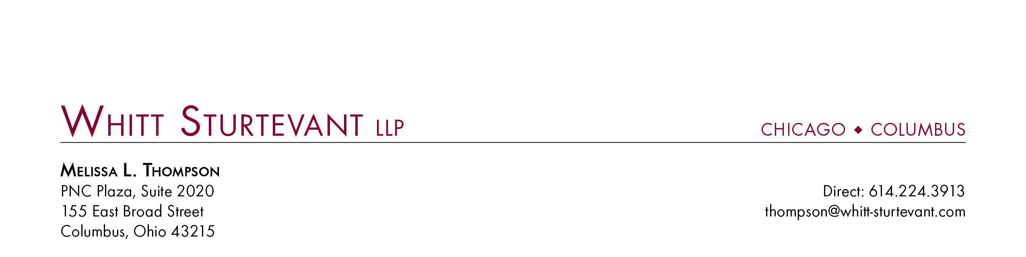

May 21, 2012

Ms. Barcy McNeal
Commission Secretary
Public Utilities Commission of Ohio
180 East Broad Street
Columbus, Ohio 43215

Re: In the Matter of the Application of Ohio American Water Company to Increase its Rates for Water and Sewer Service Provided to Its Entire Service Area, Case No. 11-4161-WS-AIR

Dear Ms. McNeal:

Enclosed please find Aqua Ohio Water Company, Inc.’s updated Schedule C-8, filed as a Late Filed Exhibit in connection with the above-captioned proceeding. This filing is made pursuant to the Ohio Adm. Code 4901-7-01, Appendix A, Chapter II, Section C, Paragraph (D)(5).

Please do not hesitate to contact me with any questions.

Very Truly Yours,

Melissa L. Thompson

