September 2, 2021

**Via Electronic Filing**

Ms. Tanowa Troupe, Secretary

Public Utilities Commission of Ohio

180 East Broad Street, 13th Floor

Columbus, OH 43215-0573

RE: Global Crossing Local Services, Inc.

Case No. 21-0809-TP-ATA and 90-5102-CT-TRF

Dear Ms. Troupe:

Attached for filing, please find the following FINAL tariff revisions for Global Crossing Local Services, Inc. P.U.C.O. Tariff No. 4. These revisions were approved on August 20, 2021.

4th Revised Sheet 1

Section 1 - 1st Revised Sheet 8

Section 1 - 1st Revised Sheet 11

Section 3 – 1st Revised Sheet 66

Section 3 - 4th Revised Sheet 67

Section 3 – 5th Revised Sheet 68

Section 3 – 4th Revised Sheet 69

Section 3 – 1st Revised Sheet 70

If you have any questions regarding this filing, please contact me.

Sincerely,

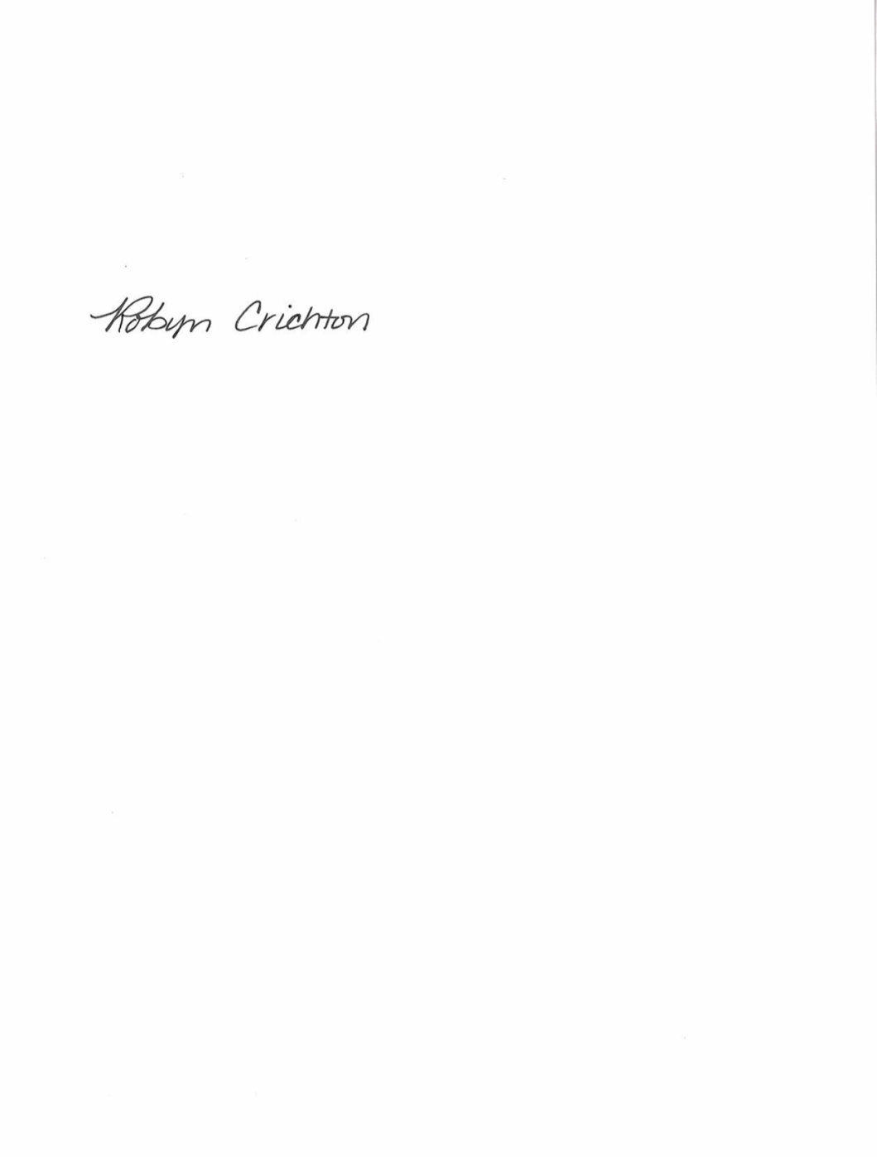

Robyn Crichton

cc: Joshua Motzer, CenturyLink

OH2021-08

**Robyn Crichton**

Government Operations Manager

[Robyn.M.Crichton@Centurylink.com](mailto:Robyn.M.Crichton@Centurylink.com)

12337 South Quail Ridge Drive

Olathe, KS 66061

Tel: (913) 884-1131