June 16, 2023

**Via Electronic Filing**

Ms. Tanowa Troupe, Secretary

Public Utilities Commission of Ohio

180 East Broad Street, 13th Floor

Columbus, OH 43215-0573

RE: Global Crossing Local Services, Inc.

Case Nos. 23-0673-TP-ATA and 90-5102-CT-TRF

Dear Ms. Troupe:

Enclosed for filing are revisions to the Global Crossing Local Services, Inc. P.U.C.O. Tariff No. 4, submitted with a proposed effective date of July 29, 2023. The following tariff pages are enclosed:

Section 3 - 6th Revised Sheet 67

Section 3 – 7th Revised Sheet 68

Section 3 – 6th Revised Sheet 69

Section 3 – 3rd Revised Sheet 70

This filing proposes the third step in implementing the 8YY Access Service reductions mandated in the Federal Communications Commission's October 9, 2020 Report and Order in WC Docket No. 18-156, (FCC 20-143), (8YY Access Charge Reform).

If you have any questions regarding this filing, please contact me.

Sincerely,

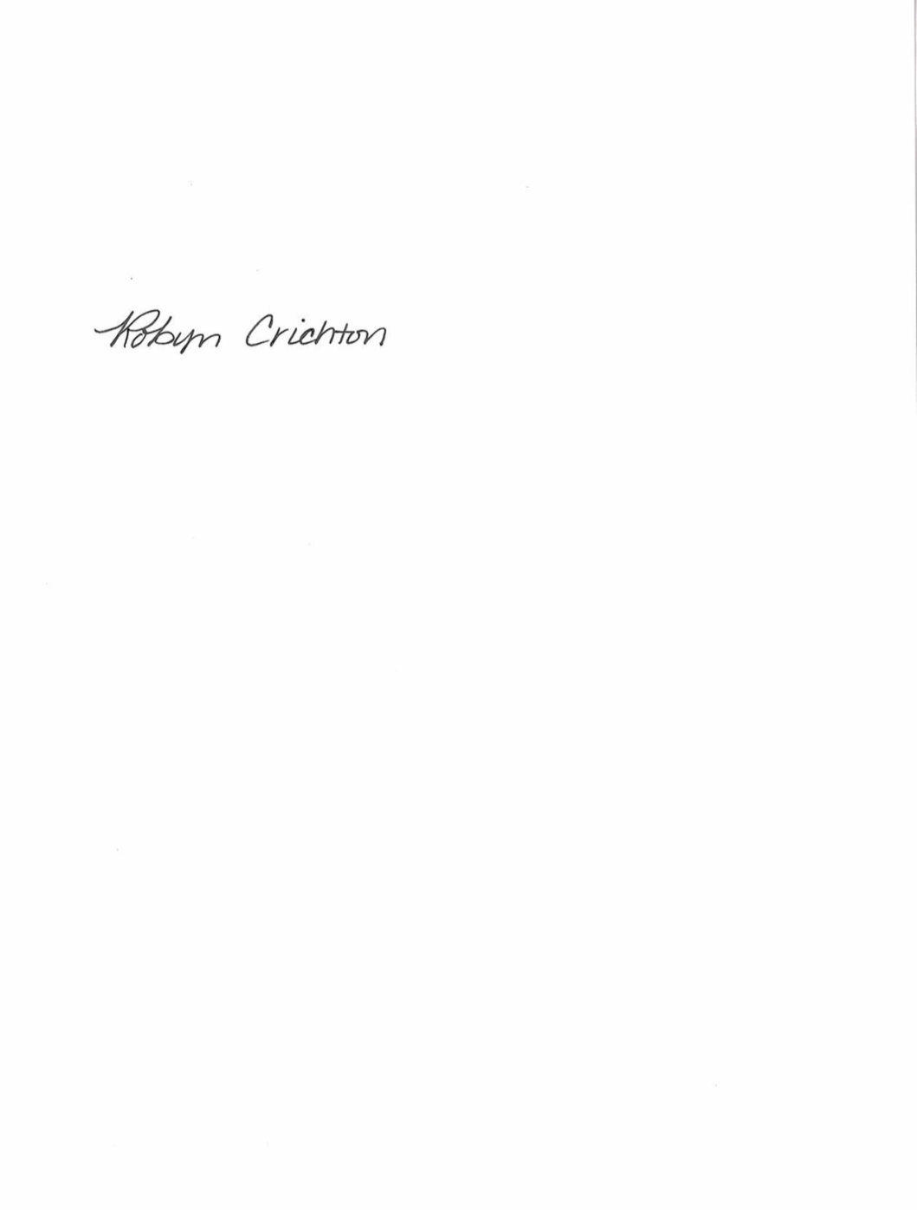

Robyn Crichton

cc: Al Lubeck, CenturyLink

OH2023-01

**Robyn Crichton**

Government Operations Director

[Robyn.M.Crichton@Lumen.com](mailto:Robyn.M.Crichton@Lumen.com)

100 CenturyLink Drive, Monroe, LA 71203

Tel: (913) 884-1131