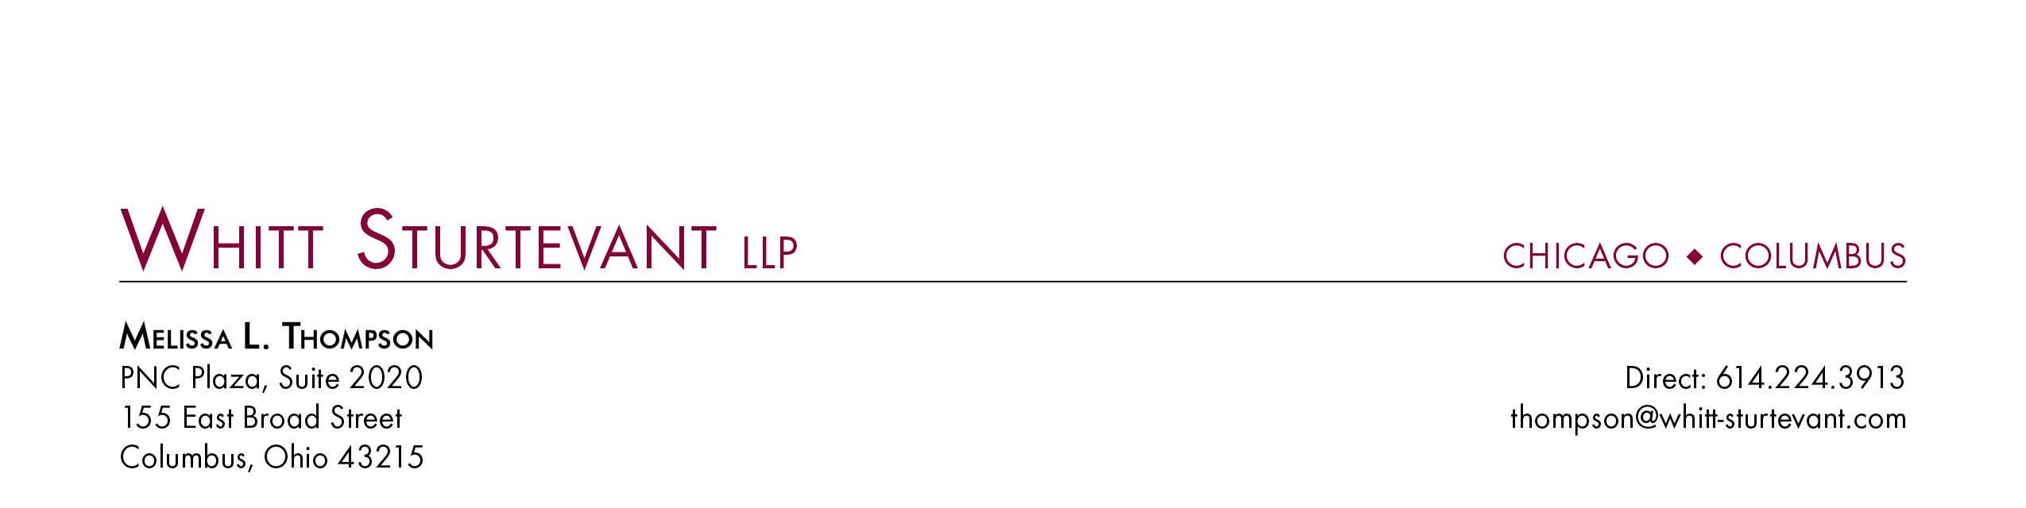

April 23, 2012

Ms. Barcy McNeal

Commission Secretary

Public Utilities Commission of Ohio

180 East Broad Street

Columbus, Ohio 43215

Re: *In the Matter of the Implementation of Section 749.10 of Amended Substitute House Bill 153*, Case No. 11-5384-AU-UNC

Dear Ms. McNeal:

Pursuant to the Commission’s December 14, 2011 Finding and Order in Case No. 11-5384-AU-UNC, Ohio-American Water Company gives notice to the Commission of its $4,406.35 payment to the Ohio Department of Development on April 23, 2012.

Please do not hesitate to contact me with any questions.

Very Truly Yours,

Melissa L. Thompson