September 22, 2021

**Via Electronic Filing**

Ms. Tanowa Troupe, Secretary

Public Utilities Commission of Ohio

180 East Broad Street, 13th Floor

Columbus, OH 43215-0573

Re: CenturyTel of Ohio, Inc. d/b/a CenturyLink

Case No. 90-5010-TP-TRF and Case No. 21-0988-TP-ZTA

Dear Secretary:

Enclosed for filing is CenturyTel of Ohio, Inc. d/b/a CenturyLink’s tariff to increase Business and Residential/Church Initial Line rates. This filing also reflects the new maximum rates for these services.

Section 2, Tenth Revised Sheet 1

Section 2, Fourth Revised Sheet 3

These tariff sheets are filed with a September 22, 2021 issue date and an effective date of September 24, 2021.

If you have any questions regarding this filing, please call me or Mr. Joshua Motzer at (614) 221-5354.

Sincerely,

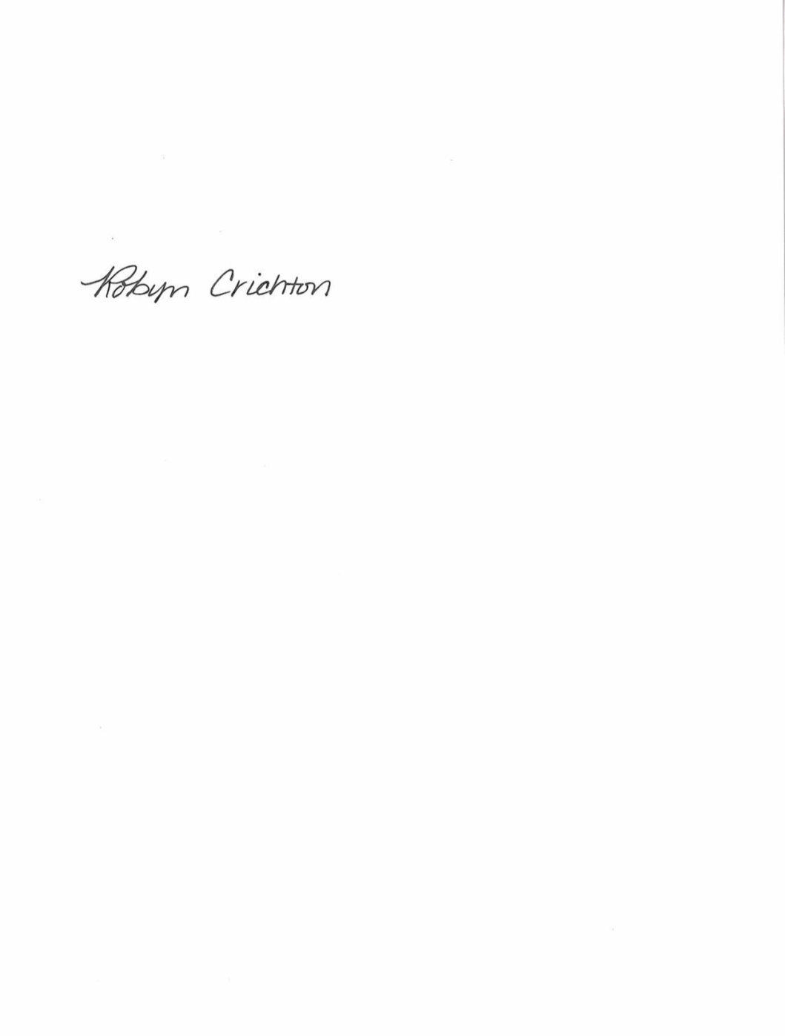

Robyn Crichton

cc: Joshua Motzer, CenturyLink

OH2021-05

**Robyn Crichton**

Government Operations Manager

[Robyn.M.Crichton@Centurylink.com](mailto:Robyn.M.Crichton@Centurylink.com)

12337 South Quail Ridge Drive

Olathe, KS 66061

Tel: (913) 884-1131

**Robyn Crichton**

Government Operations Manager

[Robyn.M.Crichton@Centurylink.com](mailto:Robyn.M.Crichton@Centurylink.com)

12337 South Quail Ridge Drive

Olathe, KS 66061

Tel: (913) 884-1131

**Robyn Crichton**

Government Operations Manager

[Robyn.M.Crichton@Centurylink.com](mailto:Robyn.M.Crichton@Centurylink.com)

12337 South Quail Ridge Drive

Olathe, KS 66061

Tel: (913) 884-1131

**Robyn Crichton**

Government Operations Manager

[Robyn.M.Crichton@Centurylink.com](mailto:Robyn.M.Crichton@Centurylink.com)

12337 South Quail Ridge Drive

Olathe, KS 66061

Tel: (913) 884-1131