September 22, 2021

**Via Electronic Filing**

Ms. Tanowa Troupe, Secretary

Public Utilities Commission of Ohio

180 East Broad Street, 13th Floor

Columbus, OH 43215-0573

Re: United Telephone Company of Ohio d/b/a CenturyLink

Case No. 90-5041-TP-TRF and Case No. 21-0989-TP-ZTA

Dear Secretary:

Enclosed for filing is United Telephone Company of Ohio d/b/a CenturyLink’s tariff to increase Residential Individual Line rates for competitive exchanges and increase Business Individual Line rates for competitive exchanges XI though XXII. This filing also reflects the new maximum rates for those exchanges. Zone charges for B and C are also being reduced. The following revisions are included in this filing:

Section 2, 5th Revised Sheet 2

Section 2, 6th Revised Sheet 2.1

Section 2, 5th Revised Sheet 2.2

Section 2, 5th Revised Sheet 2.3

Section 2, 6th Revised Sheet 2.4

Section 2, 10th Revised Sheet 3

Section 2, 2nd Revised Sheet 4

These tariff sheets are filed with a September 22, 2021 issue date and an effective date of September 24, 2021.

If you have any questions regarding this filing, please call me or Mr. Joshua Motzer at (614) 221-5354.

Sincerely,

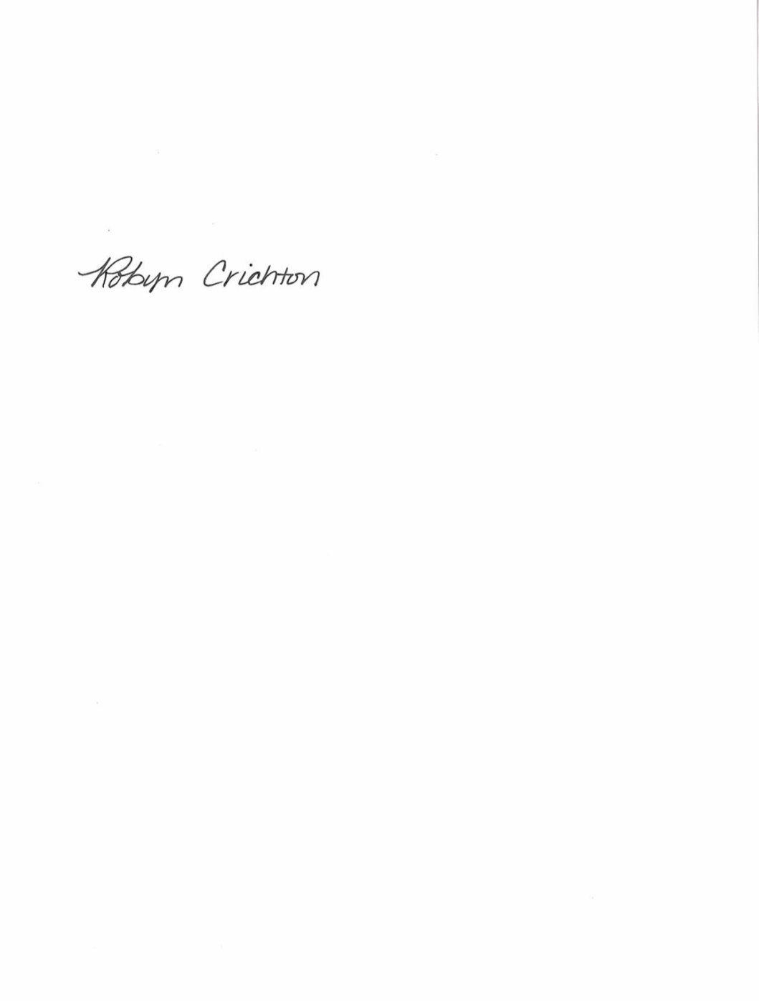

Robyn Crichton

cc: Joshua Motzer, CenturyLink

OH2021-05

**Robyn Crichton**

Government Operations Manager

[Robyn.M.Crichton@Centurylink.com](mailto:Robyn.M.Crichton@Centurylink.com)

12337 South Quail Ridge Drive

Olathe, KS 66061

Tel: (913) 884-1131

**Robyn Crichton**

Government Operations Manager

[Robyn.M.Crichton@Centurylink.com](mailto:Robyn.M.Crichton@Centurylink.com)

12337 South Quail Ridge Drive

Olathe, KS 66061

Tel: (913) 884-1131

**Robyn Crichton**

Government Operations Manager

[Robyn.M.Crichton@Centurylink.com](mailto:Robyn.M.Crichton@Centurylink.com)

12337 South Quail Ridge Drive

Olathe, KS 66061

Tel: (913) 884-1131

**Robyn Crichton**

Government Operations Manager

[Robyn.M.Crichton@Centurylink.com](mailto:Robyn.M.Crichton@Centurylink.com)

12337 South Quail Ridge Drive

Olathe, KS 66061

Tel: (913) 884-1131