Exhibit C
Current DEO Billing Terms Page
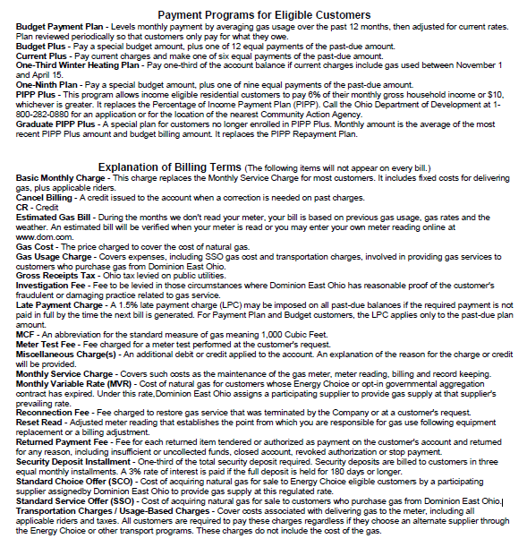

Proposed Revisions to DEO Billing Terms Page

Payment Programs for Eligible Customers
Budget Payment Plan – A fixed monthly plan calculated on current rates and actual usage that is reviewed periodically and adjusted, with an annual true up in May.
Budget Plus - Pay a budget amount, plus one of 12 equal payments of the past-due amount.
Current Plus - Pay current charges and make one of six equal payments of the past-due amount.
One-Third Winter Heating Plan - Pay one-third of the account balance if current charges include gas used between November 1 and April 15.
One-Ninth Plan - Pay a budget amount, plus one of nine equal payments of the past-due amount.
PIPP Plus - This program allows income eligible residential customers to pay 6% of their monthly gross household income or $10, whichever is greater. It replaces the Percentage of Income Payment Plan (PIPP). Call the Ohio Department of Development at 1-800-282-0880 for an application or for the location of the nearest Community Action Agency.
Graduate PIPP Plus - A special plan for customers no longer enrolled in PIPP Plus. Monthly amount is the average of the most recent PIPP Plus amount and budget billing amount.

Explanation of Billing Terms

Basic Service Charges – The applicable Basic Service Charges for each rate schedule include a Service Charge to cover the fixed costs for delivering gas, plus associated riders
Cancel Billing - A credit issued to the account when a correction is needed on past charges.
CR - Credit
Estimated Gas Bill - When we cannot obtain a meter reading, your bill is based on previous gas usage, gas rates and the weather. An estimated bill will be verified when your meter is read or you may enter your own meter reading online at www.dom.com.
Gas Cost - The price charged to cover the cost of natural gas.
Gas Usage Charge - Covers expenses, including SSO gas cost and transportation charges, involved in providing gas services to customers who purchase gas from Dominion East Ohio.
Gross Receipts Tax - Ohio tax levied on public utilities.
Investigation Fee - Fee to be levied in those circumstances where Dominion East Ohio has reasonable proof of the customer's fraudulent or damaging practice related to gas service.
Late Payment Charge - A 1.5% late payment charge (LPC) may be imposed on all past-due balances if the required payment is not paid in full by the time the next bill is generated. For Payment Plan and Budget customers, the LPC applies only to the past-due plan amount.
MCF - An abbreviation for the standard measure of gas meaning 1,000 Cubic Feet.
Meter Test Fee - Fee charged for a meter test performed at the customer's request.
Miscellaneous Charge(s) - An additional debit or credit applied to the account. An explanation of the reason for the charge or credit will be provided.

Monthly Variable Rate (MVR) - Cost of natural gas for customers whose Energy Choice or opt-in governmental aggregation contract has expired. Under this rate, Dominion East Ohio assigns a participating supplier to provide gas supply at that supplier's prevailing rate.
Reconnection Fee - Fee charged to restore gas service that was terminated by the Company or at a customer's request.
Reset Read - Adjusted meter reading that establishes the point from which you are responsible for gas use.
Returned Payment Fee - Fee for each returned item tendered or authorized as payment on the customer's account and returned for any reason.
Service Charge - This charge includes fixed costs for delivering gas.
Security Deposit Installment - One-third of the total security deposit required. Security deposits are billed to customers in three equal monthly installments. A 3% rate of interest is paid if the full deposit is held for 180 days or longer. Deposits are refunded with interest to residential accounts if required payments are made for 12 consecutive months and were not late more than two months during that time, you are not delinquent, or an account is closed for 10 days or longer. Deposits for commercial and industrial accounts are reviewed every 24 months.
Standard Choice Offer (SCO) - Cost of acquiring natural gas for sale to Energy Choice eligible customers by a participating supplier assigned by Dominion East Ohio to provide gas supply at this regulated rate.
Standard Service Offer (SSO) - Cost of acquiring natural gas for sale to customers who purchase gas from Dominion East Ohio.
Transportation Charges / Usage-Based Charges - Cover costs associated with delivering gas to the meter, including all applicable riders and taxes. All customers are required to pay these charges regardless if they choose an alternate supplier through the Energy Choice or other transport programs. These charges do not include the cost of the gas.

