Case No.: 09-856-EL-REN

A. Name of Renewable Generating Facility: Alackness, Joe
The name specified will appear on the facility’s certificate of eligibility issued by the Public Utilities Commission of Ohio.

Original Data:
G. Certification Criteria 2: Qualified Resource or Technology

You should provide information for only one resource or technology on this application; please check and/or fill out only one of the sections below. If you are applying for more than one resource or technology, you will need to complete a separate application for each resource or technology.

For the resource or technology you identify below, please provide a written description of your system. Please indicate if the facility is a customer-owned renewable distributed generation system. Please also include a detailed description of how the output of the facility is going to be measured and verified. If the facility is behind-the-meter and grid connected, please describe the configuration of the meter and the meter type. Please also attach digital photographs that depict an accurate characterization of your installed system. Please indicate the date(s) the photographs were taken. If you need additional sheets for the description of your system, please include those as an exhibit and clearly identify the subject matter in the heading.

Solar PV – The system is a customer owned, grid connected, behind the meter solar pv facility with net metering. The system has panels on two locations, the house and the garage. The system has 3 Sunpower inverters being used to track production. Two of the inverters are attached to the house (5000M) and 1 to the garage (4000M) The specifications of the inverters are attached at the end of the document.

New Information:
G.2. Please include a detailed description of how the output of the facility is going to be measured and verified, including the configuration of the meter(s) and the meter type(s).

In addition to the inverters, the system has 2 utility grade meters that were installed when the system was installed. There was a miscommunication between myself and the customer on these. I have the meter specifics below.

The facility has an Itron CL200 240V 3W Type C1S meter and a GE CL200 240V 3W Type I-70-S meter.

The sum of the meters production has been used since inception to measure and enter production data into GATS.

Original Data:

N. Meter Specifications

All facilities are required to measure output with a utility grade meter. Please provide this information for each meter used in your system.

Manufacturer: Sunpower
Serial Number: 2000722278
Type: SPR-5000m
Date of Last Certification: Installation
Total kWh shown on meter at time of photograph: 1,859

Manufacturer: Sunpower
Serial Number: 2000720519
Type: SPR-5000m
Date of Last Certification: Installation
Total kWh shown on meter at time of photograph: 1,867

Manufacturer: Sunpower
Serial Number: 2000734981
Type: SPR-4000m
Date of Last Certification: Installation
Total kWh shown on meter at time of photograph: 1,453

New Information:
Manufacturer: GE
Serial Number: 82 425 096
Type: CL200 240V 3W Type I-70-S
Date of Last Certification: 10/13/08
Total kWh shown on meter at time of photograph: 4,464 kWh

Manufacturer: Itron
Serial Number: 57 720 888
Type: CL200 240V 3W Type C1S
Date of Last Certification: 10/08
Total kWh shown on meter at time of photograph: 1,860 kWh

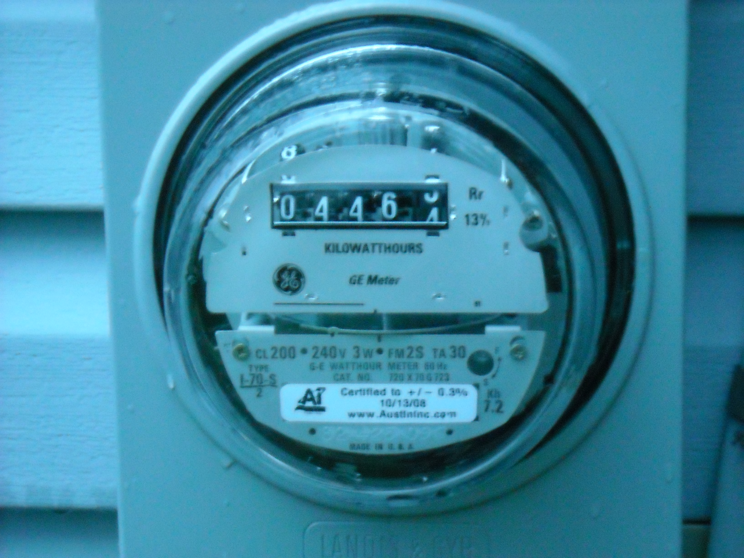
10/27/09
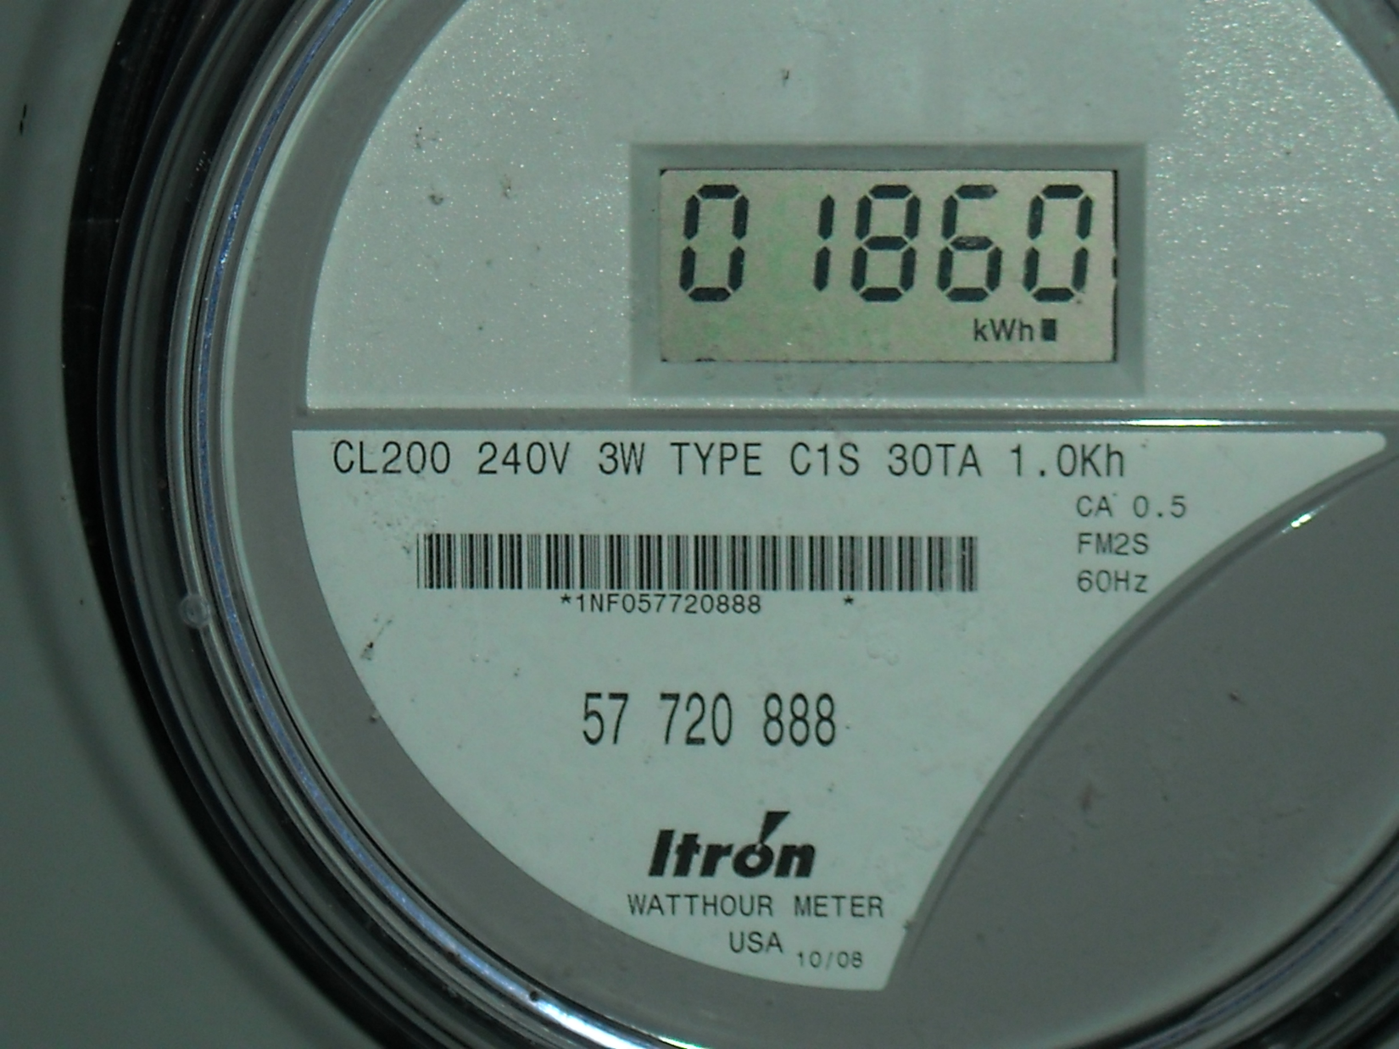
10/27/09

1. I am the duly authorized representative of Alackness.
2. I have personally examined and am familiar with all information
contained in the foregoing responses, including any exhibits and
attachments, and that based upon my inquiry of those persons immediately
responsible for obtaining the information contained in the responses, I
believe that the information is true, accurate and complete.
3. I am aware that there are significant penalties for submitting
false information, including the possibility of fine and imprisonment.
__________________________________ ________________
Signature and Title Date

