Case No.: _10_-_0720_-EL-REN

A. Name of Renewable Generating Facility: Dull Homestead Inc.
The name specified will appear on the facility’s certificate of eligibility issued by the Public Utilities Commission of Ohio.

Facility Location
Street Address: 10404 National Road
City: Brookville State: OH Zip Code: 45309

Facility Latitude and Longitude
Latitude: 39.836 Longitude: -84.3
There are internet mapping tools available to determine your latitude and longitude, if you do not have this information.

If applicable, U.S. Department of Energy, Energy Information Administration Form EIA-860 Plant Name and Plant Code.

EIA-860 Plant Name:

EIA Plant Code:

B. Name of the Facility Owner: Dull Homestead Inc. Ralph Dull
Please note that the facility owner name listed will be the name that appears on the certificate. The address provided in this section is where the certificate will be sent.

If the facility has multiple owners, please provide the following information for each on additional sheets.

Legal Name of Contact Person (First Name, MI, Last Name): Ralph V. Dull
Title: Owner
Organization: Dull Homestead Inc.
Street Address: 10404 National Road
City: Brookville State: OH Zip Code: 45309
Country: Montgomery
Phone: 937-832-6365 Fax: Email Address: christine@dull.com
Web Site Address (if applicable):

C. Name under which Facility Owner will do business in Ohio: Dull Homestead Inc.

Legal Name of Contact Person (First Name, MI, Last Name): Ralph V. Dull
Title: Owner
Organization: Dull Homestead Inc.
Street Address: 10404 National Road
City: Brookville State: OH Zip Code: 45309
Country: Montgomery
Phone: 937-832-6365 Fax: N/A Email Address: christine@dull.com
Web Site Address (if applicable):

D. Name of Generation Facility Operating Company: Dull Homestead Inc.
Legal Name of Contact Person (First Name, MI, Last Name): Ralph V. Dull
Title: Owner
Organization: Dull Homestead Inc.
Street Address: 10404 National Road
City: Brookville State: OH Zip Code: 45309
Country: Montgomery
Phone: 937-832-6365 Fax: Email Address: christine@dull.com
Web Site Address (if applicable):

E. Contact person for regulatory or emergency matters
Legal Name of Contact Person (First Name, MI, Last Name): Ralph V. Dull
Title: Owner
Organization: Dull Homestead Inc.
Street Address: 10404 National Road
City: Brookville State: OH Zip Code: 45309
Country: Montgomery
Phone: 937-832-6365 Fax: Email Address: christine@dull.com
Web Site Address (if applicable):

F. Certification Criteria 1: Deliverability of the Generation into Ohio
Ohio Revised Code (ORC) Sec. 4928.64(B)(3)

The facility must have an interconnection with an electric utility.

Check which of the following applies to your facility’s location:

_X_ The facility is located in Ohio.

__ The facility is located in a state geographically contiguous to Ohio (Indiana, Kentucky, Michigan, Pennsylvania, or West Virginia).

__ The facility is located in the following state:

If the renewable energy resource generation facility is not located in Ohio, Indiana, Kentucky, Michigan, Pennsylvania, or West Virginia, you are required to submit a study by one of the regional transmission organizations (RTO) operating in Ohio, either PJM or Midwest ISO, demonstrating that the power from your facility is physically deliverable into the state of Ohio. The study may be conducted by someone other than the RTO provided that the RTO approves the study. This study must be appended to your application as an exhibit.

G. Certification Criteria 2: Qualified Resource or Technology

You should provide information for only one resource or technology on this application; please check and/or fill out only one of the sections below. If you are applying for more than one resource or technology, you will need to complete a separate application for each resource or technology.

G.1. For the resource or technology you identify in Sections G.4 – G.13 below, please provide a written description of the system.

This solar generating system is a grid-tied 22.5KWatt Solar PV array and supporting equipment including a quantity of 105 Sanyo Model 215 watt panels, 3 combiner boxes, 3 Sunny Boy Model 7000 inverters, AC and DC breakers, utility meter and Sunny Win Box for monitoring. Array is arranged in 3 sections each with 5 columns of 7 panels in one string which are connected in a combiner box and then wired to 1 of 3 Inverters. Inverter outputs go through a breaker and terminated in the building’s 200Amp distribution panel.

G.2. Please include a detailed description of how the output of the facility is going to be measured and verified, including the configuration of the meter(s) and the meter type(s).

Outputs of each of the three 7000 watt Sunnyboy UL 1741/IEEE 1547 inverters are input into 3 AC disconnects (DU222RB 60 A) and then to a utility grade meter which is then connected to the building’s distribution panel. The utility grade meter is UL listed and CEC approved, and displays cumulated KWh energy produced. The utility meter is a Schlumberger with the following specifications: Analog, 240 volt, 2S form, 200 Class, J5S Type, 3 Wire.

In addition to the utility grade meter the package includes a SMA Sunny WebBox which is a useful tool for monitoring the performance of the system and a method for service notifications.
It provides:
- Recording yield
- Remote diagnosis
- Automatic data transfer at chosen intervals
- Data storage and display via Ethernet
- via Sunny Portal provides access from any Web browser

G.3. Please attach digital photographs that depict an accurate characterization of the renewable generating facility. Please indicate the date(s) the photographs were taken. For existing facilities, these photographs must be submitted for your application to be reviewed. For proposed facilities or those under construction, photographs will be required to be filed within 30 days of the on-line date of the facility.

INSERT PHOTOGRAPH(S)

Date photograph taken: March 24th 2010

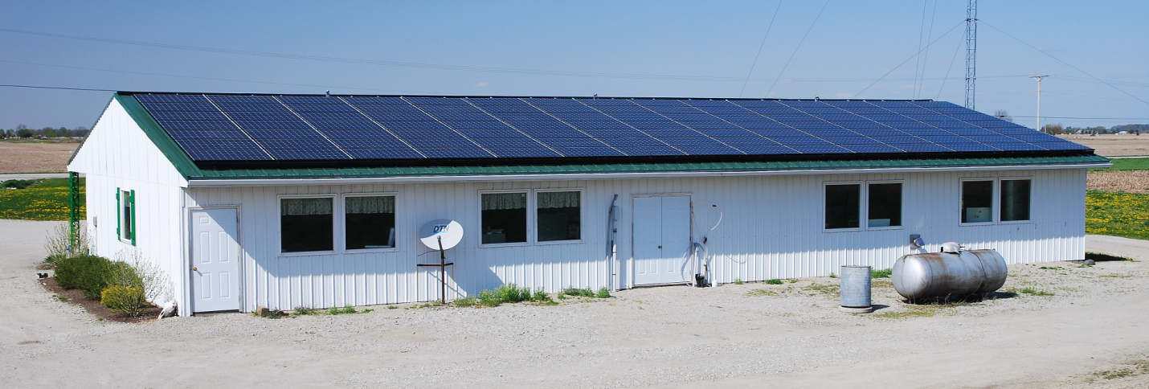

Final day of panel installation - March 4th. 105 panels

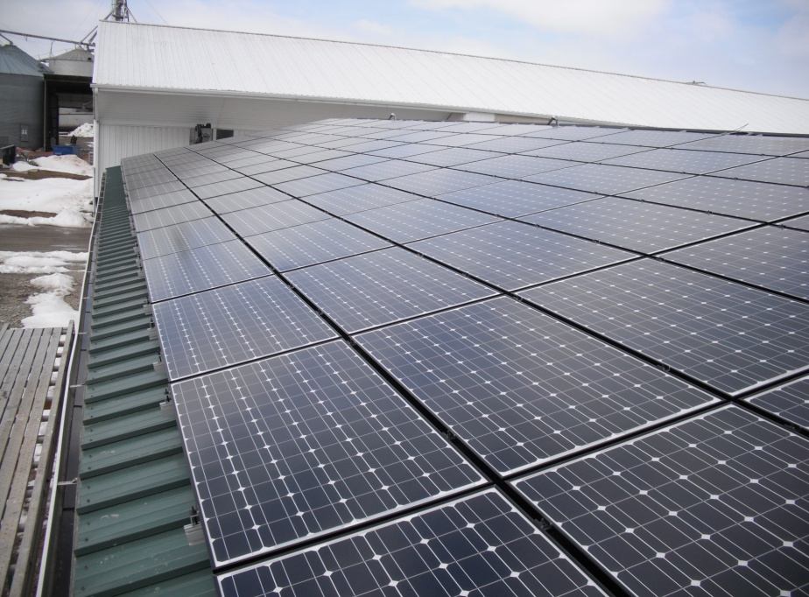

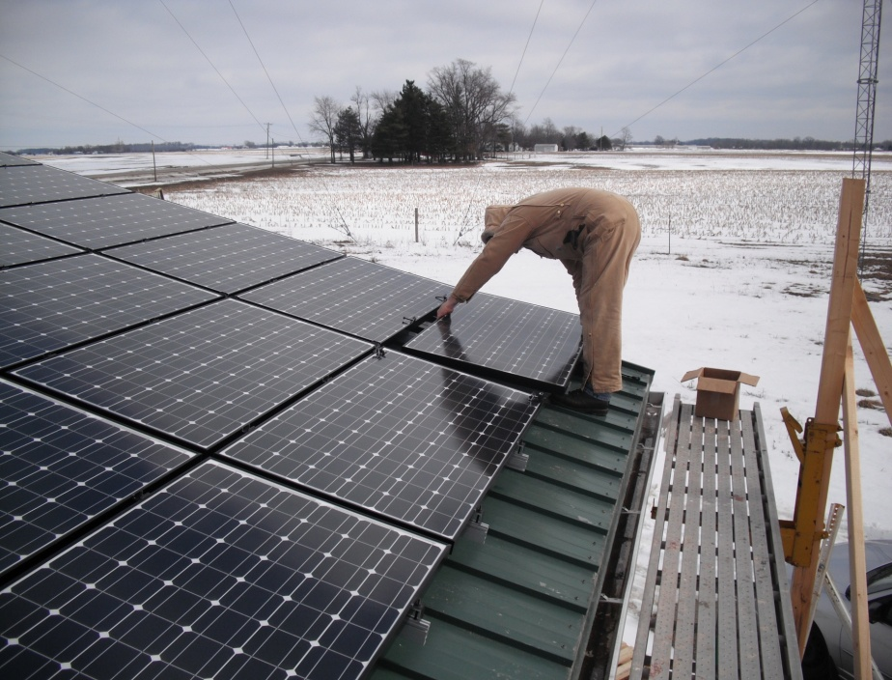

Last Panel to go in.

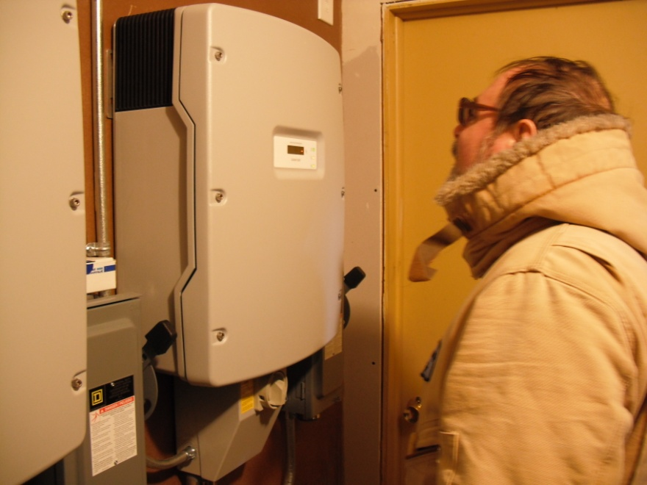
Viewing one of the Sunny Boy Inverters

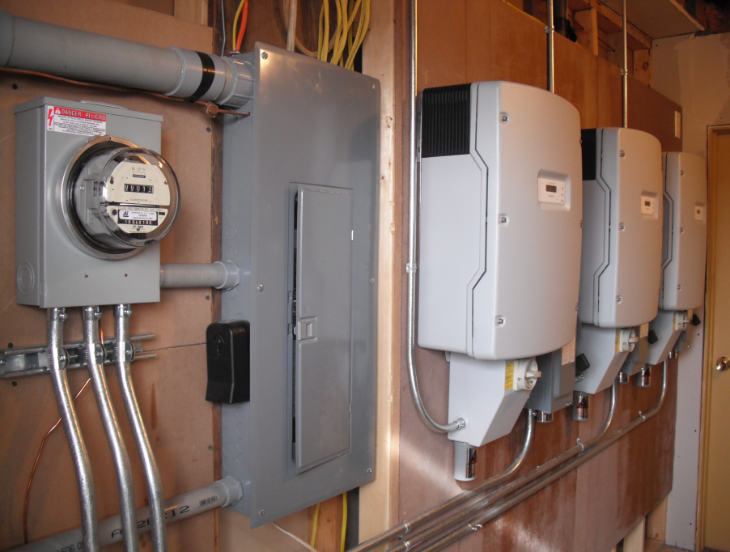
Utility room showing the 3 inverters, main AC panel and the Power Meter for just the solar array. The three inputs are from the 3 inverters.

