Streamlined Filing
This streamlined filing is being made on 15
days' notice in accordance with Section
204(a)(3) of the Communications Act.


November 9, 2007

Transmittal No. 38
Secretary
Federal Communications Commission
Washington, DC 20554

Attention: Competitive Pricing Division, Wireline Competition Bureau

The accompanying tariff material, issued on behalf of the Embarq local operating companies (Embarq LOC) and bearing Tariff F.C.C. No. 1 is sent to you for filing in compliance with the requirements of the Communications Act of 1934, as amended.

These revisions, scheduled to become effective November 24, 2007, consist of tariff pages as indicated on the following check sheets:

Tariff F.C.C. No. Check Sheet No.

1 | 39th Revised Page 1 | Original Page 1.25.1
 | 2nd Revised Page 1.22.1 | 7th Revised Page 1.26
 | Original Page 1.22.2 | Original Page 1.26.1
 | Original Page 1.22.3 | 7th Revised Page 1.27
 | 14th Revised Page 1.23 | 5th Revised Page 1.28
 | Original Page 1.23.1 | 4th Revised Page 1.29
 | 8th Revised Page 1.24 | 5th Revised Page 1.30
 | 8th Revised Page 1.25 | 3rd Revised Page 1.33

This filing is being made on 15 days' notice under the Federal Communications Commission's streamlined filing procedures, and establishes regulations, rates and charges for the provision of interstate switched dedicated, special access and ordering option, additional labor and miscellaneous services in the Lima, Ohio metropolitan statistical area (MSA) where Embarq LOC has been granted Phase II pricing flexibility in accordance with subpart H of the Commission's Part 69 rules.

Transmittal No. 38
Page 2
November 9, 2007

In accordance with the requirements of Section 61.21(a)(3) of the Commission’s Rules, the FCC Registration Number (FRN) for Embarq is 0014-7911-64. Embarq LOC is filing this transmittal on behalf of issuing carriers with the following FRNs:

0004-1465-85 | 0002-6434-35 | 0001-5666-94
0004-1404-22 | 0002-3372-44 | 0002-9388-43
0001-8252-98 | 0002-3916-39 | 0001-7701-22
0002-9015-51 | 0005-0517-68 | 0004-1839-19
0005-0517-43 | 0001-6851-48 | 0001-7770-36
0002-5952-47 | 0002-3825-70
0002-3420-38 | 0001-9523-40

Description and Justification and a Tariff Review Plan detailing the impact of the removal of these services from the traffic sensitive, trunking and special access price cap baskets is provided as a part of this filing in compliance with the Commission's pricing flexibility requirements.

Payment in the amount of $775.00 has been electronically transmitted to the Mellon Bank in Pittsburgh, Pennsylvania, in accordance with the fee program procedures. The Form 159 is being transmitted electronically via ETFS as a proprietary document.

All correspondence and inquiries in connection with this filing should be addressed to me at 5454 West 110th Street, Mailstop KSOPKJ0502-508, Overland Park, Kansas 66211, (913) 345-7572.

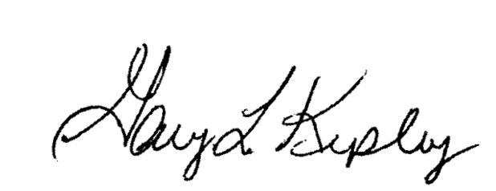

Gary L. Kepley
Director – Regulatory Systems
Embarq Corporation

Attachments
Transmittal Letter
Revised Tariff Pages
Description and Justification
Tariff Review Plan

In the Matter of Petition of the Embarq Local Operating Companies for Phase I and Phase II Pricing Flexibility for Special Access and Dedicated Transport Services in the Lima, Ohio and Mansfield, Ohio Metropolitan Statistical Areas and Phase I and Phase II Pricing Flexibility for Channel Termination Services in the Lima, Ohio Metropolitan Statistical Area, WCB/Pricing File No. 07-13, Order, (DA-07-3840), released September 5, 2007.

