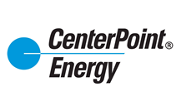
CenterPoint Energy Ohio
211 NW Riverside Drive
Evansville, IN 47708

J. Waylon Ramming
Sr. Analyst, Regulatory and Rates
waylon.ramming@centerpointenergy.com
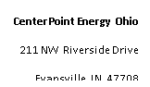

_____________________________________________________________________________________________

July 28, 2021

Ms. Tanowa Troupe
Secretary – Docketing Division
Public Utilities Commission of Ohio
180 East Broad Street
Columbus Ohio 43215

RE: PUCO Case No. 21-320-GA-UEX and 89-8005-GA-TRF

Dear Ms. Troupe:

Pursuant to the Application filed by Vectren Energy Delivery of Ohio, Inc. d/b/a CenterPoint Ohio (“CEOH”) and the Finding and Order dated July 28, 2021 in Case No. 21-320-GA-UEX, CEOH hereby submits P.U.C.O. No. 4, Sheet No. 39, Second Revised Page 1 of 1, which replaces P.U.C.O. No. 4, Sheet No. 39, First Revised Page 1 of 1.

Thank you for your attention to this matter.

Respectfully submitted,

/s/ J. Waylon Ramming

J Waylon Ramming
Sr. Analyst, Regulatory and Rates

Enclosure

