The Public Utilities Commission of Ohio
TELECOMMUNICATIONS APPLICATION FORM for ROUTINE PROCEEDINGS
(Effective: 01/18/2008)

In the Matter of the Application of Telephone Service
Company to Add a TRS Charge to its Tariff
)
)
)
)
TRF Docket No. 90-5039 TP-TRF
Case No. 09 - 179 -TP - ZTA
NOTE: Unless you have reserved a Case # or are filing a Contract, leave the “Case No” fields BLANK.

Name of Registrant(s) Telephone Service Company
DBA(s) of Registrant(s)
Address of Registrant(s) 2 Willipie Street, Wapakoneta, Ohio 45895
Company Web Address www.telserco.com
Regulatory Contact Person(s) Kimberly C. Klingler | Phone 419-739-2296 | Fax 419-738-2299
Regulatory Contact Person’s Email Address kimk@telserco.com
Contact Person for Annual Report Lonnie D. Pedersen |  | Phone 419-739-2227
Address (if different from above)
Consumer Contact Information Kimberly C. Klingler |  | Phone 419-739-2296
Address (if different from above)
Motion for protective order included with filing? Yes No
Motion for waiver(s) filed affecting this case? Yes No [Note: Waivers may toll any automatic timeframe.]

Section I – Pursuant to Chapter 4901:11-6 OAC – Part I – Please indicate the Carrier Type and the reason for submitting this form by checking the boxes below. CMRS providers: Please see the bottom of Section II.
NOTES: (1) For requirements for various applications, see the identified section of Ohio Administrative Code Section 4901 and/or the supplemental application form noted.
Carrier Type Other (explain below) | ILEC | CLEC | CTS | AOS/IOS
Tier 1 Regulatory Treatment
Change Rates within approved Range | TRF 1-6-04(B)  (0 day Notice) | TRF 1-6-04(B)  (0 day Notice)
New Service, expanded local calling area, correction of textual error | ZTA 1-6-04(B)  (0 day Notice) | ZTA 1-6-04(B)  (0 day Notice)
Change Terms and Conditions, Introduce non-recurring service charges | ATA 1-6-04(B)  (Auto 30 days) | ATA 1-6-04(B)  (Auto 30 days)
Introduce or Increase Late Payment or Returned Check Charge | ATA 1-6-04(B)  (Auto 30 days) | ATA 1-6-04(B)  (Auto 30 days)
Business Contract | CTR 1-6-17  (0 day Notice) | CTR 1-6-17  (0 day Notice)
Withdrawal | ATW 1-6-12(A)  (Non-Auto) | ATW 1-6-12(A)  (Auto 30 days)
Raise the Ceiling of a Rate | Not Applicable | SLF 1-6-04(B)  (Auto 30 days)
Tier 2 Regulatory Treatment
Residential - Introduce non-recurring service charges | TRF 1-6-05(E)  (0 day Notice) | TRF 1-6-05(E)  (0 day Notice)
Residential - Introduce New Tariffed Tier 2 Service(s) | TRF 1-6-05(C)  (0 day Notice) | TRF 1-6-05(C)  (0 day Notice) | TRF 1-6-05(C)  (0 day Notice)
Residential - Change Rates, Terms and Conditions, Promotions, or Withdrawal | TRF 1-6-05(E)  (0 day Notice) | TRF 1-6-05(E)  (0 day Notice) | TRF 1-6-05(E)  (0 day Notice)
Residential - Tier 2 Service Contracts | CTR 1-6-17  (0 day Notice) | CTR 1-6-17  (0 day Notice) | CTR 1-6-17  (0 day Notice)
Commercial (Business) Contracts | Not Filed | Not Filed | Not Filed
Business Services (see “Other” below) | Detariffed | Detariffed | Detariffed
Residential & Business Toll Services (see “Other” below) | Detariffed | Detariffed | Detariffed
(2) Information regarding the number of copies required by the Commission may be obtained from the Commission’s web site at www.puco.ohio.gov under the docketing information system section, by calling the docketing division at 614-466-4095, or by visiting the docketing division at the offices of the Commission.
Section I – Part II – Certificate Status and Procedural
Certificate Status | ILEC | CLEC | CTS | AOS/IOS
Certification (See Supplemental ACE form) |  | ACE 1-6-10  (Auto 30 days) | ACE 1-6-10  (Auto 30 days) | ACE 1-6-10  (Auto 30 days)
Add Exchanges to Certificate | ATA 1-6-09(C)  (Auto 30 days) | AAC 1-6-10(F)  (0 day Notice) | CLECs must attach a current CLEC  Exchange Listing Form
Abandon all Services - With Customers | ABN 1-6-11(A)  (Non-Auto) | ABN 1-6-11(A)  (Auto 90 day) | ABN 1-6-11(B)  (Auto 14 day) | ABN 1-6-11(B)  (Auto 14 day)
Abandon all Services - Without Customers |  | ABN 1-6-11(A)  (Auto 30 days) | ABN 1-6-11(B)  (Auto 14 day) | ABN 1-6-11(B)  (Auto 14 day)
Change of Official Name (See below) | ACN 1-6-14(B)  (Auto 30 days) | ACN 1-6-14(B)  (Auto 30 days) | CIO 1-6-14(A)  (0 day Notice) | CIO 1-6-14(A)  (0 day Notice)
Change in Ownership (See below) | ACO 1-6-14(B)  (Auto 30 days) | ACO 1-6-14(B)  (Auto 30 days) | CIO 1-6-14(A)  (0 day Notice) | CIO 1-6-14(A)  (0 day Notice) (
Merger (See below) | AMT 1-6-14(B)  (Auto 30 days) | AMT 1-6-14(B)  (Auto 30 days) | CIO 1-6-14(A)  (0 day Notice) | CIO 1-6-14(A)  (0 day Notice)
Transfer a Certificate (See below) | ATC 1-6-14(B)  (Auto 30 days) | ATC 1-6-14(B)  (Auto 30 days) | CIO 1-6-14(A)  (0 day Notice) | CIO 1-6-14(A)  (0 day Notice)
Transaction for transfer or lease of property, plant or business (See below) | ATR 1-6-14(B)  (Auto 30 days) | ATR 1-6-14(B)  (Auto 30 days) | CIO 1-6-14(A)  (0 day Notice) | CIO 1-6-14(A)  (0 day Notice)
Procedural
Designation of Process Agent(s) | TRF  (0 day Notice) | TRF  (0 day Notice) | TRF  (0 day Notice) | TRF  (0 day Notice)
Section II – Carrier to Carrier (Pursuant to 4901:1-7), CMRS and Other
Carrier to Carrier | ILEC | CLEC
Interconnection agreement, or amendment to an approved agreement | NAG 1-7-07  (Auto 90 day) | NAG 1-7-07  (Auto 90 day)
Request for Arbitration | ARB 1-7-09  (Non-Auto) | ARB 1-7-09  (Non-Auto)
Introduce or change c-t-c service tariffs, | ATA 1-7-14  (Auto 30 day) | ATA 1-7-14  (Auto 30 day)
Introduce or change access service pursuant to 07-464-TP-COI | ATA  (Auto 30 day)
Request rural carrier exemption, rural carrier supension or modifiction | UNC 1-7-04 or  (Non-Auto) 1-7-05 | UNC 1-7-04 or (Non-Auto) 1-7-05
Pole attachment changes in terms and conditions and price changes. | UNC 1-7-23(B)  (Non-Auto) | UNC 1-7-05  (Non-Auto)
CMRS Providers See 4901:1-6-15 | RCC  [Registration & Change in Operations]  (0 day) |  | NAG  [Interconnection Agreement or Amendment] (Auto 90 days)
Other* (explain)
*NOTE: During the interim period between the effective date of the rules and an Applicant’s Detariffing Filing, changes to existing business Tier 2 and all toll services, including the addition of new business Tier 2 and all new toll services, will be processed as 0-day TRF filings, and briefly described in the “Other” section above.
All Section I and II applications that result in a change to one or more tariff pages require, at a minimum, the following exhibits. Other exhibits may be required under the applicable rule(s). ACN, ACO, AMT, ATC, ATR and CIO applications see the 4901:1-6-14 Filing Requirements on the Commission's Web Page for a complete list of exhibits.
Exhibit | Description:
A | The tariff pages subject to the proposed change(s) as they exist before the change(s)
B | The Tariff pages subject to the proposed change(s), reflecting the change, with the change(s) marked in the right margin.
C | A short description of the nature of the change(s), the intent of the change(s), and the customers affected.
D | A copy of the notice provided to customers, along with an affidavit that the notice was provided according to the applicable rule(s).
Section III. – Attestation
Registrant hereby attests to its compliance with pertinent entries and orders issued by the Commission.

AFFIDAVIT
Compliance with Commission Rules and Service Standards

I am an attorney of the applicant corporation, Telephone Service Company  (Name) |  |  | , and am authorized to make this statement on its behalf.
I attest that these tariffs comply with all applicable rules, including the Minimum Telephone Service Standards (MTSS) Pursuant to Chapter 4901:1-5 OAC for the state of Ohio. I understand that tariff notification filings do not imply Commission approval and that the Commission’s rules, including the Minimum Telephone Service Standards, as modified and clarified from time to time, supersede any contradictory provisions in our tariff. We will fully comply with the rules of the state of Ohio and understand that noncompliance can result in various penalties, including the suspension of our certificate to operate within the state of Ohio.

I declare under penalty of perjury that the foregoing is true and correct.

Executed on (Date) March 6, 2009 | at (Location) Columbus, Ohio
 |  | *(Signature and Title) /s/ Carolyn S. Flahive |  |  | (Date) 3/06/09
- This affidavit is required for every tariff-affecting filing. It may be signed by counsel or an officer of the applicant, or an authorized agent of the applicant.

VERIFICATION

I, Carolyn S. Flahive
verify that I have utilized the Telecommunications Application Form for Routine Proceedings provided by the Commission and that all of the information submitted here, and all additional information submitted in connection with this case, is true and correct to the best of my knowledge.

*(Signature and Title) /s/ Carolyn S. Flahive |  |  |  | (Date) 3/06/09
*Verification is required for every filing. It may be signed by counsel or an officer of the applicant, or an authorized agent of the applicant.
Send your completed Application Form, including all required attachments as well as the required number of copies, to:

Public Utilities Commission of Ohio
Attention: Docketing Division
180 East Broad Street, Columbus, OH 43215-3793

Or
Make such filing electronically as directed in Case No 06-900-AU-WVR

EXHIBIT A

(SUPERSEDING TARIFF SHEETS)

ALPHABETICAL INDEX TO TOPICS

 | Classification* | Section | Sheet No.
811 Service for “One Call” Notification Systems |  | 8 | 65
Advanced Calling Services (ACS) |  | 4 | 37
Application of Tariff |  | 1 | 5
Construction Charges |  | 2 | 20
Custom Calling Services | Multiple Tiers | 4 | 34
Directory Assistance Service |  | 2 | 17
Directory and Listing Services | Multiple Tiers | 2 | 23
Establishment and Furnishing of Service |  | 1 | 9
Exchange Rates & Maps | Multiple Tiers | 5 | 50
Expanded Service Area & Maps |  | 7 | 61
IntraLATA Presubscription |  | 6 | 58
Lifeline Assistance |  | 3 | 28
Link Up |  | 3 | 26
Mileage Charges | Tier 1 Core | 2 | 20
Obligation and Liability of Telephone Company |  | 1 | 5
Optional Bundled Packages |  | 5 | 54
Service Connection Assistance |  | 3 | 24
Service Connection Charges | Multiple Tiers | 5 | 55
Special Assemblages |  | 2 | 23
Touch Tone Service |  | 2 | 23
Use of Service and Facilities |  | 1 | 7
Vacation Rates |  | 2 | 17

MISCELLANEOUS SERVICES AND EQUIPMENT

V. SPECIAL ASSEMBLAGES

Where the telephone company, at the request of the subscriber, furnishes special assemblages or special services which are not provided for or established under this tariff, a charge thereof, in addition to the published rates, will be made in each case. Special assemblages will be made at the discretion of the telephone company.

VI. DIRECTORY AND LISTING SERVICES

The following services are available to subscribers at the monthly rates below:
Rate Max

(a) Extra Name Service, Residence $ 1.75/month

(b) Unlisted/Non-Published Number, each *Tier 1 Non-Core $ 2.00/month $4.00
(c) Enterprise Listing, each $ 5.00/month
(d) Foreign Listing, Residence $ 1.75/month

VII. TOUCH TONE SERVICE

Touch tone service is included in the access line rate.¹

Note: *Rates for Tier 1 Core services are capped at current rates. Rates for Tier 1 Non-Core services are capped at current rates until August 1, 2008. After August 1, 2008, Tier 1 Non-Core rates can be increased to a maximum cap of double the initial rate, other than the second local exchange access line and call waiting, which are limited to a ten percent increase per year until they cap at double the initial rate. This pricing flexibility is in accordance with O.A.C. 4901:1-4 and Alt Reg Case No. 06-794-TP-ALT, effective August 1, 2006.

EXHIBIT B

(PROPOSED TARIFF SHEETS)

ALPHABETICAL INDEX TO TOPICS

 | Classification* | Section | Sheet No.
811 Service for “One Call” Notification Systems |  | 8 | 65
Advanced Calling Services (ACS) |  | 4 | 37
Application of Tariff |  | 1 | 5
Construction Charges |  | 2 | 20
Custom Calling Services | Multiple Tiers | 4 | 34
Directory Assistance Service |  | 2 | 17
Directory and Listing Services | Multiple Tiers | 2 | 23
Establishment and Furnishing of Service |  | 1 | 9
Exchange Rates & Maps | Multiple Tiers | 5 | 50
Expanded Service Area & Maps |  | 7 | 61
IntraLATA Presubscription |  | 6 | 58
Lifeline Assistance |  | 3 | 28
Link Up |  | 3 | 26
Mileage Charges | Tier 1 Core | 2 | 20
Obligation and Liability of Telephone Company |  | 1 | 5
Optional Bundled Packages |  | 5 | 54
Service Connection Assistance |  | 3 | 24
Service Connection Charges | Multiple Tiers | 5 | 55
Special Assemblages |  | 2 | 23
TRS Assessment |  | 2 | 23 | (N)
Touch Tone Service |  | 2 | 23
Use of Service and Facilities |  | 1 | 7
Vacation Rates |  | 2 | 17

MISCELLANEOUS SERVICES AND EQUIPMENT

V. SPECIAL ASSEMBLAGES

Where the telephone company, at the request of the subscriber, furnishes special assemblages or special services which are not provided for or established under this tariff, a charge thereof, in addition to the published rates, will be made in each case. Special assemblages will be made at the discretion of the telephone company.

VI. DIRECTORY AND LISTING SERVICES

The following services are available to subscribers at the monthly rates below:
Rate Max

(a) Extra Name Service, Residence $ 1.75/month

(b) Unlisted/Non-Published Number, each *Tier 1 Non-Core $ 2.00/month $4.00
(c) Enterprise Listing, each $ 5.00/month
(d) Foreign Listing, Residence $ 1.75/month

VII. TOUCH TONE SERVICE

Touch tone service is included in the access line rate.¹
(N)

VIII. TELECOMMUNICATIONS RELAY SERVICES (TRS) CHARGE

Customers may be assessed an annual charge per line to fund the Telecommunications Relay Services for the State of Ohio in accordance with section 4905.84 of the Revised Code. This charge shall in no event exceed the per end user line (or equivalent) assessment of the Public Utilities Commission of Ohio levied upon the Company.

Note: *Rates for Tier 1 Core services are capped at current rates. Rates for Tier 1 Non-Core services are capped at current rates until August 1, 2008. After August 1, 2008, Tier 1 Non-Core rates can be increased to a maximum cap of double the initial rate, other than the second local exchange access line and call waiting, which are limited to a ten percent increase per year until they cap at double the initial rate. This pricing flexibility is in accordance with O.A.C. 4901:1-4 and Alt Reg Case No. 06-794-TP-ALT, effective August 1, 2006.

EXHIBIT C

The Applicant, Telephone Service Company, hereby adds a TRS surcharge to its tariff pursuant to Ohio Adm. Code 4901:1-6-24(G). This surcharge will be billed annually in the month of May. The Applicant will provide customers with notice of this new charge via a bill message on their April bills.
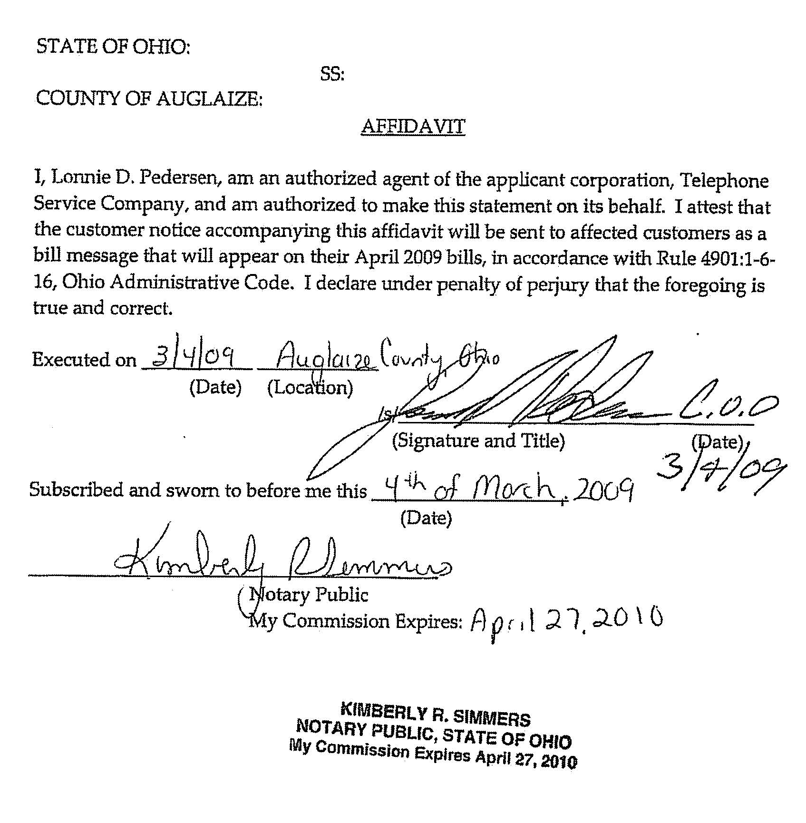
TELEPHONE SERVICE COMPANY

TRS Assessment Customer Notice
April 2009 Bill Message

Your May 2009 bill will include a $.16 surcharge that will help fund Telecommunications Relay Services (TRS) for the State of Ohio. TRS is a service that provides telecommunications assistance to customers with special needs. If you have any questions, please contact us in Wapakoneta at 419-739-2200 or in St. Marys at 419-300-2300.

