
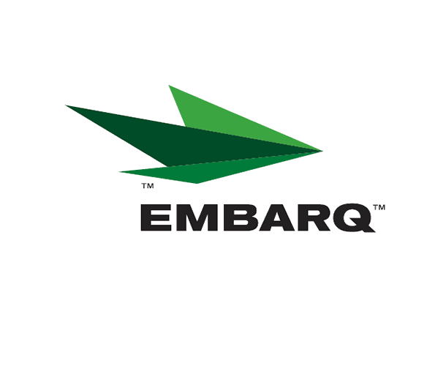

Embarq Corporation
Mailstop: KSOPKJ0502-5022
5454 West 110th Street
Overland Park, KS 66211
Glenda.Munson@EMBARQ.com
Glenda L. Munson
TARIFF ANALYST I
Voice: (913) 315-9346
Fax: (913) 315-0763

VIA E-FILE

April 2, 2008

Ms. Renee' Jenkins, Director of Administration
Public Utilities Commission of Ohio
180 East Broad Street, 13th Floor
Columbus, OH 43215-0573

Re: United Telephone Company of Ohio d/b/a Embarq
Case No. 08-385-TP-ATA

Dear Ms. Jenkins:

Enclosed is the PDF file for the de-tariff filing that Commission staff requested. This PDF file contains the entire filing. The data files are no longer available.

If you have any questions regarding this filing, please call Gary Baki at 614-220-8629.

Sincerely,

/s/ Glenda L. Munson

Enclosures

cc: Gary Baki
OH 08-05

