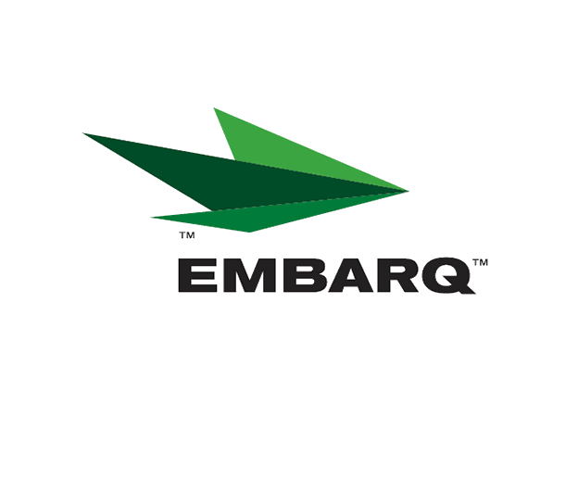



Embarq Corporation
Mailstop: KSOPKJ0502-5022
5454 West 110th Street
Overland Park, KS 66211
Glenda.Munson@EMBARQ.com

Via E-File

March 3, 2008

Ms. Renee' Jenkins, Director of Administration
Public Utilities Commission of Ohio
180 East Broad Street, 13th Floor
Columbus, OH 43215-0573

RE: Embarq Communications, Inc.
Case Nos. 90-6335-CT-TRF

Dear Ms. Jenkins:

Enclosed for filing are the original revisions to Embarq Communications, Inc. Interexchange Telecommunications Services Tariff. This filing should be processed as a zero day filing to become effective March 3, 2008.

The following revisions are enclosed:

Section 106 |  | 3rd Revised Page 14
Glenda L. Munson
TARIFF ANALYST I
Voice: (913) 345-7550
Fax: (913) 345-6756


This filing proposes to reduce the monthly recurring charge for the obsolete (grandfathered) Small Business Unlimited Solutions service.

If you have any questions regarding this filing, please call Gary Baki at 614-220-8629.

Sincerely,

/s/ Glenda L. Munson

Glenda L. Munson

Enclosure
cc: Gary Baki
OH 08-08
Glenda L. Munson
TARIFF ANALYST I
Voice: (913) 315-9346
Fax: (913) 315-0763

