Memorandum

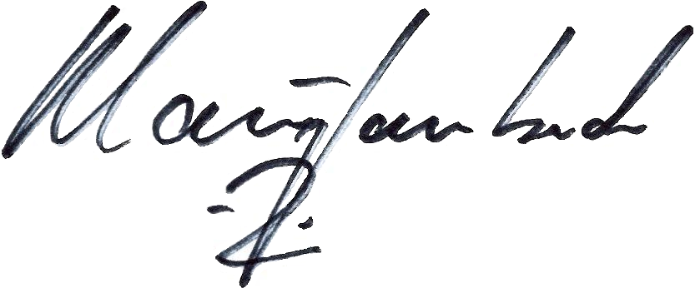
To: Greg Price, Attorney Examiner
Legal Department
From: Klaus Lambeck, Chief
Facilities, Siting & Environmental Analysis Division
Department of Energy and Environment
Date: July 7, 2009
Re: Motion for Waivers, Case No. 09-0479-EL-BGN

On June 5, 2009, Hardin Wind Energy LLC (Applicant) filed a motion for waivers of the following Board rules and statutes: O.R.C. 4906.06(A)(6), filing of the application at least one year prior to commencement of construction; O.A.C. 4906-17-04(A), providing all of the required information in relation to the site selection study; and O.A.C. 4906-17-05(D)(2), filing the PJM system impact study with the application.

Staff does not object to any of these waiver requests, but reserves the right to require information from the Applicant in areas covered by the waiver requests if Staff determines it to be necessary during the course of the investigation. Regarding the filing of the PJM system impact study, Staff will not be able to complete its investigation of the project and make a recommendation to the Board until the required PJM studies are received.

In response to the Applicant’s uncertainty regarding rule 4906-17-04(A)(1)(c), Staff would like to clarify that this rule does not refer to a list of specific quantitative factors, it simply refers to any quantitative factors that the Applicant might have defined and applied in their site selection study.

