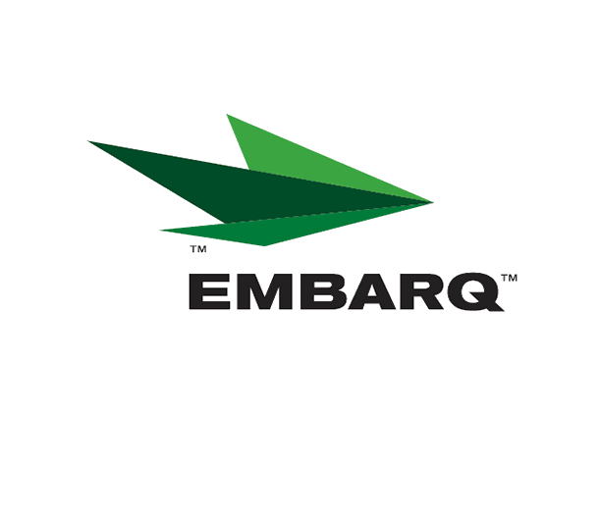


Embarq Corporation
Mailstop: KSOPKJ0502-5022
5454 West 110th Street
Overland Park, KS 66211
Glenda.Munson@EMBARQ.com

Via E-FILE

February 1, 2008

Ms. Renee’ Jenkins, Director of Administration
Public Utilities Commission of Ohio
180 East Broad Street, 13th Floor
Columbus, OH 43215-0573

Re: United Telephone Company of Ohio d/b/a Embarq
Case No. 90-5041-TP-TRF

Dear Ms. Jenkins:

Enclosed for filing is a correction to Section 39, Sheet 16 of the United Telephone Company of Ohio d/b/a Embarq P.U.C.O. No. 5 General Exchange Tariff. This corrects the revision level of Sheet 16 from First Revised to Second Revised.

If you have any questions regarding this filing, please call Gary Baki at 614-220-8629.

Sincerely,

/s/ Glenda L. Munson

Glenda L. Munson

Enclosures
cc: Gary Baki

OH 08-02 Correction Letter
Glenda L. Munson
TARIFF ANALYST I
Voice: (913) 315-9346
Fax: (913) 315-0763

