Case No.: _10_-_1118-EL-REN

A. Name of Renewable Generating Facility: William Reeves
The name specified will appear on the facility’s certificate of eligibility issued by the Public Utilities Commission of Ohio.

Facility Location
Street Address: 5491 Tippecanoe Rd.
City: Canfield State: OH Zip Code: 44406

Facility Latitude and Longitude
Latitude: 41.038751 Longitude: -80.709627
There are internet mapping tools available to determine the latitude and longitude, if you do not have this information.

For facilities that have a total nameplate capacity of 1 MW or greater provide the U.S. Department of Energy, Energy Information Administration Form EIA-860 Plant Name and Plant Code.

EIA-860 Plant Name:

EIA Plant Code:

B. Legal Name of the Facility Owner: William Reeves
Please note that the facility owner name listed will be the name that appears on the certificate. The address provided in this section is where the certificate will be sent.

If the facility has multiple owners, please provide the following information for each on additional sheets.

Legal Name of Facility Owner Representative (First Name, MI, Last Name): William Reeves
Title:
Organization:
Street Address: 5491 Tippecanoe Rd.
City: Canfield State: OH Zip Code: 44406
Country: United States
Phone: 330-726-0663 Fax: Email Address: j_net_44406@yahoo.com
Web Site Address (if applicable):

C. List the name, address, telephone number and web site address under which the Applicant will do business in Ohio.
Legal Name of Facility Owner Representative (First Name, MI, Last Name): William Reeves
Title:
Organization:
Street Address: 5491 Tippecanoe Rd.
City: Canfield State: OH Zip Code: 44406
Phone: 330-726-0663 Fax: Email Address: j_net_44406@yahoo.com
Web Site Address (if applicable):

D. Name of Generation Facility Operating Company: William Reeves
Legal Name of Contact Person (First Name, MI, Last Name): William Reeves
Title:
Organization:
Street Address: 5491 Tippecanoe Rd.
City: Canfield State: OH Zip Code: 44406
Phone: 330-726-0663 Fax: Email Address: j_net_44406@yahoo.com
Web Site Address (if applicable):

E. Contact person for regulatory or emergency matters
Legal Name of Contact Person (First Name, MI, Last Name): William Reeves
Title:
Organization:
Street Address: 5491 Tippecanoe Rd.
City: Canfield State: OH Zip Code: 44406
Phone: 330-726-0663 Fax: Email Address: j_net_44406@yahoo.com
Web Site Address (if applicable):

F. Certification Criteria 1: Deliverability of the Generation into Ohio
Ohio Revised Code (ORC) Sec. 4928.64(B)(3)

The facility must have an interconnection with an electric utility.

Check which of the following applies to the facility’s location:

_X_ The facility is located in Ohio.

__ The facility is located in a state geographically contiguous to Ohio (Indiana, Kentucky, Michigan, Pennsylvania, or West Virginia).

__ The facility is located in the following state:

If the renewable energy resource generation facility is not located in Ohio, Indiana, Kentucky, Michigan, Pennsylvania, or West Virginia, you are required to submit a study by one of the regional transmission organizations (RTO) operating in Ohio, either PJM or Midwest ISO, demonstrating that the power from the facility is physically deliverable into the state of Ohio. The study may be conducted by someone other than the RTO provided that the RTO approves the study. This study must be appended to the application as an exhibit.

G. Certification Criteria 2: Qualified Resource or Technology

You should provide information for only one generation facility in this application; please check and/or fill out only one of the sections below. If you are applying for more than one facility, you will need to complete a separate application for each facility.

G.1. For the resource or technology you identify in Sections G.4 – G.13 below, please provide a written description of the system.

The system is a 6kW PV solar array. It is ground mounted and connected to the grid through a net metering agreement. 32 Evergreen panels, 2 – 3000 Watt Sunny Boy inverters.

G.2. Please include a detailed description of how the output of the facility is going to be measured and verified, including the configuration of the meter(s) and the meter type(s).

The generation facility will be connected to the grid using a net metering agreement. 2 – Sunny Boy inverters, model #SB 3000US, will connect to the Siemens utility grade meter – measured through GATS tracking.

G.3. Please attach digital photographs that depict an accurate characterization of the renewable generating facility. Please indicate the date(s) the photographs were taken.

Date photograph taken: 7/23/2010
INSERT PHOTOGRAPH(S)
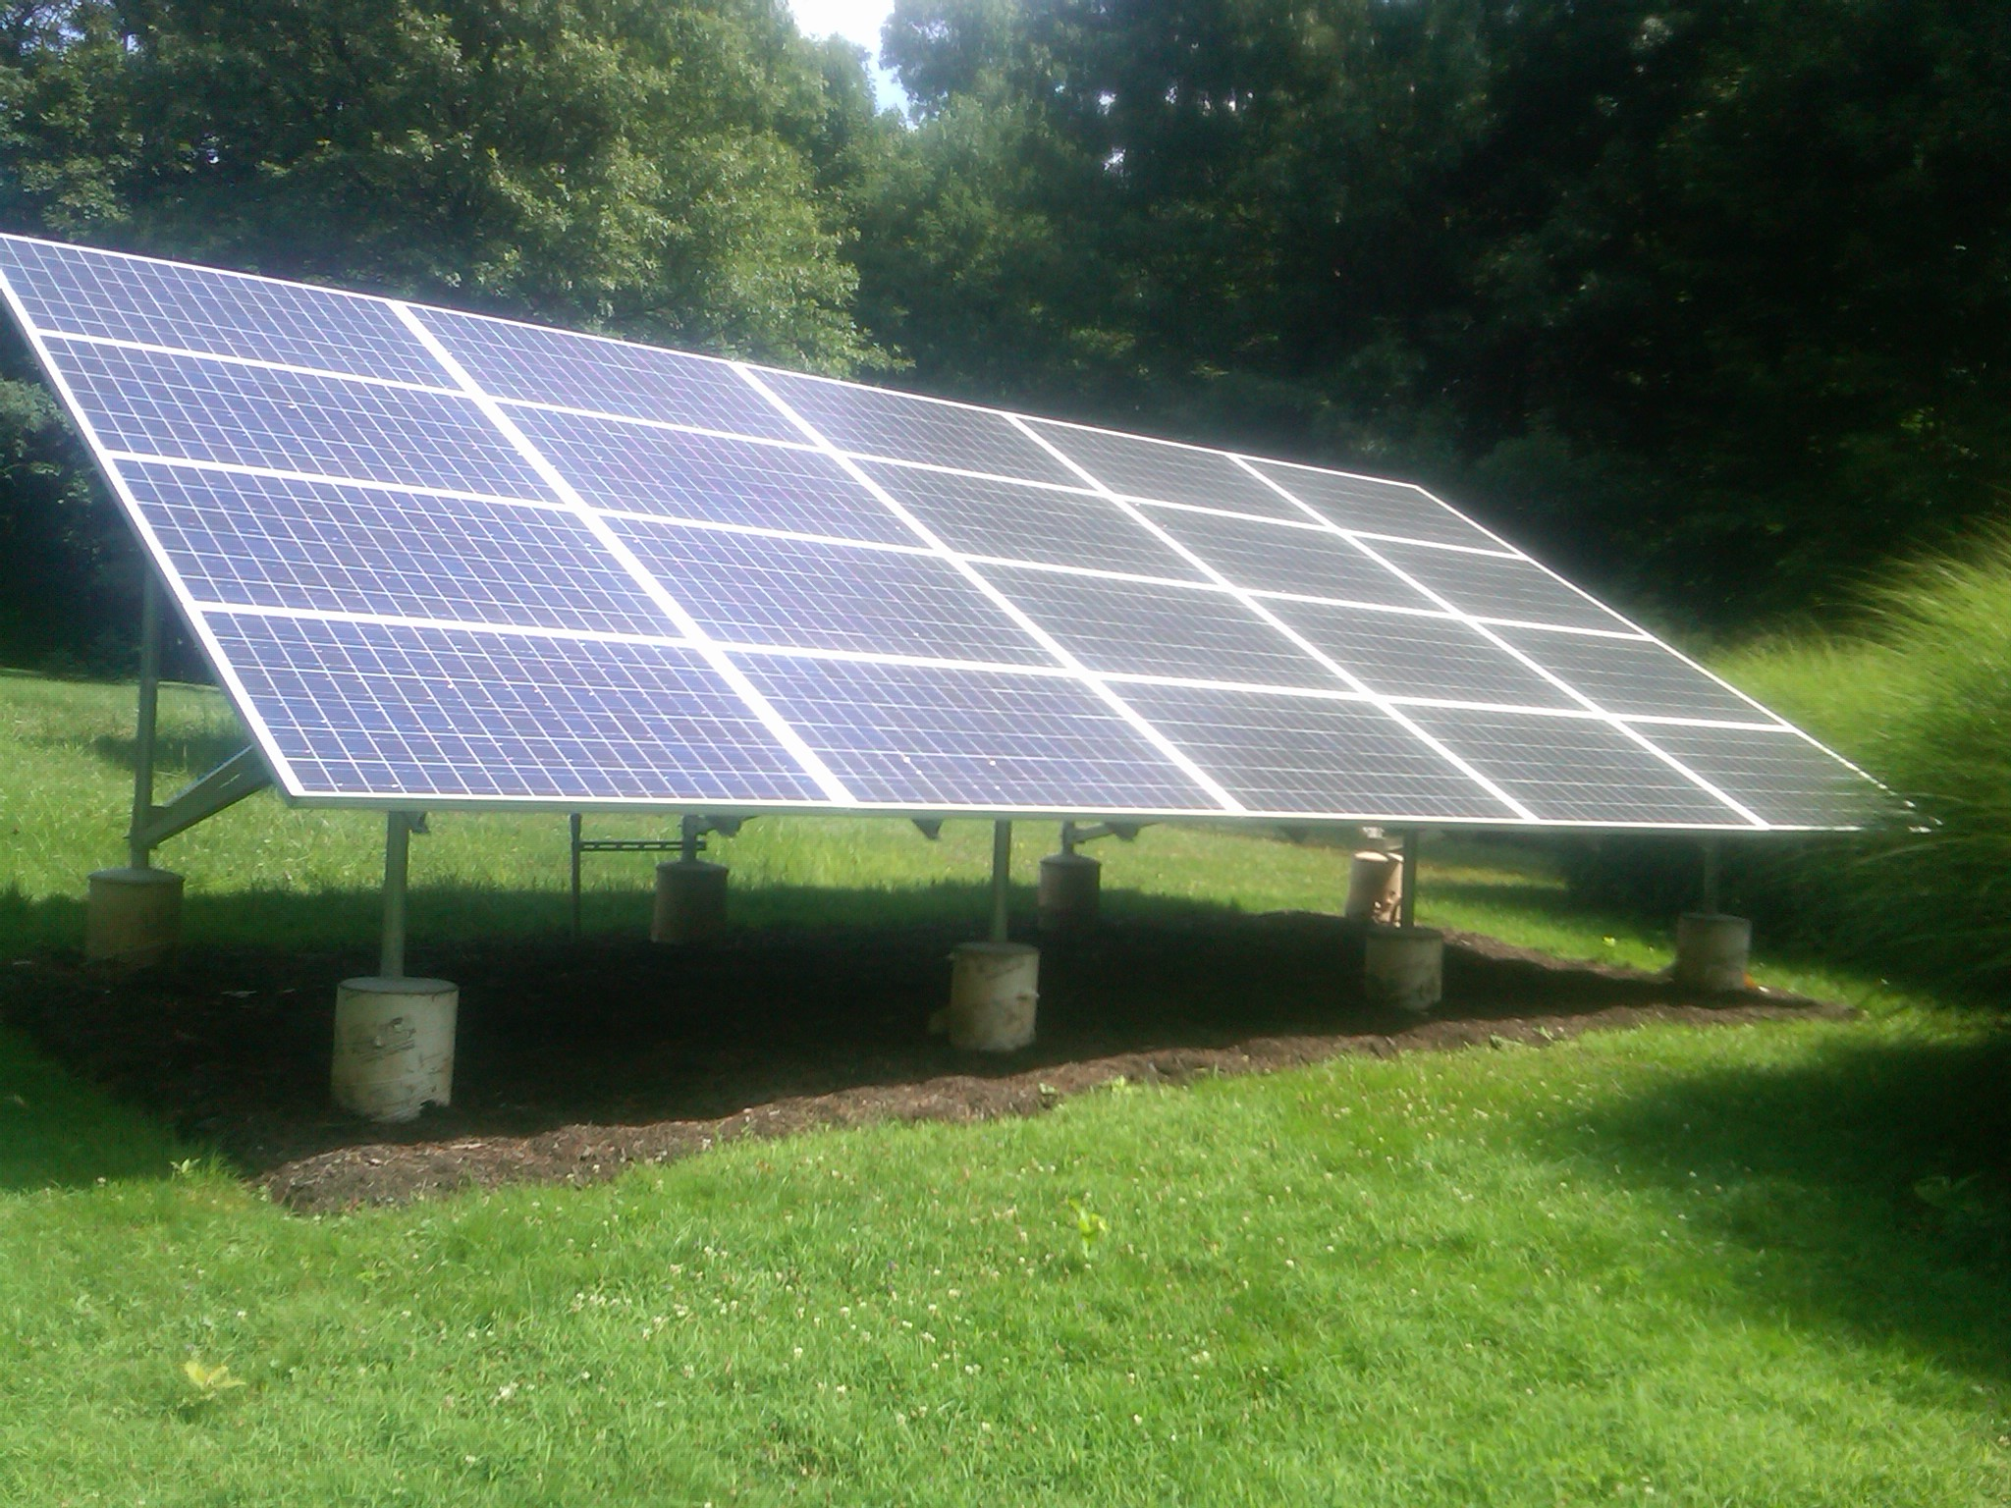
Array 1. Photo taken 7/23/2010

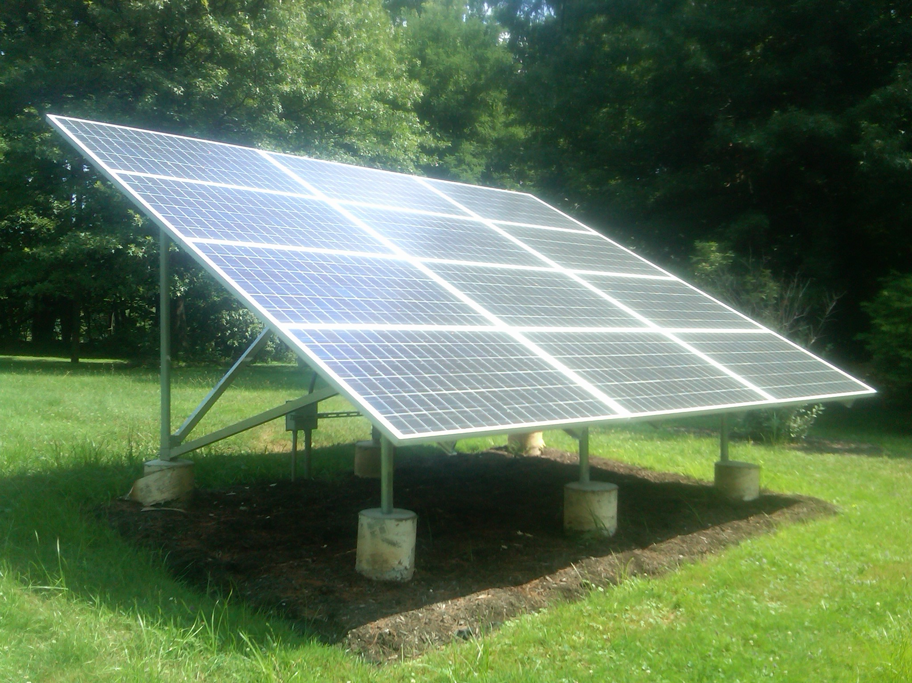
Array 2. Photo taken 7/23/2010
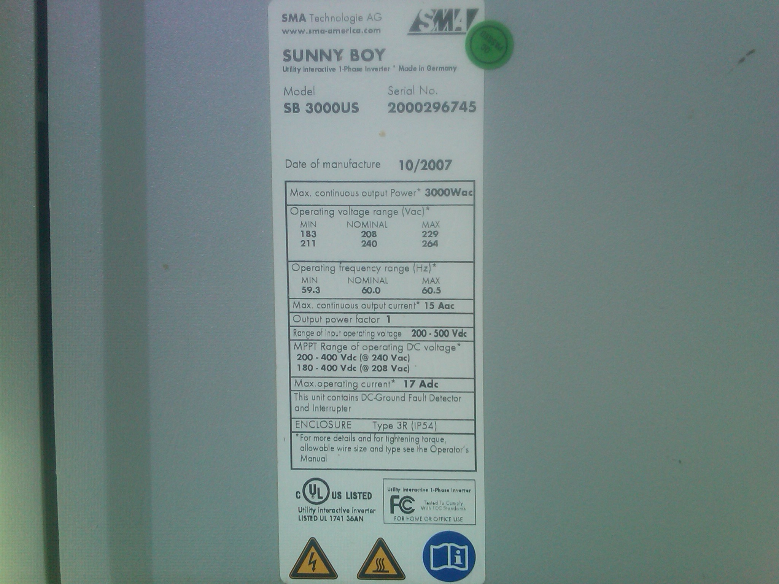
Close up of Inverter labeling. Photo taken 7/23/2010

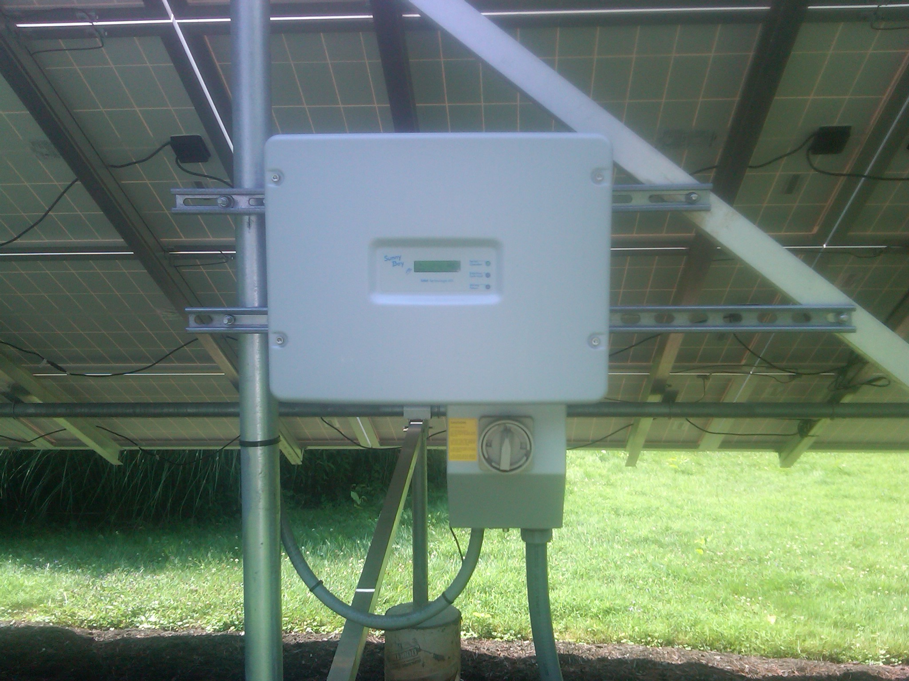
Inverter. Photo taken 7/23/2010

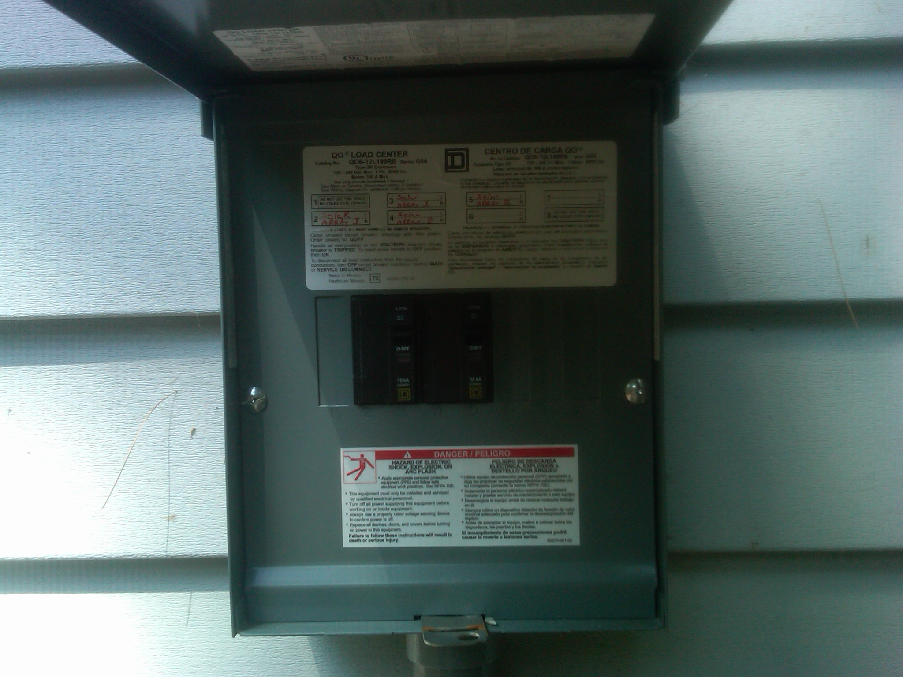
Disconnect panel. Photo taken 7/23/2010

The Applicant is applying for certification in Ohio for a facility using one of the following qualified resources or technologies (Sec. 4928.01 Ohio Revised Code):

G.4 _X_ SOLAR PHOTOVOLTAIC

Total PV Capacity (DC): 6.08kW
Total PV Capacity (AC): 5kW
Expected Capacity Factor: 0.129
Capacity factor is the ratio of the energy produced to the maximum possible at full power, over a given time period. Capacity factor may be calculated using this formula:
Projected annual generation (kWh or MWh) divided by [the nameplate capacity (in kW or MW) times 8760]

Anticipated annual output in kWh/yr: 6,871 kWh/year
Location of the PV array: __ Roof _X_ Ground __ Other
Total number of Modules and/or size of the array: 32 Evergreen 190 watt

G.4a PV Modules
For each PV module, provide the following information:

Manufacturer: Evergreen Solar
Model and Rating: ES-190/190 watts

G.5 __ SOLAR THERMAL (for electric generation)

G.6 __ WIND

Total Nameplate Capacity (kW AC): or kW DC:
Expected Capacity Factor:
Anticipated Annual Output in kWh/yr or MWh/yr:
Total Number of Generators:

G.6a Wind Generators
If the facility includes multiple generators, please provide the following information for each unique generator within the facility.

Manufacturer:
Model Name and Number:
Generator Nameplate Capacity (kW AC):
Wind Hub Height (ft):
Wind Rotor Diameter (ft):

G.7 __ HYDROELECTRIC ("hydroelectric facility" means a hydroelectric generating facility that is located at a dam on a river, or on any water discharged to a river, that is within or bordering this state or within or bordering an adjoining state (Sec. 4928.01(35) O.R.C.)

Check each of the following to verify that the facility meets each of the statutory standards (Sec. 4928.01(35) O.R.C.):

__ (a) The facility provides for river flows that are not detrimental for fish, wildlife, and water quality, including seasonal flow fluctuations as defined by the applicable licensing agency for the facility.

__ (b) The facility demonstrates that it complies with the water quality standards of this state, which compliance may consist of certification under Section 401 of the "Clean Water Act of 1977," 91 Stat. 1598, 1599, 33 U.S.C. 1341, and demonstrates that it has not contributed to a finding by this state that the river has impaired water quality under Section 303(d) of the "Clean Water Act of 1977," 114 Stat. 870, 33 U.S.C. 1313.

__ (c) The facility complies with mandatory prescriptions regarding fish passage as required by the Federal Energy Regulatory Commission license issued for the project, regarding fish protection for riverine, anadromous, and catadromus fish.

__ (d) The facility complies with the recommendations of the Ohio Environmental Protection Agency and with the terms of its Federal Energy Regulatory Commission license regarding watershed protection, mitigation, or enhancement, to the extent of each agency's respective jurisdiction over the facility.

__ (e) The facility complies with provisions of the "Endangered Species Act of 1973," 87 Stat. 884, 16 U.S.C. 1531 to 1544, as amended.

__ (f) The facility does not harm cultural resources of the area. This can be shown through compliance with the terms of its Federal Energy Regulatory Commission license or, if the facility is not regulated by that commission, through development of a plan approved by the Ohio Historic Preservation Office, to the extent it has jurisdiction over the facility.

__ (g) The facility complies with the terms of its Federal Energy Regulatory Commission license or exemption that are related to recreational access, accommodation, and facilities or, if the facility is not regulated by that commission, the facility complies with similar requirements as are recommended by resource agencies, to the extent they have jurisdiction over the facility; and the facility provides access to water to the public without fee or charge.

__ (h) The facility is not recommended for removal by any federal agency or agency of any state, to the extent the particular agency has jurisdiction over the facility.

G.7 .1 Is the facility currently certified by the Low-Impact Hydro Institute?

__ Yes

__ No

G.8 __ GEOTHERMAL

G.9__ SOLID WASTE (as defined in Section 3734.01, O.R.C.), electricity generation using fuel derived from solid wastes through fractionation, biological decomposition, or other process that does not principally involve combustion. (Sec. 4928.01(A)(35) O.R.C.)

Describe the content (fully characterize the fuel material) and source of solid waste:

Is the facility co-firing more than one fuel type?

____ Yes

____ No

If co-firing an electric generating with a solid waste resource, the proportion of fuel input attributable to the solid waste resource shall dictate the proportion of electricity output from the facility that can be considered solid waste energy.

Identify all fuel types used by the facility and respective proportions (show by the percent of heat input):

Please attach the formula for computing the proportions of output per fuel type by MWh or kWh generated.

What is the expected heat content for each of the fuels used by the plant?

What is the projected annual generation from each fuel type?

G.10__ BIOMASS (includes biologically-derived methane gas, such as landfill gas)

Identify the fuel type used by the facility:

Describe the content (fully characterize the fuel material) and source of solid waste:

Is the facility co-firing more than one fuel type?

____ Yes

____ No
If co-firing an electric generating facility with a biomass energy resource, the proportion of heat input attributable to the biomass energy resource shall dictate the proportion of electricity output from the facility that can be considered biomass energy.

G.10a List all fuel types used by the facility and respective proportions (show by the percent of heat input):

G.10b Please attach the formula for computing the proportions of output per fuel type by MWh or kWh generated.

G.10c What is the expected heat content for each of the fuels used by the plant?

G.10d What is the projected annual generation from each fuel type?

G.11 __ FUEL CELL (any fuel cell used in the generation of electricity, including, but not limited to, a proton exchange membrane fuel cell, phosphoric acid fuel cell, molten carbonate fuel cell, or solid oxide fuel cell; Sec. 4928.01(35)(A) O.R.C.).

Identify all fuel types used by the facility and respective proportions (show by the percent of heat input):

G.12 __ STORAGE FACILITY

H. Certification Criteria 3: Placed-in-Service Date (Sec. 4928.64. (A)(1) O.R.C.)

The Renewable Energy Facility:

__ has a placed-in-service date before January 1, 1998; (month/day/year):

_X_ has a placed-in-service date on or after January 1, 1998; (month/day/year): 10/20/2009

__ has been modified or retrofitted on or after January 1, 1998; (month/day/year):

Please provide a detailed description of the modifications or retrofits made to the facility that rendered it eligible for consideration as a qualified renewable energy resource. In your description, please include the date of initial operation and the date of modification or retrofit to use a qualified renewable resource. Please include this description as an exhibit attached to your application filing and identify the subject matter in the heading of the exhibit.

__ Not yet online; projected in-service date (month/day/year):

H.1 Is the renewable energy facility owner a mercantile customer?

ORC Sec. 4928.01 (19) "Mercantile customer" means a commercial or industrial customer if the electricity consumed is for nonresidential use and the customer consumes more than seven hundred thousand kilowatt hours per year or is part of a national account involving multiple facilities in one or more states.

_X_ No

__ Yes

Has the mercantile customer facility owner committed to integrate the resource under the provisions of Rule 4901:1-39-08 O.A.C?

__ No

__ Yes

If yes, please attach a copy of your approved application as an exhibit to this filing.

I. Facility Information

The nameplate capacity of the entire facility in megawatts (MW): 0.00608 DC MW

If applicable, what is the expected net heat rate of the facility:
N/A BTU/kWh
Number of Generating Units: 1

I.1 For each generating unit, provide the following information:

In-Service date of each unit | The nameplate capacity of each unit in megawatts (MW) | Projected Annual Generation (MWh) | Expected Annual Capacity Factor %
10/20/2009 | 0.00608 | 6.871 | 12.9%
(To expand the number of rows if more units need to be reported, place your cursor in the bottom right cell and hit tab).

J. Regional Transmission Organization Information

In which Regional Transmission Organization area is your facility located:

__ Within Geographic Area of PJM Interconnection, L.L.C.

_X_ Within Geographic Area of Midwest ISO

__ Other (specify):

K. Attribute Tracking System Information

Are you currently registered with an attribute tracking system: __ Yes _X_ No

In which attribute tracking system are you currently registered or in which do you intend to register (the tracking system you identify will be the system the PUCO contacts with your eligibility certification):

_X_ GATS (Generation Attribute Tracking System)

__ M-RETS (Midwest Renewable Energy Tracking System)

__ Other (specify):

K.1 Enter the generation ID number the facility has been assigned by the tracking system:
If the generation ID number has not yet been assigned, you will need to provide this number to the PUCO within 15 days of the facility receiving this number from the tracking system).

L. Other State Certification

Is the facility certified by another state as an eligible generating resource to meet the renewable portfolio standards of that state?
__ Yes
_X_ No

L.1 If yes, for each state, provide the following information:
Name of State | State Certification Agency | State Certification Number | Date Issued
(To expand the number of rows if more units need to be reported, place your cursor in the bottom right cell and hit tab).

M. Type of Generating Facility

Please check all of the following that apply to the facility:

__ Utility Generating Facility:

__ Investor Owned Utility

__ Rural Electric Cooperative

__ Municipal System

__ Electric Services Company (competitive retail electric service provider certified by the PUCO)

_X_ Distributed Generation with a net metering and interconnection agreement with a utility.
Identify the utility: Ohio Edison

__ Distributed Generation with both on-site use and wholesale sales.
Identify the utility with which the facility is interconnected:

__ Distributed Generation, interconnected without net metering.
Identify the utility with which the facility is interconnected:

N. Meter Specifications

Metering Requirements

If the renewable energy resource generating facility is 6 kW or below, the output may be measured with either an inverter meter or a utility grade meter.
All facilities that are larger than 6 kW must measure the output of the facility with a utility grade meter. Facilities that are larger than 6 kW and that are not measuring output with a utility grade meter will not be certified. OAC 4901:1-40-04 (D)(1)

Please only report on the meter or the meters used to measure the output from the facility which will be reported to the attribute tracking system.
The meter(s) that are measuring output from the facility are:
____ Inverter Meter(s)
_X__ Utility Grade Meter(s)
Please provide the following information for each meter used in your system.
Manufacturer: Siemens
Serial Number:
Type: AXALT-2SE CL 320 240V 3W 60Nz TA-50 Kh 12
Date of Last Certification:

Attach a photograph of the meter(s) with date image taken. The meter reading(s) must be clearly visible in the photograph.

Report the total meter reading number at the time the photograph was taken and specify the appropriate unit of generation (e.g., kWh): kWh

Date photograph taken: 7/23/2010
INSERT PHOTOGRAPH(S)

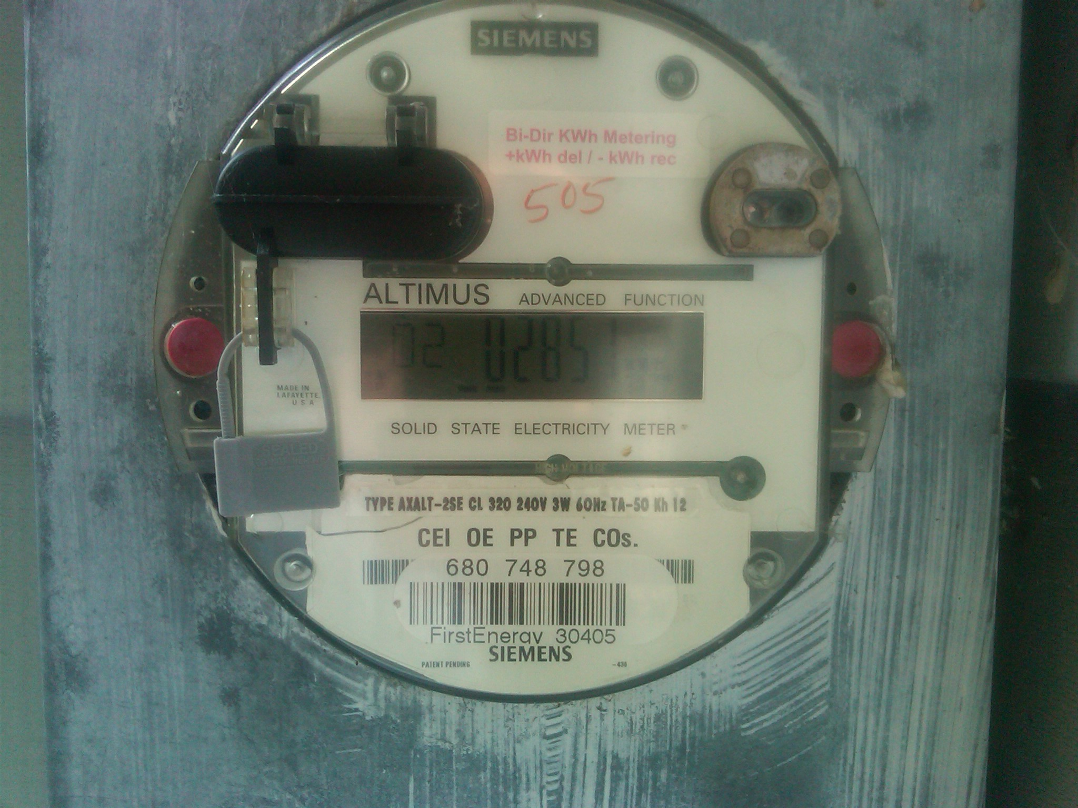

O. Start date from which the facility may begin reporting generation towards the creation of Renewable Energy Credits (RECs)

The start date from which an attribute tracking system will begin to count generation data toward the creation of renewable energy credits will be the date of certificate issuance in the state of Ohio, unless the facility satisfies one of the criterion established in the Commission’s June 17, 2009 Entry on Rehearing issued in Case No. 08-888-EL-ORD.

In that Entry, the Commission found it to be appropriate to recognize the creation of RECs back to July 31, 2008, the date in which the Ohio alternative energy portfolio standard law became effective, provided that “The facility was a participant in an existing attribute tracking system during that time or had a meter in place which can accurately demonstrate generation levels from July 31, 2008 forward.” (June 17, 2009 Entry on Rehearing at 34.)

- Existing attribute tracking system:
- For facilities that are currently participating in an attribute tracking system, it is not sufficient to merely be registered with the tracking system; you also must be reporting generation data.
- If the facility was a participant in an existing attribute tracking system, please state the specific start date that will be used to recognize historical RECs.

(2) Meter which can accurately demonstrate generation levels from July 31, 2008:
- For facilities which have had a meter in place, accurately demonstrating generation levels must include documentation from an electric remote monitoring and reporting system, from the specified start date, and recorded on at least a monthly basis.
- If the facility had a meter that accurately demonstrates generation levels, please state the specific start date, and attach documentation from the remote monitoring and reporting system.

If the facility was a participant in an existing attribute tracking system, please state the specific start date, in accordance with the tracking system’s rules, that will be used to recognize historical RECs:

If the facility had a meter that accurately demonstrates generation levels, please state the specific start date, and below insert documentation from the remote monitoring and reporting system: 10/20/2009; Inverter recorded data on-site data collection with photo documentation below.

INSERT DOCUMENTATION

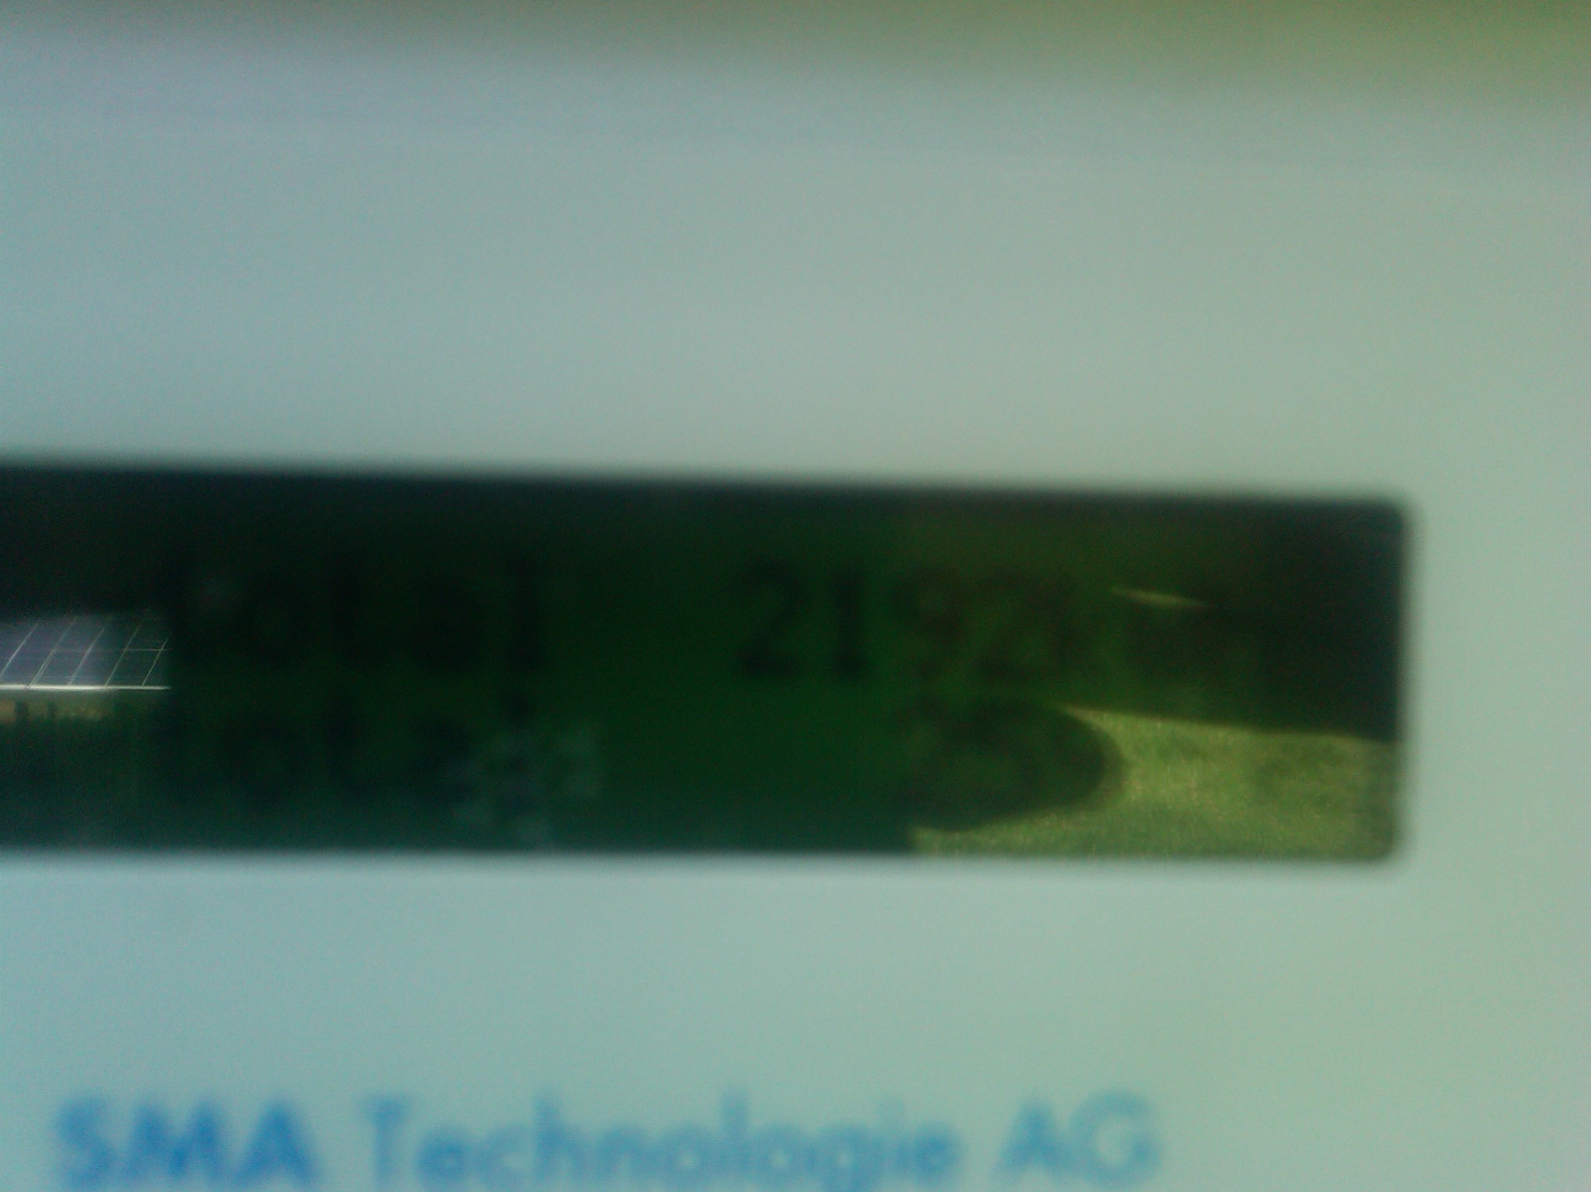
Array 1: kWh production from start date. Photo taken 7/23/2010

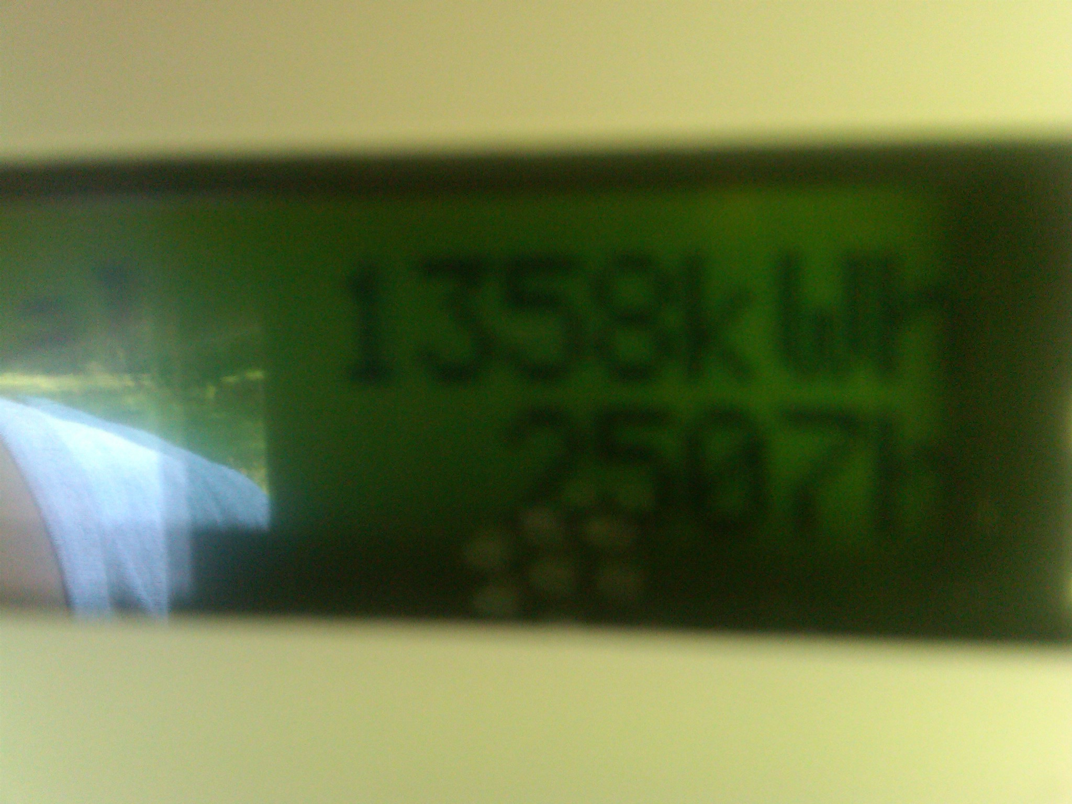
Array 2: kWh production from start date. Photo taken 7/23/2010

Also, in the Commission’s Entry on Rehearing, the Commission explained that consistent with its policy on double counting, the Commission “will not retroactively recognize any past RECs which have been sold or otherwise consumed.” (June 17, 2009 Entry on Rehearing at34.)

Has any of the generation of the facility been tracked as RECs that have been sold or otherwise consumed? Yes X No

The Public Utilities Commission of Ohio reserves the right to verify the accuracy of the data reported to the tracking system and to the PUCO.

Version: July 1, 2010

