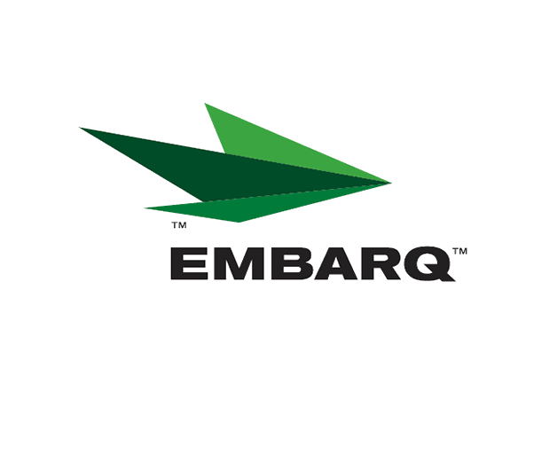



Embarq Corporation
Mailstop: KSOPKJ0502-5022
5454 West 110th Street
Overland Park, KS 66211
Glenda.Munson@EMBARQ.com

VIA E-FILE

March 7, 2008

Ms. Renee' Jenkins, Director of Administration
Public Utilities Commission of Ohio
180 East Broad Street, 13th Floor
Columbus, OH 43215-0573

RE: Embarq Communications, Inc.
Case Nos. 90-6335-CT-TRF
Embarq's Tariff Filing Reference No. OH 08-03

Dear Ms. Jenkins:

Enclosed for filing is the replacement page for Section 5, 3rd Revised Sheet 5. This page adds additional language as agreed upon with staff.

If you have any questions regarding this filing, please call Gary Baki at 614-220-8629.

Sincerely,


/s/ Glenda L. Munson

Glenda L. Munson

Enclosure
Cc: Gary Baki
OH 08-03

Glenda L. Munson
TARIFF ANALYST I
Voice: (913) 315-9346
Fax: (913) 315-0763

