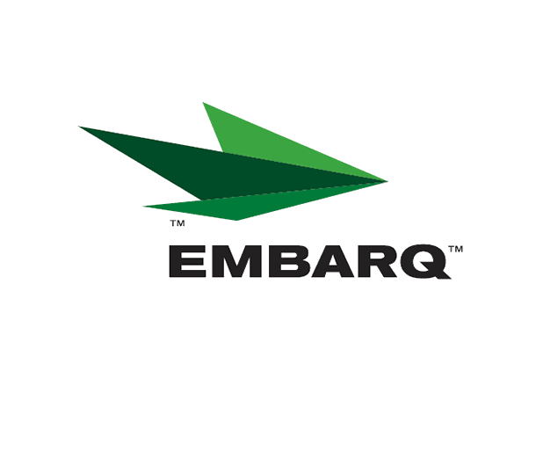



Embarq Corporation
Mailstop: KSOPKJ0502-5022
5454 West 110th Street
Overland Park, KS 66211
Glenda.Munson@EMBARQ.com

Via E-File/DHL

May 1, 2007

Ms. Renee’ Jenkins, Director of Administration
Public Utilities Commission of Ohio
180 East Broad Street, 13th Floor
Columbus, OH 43215-0573

Re: United Telephone Company of Ohio d/b/a Embarq
Case No. 90-5041-TP-TRF

Dear Ms. Jenkins:

Enclosed for filing are an original and three copies of revisions to United Telephone Company of Ohio d/b/a Embarq P.U.C.O. No. 5 General Exchange Tariff. This filing should be processed as a day filing, to become effective May 1, 2007.

The following tariff sheets are enclosed:

P.U.C.O. No. 5, General Exchange Tariff | Section 28 | Fourth Revised Sheet 28

This filing cancels a business promotion that waived applicable service charges. A subsequent filing removes the Service Charges language from the tariff for new and additional Connection Central Bundle lines.

If you have any questions regarding this filing, please call Becky Donahue at 614-220-8624.

Sincerely,

/s/ Glenda L. Munson

Glenda L. Munson

Enclosures
cc: B. Donahue
OH 07-24
Glenda L. Munson
TARIFF ANALYST I
Voice: (913) 315-9346
Fax: (913) 315-0763

