Case No.: 09-808-EL-REN

A. Name of Renewable Generating Facility: Lachman Residence
The name specified will appear on the facility’s certificate of eligibility issued by the Public Utilities Commission of Ohio.

Facility Location:
Street Address: 101 S. May Ave.
City: Athens State: OH Zip Code: 45701

Facility Latitude and Longitude
Latitude: 35.4653 Longitude: -97.5656
There are internet mapping tools available to determine your latitude and longitude, if you do not have this information.

If applicable, U.S. Department of Energy, Energy Information Administration Form EIA-860 Plant Name and Plant Code.

EIA-860 Plant Name:

EIA Plant Code:

B. Name of the Facility Owner: Ben & Catherine Lachman
Please note that the facility owner name listed will be the name that appears on the certificate.

If the facility has multiple owners, please provide the following information for each on additional sheets.

Applicant’s Legal Name: Benjamin Lachman
Title: Home Owner
Organization: none
Owner’s Address:
Street Address: 101 S. May Ave.
City: Athens State: OH Zip Code: 45701
Country: USA
Phone: 740-592-9636 Fax: Email Address: blachman@mac.com
Web Site Address (if applicable):

C. List name, address, telephone number and web site address under which Applicant will do business in Ohio.

Applicant’s Legal Name: Benjamin Lachman
Title: Home Owner
Organization: none
Please note that the company name will appear on the certificate
Owner’s Address:
The address provided in this section is where the certificate will be sent
Street Address: 101 S. May Ave.
City: Athens State: OH Zip Code: 45701
Country: USA
Phone: 740-592-9636 Fax: Email Address: blachman@mac.com
Web Site Address (if applicable):

D. Name of Generation Facility Operating Company: Self
Legal Name of Contact Person: Benjamin Lachman
Title: Home Owner
Organization: none
Operator’s Address: Home
Street Address: 101 S. May Ave.
City: Athens State: OH Zip Code: 45701
Country: USA
Phone: 740-592-9636 Fax: Email Address: blachman@mac.com
Web Site Address (if applicable):

E. Contact person for regulatory or emergency matters:
Legal Name of Contact Person: Benjamin Lachman
Title: Home Owner
Organization: none
Operator’s Address:
Street Address: 101 S. May Ave.
City: Athens State: OH Zip Code: 45701
Country: USA
Phone: 740-590-0009 Fax: Email Address: blachman@mac.com
Web Site Address (if applicable):

F. Certification Criteria 1: Deliverability of the Generation into Ohio
Ohio Revised Code (ORC) Sec. 4928.64(B)(3)

The facility must have an interconnection with an electric utility.

Check which of the following applies to your facility’s location:

_x_ The facility is located in Ohio.

__ The facility is located in a state geographically contiguous to Ohio (Indiana, Kentucky, Michigan, Pennsylvania, or West Virginia).

__ The facility is located in the following state:

If the renewable energy resource generation facility is not located in Ohio, Indiana, Kentucky, Michigan, Pennsylvania, or West Virginia, you are required to submit a study by one of the regional transmission organizations (RTO) operating in Ohio, either PJM or Midwest ISO, demonstrating that the power from your facility is physically deliverable into the state of Ohio. The study may be conducted by someone other than the RTO provided that the RTO approves the study. This study must be appended to your application as an exhibit.

G. Certification Criteria 2: Qualified Resource or Technology

You should provide information for only one resource or technology on this application; please check and/or fill out only one of the sections below. If you are applying for more than one resource or technology, you will need to complete a separate application for each resource or technology.

For the resource or technology you identify below, please provide a written description of your system. Please indicate if the facility is a customer-owned renewable distributed generation system. Please also include a detailed description of how the output of the facility is going to be measured and verified. If the facility is behind-the-meter and grid connected, please describe the configuration of the meter and the meter type. Please also attach digital photographs that depict an accurate characterization of your installed system. Please indicate the date(s) the photographs were taken. If you need additional sheets for the description of your system, please include those as an exhibit and clearly identify the subject matter in the heading.

6.3 kW Customer owned, roof mounted Solar PV array. Grid connected, net-metered residential AEP customer. Measurement will be conducted using the Sunpower Corp SPR-6000m inverter’s internal metering system. Photograph taken 8/20/2009
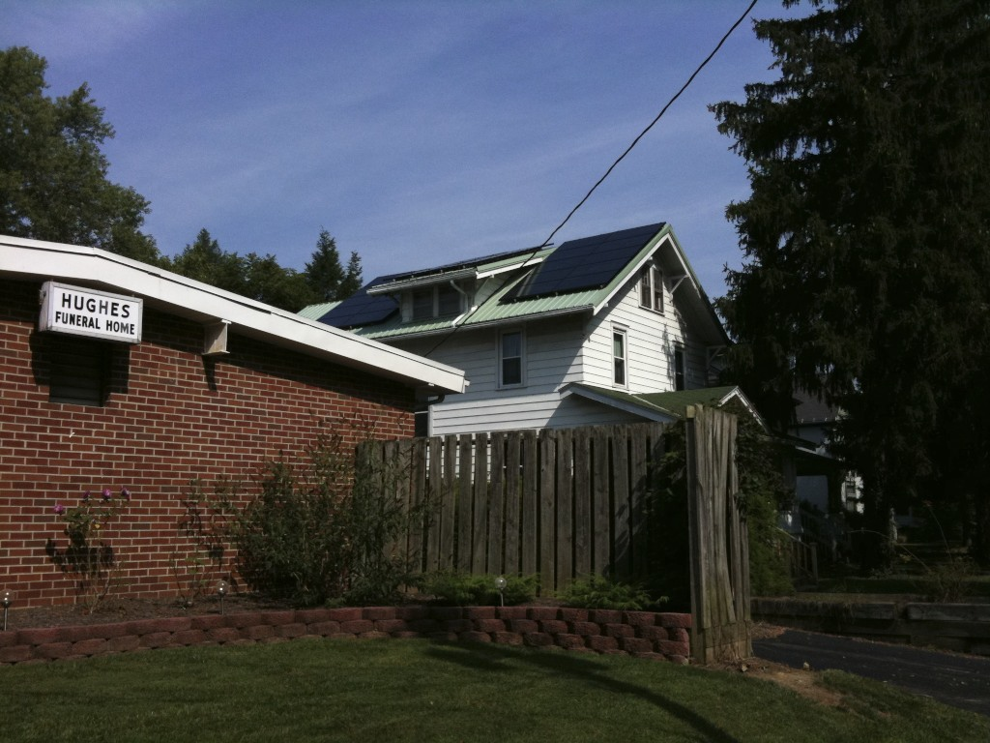
The Applicant is applying for certification in Ohio based on the following qualified resource or technology (Sec. 4928.01 O.R.C.):

G.1 _x_ SOLAR PHOTOVOLTAIC

Total PV Capacity (DC): 6300W
Total PV Capacity (AC): 5550W
Expected Capacity Factor: .131
Anticipated Annual output in kWh/yr: 7202 kWh/yr.
Location of the PV array: _x_ Roof __ Ground __ Other
# of Modules and/or size of the array: 30 panels

G.1a PV Modules
For each PV module, provide the following information:

Manufacturer: Sunpower Corporation
Model and Rating: SPR-210-BLK-U (210W)

G.2 __ SOLAR THERMAL

G.3 __ WIND

Total Nameplate Capacity (kilowatts AC): kW DC
Expected Capacity Factor:
Anticipated Annual Output in kWh/yr or MWh/yr:
# of Generators:

G.3a Wind Generators
If your system includes multiple generators, please provide the following information for each unique generator you have in your system

Manufacturer:
Model Name and Number:
Generator Nameplate Capacity (kilowatts AC):
Wind Hub Height (ft):
Wind Rotor Diameter (ft):

G.4 __ HYDROELECTRIC ("hydroelectric facility" means a hydroelectric generating facility that is located at a dam on a river, or on any water discharged to a river, that is within or bordering this state or within or bordering an adjoining state (Sec. 4928.01(35) O.R.C.)

Check each of the following to verify that your facility meets each of the statutory standards (Sec. 4928.01(35) O.R.C.):

__ (a) The facility provides for river flows that are not detrimental for fish, wildlife, and water quality, including seasonal flow fluctuations as defined by the applicable licensing agency for the facility.

__ (b) The facility demonstrates that it complies with the water quality standards of this state, which compliance may consist of certification under Section 401 of the "Clean Water Act of 1977," 91 Stat. 1598, 1599, 33 U.S.C. 1341, and demonstrates that it has not contributed to a finding by this state that the river has impaired water quality under Section 303(d) of the "Clean Water Act of 1977," 114 Stat. 870, 33 U.S.C. 1313.

__ (c) The facility complies with mandatory prescriptions regarding fish passage as required by the Federal Energy Regulatory Commission license issued for the project, regarding fish protection for riverine, anadromous, and catadromus fish.

__ (d) The facility complies with the recommendations of the Ohio Environmental Protection Agency and with the terms of its Federal Energy Regulatory Commission license regarding watershed protection, mitigation, or enhancement, to the extent of each agency's respective jurisdiction over the facility.

__ (e) The facility complies with provisions of the "Endangered Species Act of 1973," 87 Stat. 884, 16 U.S.C. 1531 to 1544, as amended.

__ (f) The facility does not harm cultural resources of the area. This can be shown through compliance with the terms of its Federal Energy Regulatory Commission license or, if the facility is not regulated by that commission, through development of a plan approved by the Ohio Historic Preservation Office, to the extent it has jurisdiction over the facility.

__ (g) The facility complies with the terms of its Federal Energy Regulatory Commission license or exemption that are related to recreational access, accommodation, and facilities or, if the facility is not regulated by that commission, the facility complies with similar requirements as are recommended by resource agencies, to the extent they have jurisdiction over the facility; and the facility provides access to water to the public without fee or charge.

__ (h) The facility is not recommended for removal by any federal agency or agency of any state, to the extent the particular agency has jurisdiction over the facility.

G.5 __ GEOTHERMAL

G.6 __ SOLID WASTE (as defined in ORC section 3734.01), electricity generation using fuel derived from solid wastes through fractionation, biological decomposition, or other process that does not principally involve combustion. (Sec. 4928.01(A)(35) O.R.C.)

Identify all fuel types used by the facility and respective proportions (show by the percent of heat input):

G.7 __ BIOMASS

Identify the fuel type used by the facility:

If co-firing an electric generating facility with a biomass energy resource, the proportion of fuel input attributable to the biomass energy resource shall dictate the proportion of electricity output from the facility that can be considered biomass energy.

G.7a List all fuel types used by the facility and respective proportions (show by the percent of heat input):

G.7b Please attach the formula for computing the proportions of output per fuel type by MWh or kWh generated.

G.8 __ FUEL CELL (any fuel cell used in the generation of electricity, including, but not limited to, a proton exchange membrane fuel cell, phosphoric acid fuel cell, molten carbonate fuel cell, or solid oxide fuel cell; Sec. 4928.01(35)(A) O.R.C.).

Identify all fuel types used by the facility and respective proportions:

G.9 __ STORAGE FACILITY

If using compressed air or pumped hydropower, the renewable energy resource used to impel the resource into the storage reservoir is (include resource type and facility name):

H. Certification Criteria 3: Placed in Service Date (Sec. 4928.64. (A)(1) O.R.C.)

The Renewable Energy Facility:

__ has a placed-in-service date before January 1, 1998; (month/day/year):

_x_ has a placed-in-service date on or after January 1, 1998; (month/day/year): 8/14/2009

__ has been modified or retrofitted on or after January 1, 1998; (month/day/year):

Please provide a detailed description of the modifications or retrofits made to the facility that rendered it eligible for consideration as a qualified renewable energy resource. In your description, please include the date of initial operation and the date of modification or retrofit to use a qualified renewable resource. Please include this description as an exhibit attached to your application filing and identify the subject matter in the heading of the exhibit.

__ Not yet online; projected in-service date (month/day/year):

H.1 Is the renewable energy facility owner a mercantile customer?

ORC Sec. 4928.01 (19) "Mercantile customer" means a commercial or industrial customer if the electricity consumed is for nonresidential use and the customer consumes more than seven hundred thousand kilowatt hours per year or is part of a national account involving multiple facilities in one or more states.

_x_ No

__ Yes

Has the mercantile customer facility owner committed to integrate the resource under the provisions of Rule 4901:1-39-08 O.A.C?

__ No

__ Yes

If yes, please attach a copy of your approved application as an exhibit to this filing.

I. Facility Information

The nameplate capacity of the entire facility in megawatts (MW): .0063

If applicable, what is the expected heat rate of resource used per kWh of net generation:
BTU/kWh
Number of Generating Units:

I.1 For each generating unit, provide the following information:

In-Service date of each unit | The nameplate capacity of each unit in megawatts (MW) | Projected Annual Generation | Expected Annual Capacity Factor %
8/14/2009 | .0063 MW | 7.2 MWh | .131
(To expand the number of rows if more units need to be reported, place your cursor in the bottom right cell and hit tab).

J. Regional Transmission Organization Information

J.1 In which Regional Transmission Organization area is your facility located:

_x_ Within Geographic Area of PJM Interconnection, L.L.C.

__ Within Geographic Area of Midwest ISO

__ Other (specify):

J.2 Are you a member of a regional transmission organization?

__ Yes; specify which one:

_x_ No; explain why you are not a member of a regional transmission organization: residential net metering customer < 10 kW

J.3 Balancing Authority operator or control area operator for the facility:

_x_ PJM

__ Midwest ISO

__ Other (specify):

K. Attribute Tracking System Information

Are you currently registered with an attribute tracking system: __x Yes __ No

In which attribute tracking system are you currently registered or in which do you intend to register (the tracking system you identify will be the system the PUCO contacts with your eligibility certification):

_x_ GATS

__ M-RETS

__ Other (specify):

K.1 Enter the generation ID number you have been assigned by the tracking system: N/A
If the generation ID number has not yet been assigned, you will need to provide this number to the PUCO within 15 days of your facility receiving this number from the tracking system).

L. Other State Certification

Is the facility certified by another state as an eligible generating resource to meet the renewable portfolio standards of that state?
__ Yes
_x_ No

L.1 If yes, for each state, provide the following information:
Name of State | State Certification Agency | State Certification Number | Date Issued
(To expand the number of rows if more units need to be reported, place your cursor in the bottom right cell and hit tab).

M. Type of Generating Facility

Please check all of the following that apply to your facility:

__ Utility Generating Facility:

__ Investor Owned Utility

__ Rural Electric Cooperative

__ Municipal System

__ Electric Services Company (competitive retail electric service provider)

_x_ Distributed Generation with a net metering and interconnection agreement with a utility.
Identify the utility: American Electric Power

__ Distributed Generation with both on-site use and wholesale sales.
Identify the utility with which the facility is interconnected:

__ Distributed Generation, interconnected without net metering.
Identify the utility with which the facility is interconnected:

Note: if the facility does not yet have an interconnection agreement with a utility or transmission system operator, please note here the status of the application for such an agreement:

N. Meter Specifications

All facilities are required to measure output with a utility grade meter. Please provide this information for each meter used in your system.

Manufacturer: Sunpower Corporation
Serial Number: 2000317350
Type: SPR-6000m
Date of Last Certification: 8/14/2009 (Installed)

Attach a photograph of the meter with date image taken. The meter reading must be clearly visible in the photograph.

Total kWh shown on meter at time of photograph: 718.8kWh

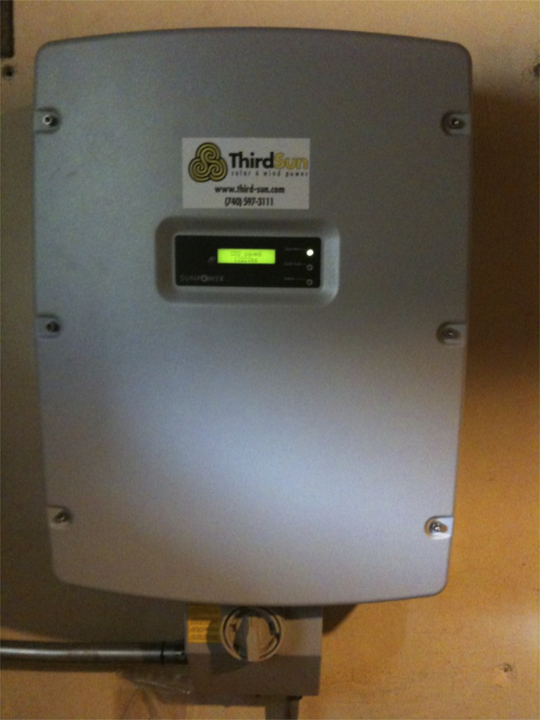
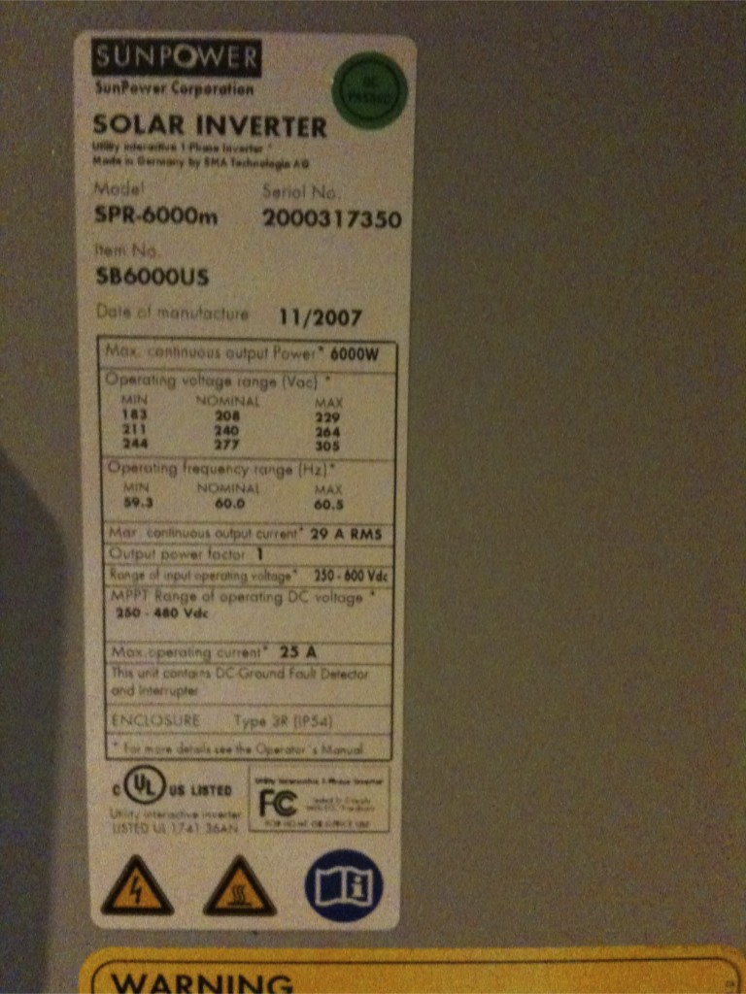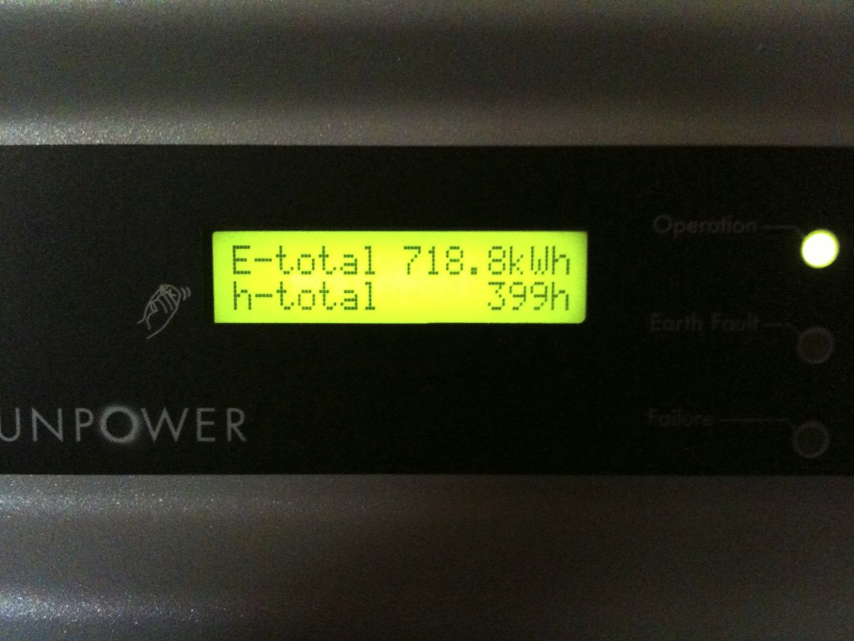
Photos taken 9/15/09

Exterior AEP Meter
Manufacturer: GE
Serial Number: 35-789-509
Type: kV2c Multifunction Meter
Date of Last Certification: 9/4/2009 (Installed)

Attach a photograph of the meter with date image taken. The meter reading must be clearly visible in the photograph.

Total kWh shown on meter at time of photograph: 00051

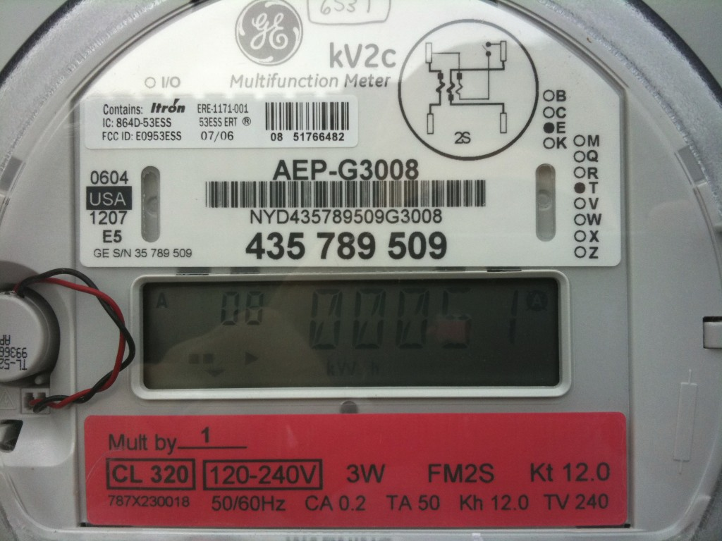
Photo taken 9/9/09

The Public Utilities Commission of Ohio reserves the right to verify the accuracy of the data reported to the tracking system and to the PUCO.

