

Online application for Certification as an Eligible Ohio Renewable Energy Resource Generating Facility
V61511
Case No.: 12-0136-EL-REN
A. Name of Renewable Generating Facility: Penn Herb Company, Ltd.
The name specified will appear on the facility's certificate of eligibility issued by the Public Utilities Commission of Ohio.
Facility Location
Street Address: 10601 Decatur Road City: Philadelphia State: PA County: Philadelphia Zip Code: 19154
Facility Latitude and Longitude
Latitude: -74.9956 Longitude: 40.0891
There are internet mapping tools available to determine the latitude and longitude, if you do not have this information.
If applicable, U.s. Department of Energy, Energy Information Administration Form EIA-860 Plant Name and Plant Code.
EIA-860 Plant Name:
EIA Plant Code:
B. Legal Name of the Facility Owner Please note that the facility owner name listed will be the name that appears on the certificate. The address provided in this section is where the certificate will be sent.
If the facility has multiple owners, please provide the following information for each on additional sheets.
Legal Name of the Facility Owner: William P. Betz Jr. Legal Name of Facility Owner Representative (First Name, MI, Last Name): William P. Betz Jr. Title: Owner Organization: Penn Herb Company, Ltd. Street Address: 10601 Decatur Road Ste 2 City: Philadelphia State: PA Zip Code: 19154 Phone: 215-632-6100 x301 Fax: 215-632-7945 Email Address: wbetzjr@pennherb.com Web Site Address: www.pennherb.com
C. List the name, address, telephone number and web site address under which the Applicant will do business in Ohio.
Legal Name of Facility Owner Representative (First Name, MI, Last Name): William P. Betz Jr. Title: Owner Organization: Penn Herb Company, Ltd. Street Address: 10601 Decatur Road Ste 2 City: Philadelphia State: PA Zip Code: 19154 Phone: 215-632-6100 x301 Fax: 215-632-7945 Email Address: wbetzjr@pennherb.com Web Site Address: www.pennherb.com

D. Name of Generation Facility Operating Company: Name of Generation Facility Operating Company: Penn Herb Company, Ltd. Legal Name of Contact Person (First Name, MI, Last Name): William P. Betz Jr. Title: Owner Organization: Penn Herb Company, Ltd. Street Address: 10601 Decatur Road Ste 2 City: Philadelphia State: PA Zip Code: 19154
Phone: 215-632-6100 x301 Fax: 215-632-7945 Email Address: wbetzjr@pennherb.com Web Site Address (if applicable): www.pennherb.com
E. Regulatory/Emergency contact
Legal Name of Contact Person (First Name, MI, Last Name):William P. Betz Jr.
Title: Owner
Organization: Penn Herb Company, Ltd.
Street Address: 10601 Decatur Road Ste 2
City: Philadelphia |  |  |  |  |  | State: PA | Zip Code: 19154
Phone: 215-632-6100 x301 |  |  |  |  |  | Fax: 215-632-7945
Email Address: wbetzjr@pennherb.com
Web Site Address: www.pennherb.com

F. Certification Criteria 1: Deliverability of the Generation into Ohio
Ohio Revised Code (ORC) Sec. 4928.64(B)(3)
Thef acilityfmustfhavefanfinterconnectionfwithfanfelectricfutility.
Check which of the following applies to the facility's location:
No The facility is located in Ohio.
Yes The facility is located in a state geographically contiguous to Ohio (Indiana, Kentucky, Michigan, Pennsylvania, or West Virginia).
No The facility is located in the following state:
(If the renewable energy resource generation facility is not located in Ohio, Indiana, Kentucky, Michigan, Pennsylvania, or West Virginia, you are required to submit a POWER FLOW study by one of the regional transmission organizations (RTO) operating in Ohio, either P1M or Midwest ISO, demonstrating that the power from the facility is physically deliverable into the state of Ohio. . This study must be appended to the application as an exhibit. THE FACILITY MUST BE INTERCONNECTED TO TRANSMISSION LINES. FOR ADDITIONAL INFORMATION ON DELIVERABILITY REQUIREMENTS, PLASE REFER TO THE COMMISSION FINDING & ORDER of 3/23/11 IN CASE NO. 09-555-EL-REN.)
G. Certification Criteria 2: Qualified Resource or Technology
You should provide information for only one resource or technology on this application; please check and/or fill out only one of the sections below. If you are applying for more than one resource or technology, you will need to complete a separate application for each resource or technology.
G.1. For the resource or technology you identify in Sections G.4 - G.13 below, please provide a written description of the system.
Roof mounted photovoltaic system consisting of 533 Sharp ND-224UC1 Modules and 14 SMA SB7000US inverters.
G.2. Please include a detailed description of how the output of the facility is going to be measured and verified, including the configuration of the meter(s) and the meter type(s).
The facility has a Hunt Power Company model 208400 KIT utility grade meter that is used to report production to GATS on a monthly basis.
G.3. Please submit digital photographs that depict an accurate characterization of the renewable generating facility. Please indicate the date(s) the photographs were taken. For existing facilities, these photographs must be submitted for your application to be reviewed. For proposed facilities or those under construction, photographs will be required to be filed within 30 days of the on-line date of the facility.
December 30, 2009
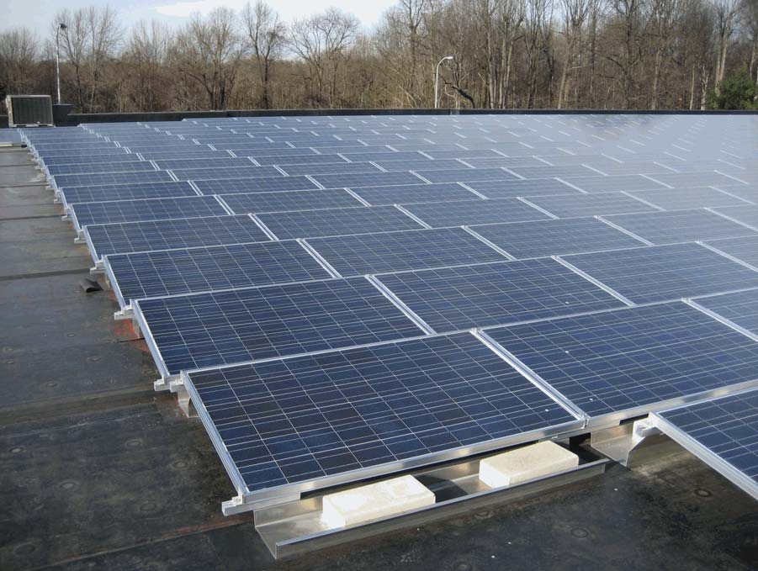
December 30, 2009
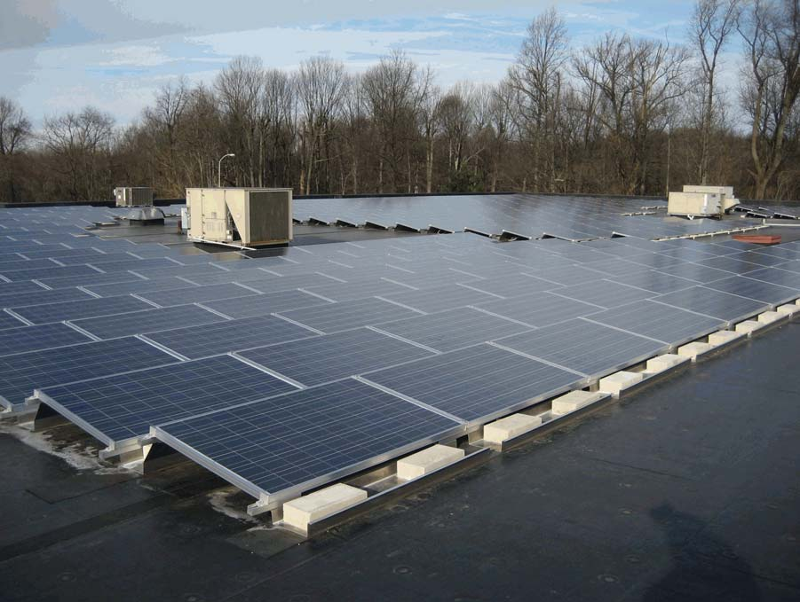
December 30, 2009
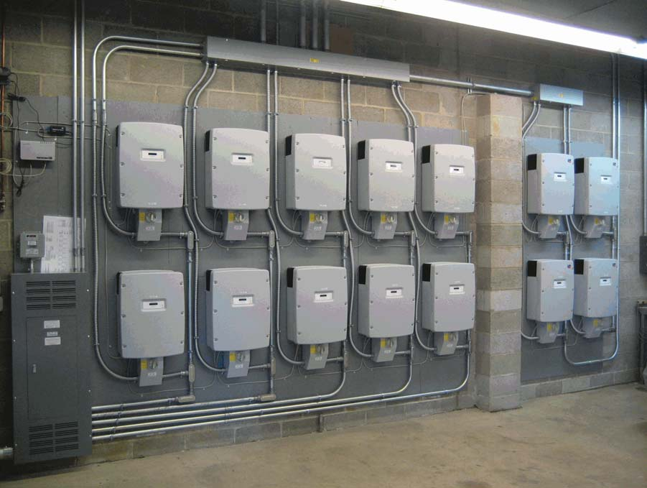
December 30, 2009
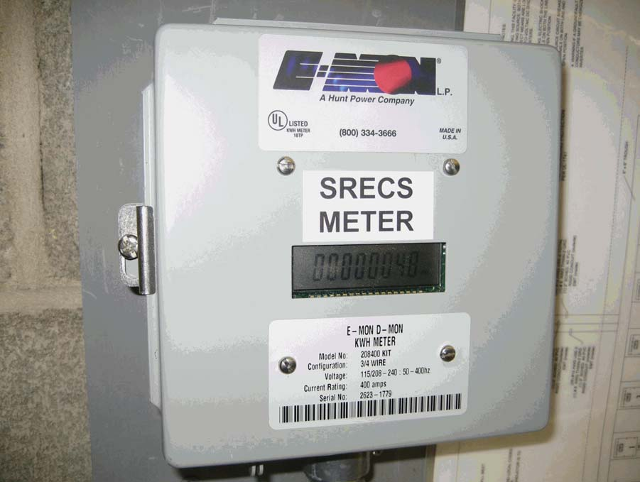
December 30, 2009
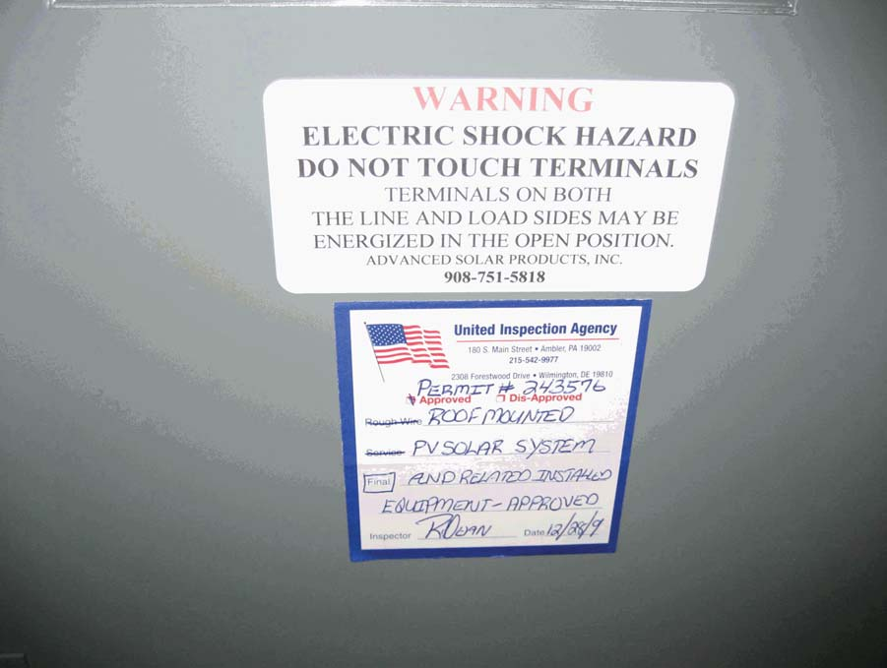
December 30, 2009
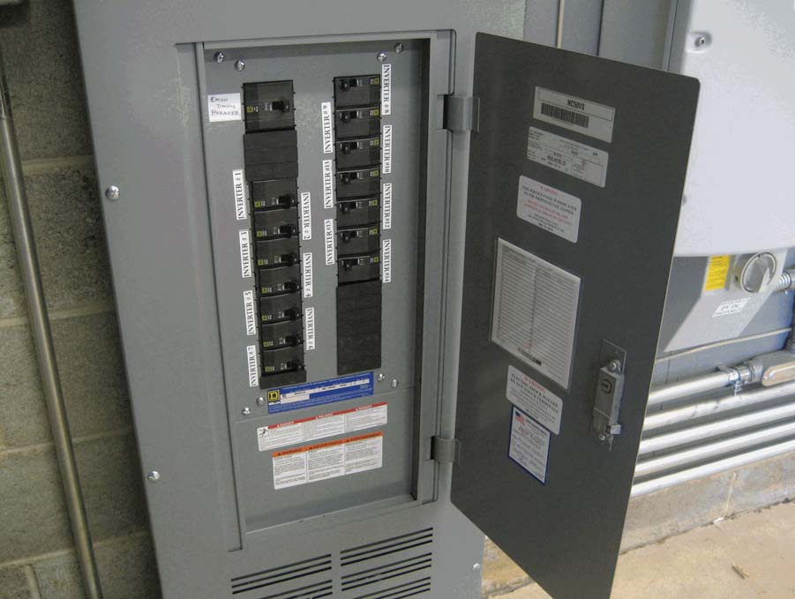
The Applicant is applying for certification in Ohio for a facility using one of the following qualified resources or technologies (Sec. .928.01 ORC):
G.. SOLAR PHOTOVOLTAIC
G..a Location of the PV array: Yes Roof No Ground No Other Description: G..b Total number of Modules: 533
G...1 PV Modules
For each PV module, provide the following information:
G...1.a Manufacturer: Sharp G...1.b Model and Rating: ND-224UC1 - 224 Watts
H. Certification Criteria 3: Placed-in-Service Date (Sec. 4928.64. (A)(1) O.R.C.) The Renewable Energy Facility: No has a placed-in-service date before January 1, 1998; (month/day/year): Yes has a placed-in-service date on or after January 1, 1998; (month/day/year): 12/18/09 No has been modified or retrofitted on or after January 1, 1998; (month/day/year): Please provide a detailed description of the modifications or retrofits made to the facility that
rendered it eligible for consideration as a qualified renewable energy resource. In your description, please include the date of initial operation and the date of modification or retrofit to use a qualified renewable resource. Please include this description as an exhibit attached to your application filing and identify the subject matter in the heading of the exhibit.
No Not yet online; projected in-service date (month/day/year):
H.1 Is the renewable energy facility owner a mercantile customer? No
ORC Sec. 4928.01 (19) "Mercantile customer" means a commercial or industrial customer if the electricity consumed is for nonresidential use and the customer consumes more than seven hundred thousand kilowatt hours per year or is part of a national account involving multiple facilities in one or more states.
Has the mercantile customer facility owner committed to integrate the resource under the provisions of Rule 4901:1-39-08 O.A.C? No
If yes, please insert/submit a copy of your approved application as an exhibit to this filing.
I. Facility Information
L a The nameplate capacity of the entire facility kilowatts (kW): 119.39 or in megawatts (MW): 0.119392
L b If applicable, what is the expected heat rate of resource used per kWh of net generation: BTU/kWh
I.1 For each generating unit, provide the following information:
Unit In-Service Date 12/18/09 | Unit Nameplate Capacity (MW) 0.119392 | Projected Gross Annual Generation 140 | Expected Annual Capacity Factor % 13.4 | Number of Generating Units 1

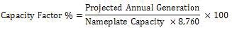
J. Regional Transmission Organization Information
In which Regional Transmission Organization area is your facility located: Yes Within Geographic Area of PJM Interconnection, L.L.C. No Within Geographic Area of Midwest ISO No Other (specify):
K. Attribute Tracking System Information
Are you currently registered with an attribute tracking system: Yes
In which attribute tracking system are you currently registered or in which do you intend to register (the tracking system you identify will be the system the PUCO contacts with your eligibility certification):
Yes GATS (Generation Attribute Tracking System) No M-RETS (Midwest Renewable Energy Tracking System)
Other (specify):
K.1 Enter the generation ID number you have been assigned by the tracking system: 42337
(If the generation ID number has not yet been assigned, you will need to file this number in the puca case Docket within 15 days of the facility receiving this number from the tracking system).
L. Other State Certification
Is the facility certified by another state as an eligible generating resource to meet the renewable portfolio standards of that state? Yes
L.1 If yes, for each state, provide the following information:
Name of State Pennsylvania | State Certification Agency PA Sunshine | State Certification Number PSP-00566-PV | Date Issued January 15, 2010
M. Type of Generating Facility
Please check all of the following that apply to the facility:
No Utility Generating Facility:
No Investor Owned Utility
No Rural Electric Cooperative
No Municipal System

No Electric Services Company (competitive retail electric service provider certified by the PUCO)
Yes Distributed Generation with a net metering and interconnection agreement with a utility. Identify the utility: PECO
No Distributed Generation with both on-site use and wholesale sales. Identify the utility with which the facility is interconnected:
No Distributed Generation, interconnected without net metering. Identify the utility with which the facility is interconnected:
N. Meter Specifications
Metering Requirements
If the renewable energy resource generating facility is 6 kW or below, the output may be measured with either an inverter meter or a utility grade meter. All facilities that are larger than 6 kW must measure the output of the facility with a utility grade meter. Facilities that are larger than 6 kW and that are not measuring output with a utility grade meter will not be certified. OAC4901:1-40-04 (D)(l) Please only report on the meter or the meters used to measure the output from the facility which will be reported to the attribute tracking system.
N.aThe meter(s) that are measuring output from the facility are: N Inverter Meter(s) Y Utility Grade Meter(s) (Must meet ANSI 12.1, or demonstrate an accuracy level of ± 2% )
N.l Please provide the following information for each meter used in your system.
N.1.a Manufacturer: Hunt Power Company
N.1.b Serial Number: 2623-1779
N.1.c Type: Digital display utility grade meter
N.1.d Date of Last Certification: December 01, 2011
Attach a photograph of the meter(s) with date image taken. The meter reading(s) must be clearly visible in the photograph.
N.1.e Report the total meter reading number at the time the photograph was taken and specify the appropriate unit of generation (e.g., kWh): 270099 kWh
December 30, 2011
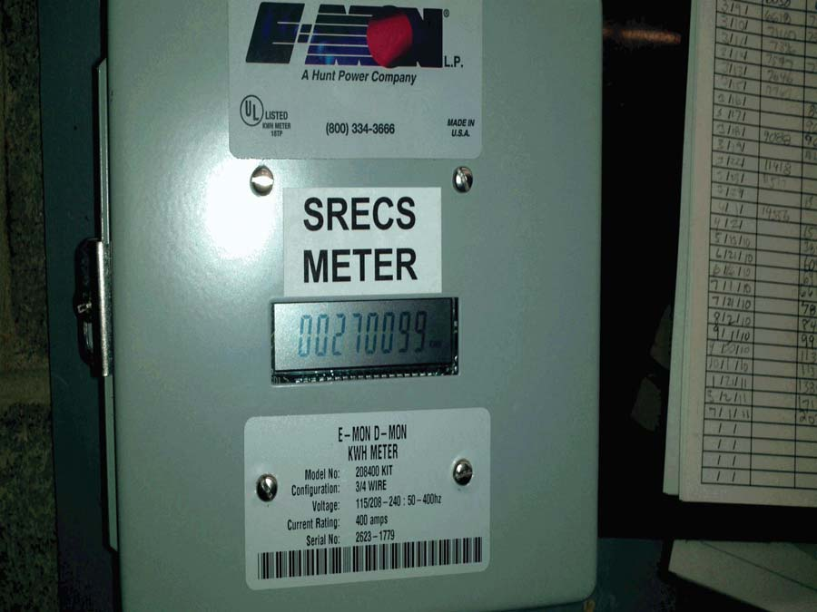
O. Start date from which applicant requests to begin reporting generation towards the creation of Renewable Energy Credits (RECs) for Ohio�s purposes
The start date from which an attribute tracking system will begin to count generation data toward the creation of renewable energy credits for Ohio's purposes will be the date of certificate issuance in the state of Ohio (i.e. generation prior to the date of certification would not be recognized), unless the facility satisfies one of the criterion established in the Commission's June 17, 2009 Entry on Rehearing issued in Case No. 08-888-EL-ORD.
In that Entry, the Commission found it to be appropriate to recognize the creation of RECs back to July 31, 2008, the date in which the Ohio alternative energy portfolio standard law became effective, provided that �The facility was a participant in an existing attribute tracking system during that time or had a meter in place which can accurately demonstrate generation levels from July 31, 2008 forward.� (June 17, 2009 Entry on Rehearing at 34.)
(1) Existing attribute tracking system:
a. For facilities that are currently participating in an attribute tracking system, it is not sufficient to merely be registered with the tracking system; you also must be reporting generation data.
b. If the facility was a participant in an existing attribute tracking system, please state the specific start date that will be used to recognize historical RECs.
(2) Meter which can accurately demonstrate generation levels from July 31, 2008:
a. For facilities which have had a meter in place, accurately demonstrating generation levels must include documentation from an electric remote monitoring and reporting system, from the specified start date, and recorded on at least a monthly basis.
b. If the facility had a meter that accurately demonstrates generation levels, please state the specific start date, and attach documentation from the remote monitoring and reporting system.

Note: An application that leaves section O blank, or does not include the required documentation, will be assigned a start date for Ohio that corresponds with the date of Ohio certification.
If the facility was a participant in an existing attribute tracking system, please state the specific start date, in accordance with the tracking system's rules, that will be used to recognize historical RECs: March 08, 2010
If the facility had a meter that accurately demonstrates generation levels, please state the specific start date, and below insert documentation from the remote monitoring and reporting system:
Also, in the Commission's Entry on Rehearing, the Commission explained that consistent with its policy on double counting, the Commission �will not retroactively recognize any past RECs which have been sold or otherwise consumed.� (June 17, 2009 Entry on Rehearing at34.)
Has any of the generation of the facility been tracked as RECS that have been sold or otherwise consumed? No
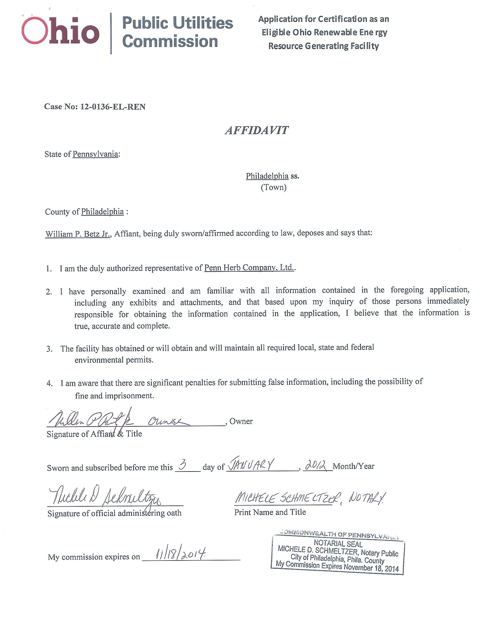
�he Public Utilities Commission of Ohio reserves the right to verify the accuracy of the data reported to the tracking system and to the PUCO.
Version: June 15, 2011

