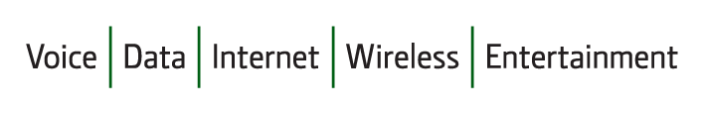
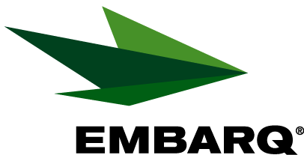

Embarq Corporation
Mailstop: KSOPKJ0502-5022
5454 West 110th Street
Overland Park, KS 66211
Glenda.Munson@EMBARQ.com

Via E-FILE

June 23, 2009

Ms. Renee’ Jenkins, Director of Administration
Public Utilities Commission of Ohio
180 East Broad Street, 13th Floor
Columbus, OH 43215-0573

Re: United Telephone Company of Ohio d/b/a Embarq
Case No. 90-5041-TP-TRF

Dear Ms. Jenkins:

Enclosed for filing are revisions to United Telephone Company of Ohio d/b/a Embarq P.U.C.O. No. 5 General Exchange Tariff. This filing should be processed as a zero day filing, to become effective June 23, 2009. The following tariff sheets are enclosed:

Section 34 | First Revised Sheet 3
 | Second Revised Sheet 6

This filing reflects the name change of the federal food stamp program to Supplemental Nutrition Assistance Program (SNAP), compliant with the mandated name change for that program under the Food, Conservation and Energy Act of 2008. This program is one of several qualifiers for the Lifeline Assistance program.

If you have any questions regarding this filing, please call Gary Baki at 614-220-8629.


Sincerely,

/s/ Glenda L. Munson

Glenda L. Munson

Enclosures
cc: Gary Baki
OH 09-11 Letter
Glenda L. Munson
TARIFF ANALYST I
Voice: (913) 315-9346
Fax: (913) 315-0763

