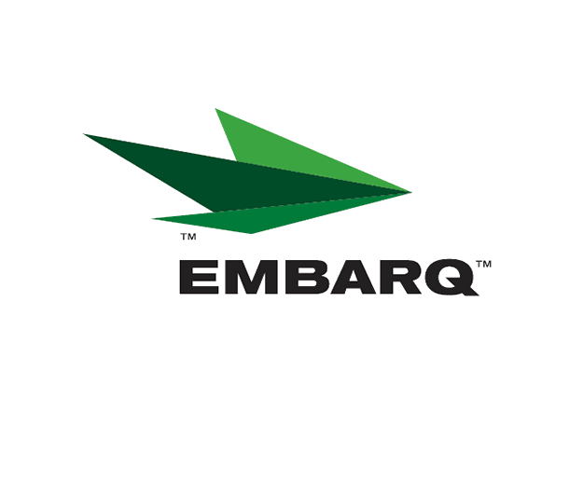



Embarq Corporation
Mailstop: KSOPKJ0502-5022
5454 West 110th Street
Overland Park, KS 66211
Glenda.Munson@EMBARQ.com

Via E-File

February 1, 2008

Ms. Renee' Jenkins, Director of Administration
Public Utilities Commission of Ohio
180 East Broad Street, 13th Floor
Columbus, OH 43215-0573

RE: Embarq Communications, Inc.
Case Nos. 90-6335-CT-TRF

Dear Ms. Jenkins:

Enclosed for filing are the original revisions to Embarq Communications, Inc. Interexchange Telecommunications Services Tariff. This filing should be processed as a zero day filing to become effective February 1, 2008.

The following revisions are enclosed:

Section 6 |  | Original Page 8.5
 |  | Original Page 8.6
 |  | Original Page 8.7
Glenda L. Munson
TARIFF ANALYST I
Voice: (913) 315-9346
Fax: (913) 315-0763


This filing introduces Block of Time for Integrated Service, a calling plan available to business customers.

If you have any questions regarding this filing, please call Gary Baki at 614-220-8629.

Sincerely,

/s/ Glenda L. Munson

Glenda L. Munson

Enclosure
cc: Gary Baki
OH 08-04
Glenda L. Munson
TARIFF ANALYST I
Voice: (913) 315-9346
Fax: (913) 315-0763

