April 11, 2012

Ms. Barcy McNeal
Public Utilities Commission of Ohio
Administration/Docketing
180 East Broad Street, 11th Floor
Columbus, OH 43215-3793

RE: Case No. 10-2929-EL-UNC

Dear Ms. McNeal:

This letter is to submit the following in the above-captioned case, in support of The Ohio Manufacturers’ Association’s Motion for Protective Order to Prevent Public Disclosure filed today:

- Attachment A – Affidavit of Kevin R. Schmidt; and
- Attachment B - Discovery

If you have any questions regarding this matter, please do not hesitate to contact me.

Sincerely,
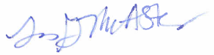
Lisa G. McAlister
On behalf of the Ohio Manufacturers’ Assn

Enclosures

cc: Parties of Record

