
Staff Report of Investigation

In the Matter of an Application by American )
Transmission Systems, Incorporated for a Certificate of ) Case No.: 08-123-EL-BTX
Environmental Compatibility and Public Need for the )
Chamberlin-Shalersville 138 kV Transmission Line )

OHIO POWER
SITING BOARD

EQUAL OPPORTUNITY EMPLOYER AND SERVICE PROVIDER

www.OPSB.ohio.gov
In the Matter of an Application by American )
Transmission Systems, Incorporated for a Certificate of ) Case No.: 08-123-EL-BTX
Environmental Compatibility and Public Need for the )
Chamberlin-Shalersville 138 kV Transmission Line )

Staff Report of Investigation
and
Recommended Findings

Submitted to the
Ohio Power Siting Board
BEFORE
THE POWER SITING BOARD
OF
THE STATE OF OHIO

In the Matter of an Application by American )
Transmission Systems, Incorporated for a Certificate of ) Case No.: 08-123-EL-BTX
Environmental Compatibility and Public Need for the )
Chamberlin-Shalersville 138 kV Transmission Line )

Members of the Board:

Alan R. Schriber, Chairman, PUCO Timothy J. DeGeeter, State Representative

Lisa Patt-McDaniel, Director, ODD Louis W. Blessing, State Representative

Alvin Jackson, M.D., Director, ODH Tom Sawyer, State Senator

Robert Boggs, Director, ODA (Vacant), State Senator
Christopher Korleski, Director, OEPA
Sean Logan, Director, ODNR
Lorry Wagner, PhD, Public Member

To The Honorable Power Siting Board:

In accordance with provisions of the Ohio Revised Code (ORC) Section 4906.07 (C), and the Commission’s rules, the Staff has completed its investigation in the above matter and submits its findings and recommendations in this Staff Report for consideration by the Ohio Power Siting Board (Board).

The Staff Report of Investigation and Recommended Findings has been prepared by the Staff of the Public Utilities Commission of Ohio. The findings and recommendations contained in this report are the result of Staff coordination with the Ohio Environmental Protection Agency, the Ohio Department of Health, the Ohio Department of Development, the Ohio Department of Natural Resources and the Ohio Department of Agriculture. In addition, the Staff coordinated with the Ohio Department of Transportation, the Ohio Historical Society, and the U.S. Fish and Wildlife Service.

In accordance with ORC Section 4906.07 and 4906.12, copies of this Staff Report have been filed with the Docketing Division of the Public Utilities Commission of Ohio on behalf of the Ohio Power Siting Board and served upon the Applicant or its authorized representative, the parties of record and the main public libraries of the political subdivisions in the project area.

The Staff Report presents the results of the Staff’s investigation conducted in accordance with ORC Chapter 4906 and the Rules of the Board, and does not purport to reflect the views of the Board nor should any party to the instant proceeding consider the Board in any manner constrained by the findings and recommendations set forth herein.

Respectfully submitted,
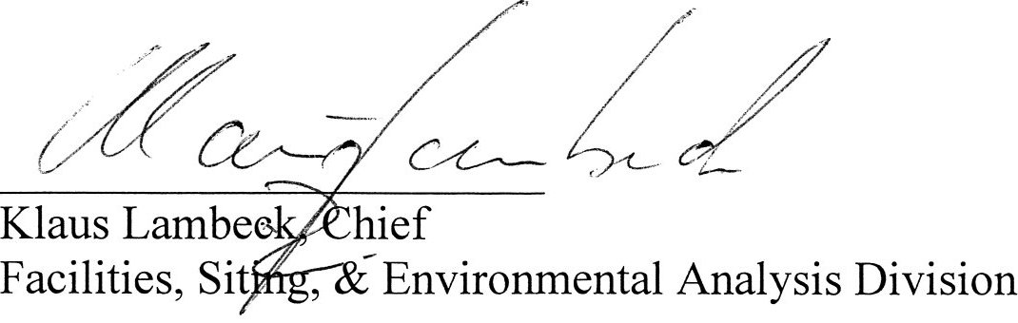

TABLE OF CONTENTS

STAFF'S LETTER i

TABLE OF CONTENTS iii

ACRONYMS iv

I. INTRODUCTION 1
Ohio Power Siting Board 1
Applicant 2
Route Selection 3
Project Description………………………………………………………… 5
Figures 1-4 (Route Maps) 6

II. HISTORY OF THE APPLICATION 10

III. CRITERIA 11

IV. NATURE OF INVESTIGATION 13

V. CONSIDERATIONS AND RECOMMENDED FINDINGS 14
ORC Section 4906.10(A)(1) 14
ORC Section 4906.10(A)(2) 16
ORC Section 4906.10(A)(3) 21
ORC Section 4906.10(A)(4) 24
ORC Section 4906.10(A)(5) 25
ORC Section 4906.10(A)(6) 27
ORC Section 4906.10(A)(7) 28
ORC Section 4906.10(A)(8) 29

VI. Recommended Conditions of Certificate 30

APPENDIX 35
Docketing Record

ACRONYMS

ATSI American Transmission Systems, Inc.
BMP Best Management Practices
DNAP Department of Natural Areas and Preserves
EMF Electromagnetic Fields
kV Kilovolts
NRHP National Register of Historic Places
OAC Ohio Administrative Code
ODA Ohio Department of Agriculture
ODD Ohio Department of Development
ODH Ohio Department of Health
ODNR Ohio Department of Natural Resources
Ohio EPA Ohio Environmental Protection Agency
OHI Ohio Historic Inventory
OHPO Ohio Historic Preservation Office
OPSB Ohio Power Siting Board
ORC Ohio Revised Code
PUCO Public Utilities Commission of Ohio
USFWS United States Fish and Wildlife Service
r-o-w right-of-way

I. INTRODUCTION

Ohio Power Siting Board

The Ohio Power Siting Board (Board or OPSB) was created on November 15, 1981, by amended Substitute House Bill 694 as a separate entity within the Public Utilities Commission of Ohio. The authority of the Board is outlined in Ohio Revised Code (ORC) Chapter 4906.

The Board is authorized to issue certificates of environmental compatibility and public need for the construction, operation, and maintenance of major utility facilities as defined in ORC Section 4906.01. Included within this definition are electric generating plants and associated facilities designed for or capable of operation at fifty megawatts or more, electric transmission lines and associated facilities of a design capacity greater than or equal to 125 kilovolts (kV), and gas and natural gas transmission lines and associated facilities designed for, or capable of, transporting gas or natural gas at pressures in excess of 125 pounds per square inch. In addition, per ORC Section 4906.20, the Board has jurisdiction for economically significant wind farms, defined as wind turbines and associated facilities with a single interconnection to the electrical grid and designed for, or capable of, operation at an aggregate capacity of five or more megawatts but less than fifty megawatts.

Membership of the Board is specified in ORC Section 4906.02(A). The members include: the Chairman of the Public Utilities Commission who serves as Chairman of the Board, the directors of the Environmental Protection Agency, the Department of Health, the Department of Development, the Department of Agriculture, and the Department of Natural Resources. The Governor appoints a member of the public, specified as an engineer, to the Board from a list of three nominees provided by the Ohio Consumers’ Counsel. Included as ex-officio members of the Board are two members (with alternates) from each House of the Ohio Legislature.

The OPSB has promulgated rules and regulations, found in Chapter 4906 of the Ohio Administrative Code (OAC), which establish application procedures for major utility facilities and wind farms. Pursuant to ORC Section 4906.07(C) and these rules, the Board’s Staff (Staff) evaluates and investigates applications and reports the results of such investigations, including recommended findings and recommended conditions for certification, in the Staff Report of Investigation.

American Transmission Systems, Incorporated
Ohio Edison Company
FirstEnergy Corporation

American Transmission Systems, Incorporated (ATSI) and Ohio Edison Company (Ohio Edison) are subsidiaries of FirstEnergy Corporation.

ATSI owns and manages high-voltage transmission facilities, covering 7100 miles of transmission lines, with nominal voltages of 69kV, 138kV, and 345kV. These serve the customers of Ohio Edison, Penn Power, Toledo Edison, and Cleveland Electric Illuminating Company. ATSI’s transmission system offers gateways into Pennsylvania, Michigan, and southern Ohio.

Ohio Edison is an electric utility operating company that distributes electricity to just over one million customers in northeastern and central Ohio.

FirstEnergy Corporation is an energy company headquartered in Akron, Ohio. In 2008, FirstEnergy Corporation’s total revenues were over $13.6 billion. Its subsidiaries and affiliates are involved in the generation, transmission, and distribution of electricity, as well as energy management and other energy-related services. Its seven electric utility operating companies serve 4.3 million customers in Ohio, Pennsylvania and New Jersey. Its generation subsidiaries control more than 14,000 megawatts (MW) of capacity generated by coal (7,932 MW), nuclear (3,945 MW), natural gas or oil (1,599 MW), and pumped-storage/hydroelectric/wind facilities (796 MW).

Route Selection

American Transmission Systems, Inc. (ATSI) obtained the services of URS Corporation (URS Corp.) to perform a route selection study in accordance with the provisions of OAC 4906-15-03 for electricity facilities. This study was used to identify the Preferred and Alternate routes for the electric transmission lines from the Shalersville Substation to the Chamberlin Substation. Boundaries of the study area were identified as well as any major constraints within the area that may affect the route selection. Additionally, the study identified screening attributes including environmental, land use, cultural, and engineering factors that may represent constraints upon route segment selection. One hundred and seven routes were identified, scored, and ranked with respect to the identified attributes. The results of this data are presented in Table 3 of the application.

Route preferences were identified at this time. However, it was noted that many high scoring routes used the available open-arm position on existing 345 kV transmission line towers along 7.5 miles of existing right of way (r-o-w). ATSI proposed maintaining the open-arm portion as a common section of all routes because of its potential to minimize ecological and social impacts.

It should be noted that ATSI applied for a waiver of OAC 4906-5-04(A) which states that “two routes shall be considered as alternatives if not more than twenty percent of the routes are in common”. ATSI proposed that the Preferred and Alternate routes should both utilize 7.5 miles of existing right-of-way and the available open-arm position on existing towers in order to minimize environmental and social impacts. As a result, the majority of the two routes would be in common. On April 1, 2008, the Administrative Law Judge granted ATSI the waiver which permitted both routes to share the proposed 7.5-mile corridor.

As a result, a supplementary route selection study was conducted to identify the Preferred and Alternate routes that would link each substation to the open arm segment identified in the original route selection study. A separate route selection study was performed for the connections to the Shalersville and Chamberlin substations, each using the same attributes, scoring, and ranking system used in the original route selection study.

The Shalersville connection originates at the Shalersville Substation, located in the city of Streetsboro, and connects with the southern end of the open arm segment. Thirteen route options were identified and evaluated (results in Tables 4 and 5). The route with the best score was chosen as the Preferred Route, which exists completely within existing utility easements. The Alternate Route was identified as the route with the next highest ranking score.

The Chamberlin connection originates at the Chamberlin Substation, located in the northwest corner of the project area, and connects with the open-arm segment. Three route options were identified and evaluated (results in Tables 4 and 5). The route that received the best score was identified as the Preferred Route. This route will require ATSI to notify the FAA before construction due to the nearby Medina Supply Company Heliport, as well as rebuilding 1,719 feet of an existing 69 kV transmission line and clearing of additional r-o-w; however, the Preferred Route provides the most direct route. The Alternate Route had the next best score and utilizes existing transmission r-o-w for the majority of its length.

Overall, the original Route Selection Study and the Supplementary Selection Study demonstrate a thorough evaluation and selection process that entailed the consideration of multiple factors and constraints. Staff has reviewed and evaluated the materials presented by the Applicant and accepts that the selection process has led to the selection of the appropriate preferred and alternative routes.

Project Description

The Applicant proposes to install a new 10-mile long 138 kV electric transmission line between the Chamberlin Substation in Twinsburg, Summit County, Ohio and the Shalersville Substation in Streetsboro, Portage County, Ohio. The project is needed to reinforce the existing transmission system and accommodate expected growth in the Aurora, Northfield and Twinsburg areas.

About 7.4 miles of the new line would be installed on existing tower structures, referred to as the common arm route or the in-common route. Currently, the tower structures along the in-common portion of the project have an open arm already in place that is suitable for the new line. New construction would be required at both ends of the in-common section. The in-common portion of the project would be designed for 345 kV operation, but it would operate at 138 kV. The new construction portions of the project would be designed and constructed for 138 kV operation.

Preferred Route

The Preferred Route originates at the Chamberlin Substation, located on the west side of Chamberlin Road about 2,000 feet north of Highland Road in Twinsburg Township. The Preferred Route then trends to the south approximately 4,000 feet through an industrial area, before connecting with the in-common route.

After leaving the in-common route on the eastern side of the project, the Preferred Route follows an existing transmission line directly southwest to the Shalersville Substation. This segment of the proposed line is about 8,000 feet in length. The surrounding area is evenly divided between commercial and residential uses.

Alternate Route

The Alternate Route leaves the Chamberlin Substation and follows an existing transmission line directly south for approximately 4,000 feet. This portion of the line follows along Chamberlin Road, passing through an industrial area before joining the in-common route.

When the Alternate Route leaves the in-common route at the eastern end of the project, it traverses due east for about 2,000 feet. The Alternate Route then turns south to follow along State Route 43 for approximately 4,000 feet. The Alternate Route next trends southeast about 3,800 feet to connect into the Shalersville Substation.

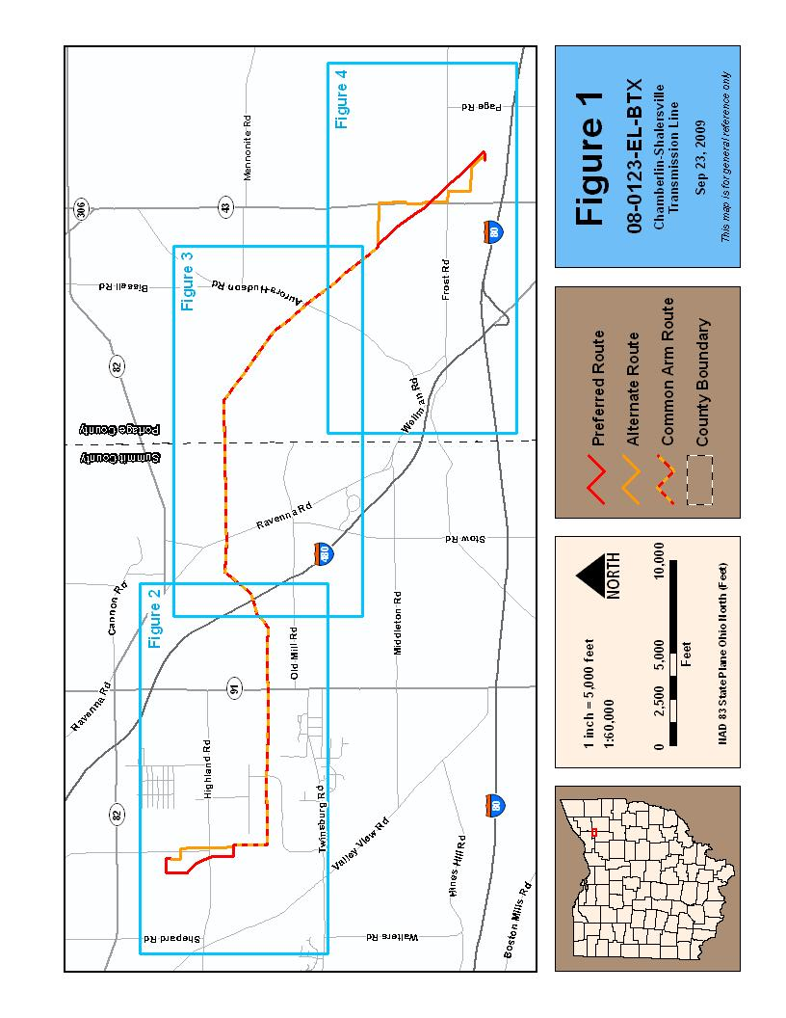
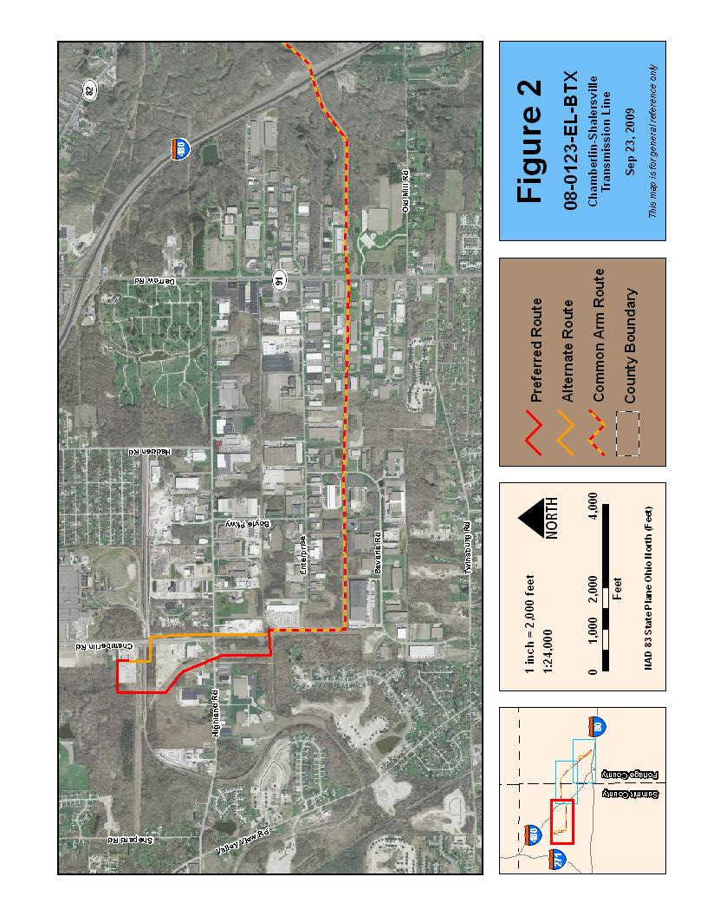
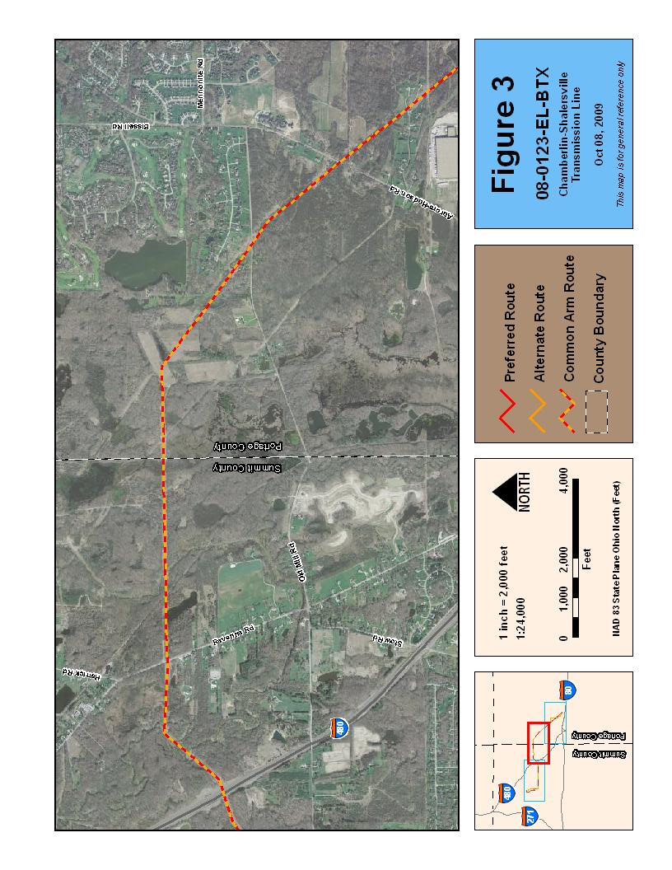

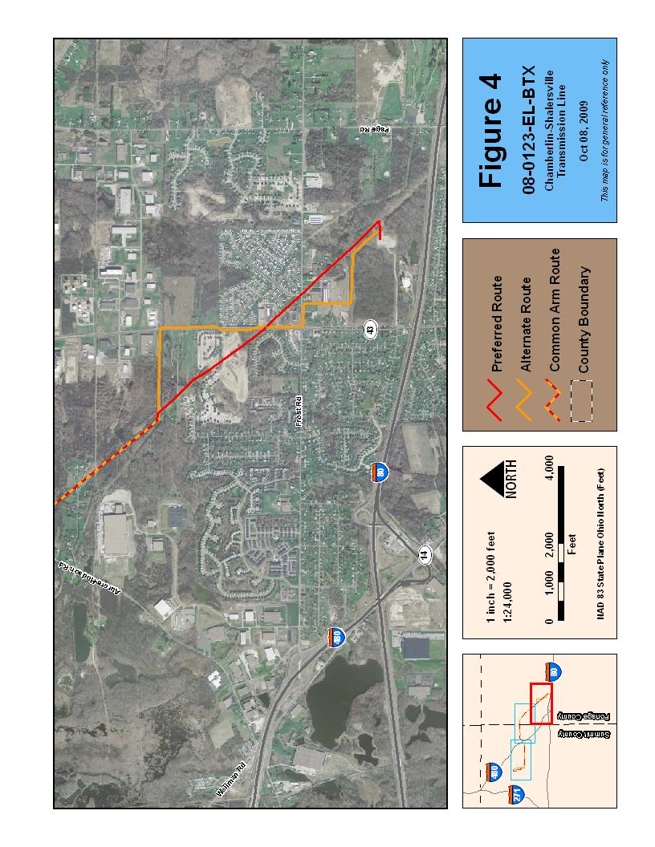
II. HISTORY OF THE APPLICATION

Application procedures and requirements for information are specified in Section 4906.06 of the ORC, and are detailed in the Rules and Regulations of the Board. This is a summary of the history of the application for Case No. 08-123-EL-BTX.

Prior to formally submitting its application, the Applicant consulted with the Board Staff and representatives of the Board, including the Ohio EPA, regarding application procedures. Additionally, the Applicant hosted on-site meetings with the Staff regarding the proposed project and the surrounding area.

The Applicant held a public informational meeting on the evening of March 5, 2008, at Dodge Intermediate School in Twinsburg, Ohio. The meeting was held to inform and familiarize the public, and to receive comments from the public, about the Applicants’ proposed electric transmission line project.

On February 8, 2008, the Applicant filed a motion for waiver of the limitation of the Alternate Route to no more than 20% in common with the Preferred Route. On April 1, 2008, the hearing examiner granted the Applicant’s motion for this waiver.

On April 6, 2009, the Applicant filed its application for a Certificate of Environmental Compatibility and Public Need to construct either a 10.1 mile Preferred Route, or 9.6 mile Alternate Route, of 138 kV electric transmission line in Summit and Portage counties.

The Chairman accepted, on June 4, 2009, the certificate application as complete and complying with the content requirements of ORC section 4906.06 and OAC Chapters 4906-1 to 4906-15.

Two hearings have been scheduled. A local public hearing has been scheduled for October 27, 2009 at 6:00 p.m. at the R. B. Chamberlin Middle School Auditorium, 10270 Ravenna Road, Twinsburg, Ohio 44087. The adjudicatory hearing will commence on November 2, 2009 at 10:00 a.m., in Hearing Room 11-F, at the offices of the Public Commission of Ohio (PUCO), 180 East Broad Street, Columbus, Ohio.

This summary of the history of the application does not include every filing that has been made in case no. 08-0123-EL-BTX. The docketing record for this case, which lists all documents filed in this case, is available at the PUCO Docketing website: http://dis.puc.state.oh.us/.

III. CRITERIA

The recommendations and conditions in this Staff Report of Investigation and Findings were developed pursuant to the criteria for certification set forth in Chapter 4906, ORC. Technical investigations and evaluations were conducted under guidance of the Ohio Power Siting Board Rules and Regulations.

Section 4906.10(A) of the ORC reads in part:

The Board shall not grant a certificate for the construction, operation and maintenance of a major utility facility, either as proposed or as modified by the Board, unless it finds and determines:

- The basis of the need for the facility if the facility is an electric transmission line or gas or natural gas transmission line;

- The nature of the probable environmental impact;

- That the facility represents the minimum adverse environmental impact, considering the state of available technology and the nature and economics of the various alternatives, and other pertinent considerations;

- In the case of an electric transmission line or generation facility, that such facility is consistent with regional plans for expansion of the electric power grid of the electric systems serving this state and interconnected utility systems and that the facility will serve the interests of electric system economy and reliability;

- That the facility will comply with Chapters 3704, 3734, and 6111 of the Revised Code and all rules and standards adopted under those chapters and under Sections 1501.33, 1501.34, and 4561.32 of the Revised Code. In determining whether the facility will comply with all rules and standards adopted under Section 4561.32 of the Revised Code, the Board shall consult with the Office of Aviation of the Division of Multi-Modal Planning and Programs of the Department of Transportation under Section 4561.341 of the Revised Code;

- That the facility will serve the public interest, convenience, and necessity;

- In addition to the provisions contained in divisions (A)(1) through (A)(6) of this section and rules adopted under those divisions, what its impact will be on the viability as agricultural land of any land in an existing agricultural district established under Chapter 929 of the Revised Code that is located within the site and alternative site of the proposed major utility facility. Rules adopted to evaluate impact under division (A)(7) of this section shall not require the compilation, creation, submission, or production of any information, document, or other data pertaining to land not located within the site and alternate site; and

- That the facility incorporates maximum feasible water conservation practices as determined by the Board, considering available technology and the nature and economics of the various alternatives.

IV. NATURE OF INVESTIGATION

The Board’s Staff has reviewed the application submitted by American Transmission Systems, Inc., for certification of the proposed Chamberlin-Shalersville Transmission Line and other materials filed with the Board under Case Number 08-123-EL-BTX. The application was prepared and submitted pursuant to OAC Chapter 4906 according to the Board’s Rules and Regulations.

The Board’s Staff, which consists of career professionals drawn from the Staff of the Public Utilities Commission of Ohio and other member agencies of the OPSB, has the responsibility to evaluate, assess, and make recommendations on applications subject to Board jurisdiction. The investigation has been coordinated among the agencies represented on the Board and with other interested agencies such as the Ohio Department of Transportation, the Ohio Historical Society, and the U.S. Fish and Wildlife Service.

The Recommended Findings resulting from the Staff’s investigation in this Report are made pursuant to ORC Section 4906.07(C) and the Board’s Rules and Regulations.

V. CONSIDERATIONS AND RECOMMENDED FINDINGS

In the matter of the application of American Electric Transmission Systems, Inc., the following considerations and recommended findings are submitted pursuant to and in accordance with ORC Section 4906.07(C).

Considerations for ORC Section 4906.10(A)(1)

Basis of Need

American Transmission Systems Incorporated (ATSI), a wholly owned subsidiary of FirstEnergy Corporation, submitted an Application to the Ohio Power Siting Board for a Certificate of Environmental Compatibility and Public Need to install a new 10 mile long 138 kV overhead transmission line between the Chamberlin Substation in Twinsburg, Ohio and the Shalersville Substation in Streetsboro, Ohio.

Purpose

ATSI plans to install the proposed Chamberlin–Shalersville 138 kV transmission line to provide additional 138 kV transmission reinforcement to meet expected load growth in the Chamberlin Substation area. Analysis shows that local losses will be reduced and reliability will be improved.

Existing ATSI Electric Transmission System Configuration at the Chamberlin Substation

The Chamberlin Substation is configured with a 345/138 kV transformer, two 138/69 kV transformers, two 138 kV capacitor banks, three 138 kV transmission lines, and five 69 kV lines.

Projected ATSI Electric Transmission System Conditions at the Chamberlin Substation Area

The Applicant states that when the Chamberlin 345/138 kV transformer is out of service during the projected system conditions that the underlying 138 kV and 69 kV lines are expected to be overloaded in the Chamberlin Substation area.

Technical Study to Justify Need for the Chamberlin – Shalersville 138 kV Transmission line Supply Project

Staff reviewed the Applicant’s load flow study results with and without the Chamberlin – Shalersville 138 kV Transmission Line Supply Project. In addition, ATSI provided additional responses to Staff data requests. The Applicant used base case models for the load flow study for the projected 2010 and 2012 summer peak load conditions. These models were based on 2008 series NERC load flow models, with 2012 and 2018 Ohio Edison forecasts with and without the new project. Staff reviewed analysis and data that the company provided under seal regarding power transcription diagrams for load flow contingencies.
ATSI Electric Transmission System Performance without the Proposed Facility

ATSI system normal condition for the 138 kV and 69 kV is expected to perform within the normal voltage and thermal capability of the system. However, for several credible single contingencies, the 138 kV and 69 kV facilities are expected to be overloaded with the voltage violations in the area.

ATSI Electric Transmission System Performance with the Proposed Facility

Staff verified that the contingency analysis with the new Chamberlin – Shalersville 138 kV transmission line in-service, thermal overloading and voltage on the facilities are expected to be within the normal operating capabilities.

Conclusion

Staff concurs with the Company that the addition of the Chamberlin–Shalersville 138 kV transmission line would enhance 138 kV and 69 kV network performances in the area. The company’s proposed facility is justified to improve system reliability and provide additional 138 kV transmission reinforcement in the area.

Recommended Findings

Staff recommends that the Board find that the basis of need for the project has been demonstrated. The Staff also recommends that any certificate issued by the Board for the proposed facility include the conditions specified in the section of this report entitled Recommended Conditions of Certificate.
Considerations for ORC Section 4906.10(A)(2)

Nature of Probable Environmental Impact

The Staff has reviewed the environmental information contained in the record compiled to date in this proceeding and has supplemented its review with site visits to the project area and discussions with employees and representatives of the Applicant. As a result, the Staff has found the following with regard to the nature of the probable environmental impact:

- The Preferred Route crosses 9 streams totaling approximately 997.5 linear feet. The Alternate Route crosses 4 streams totaling 458.3 linear feet. The in-common route crosses 18 streams totaling 6,201.5 feet. Impacts associated with these crossings could include erosion from vegetation clearing, sedimentation from storm water runoff, water temperature increase and loss of habitat.

- One pond will be crossed for the Preferred Route. There is one pond within 100 feet of the Alternate Route, but no ponds will be crossed by the route. The in-common route will cross six ponds and be within 20 feet of another pond. Regardless of the route selected, no impacts to ponds are expected.

- The Preferred Route crosses 14 wetlands totaling 1,612 linear feet. The Alternate Route crosses 12 wetlands totaling 827 linear feet of wetland. The in-common route crosses 33 wetlands totaling 6,728.7 linear feet. Impacts to wetlands include permanent loss of trees and other habitat, habitat fragmentation, soil compaction, surface water flow disruption, and aesthetic impacts.

- Approximately 9.7 acres of forest and 1.6 acres of scrub-shrub would be cleared for the Preferred Route, while 6.9 acres of forest and 0.2 acres of scrub-shrub would be cleared for the Alternate Route. 1.2 acres of forest and 0.4 acres of scrub-shrub will be cleared for the in-common route. In addition to significantly altering or eliminating existing vegetated communities and associated woodland wildlife populations, tree clearing poses impacts to the physical, chemical and biological characteristics of soils. Soil productivity and nutrient regime are important functions in forests.

- Some trees that present a danger to the line would have to be removed along many of the streams that would be crossed by either the Preferred or Alternate routes. These riparian trees help maintain the bank stability by holding soils in place and by also reducing the volume and energy of rainfall reaching the forest floor. The trees and vegetation along stream banks function to provide shading and food for wildlife species. This shading helps reduce the amount of direct sunlight reaching the streams, reducing algae blooms and controlling water temperature. Lower water temperatures equal higher oxygen solubility and greater numbers of water-cleansing microorganisms. In addition, the leaves, fruits and seeds, as well as resident insects from the streamside vegetation serve as a food source not only for birds and mammals, but also for the macroinvertebrates and fish species in the streams.

- All vegetation within the 60 foot right-of-way and adjacent to the right-of-way that presents a danger to the line, or access to the line, will be cleared and the right-of-way will be permanently maintained.

- There is one nature preserve, Tinker’s Creek, in the vicinity of the project site. This preserve serves as the nest site for a bald eagle pair further described in paragraph 11 below. However, there are no state parks, wildlife areas, scenic rivers, federal wilderness areas, wildlife refuges, or designated Critical Habitat for threatened/endangered species within the vicinity of the proposed project.

- The Preferred Route includes numerous wetlands, streams, and wooded areas. The project area contains habitat supporting numerous common reptile, amphibian, bird, and mammal species. Species along the project route will likely be impacted, both directly and indirectly, during the construction and operation of the proposed electric transmission line. Impacts to wildlife could include the loss of habitat, increased habitat fragmentation, temporary and permanent displacement, and direct mortality due to construction activities. Interior forest species will be most negatively impacted by the cleared r-o-w in wooded areas, while species which tolerate/prefer edge habitats and early successional habitats may be impacted positively.

- Because the Alternate Route follows an existing road corridor, fewer pockets of suitable wildlife habitat are expected to be impacted when compared to the Preferred Route. Forest fragmentation is expected to be significantly less with the Alternate Route, as the required tree clearing would be along existing edges rather than bisecting wooded areas.

- A records survey at ODNR indicated the presence of 13 protected plant species within 1,000 ft of the transmission line corridors. None of the protected plant species were observed in field surveys.

- The bald eagle (Haliaeetus leucocephalus) is no longer a federally protected species, but is still protected under the Bald and Golden Eagle Protection Act (Eagle Act) and the Migratory Bird Treaty Act (MBTA). There are records of a bald eagle pair nesting within Tinker’s Creek Nature Preserve since 2000. The nest location, as provided by ODNR-DNAP, is 760 feet from the in common portion of the transmission line. Upon consultation with USFWS, Staff completed a USFWS threat matrix that provided a recommended setback of 660 feet between construction activities and the nest site. If activities are to be performed closer than 660 feet, then all clearing, external construction, and landscaping activities within 660 feet of the nest are restricted to outside the nesting season (i.e., outside the nesting season is from August through mid-January since the nesting season in the Midwest is generally from late January through late July). If helicopter stringing is to be conducted, the Applicant must coordinate with USFWS and may be restricted to activity outside of 1,000 feet of the nesting site.

- The black tern (Chlidonias niger) is an endangered bird species within the State of Ohio and the National Heritage Database has record of it in the project area. Upon field investigation, there is no evidence of this species within the study corridor. The golden winged warbler (Vermivora chrysoptera), also an endangered species in Ohio, is a potential inhabitant of both Summit and Portage counties. Upon field investigation, no evidence of this species’ presence within the study corridor exists.

- There is a red-tailed hawk’s (Buteo jamaicensis) nest on one of the existing towers (located at coordinates 41º 17’ 41.31” N -81º 25’ 02.52” W) that also needs to be protected from disturbance to the greatest extent possible. This includes seasonal restrictions similar to those for the bald eagle, minimal/no mechanized equipment in the general vicinity of the tower, hand-stringing of the new conductors at this location, and any other conditions recommended by ODNR/USFWS.

- The eastern massasauga (Sistrurus catenatus) snake, listed as an endangered species, is native to Ohio and is a known inhabitant of Portage County. The eastern massasauga’s presence within the right-of-way is undetermined; however no specimens were sighted during field investigation.

- The historical ranges for the black bear (Ursus americanus) and bobcat (Lynx rufus), both state endangered species, include the project area. No evidence of these species was observed during field reconnaissance. If present, the mobility of these species should limit the potential for direct impacts as a result of the construction and operation of the project. Further, their tolerance for habitat heterogeneity should limit any indirect impacts associated with converting some amount of forested habitat to more open, field-like habitat.

- The Indiana bat (Myotis sodalis), a state and federally endangered species, is a tree-roosting species during non-winter months and has a summer range that historically includes the project area. The Applicant has identified some segments of both routes that possess potentially suitable, albeit low quality, habitat for Indiana bats, while other segments do not appear to have the typical necessary habitat characteristics (i.e., the understory is too thick, the trees are too small). The Applicant has proposed to conduct tree clearing between September 30th and April 1st to limit potential impacts to this species.

- The eastern pondmussel (Ligumia nasuta), a state endangered mollusk species, is a potential inhabitant of the lower Great Lakes drainage area. Preferred habitat of the eastern pondmussel is sheltered areas of lakes or slow streams. The pondmussel’s presence within the adjacent streams and ponds is undetermined; however no specimens were sighted during field investigation.

- The American emerald (Cordulia shurtleffi), Mitchell’s satyr butterfly (Neonympha m. mitchellii), brush-tipped emerald (Somatochlora walshii), chalk-fronted corporal (Ladona julia), elfin skimmer (Nannothemis bella), frosted whiteface (Leucorrhinia frigid), pointed sallow (Epiglaea apiata) and racket-tailed emerald (Dorocordulia libera) are state and federally endangered invertebrates that are possible inhabitants of Summit and Portage counties. No direct impact to these species is expected due to their mobility.

- Thirty-eight residences are located within 100 feet of the Preferred Route and 38 residences are located within 100 feet of the Alternate Route. Five residences are located within 100 feet of the in-common route. Along the Preferred Route, 492 residences are located within 1,000 feet, while 452 residences are located within 1,000 feet of the Alternate Route.

- Thirty-five industrial uses are located within 100 feet of the Preferred Route and 128 within 1,000 feet. The Alternate Route has 35 industrial uses within 100 feet and 143 within 1,000 feet. Twenty-seven of the industrial uses are located within 100 feet of the in-common route. One industrial use is located within the r-o-w of the Preferred Route.

- One commercial use is located within 100 feet of the Preferred Route and five within 1,000 feet. The Alternate Route has three commercial uses within 100 feet and five within 1,000 feet. None of the commercial uses are located within 100 feet of the common arm.

- There are no institutional uses within 100 feet of either the Preferred or Alternate route. The Faith Baptist Church is within 1,000 feet of both the Preferred and Alternate routes. There may be traffic delays during construction for both the Preferred and Alternate routes. There would be no other likely impacts on institutional uses for the Preferred or Alternate routes.

- A portion of the in-common route crosses the Tinker Creek State Park. This section of the route would be constructed on the open arms of an existing 345 kV transmission line. The tennis courts south of Frost Road are in the r-o-w of the Preferred Route; however they are expected to remain in operation. There are no other recreational uses along the Preferred or Alternate routes.

- Roughly 1,500 feet of the in-common route cross through agricultural land use. The impacts from construction equipment could include soil compaction, damage to current crops, and possible damage to underground drainage systems. There are no other agricultural uses along the Preferred or Alternate route.

- There are no major traffic impacts expected for this project. The Alternate Route may require some traffic control due to temporary lane reductions.

- There are no known cultural resources in the area that would be impacted by the project.

- The project is expected to generate approximately $370,000 in property taxes annually.

- The Applicant estimates the cost of construction for the Preferred Route to be approximately $3.2 million. The Alternate Route is expected to cost about $4.2 million.

Recommended Findings

The Staff recommends that the Board find that the nature of the probable environmental impact has been determined for the proposed transmission routes, provided that any certificate issued by the Board for the proposed facility include the conditions specified in the section of the report entitled Recommended Conditions of Certificate.

Considerations for ORC Section 4906.10(A)(3)

Minimum Adverse Environmental Impact

The Staff has studied the Applicant’s description and analysis of the ecological, social, and economic impacts that would result from the construction and operation of the proposed 138 kV electric transmission line. The Staff requested and received additional information from the Applicant necessary to complete its review of the proposed project. Additionally, Staff conducted field visits to supplement the information contained in the Applicant’s filings.

Ecological Impacts

Plants and wildlife

The Applicant took many steps when planning its proposed routes. This forethought resulted in a reduction to potential plant and wildlife impacts. Certain segments of, and access roads for, both routes were adjusted during the planning stages, thus avoiding some of the most environmentally-sensitive areas. The Applicant has worked to identify access routes for utility equipment that would minimize any additional direct environmental impacts to sensitive habitats. The end result of this planning should be the retention of more available habitat for wildlife.

Despite these efforts, construction of either route is expected to introduce both direct and indirect impacts to plant and wildlife. The impacts would include the loss of habitat, increased habitat fragmentation, temporary and permanent displacement, and direct mortality due to construction activities. The Preferred Route has the potential to produce slightly greater negative wildlife impacts than the Alternate Route, as a result of the different habitat types that currently comprise the r-o-w for the routes.

Records indicate the historical existence of a number of threatened or endangered species in the project vicinity. As explained previously, most of these species are not expected to be negatively impacted by the proposed project and were not sighted during field investigation. However, the loss of suitable habitat may introduce the potential for the project to negatively impact the Indiana bat, if present within the project area.

The Indiana bat (Myotis sodalis), a state and federally-endangered species, has a historical range that includes the project area. As a tree-roosting species during the non-winter months, the Indiana bat, if present at the site, could be negatively impacted as a result of the tree clearing associated with the project construction and maintenance. While some segments of the route do appear to provide suitable potential habitat for the Indiana bat, other wooded portions do not possess the characteristics typically associated with Indiana bat habitat. Limiting tree removal, particularly in the areas identified as potential Indiana bat habitat, would help reduce potential impacts to this species. In addition, conducting any necessary tree clearing outside of the Indiana bat’s typical summer roosting season, as proposed by the Applicant, would help to minimize potential direct impacts to the Indiana bat. Although the Applicant intends to remove trees for the project, additional acres of trees will remain adjacent to the proposed routes. These remaining trees could offer suitable, albeit possibly low quality, habitat for the Indiana bat. Leaving any tree snags that do not present safety or reliability concerns for the line’s operation would also retain potential habitat.

The bald eagle is a species afforded protection under both the Bald and Golden Eagle Protection Act and the Migratory Bird Treaty. As noted in the preceding section, a bald eagle pair has been nesting within the Tinker’s Creek Nature Preserve (located 760 feet off r-o-w) since 2000. Similarly, a red-tailed hawk pair has been nesting on one of the existing open-arm towers. Since both these species are sensitive to human activity near their nesting sites, the proposed construction work could disturb their breeding and rearing behavior. This electric transmission line project will avoid negative impacts to these this species by coordinating construction work with the U.S. Fish and Wildlife Service and ODNR-DNAP/Division of Wildlife, restricting such work to the time period outside their nesting season, avoiding use of mechanized equipment whenever possible, minimizing human activity in the vicinity of the nests, and adhering to prescribed setbacks.

Impacts to Wetlands

While Staff expects that all felled trees will be left within, or wind-rowed along the edge of, wetland boundaries to provide wildlife habitat, this does not compensate for the adverse changes that clearing will bring to a forested wetland site.

Regardless of the route selected, the Applicant will mark any wetlands and access roads through wetlands, with appropriate flagging (orange “snow fence”). This will help prevent construction vehicles from accidently entering or crossing wetlands on either route. Only one transmission pole will be placed within wetland boundaries on the Preferred Route. No transmission poles will be placed within any wetlands for the Alternate Route.

The Preferred Route crosses 785 linear feet more of wetlands than does the Alternate Route. The Alternate Route poses much less adverse impact to wetlands than the Preferred Route alignment.

Impacts to Streams

During the project, some streams will need to be crossed by construction equipment, while others will be accessed from both sides, eliminating the need for crossing (this also applies to wetland areas). Some of these crossings would be on a one-pass basis. Where equipment must cross streams, a particular crossing method and location will be determined that will minimize impacts to the stream and the riparian vegetation. If access must occur during high flow periods, temporary culverts or bridges will be used for vehicle crossing.

In total, the Preferred Route crosses 539 linear feet of stream more than the Alternate Route does, so adverse stream impacts associated with the Preferred Route are slightly greater than those of the Alternate Route.

Impacts to Soils
Tree clearing poses impacts to the physical, chemical and biological characteristics of soils. Significant impacts to soils can alter the function of forested wetlands as well as the function of non-wetland forest communities.
The Applicant will clearly mark wetland areas prior to clearing to minimize incidental vehicle impacts. As a condition, Staff has recommended that only low compaction vehicles be used for construction to reduce compaction and impacts to soils. Natural re-vegetation in disturbed wetland areas will begin after construction crews have completed the installation activities, though only low-growing woody vegetation will be allowed to remain in the r-o-w.

Socioeconomic Impacts

The project is not expected to have any significant impact to existing land use within the project area. Residential impacts would be limited to aesthetic impacts along both the preferred and alternate routes. Some trees would be taken along the Preferred Route and the in-common route. Existing danger trees that screen traffic would be replaced with compatible vegetation. There would be no recreational use impacts caused by the construction of the in-common route which crosses Tinker Creek State Park, as construction would be limited to the open arm section of an existing 345 kV line. The tennis courts south of Frost Road will remain; however, the overhead lights will have to be removed. Construction of the in-common route would cross approximately 1,500 feet of agricultural land. The Applicant states that all damaged drainage tiles from construction activities would be repaired, all construction debris would be removed, and landowners would be compensated for lost crops. The project would not have any long-term noise impacts. Any noise impacts would be confined to the construction period. Construction activity in residential areas will be limited to daylight hours.
Conclusion
Overall project impacts are minimized by the installation of the new line onto existing structures for a majority of the r-o-w. The Preferred Route also utilizes the Applicant’s existing easements and would cost approximately $1 million less to construct. While the Preferred Route additionally presents slightly higher ecological impacts, those impacts are essentially limited to a minimal increase in required vegetative clearing. Staff concludes that while both routes are viable, the Preferred Route represents a superior choice due to its significantly reduced cost.
Recommended Findings

The Staff recommends that the Board find that the Preferred Route presents the minimum adverse environmental impact, provided that any certificate issued by the Board for the proposed facility include the conditions specified in the section of the report entitled Recommended Conditions of Certificate.
Considerations for ORC Section 4906.10(A)(4)

Electric Grid

The purpose of this section is to determine the impact of integrating the proposed Chamberlin – Shalersville 138 kV Transmission Line Supply Project into the existing transmission network of ATSI. The Applicant stated in the Application that the proposed facility will be constructed, maintained, operated, and owned by the company. This Staff review covers ATSI transmission system performance and any impacts on the regional grid.

Long Term Forecast Report

The Project has been identified as a planned transmission line in the 2009 version of The Cleveland Electric Illuminating Company, Ohio Edison Company, The Toledo Edison Company, and American Transmission Systems, Incorporated Long-Term Forecast Report to the Public Utilities Commission of Ohio. The Long Term Forecast Report was docketed in Case No. 09-504-EL-FOR.

Midwest Independent Transmission System Operator Analysis

The Applicant reported the Chamberlin – Shalersville 138 kV Transmission Line Supply Project to the Midwest Independent System Operator (MISO). MISO is a fully integrated regional transmission organization which assures industry consumers of unbiased regional grid management and open access to the transmission facilities. MISO, under federal law, is responsible to conduct transmission planning for the MISO region. The Applicant’s proposed project is included in the Midwest ISO Transmission Expansion Plan, Appendix A as a planned project designed to address reliability.

Transmission Grid Analysis

The Applicant conducted load flow studies with and without the Chamberlin – Shalersville 138 kV Transmission Line Supply Project. Staff reviewed and evaluated these studies and concluded that reinforcement of the proposed facility is expected to enhance thermal loading and voltage performance in the underlying ATSI system in the area. The proposed facility is a local area reinforcement and reliability improvement project which will reduce local losses and improve reliability by providing a new 138 kV line for Shalersville Substation.

Recommended Findings

The Staff recommends that the Board find that the proposed project is consistent with regional plans for expansion of the regional power grid and will serve the interests of electric system economy and reliability. The Staff also recommends that any certificate issued by the Board for the proposed facility include the conditions specified in the section of this report entitled Recommended Conditions of Certificate.

Considerations for ORC Section 4906.1(A)(5)

Air, Water, Solid Waste, and Aviation

Air

Air quality permits are not required for construction of the proposed facility. However, fugitive dust rules adopted pursuant to the requirements of ORC Chapter 3704 (air pollution control laws) may be applicable to the proposed facility. The Applicant has indicated that fugitive dust would be controlled, where necessary, through irrigation, mulching, or application of tackifier resins. Staff believes that these methods of dust control should be sufficient to comply with fugitive dust rules.

Water

Neither construction nor operation of the proposed facility will require the use of significant amounts of water, so requirements under ORC §§ 1503.33 and 1501.34 are not applicable to this project.

The Applicant indicates that the Preferred Route would involve spanning 27 streams and 47 wetland areas (28.6 ac). The Alternate Route would involve spanning 22 streams and 45 wetland areas (27.88 ac). The Applicant will obtain coverage under U.S. Army Corps of Engineers Nationwide Permit No. 12 for wetland impacts associated with Utility Line Activities. The Applicant will cross some of the streams with construction vehicles.

The Applicant has indicated that a Storm Water Pollution Prevention Plan (SWPPP) will be developed for the project, pursuant to Ohio EPA regulations, which will include a detailed construction access plan. Following the SWPPP, as well as using Best Management Practices for construction activities, will help minimize any erosion related impacts to streams and wetlands. Wetlands, streams, and other environmentally sensitive areas shall be clearly identified before commencement of clearing or construction. No construction or access will be permitted in these areas unless clearly specified in the constructions plans and specifications, thus minimizing any clearing related disturbance to surface water bodies. The Applicant indicates that the area of vegetation that would need to be cleared for the Preferred Route would be 12.9 acres and would be 8.7 acres for the Alternate Route. Staff believes that construction of this facility will comply with requirements of ORC Chapter 6111, and the rules and laws adopted under this chapter.

Solid Waste

The Applicant indicates that solid waste generated from construction activities would include items such as conductor scrap, construction material packaging including cartons, insulator crates, conductor reels and wrapping, and used storm water erosion control materials. The Applicant estimates that approximately 200 cubic yards of construction debris will be generated from the project. All construction related debris will be disposed of in Ohio EPA approved landfills, or other appropriately licensed and operated facilities. Any contaminated soils discovered or generated during construction would be handled in accordance with applicable regulations. Where trees and other woody vegetation would be cleared, the timber would be cut into appropriate lengths for sale or use by the landowner, or chipped or windrowed at the edge of the r-o-w, as determined by landowner preference and local conditions. Staff believes that the Applicant’s solid waste disposal plans will comply with solid waste disposal requirements in ORC Chapter 3734, and the rules and laws adopted under this chapter.

Aviation

The Applicant indicates three air transportation facilities in the project area: a private inactive heliport located approximately 1300 feet to the north in Twinsburg, the Portage County Airport located approximately 10 miles to the southeast, and the Kent State University Airport located approximately 16 miles to the southwest of the proposed transmission line.

The heliport is on the Medina Supply Company property. Consultation with the Ohio Department of Transportation, Office of Aviation has indicated that the Alternate Route would have a slight impact to the heliport. The impact on the heliport is that existing transmission structures along Chamberlin Road that are 56 to 66 feet tall would be extended to 79 feet in height. These taller structures would extend into the western approach surface for the heliport. But, the likely landing approach to the heliport currently is and would in the future be from the open field south of the heliport. This approach accounts for all of the existing structures that surround the heliport. No significant impacts to the heliport from the Preferred Route are expected.

Pursuant to ORC §§ 4906.10(A) and 4561.341, Staff consulted with the Ohio Department of Transportation, Office of Aviation, to review this application for potential impacts the facility might have on local air transportation facilities. No such concerns have been identified. Staff believes that the facility will comply with ORC § 4561.32.

Recommended Findings

The Staff finds that the proposed electric transmission line facilities will comply with the requirements specified in ORC Section 4906.10(A)(5). Further, the Staff recommends that any certificate issued by the Board for the certification of the proposed facility include the conditions specified in the section of this report entitled Recommended Conditions of Certificate.

Considerations for ORC Section 4906.10(A)(6)

Public Interest, Convenience, and Necessity

Transmission lines, when energized, generate electromagnetic fields (EMF). While laboratory studies have failed to establish a relationship between exposure to EMF and leukemia, there have been concerns that EMF may be detrimental to human health.

Because these concerns exist, the Applicant is required to compute the EMF associated with the new circuits. The fields were computed based on the maximum loadings of the lines; i.e. the highest values that might exist. The magnetic fields are a function of the electric current, the configuration of the conductors, and the distance from the transmission lines. The electric field is a function of the voltage, the line configuration and the distance from the transmission lines. The electric fields are readily shielded by physical structures, such as the walls of a house, foliage, etc.

The maximum magnetic field scenarios are listed in the application (Table 06-6). The EMF profiles are shown in Figure 06-2 through Figure 06-13. There are thirty-eight houses along the Preferred Route that are within 100 feet from the center of the r-o-w. There are thirty-eight houses along the Alternate Route that are within 100 feet from the center of the r-o-w. The Applicant will use primarily 138 kV transmission lines on single wood pole tangent structures supported on horizontal post insulators; this is a compact design that reduces EMF field strengths.

The project’s purpose is to reinforce the existing transmission system serving the greater Aurora, Northfield, and Twinsburg area to meet expected load growth. Daily current load levels will normally operate below the maximum load conditions, thereby further reducing nominal EMF values.

Radio or television interference is not expected to occur from the operation of the proposed transmission line along either the Preferred or Alternate routes.

Recommended Findings

Staff recommends that the Board find that the proposed facility will serve the public interest, convenience, and necessity. Further, the Staff recommends that any certificate issued by the Board for the proposed facility include the conditions specified in the section of this report entitled Recommended Conditions of Certificate.

Considerations for ORC Section 4906.10(A)(7)

Agricultural Districts

Classification as Agricultural District land is achieved through an application and approval process that is administered through local county auditor offices. Based upon parcel information obtained from county Auditor records, the Applicant has stated that no Agricultural District parcels are crossed by either route. A total of approximately 1,880 linear feet of agricultural land will be spanned.

Staff has also evaluated potential impacts on agricultural production. Construction-related activities (such as vehicle traffic and materials storage) could lead to temporary reductions in farm productivity caused by direct crop damage, soil compaction, broken drainage tiles, and reduction of space available for planting. However, the Applicant has indicated that it intends to take precautionary steps in order to address such potential impacts to farmland, including: repairing or replacing damaged drainage tiles to the landowner’s satisfaction and reducing soil compaction during construction. Additionally, the Applicant states that the value of any crops damaged by construction activities or by soil compaction would be reimbursed to the landowner. After construction, only the agricultural land associated with the actual pole locations would be removed from production, however r-o-w access along the line would still be required for maintenance purposes.

It is Staff’s conclusion that there would be no significant permanent impacts from the construction or maintenance of this proposed electric transmission line on Agricultural Districts. Further, construction and maintenance of the proposed electric transmission line would not impact the viability as agricultural land of any Agricultural District land.

Recommended Findings

The Staff recommends that the Board find that the impact of the proposed electric transmission line project on the viability of existing farmlands and Agricultural Districts has been determined, and will be minimal. Further, the Staff recommends that any certificate issued by the Board for the proposed facility include the conditions specified in the section of this report entitled Recommended Conditions of Certificate.

Considerations of ORC Section 4906.10(A)(8)

Water Conservation Practice

Water conservation practice as specified under ORC 4906.10(A)(8) is not applicable to the project.

Recommended Findings

The Staff recommends that the Board find that ORC Section 4906.10(A)(8) is not applicable to the project. Further, the Staff recommends that any certificate issued by the Board for the certification of the proposed facility include the conditions specified in the section of this report entitled Recommended Conditions of Certificate.

VI. RECOMMENDED CONDITIONS OF CERTIFICATE

Following a review of the application filed by American Transmission Systems, Inc. and the record compiled to date in this proceeding, the Staff recommends that a number of conditions become part of any certificate issued for the proposed facility. These recommended conditions may be modified as a result of public or other input provided subsequent to issuance of this report. At this time the Staff recommends the following conditions:

- That the facility be installed following the Applicant’s Preferred Route as presented in the application filed on April 6, 2009, and as further clarified by the Applicant’s supplemental filings.

- That the Applicant shall utilize the equipment and construction practices as described in the application, and as modified in supplemental filings, replies to data requests, and recommendations Staff has included in this Staff Report of Investigation.

- That the Applicant shall implement the mitigative measures described in the application, any supplemental filings, and recommendations Staff has included in this Staff Report of Investigation.

- Where existing traffic screening vegetation is removed at the intersection of the Preferred Route and Frost Road, the Applicant shall install a comparable amount of residential traffic screening vegetation that is compatible with the construction and operation of the facility. The Applicant shall submit a plan for such screening thirty (30) days prior to construction. If the property owner does not grant the Applicant permission to install the vegetation, the Applicant shall consult with staff for the appropriate course of action.

- That the Applicant shall properly install and maintain erosion and sedimentation control measures at the project site in accordance with the following requirements:

  - During construction of the facility, seed all disturbed soil, except within cultivated agricultural fields, within seven (7) days of final grading with a seed mixture acceptable to the appropriate County Cooperative Extension Service. Denuded areas, including spoils piles, shall be seeded and stabilized within seven (7) days, if they will be undisturbed for more than twenty-one (21) days. Reseeding shall be done within seven days of emergence of seedlings as necessary until sufficient vegetation in all areas has been established.

  - Inspect and repair all erosion control measures after each rainfall event of one-half of an inch or greater over a twenty-four (24) hour period, and maintain controls until permanent vegetative cover has been established on disturbed areas.

  - Obtain NPDES permits for storm water discharges during construction of the facility. A copy of each storm water permit or authorization, including terms and conditions, shall be provided to the Staff within seven (7) days of receipt. At least thirty (30) days prior to construction, the Storm Water Pollution Prevention Plan shall be submitted to the Staff for review and acceptance.

  - That the Applicant shall utilize BMPs when working in the vicinity of environmentally sensitive areas. This includes, but is not limited to, the installation of silt fencing (or similarly effective tool) prior to initiating construction near streams and wetlands. The installation shall be done in accordance with generally accepted construction methods and shall be inspected regularly.

- That the Applicant shall have an environmental specialist on site at all times that construction (including vegetation clearing) is being performed in or near a sensitive area such as a designated wetland, stream, river, or in the vicinity of identified threatened/endangered species or their identified habitat.

- That the Applicant shall employ the following construction methods in proximity to any watercourses:

  - All watercourses and/or wetlands shall be delineated by fencing, flagging, or other prominent means;

  - All construction equipment shall avoid watercourses and/or wetlands, except at specific locations where OPSB Staff has approved access;

  - Storage, stockpiling and/or disposal of equipment and materials in these sensitive areas shall be prohibited;

  - Structures shall be located outside of watercourses and/or wetlands, except at locations where OPSB Staff has approved placement;

  - All storm water runoff is to be diverted away from fill slopes and other exposed surfaces to the greatest extent possible, and directed instead to appropriate catchment structures, sediment ponds, etc., using diversion berms, temporary ditches, check dams, or similar measures.

- That the Applicant shall avoid and minimize, if practicable, any damage to field drainage systems resulting from construction and operation of the facility. Damaged field tile systems shall be repaired to at least original conditions at Applicant’s expense.

- That the Applicant shall not dispose of gravel or any other construction material during or following construction of the facility by spreading such material on agricultural land. All construction debris shall be promptly removed and properly disposed of.

- That the Applicant shall remove all temporary gravel and other construction laydown area materials within ten (10) days of completing construction activities.

- That the Applicant shall dispose of all contaminated soil and all construction debris in approved landfills in accordance with Ohio EPA regulations.

- That prior to construction, the Applicant shall obtain and comply with all applicable permits and authorizations as required by Federal and State entities for any activities where such permit or authorization is required. Copies of permits and authorizations, including all supporting documentation shall be provided to Staff within fifteen (15) days of issuance.

- That the Applicant shall conduct a pre-construction conference prior to the start of any project work, which the Staff shall attend, to discuss how environmental concerns will be satisfactorily addressed.

- That at the time of the pre-construction conference, the Applicant shall have marked structure locations as well as the route’s centerline and r-o-w clearing limits in environmentally sensitive areas.

- That at least thirty (30) days before the pre-construction conference, the Applicant shall submit to the Staff, for review and approval, one set of detailed drawings for the certificated electric transmission line, including all laydown areas and access points so that the Staff can determine that the final project design is in compliance with the terms of the certificate. The access plan shall consider the location of streams, wetlands, wooded areas and sensitive plant species (as identified by ODNR-DNAP).

- That the Applicant shall assure compliance with fugitive dust rules by the use of water spray, or other appropriate dust suppressant, whenever necessary.

- That the Applicant shall permanently limit clearing in all riparian areas and, specifically, within at least 25 feet from the top of the bank on each side on all streams. Vegetation clearing in these areas shall be selective hand clearing of taller-growing trees only, leaving all low growing plant species, particularly woody ones (including other trees), undisturbed unless otherwise directed by Staff. All stumps shall be left in place.

- That a public information program be instituted that informs affected property owners of the nature of the project, specific contact information of Applicant personnel who are familiar with the project, the proposed timeframe for project construction, and a schedule for restoration activities. Notification to property owners shall be given at least thirty (30) days prior to work on the affected property.

- That existing septic systems impacted by construction, operation or maintenance of either line, be repaired or replaced by the Applicant to at least original condition.

- That only low-compaction vehicles be used for construction in sensitive areas to reduce impacts to soils.

- That, if the Applicant proposes to remove potential Indiana bat roost trees between April 1 and September 30, the Applicant must conduct appropriate surveys to establish whether the Indiana bat is present within the survey area and provide the results to Staff for review and approval.
- That the Applicant must coordinate with the USFWS and ODNR-DNAP in regard to construction activities within ½ mile of any known bald eagle nest, and must meet any seasonal restrictions, setback requirements, and any other measures necessary to avoid or minimize disturbance as prescribed by USFWS / ODNR-DNAP. Similar coordination and avoidance measures are also required for any work proposed in the vicinity of the red-tailed hawk nest located at coordinates 41º 17’ 41.31” N -81º 25’ 02.52” W.
- That the Applicant shall notify Staff, USFWS and ODNR-DNAP prior to construction, if helicopter ‘stringing” is to be used in this project.
- That the Applicant shall, in lieu of flagging, use orange “snow fence” to mark wetland boundaries and access roads within the r-o-w, accompanied by signage labeled in English and Spanish. This shall be done prior to initiating construction, and shall serve as sufficient notice for construction personnel to avoid sensitive areas.
- That Staff, ODNR and/or USFWS be immediately contacted if threatened or endangered species are discovered on-site during construction.
- That the Applicant shall “hand-climb” the following five towers during construction: 42815, 42814, 42813, 42812 and 42811.
- That the proposed and currently existing access road that originates at coordinates: 41º 18’ 20.10” N -81º 23’50.31” W (Aurora Road) – shall not be utilized by any heavy equipment to access the transmission line right-of-way.
- That the Applicant, shall avoid additional impacts to sensitive areas associated with the bald eagle, star-nosed mole, wetlands and CR-p03 (pond 3) by staging pulling equipment outside such areas.
- That the Applicant shall “hand-pull” the transmission line across common route wetlands 6, 7, 8 and 9, as well as across common route stream 8.
- That at least thirty (30) days prior to the pre-construction conference, the Applicant shall submit a detailed construction and restoration plan for all stream and wetland crossings for Staff’s review and approval. The plan shall include sufficiently detailed information to address the following:

  - Construction methods to be used at each location, including site-specific access and equipment crossing proposals. Construction methods and equipment movement during both dry and wet conditions should be included;

  - Storm water erosion control practices to be used during construction work in and around each crossing location;

  - Any and all stream stabilization and wetland, stream, and riparian area restoration practices to be used;

  - Applicant shall use all necessary means to ensure that no trees, limbs, branches, or other clearing residue is placed or disposed of in any stream, wetland, or other water body;

  - Applicant shall use all necessary means to ensure that no fill, topsoil, stone, or other construction-related material is placed or disposed of in any stream, wetland, or other water body, except for the short-term placement of stone, culvert pipe, timber mats, or other temporary stream crossing materials, as pre-approved by Staff;

  - To the extent practicable, crossings of ephemeral streams should occur during no flow periods.

- That the Applicant will coordinate with the appropriate authority any vehicular lane closures due to the construction of the transmission line along either route.

- That the certificate shall become invalid if the Applicant has not commenced a continuous course of construction of the proposed facility within five (5) years of the date of journalization of the certificate.

- That the Applicant shall provide to the Staff the following information as it becomes known:

  - The date on which construction will begin;

  - The date on which construction was completed;

  - The date on which the facility began commercial operation.

APPENDIX

Docketing Record

08/10/2009 | Service Notice
08/10/2009 | Entry ordering that ATSI's motions for protective orders be granted, as discussed in finding (4); that ATSI's application be effective on August 20, 2009, as discussed in finding (6); that hearings in this case be scheduled on October 27, 2009, at 6:00 p.m., in R.B. Chamberlin Middle School Auditorium, 10270 Ravenna Road, Twinsburg, Ohio 44087 and the adjudicatory hearing will commence on November 2, 2009, at 10:00 a.m., at the offices of the Public Utilities Commission of Ohio, 180 East Broad Street, Hearing Room 11-F, Columbus, Ohio 43215-3793.
08/06/2009 | Correspondence regarding the Chamberlin-Shalersville Transmission Line Supply Project, Ohio Power Siting Board application fee filed by J. Toth on behalf of FirstEnergy Service Company.
07/31/2009 | Second motion and memorandum in support for protective order for the reply to the Staff's first data request filed by M. Parke on behalf of American Transmission Systems, Incorporated.
07/31/2009 | Confidential document: Response to Staff's first data request filed by M. Parke on behalf of American Transmission Systems, Inc. (6 pgs.)
07/14/2009 | Affidavit of proof of service of certified application on additional public officers filed on behalf of American Transmission Systems, Inc. by J.Toth.
07/14/2009 | Certificate of Service filed on behalf of American Transmission Systems by J. Toth.
06/25/2009 | Affidavit of proof of service of certified application on public officers filed on behalf of American Transmission Systems Incorporated by J. Toth.
06/25/2009 | Affidavit of proof of service of certified application on public officers filed on behalf of American Transmission Systems, Inc. by J.Toth.
06/08/2009 | Correspondence to inform that the application filed with OPSB on April 6, 2009, has been found to comply with Chapters 4906-01, et seq., of the Ohio Administrative Code filed on behalf of the OPSB by A. Schriber.
04/06/2009 | Confidential document target: Motion for protective order, filed by M. Parke on behalf of American Transmission Systems, Inc.
04/06/2009 | Application for Certificate continued. ( Part 3 of 3 )
04/06/2009 | Application for Certificate continued. (Part 2 of 3)
04/06/2009 | Application for a certificate of Environmental Compatibility and Public Need for the Chamberlin/Shalersville Transmission Line Project filed by M. Parke on behalf of FirstEnergy Service Company. (Part 1 of 3)
04/06/2009 | Motion and memorandum in support for admission pro hac vice of Morgan E. Parke filed by M. Beiting, Esq. on behalf of FirstEnergy Service Company.
04/06/2009 | Motion and memorandum in support by American Transmission Systems, Incorporated for protective order for certain information produced to staff filed by M. Parke.
04/01/2008 | Service Notice
04/01/2008 | Entry granting ATSI's motion. (KWB)
03/26/2008 | Letter regarding the waiver request of the transmission line rules on behalf of American Transmission Systems, Inc. dated February 8, 2008, filed by K. Lambeck.
03/14/2008 | Proof of publication, filed by R. Schmidt, Jr. on behalf of American Transmission Systems, Inc. (Cuyahoga, Portage, and Summit Counties)
02/08/2008 | In the matter of the motion for waiver and memorandum in support of American Transmission Systems Inc. for the Chamberlin/Shalersville Transmission Line Project.

