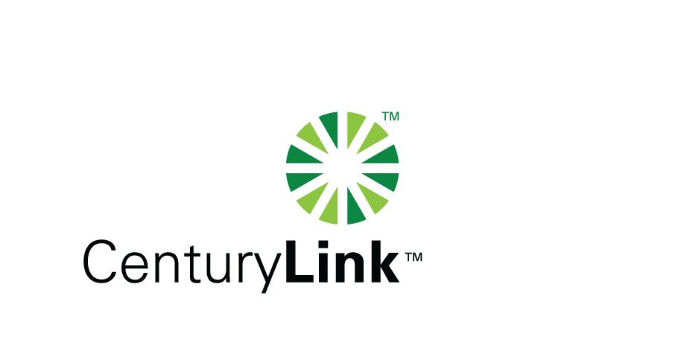
Via E-FILE

April 29, 2011
www.CenturyLink.com
5454 W. 110th Street
Overland Park, KS 66211

Ms. Renee’ Jenkins, Director of Administration
Public Utilities Commission of Ohio
180 East Broad Street, 13th Floor
Columbus, OH 43215-0573

Re: United Telephone Company of Ohio d/b/a CenturyLink
Case No. 90-5041-TP-TRF
Case No. 11-2771-TP-ATA

Dear Ms. Jenkins:

Enclosed for filing is United Telephone Company of Ohio d/b/a CenturyLink filing to establish a tariff which is for BLES services and any other tariffed services as required in accordance with the Commission’s January 19, 2011 Entry in Case No. 10-1010-TP-ORD.

If you have any questions regarding this filing, please call me or Gary Baki at (614) 220-8629.

Sincerely,

/s/ Debra A. Levy

Debra A. Levy

Enclosures

cc: Gary Baki

OH 11-01
Debra A. Levy
Tariff Analyst II
Debra.Levy@CenturyLink.com
Voice: (913) 345-7571
Fax: (913) 345-6756

