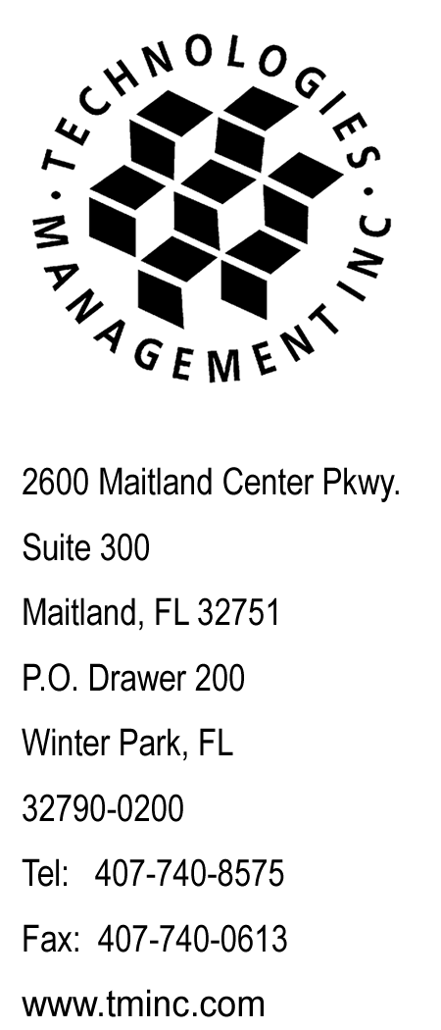
July 30, 2008

Via E-file

Ms. Renee Jenkins, Commission Secretary
Public Utilities Commission of Ohio
180 East Broad Street, 13th Floor
Columbus, OH 43215-3793

RE: Interexchange Startec Global Operating Company
Case No. 08-733-TP-ATA

Dear Ms. Jenkins:

Enclosed for filing please find the original copy of the replacement page 23 correcting the Return Check Charge to $25.00 per the request of Erin Scribner on July 24, 2008.

Please acknowledge receipt of this filing by date stamping the extra copy of this cover letter and returning it to me in the self-addressed stamped envelope.

Any questions you may have regarding this filing may be directed to me at 407-740-3001 or via email to tforte@tminc.com.

Thank you for your assistance with this matter.

Sincerely,

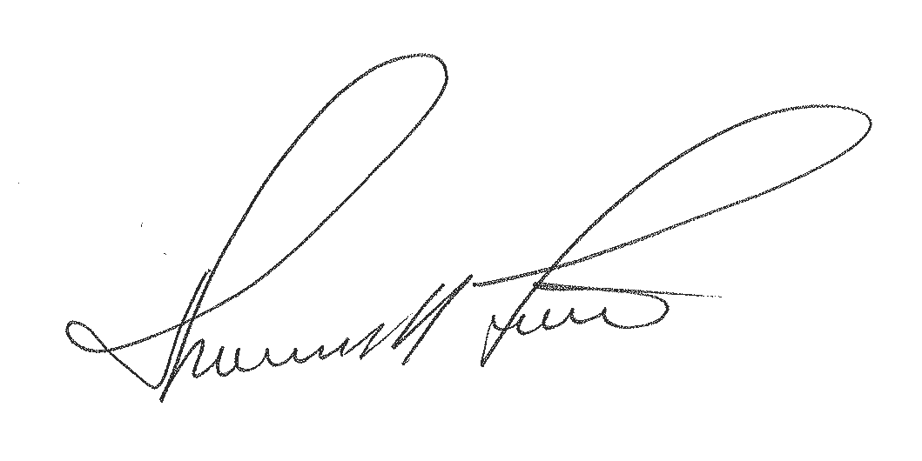

Thomas M. Forte
Consultant to Startec Global Operating Company

TMF/rg

cc: R. Felgar - Startec
file: Startec – OH IXC
tms: OHi0801a

STARTEC GLOBAL OPERATING COMPANY P.U.C.O. Tariff No. 3
Original Sheet 23

SECTION 4 - MISCELLANEOUS

4.1 General

Each Customer is charged individually for each call placed through the Company. Charges will vary by service offering, class of call, time of day, day of week, class of call and/or call duration.

4.2 Late Payment Charge

The company will charge a one-time 1.5% late payment fee on all invoices not paid by the due date identified on the Company bill.

4.3 Return Check Charge

The Company will assess a return check charge of $25.00 whenever the institution on which it is written does not accept a check or draft presented for payment of service. This charge applies each time a check is returned to the Company by a bank for insufficient funds.

