April 7, 2008

Via Hand Delivery
Ms. Reneé J. Jenkins
Director of Administration
Secretary of the Public Utilities Commission of Ohio
180 East Broad Street
Columbus, Ohio 43215
Re: In the Matter of the Application of Glandorf Telephone Company, Inc. to Make Text Changes to its Tariff to Reflect New MTSS; PUCO Case No. 08-0471-TP-ATA
Dear Ms. Jenkins:
Glandorf Telephone Company, Inc. submits an Application for electronic filing in connection with the above-referenced matter. The TRF Number for Glandorf Telephone Company, Inc. is 90-5022-TP-TRF.
Thank you for your assistance. If you have any questions, please do not hesitate to call.
Very truly yours,

/s/ Carolyn S. Flahive

Enclosure
Carolyn.Flahive@ThompsonHine.com Fax 614.469.3361 Phone 614.469.3294 | tajg DocID_Info

The Public Utilities Commission of Ohio

TELECOMMUNICATIONS APPLICATION FORM
for
ILECs Not Subject to Alternative Regulation
(Effective December 3, 2004)

In the Matter of the Application of Glandorf Telephone Company, Inc. to Make Text Changes to its Tariff to Reflect new MTSS | )  )  ) | Case No. 08 - 0471 -TP - ATA

Name of Company Glandorf Telephone Company, Inc.
Address of Company P.O. Box 31; Glandorf, Ohio 45848
Company Web Address
Regulatory Contact Person(s) Carolyn S. Flahive Phone (614) 469-3200 Fax (614) 469-3361
Regulatory Contact Person’s Email Address Carolyn.Flahive@ThompsonHine.com
Date TRF Docket No. 90 - 5022 – TP - TRF

Motion for protective order included with filing? □ Yes ☒ No
Motion for waiver(s) filed affecting this case? □ Yes ☒ No [Note: waiver(s) tolls any automatic timeframe]

NOTE: This form must accompany:
- All automatic approval/notice applications filed by incumbent local exchange companies (ILECs) not subject to a qualifying alternative regulation plan when making an application pursuant to Case Nos. 84-944-TP-COI, 86-1144-TP-COI, 89-564-TP-COI, or 99-563-TP-COI.
- All non-automatic approval applications filed by incumbent local exchange companies (ILECs) not subject to a qualifying alternative regulation plan when making an application pursuant to Section 4909.18, Ohio Revised Code.

I. Please indicate the reason for submitting this form (check one)
□ 1 (AEC) Application For Approval Of A Customer Contract For Competitive Services
□ a. Stand-Alone Contract (90-day approval, 7 copies)
□ b. Pre-Approved Contract (0-day notice, 7 copies)
□ 2 (ACO) ILEC Application for Change in Ownership Pursuant to 4905.402, Ohio Revised Code (30-day approval, 10 copies)
□ 3 (ALI) Small, For-Profit, ILEC Application For A Limited Increase In Non-Basic Rates (60-day approval, 10 copies)
☒ 4 (ATA) Application For Tariff Amendment That Does Not Result In An Increase In Rates
□ a. Large ILEC, Competitive Offerings Other Than Those Listed Under 5., Below (60-day approval, 7 copies)
☒ b. Small, for-profit ILECs (45-day approval, 10 copies) (Not-for-profit, see item 6, NFP, below)
□ 5 (ZTA) Tariff Notification Not For An Increase In Rates Involving Message Toll, Toll-Free Service, 900 And 900-Like Services, 500 Service, Calling Card, Prepaid Calling Card, Private Line, and Speed Dialing In Accordance With Waiver Granted in 99-563-TP-COI (5/11/2000 and 11/21/2002) (0-day notice, 7 copies)
NOTE: Notifications do not require or imply Commission Approval.
□ 6 (NFP) Small, not-for-profit ILEC tariff amendment
□ a. Tariff Change Not Resulting In An Increase In Rates (0-day notice, 7 copies)
□ b. Tariff Application Resulting In An Increase In Non-Basic Rates (45-day notice, 7 copies)
□ c. Tariff Application Resulting In An Increase In Basic Rates (60-day notice, 10 copies)
□ 7 (Non-Auto) All Others (non-automatic approval, indicate appropriate 3 letter code for case type in Case No. above)

THE FOLLOWING ARE TRF FILINGS ONLY, NOT NEW CASES
□ 8 Introduction or Extension of Promotional Offering (10-day notice, 3 copies)
□ 9 New Price List Rate Within an Approved Rate Range for Existing Competitive Service (0-day notice, 3 copies)

- The following exhibits corresponding to the list of cases above, at a minimum, are required to be filed:

☒ | 3, 4, 5, 6, 7 | Current Tariff Sheets (to be superseded), if applicable
☒ | 3, 4, 5, 6, 7 | Proposed Tariff Sheets
☒ | 2, 3, 4, 5, 6, 7 | Rationale or Explanation for Change
□ | 1.a., 4.a. | Justification for Competitive Treatment
□ | 1.a., 4.a. | Cost support for non-MTS service
□ | 2, 3, 4, 5, 6, 7, 9 | Customer Notice to customers affected by proposal, and statement as to the form and timing of the notice
□ | 1 | Copy of Contract

III. Applicant is filing this application under the regulatory requirements:
☒ Established by the Commission in Case No. 89-564-TP-COI.
- Established in 4909.18 Ohio Revised Code.

- Applicant respectfully requests the Commission to permit the filing of the proposed tariff sheets, to become effective on the date shown on the proposed tariff sheets (which is a date no earlier than the day after the applicable automatic approval date), modified by any further revisions that have become effective prior to the effective date of the proposed schedule sheets.

Respectfully submitted,

GLANDORF TELEPHONE COMPANY, INC.

By: /s/ Carolyn S. Flahive
Thomas E. Lodge (0015741)
Carolyn S. Flahive (0072404)
THOMPSON HINE LLP
10 West Broad Street, Suite 700
Columbus, Ohio 43215-3435
614-469-3200
Its Attorneys

VERIFICATION

I verify that all of the information submitted herein, and all additional information submitted in connection with this case, is true and correct to the best of my knowledge.

/s/ Carolyn S. Flahive 4/7/08
*(Signature and Title) (Date)

*Verification is required for every filing, and need not be notarized except for Applications for a Limited Increase in Rates (ALIs). The verification may be signed by an officer of the applicant, its counsel, or an authorized agent of the applicant, except for ALIs. ALI applications must be signed by an officer of the company and be notarized.

Sworn to and subscribed before me this _____ day of _____________________, 2008.

_________________________________________
Notary Public, State of Ohio
My commission expires _________________.
EXHIBIT A

(SUPERSEDED TARIFF SHEETS)

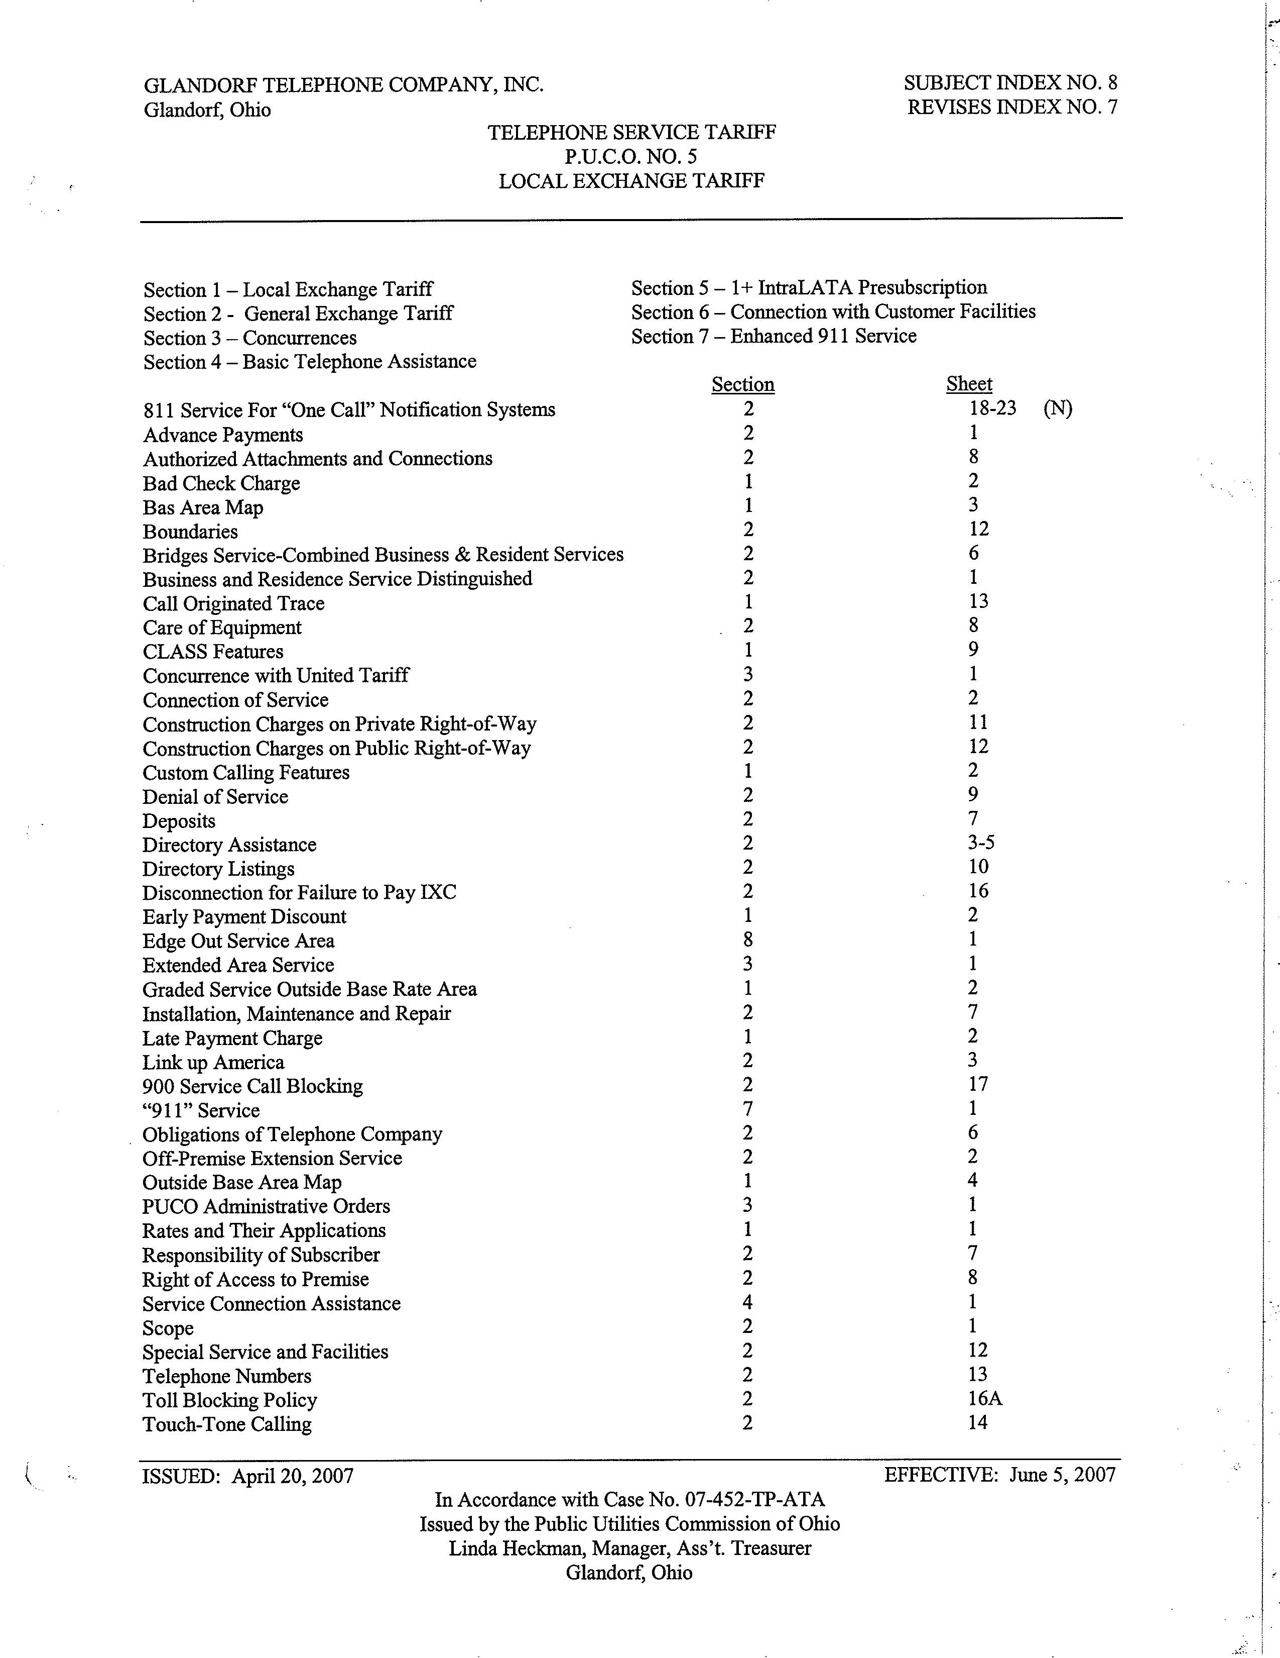
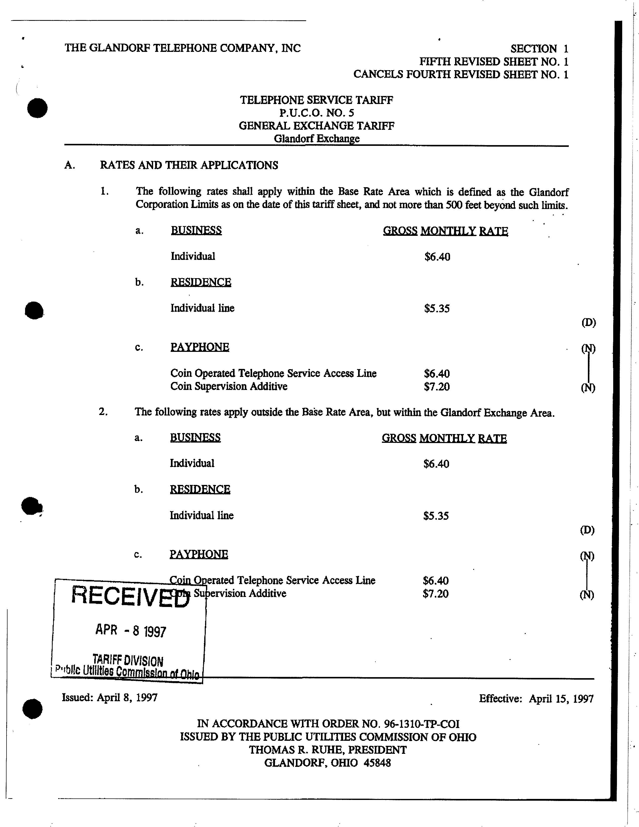
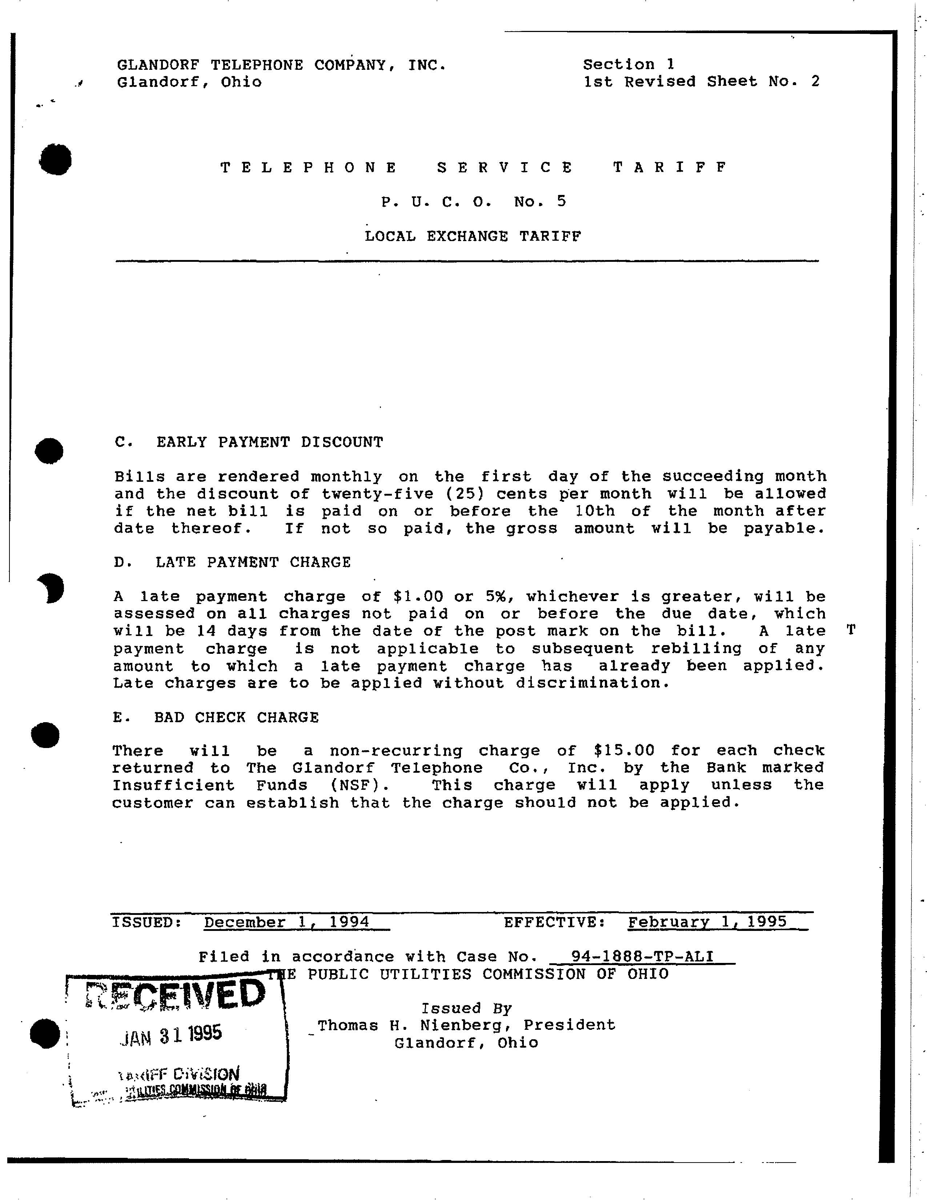
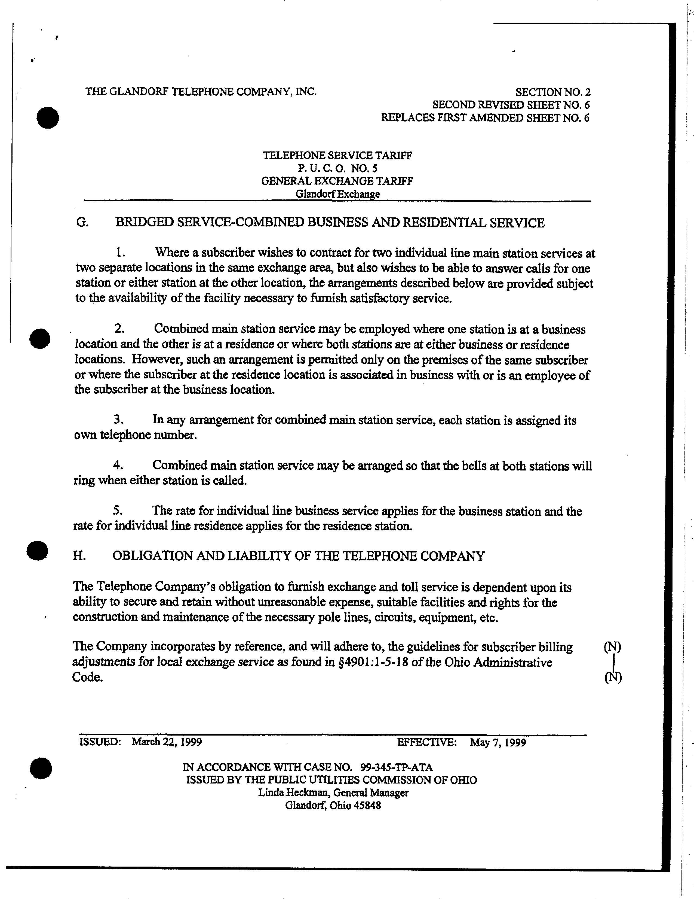
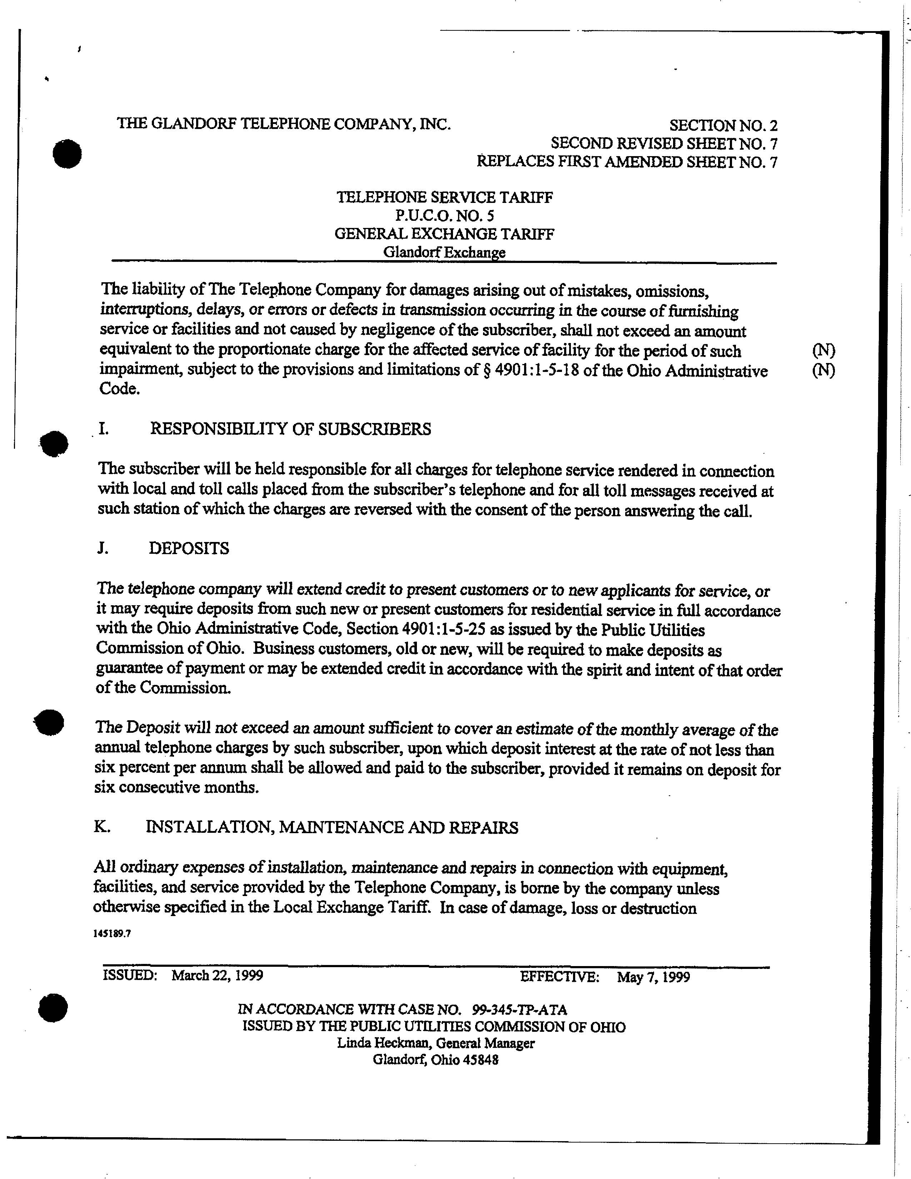
EXHIBIT B

(REVISED TARIFF SHEETS)

Section 1 – Local Exchange Tariff Section 5 – 1+ IntraLATA Presubscription
Section 2 - General Exchange Tariff Section 6 – Connection with Customer Facilities
Section 3 – Concurrences Section 7 – Enhanced 911 Service
Section 4 – Basic Telephone Assistance
Section Sheet
811 Service For “One Call” Notification Systems 2 18-23
Advance Payments 2 1
Authorized Attachments and Connections 2 8
Bad Check Charge 1 2
Bas Area Map 1 3
Boundaries 2 12
Bridges Service-Combined Business & Resident Services 2 6
Business and Residence Service Distinguished 2 1
Call Originated Trace 1 13
Care of Equipment 2 8
CLASS Features 1 9
Concurrence with United Tariff 3 1
Connection of Service 2 2
Construction Charges on Private Right-of-Way 2 11
Construction Charges on Public Right-of-Way 2 12
Custom Calling Features 1 2
Denial of Service 2 9
Deposits 2 7 (T)
Directory Assistance 2 3-5
Directory Listings 2 10
Disconnection for Failure to Pay IXC 2 16
Early Payment Discount 1 2
Edge Out Service Area 8 1
Extended Area Service 3 1
Graded Service Outside Base Rate Area 1 2
Installation, Maintenance and Repair 2 7
Late Payment Charge 1 2 (T)
Link up America 2 3
900 Service Call Blocking 2 17
“911” Service 7 1
Obligations of Telephone Company 2 6
Off-Premise Extension Service 2 2
Outside Base Area Map 1 4
PUCO Administrative Orders 3 1
Rates and Their Applications 1 1
Responsibility of Subscriber 2 7
Right of Access to Premise 2 8
Service Connection Assistance 4 1
Scope 2 1
Special Service and Facilities 2 12
Telephone Numbers 2 13
Toll Blocking Policy 2 16A
Touch-Tone Calling 2 14

 | Customers have certain rights and responsibilities under the Minimum Telephone Service Standards (Ohio Adm.Code 4901:1-5) (the “MTSS”). These safeguards can be found in the Appendix to Ohio Adm.Code 4901:1-5-03, which is entitled “Telephone Customer Rights and Responsibilities.” These rights and responsibilities include complaint handling, ordering or changing service, service repair, payment of bills, and disconnection and reconnection of service. |  |  |  |  |  | (N)
A. | RATES AND THEIR APPLICATIONS
 | 1. | The following rates shall apply within the Base Rate Area which is defined as the Glandorf Corporation Limits as on the date of this tariff sheet, and not more than 500 feet beyond such limits.
 |  | a. | BUSINESS GROSS MONTHLY RATE
 |  |  | Individual $6.40
 |  | b. | RESIDENCE
 |  |  | Individual line $5.35
 |  | c. | PAYPHONE
Coin Operated Telephone Service Access Line $6.40
Coin Supervision Additive $7.20
 | 2. | The following rates apply outside the Base Rate Area, but within the Glandorf Exchange Area.
 |  | a. | BUSINESS GROSS MONTHLY RATE
 |  |  | Individual $6.40
 |  | b. | RESIDENCE
 |  |  | Individual line $5.35
 |  | c. | PAYPHONE
Coin Operated Telephone Service Access Line $6.40
Coin Supervision Additive $7.20

C. | EARLY PAYMENT DISCOUNT  Bills are rendered monthly on the first day of the succeeding month and the discount of twenty-five (25) cents per month will be allowed if the net bill is paid on or before the 10th of the month after date thereof. If not so paid, the gross amount will be payable.
D. | LATE PAYMENT CHARGE  A late payment charge of $1.00 or 5%, whichever is greater, will apply to regulated charges not paid at least nineteen (19) days after the postmark on the customer’s bill. The late payment charge will not apply to any portion of the bill that is in bona fide dispute, any previous late payment fees included in the amount due, or to service establishment charges for lifeline services. Late charges are to be applied without discrimination. |  |  | (T)
E. | BAD CHECK CHARGE  There will be a non-recurring charge of $15.00 for each check returned to The Glandorf Telephone Co., Inc. by the Bank marked Insufficient Funds (NSF). This charge will apply unless the customer can establish that the charge should not be applied.

G. | BRIDGED SERVICE-COMBINED BUSINESS AND RESIDENTIAL SERVICE
 | 1. | Where a subscriber wishes to contract for two individual line main station services at two separate locations in the same exchange area, but also wishes to be able to answer calls for one station or either station at the other location, the arrangements described below are provided subject to the availability of the facility necessary to furnish satisfactory service.
 | 2. | Combined main station service may be employed where one station is at a business location and the other is at a residence or where both stations are at either business or residence locations. However, such an arrangement is permitted only on the premises of the same subscriber or where the subscriber at the residence location is associated in business with or is an employee of the subscriber at the business location.
 | 3. | In any arrangement for combined main station service, each station is assigned its own telephone number.
 | 4. | Combined main station service may be arranged so that the bells at both stations will ring when either station is called.
 | 5. | The rate for individual line business service applies for the business station and the rate for individual line residence applies for the residence station.
H. | OBLIGATION AND LIABILITY OF THE TELEPHONE COMPANY
 | The Telephone Company’s obligation to furnish exchange and toll service is dependent upon its ability to secure and retain without unreasonable expense, suitable facilities and rights for the construction and maintenance of the necessary pole lines, circuits, equipment, etc.
 |  |  |  | (D)

The liability of The Telephone Company for damages arising out of mistakes, omissions, interruptions, delays, or errors or defects in transmission occurring in the course of furnishing service or facilities and not caused by negligence of the subscriber, shall not exceed an amount equivalent to the proportionate charge for the affected service of facility for the period of such impairment.
I. | RESPONSIBILITY OF SUBSCRIBERS  The subscriber will be held responsible for all charges for telephone service rendered in connection with local and toll calls placed from the subscriber’s telephone and for all toll messages received at such station of which the charges are reversed with the consent of the person answering the call.
J. | DEPOSITS  When the Company assesses a deposit, it will do so based on a statewide average monthly bill in accordance with the MTSS. |  |  | (T)
K. | INSTALLATION, MAINTENANCE AND REPAIRS  All ordinary expenses of installation, maintenance and repairs in connection with equipment, facilities, and service provided by the Telephone Company, is borne by the company unless otherwise specified in the Local Exchange Tariff. In case of damage, loss or destruction

EXHIBIT C

The Applicant, Glandorf Telephone Company, Inc., hereby revises its tariff to reflect the new Minimum Telephone Service Standards adopted pursuant to Case No. 05-1102-TP-ORD. Specifically, the Applicant has a) inserted the statements required pursuant to the Entry issued September 26, 2007 informing customers of their rights and responsibilities under the MTSS and referencing the Appendix to Rule 4901:1-5-03 and b) deleted other references to specific MTSS.

