

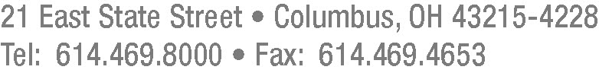

Frank Darr
(614) 719-2855-Direct Dial
fdarr@mwncmh.com
January 26, 2012

Betty McCauley
Secretary
Docketing Division
Public Utilities Commission of Ohio
180 East Broad Street, 11th Floor
Columbus, OH 43215-3793

RE: In the Matter of the Application of Ohio Edison Company and the University of Akron to Commit Energy Efficiency/Peak Demand Reduction Programs, Case No. 11-2081-EL-EEC.

Dear Secretary McCauley:

On June 24, 2011, the University of Akron (“U of A”) and Ohio Edison Company (“Ohio Edison”) submitted a joint application in this proceeding. On August 11, 2011, Ohio Edison filed a motion to amend the application and memorandum in support.

Through this letter, U of A and Ohio Edison notify the Public Utilities Commission of Ohio (“PUCO”) that U of A is not seeking to include Project #4, Guzzetta Hall Addition, and Project #6, Robertson Café Renovation listed in the August 11, 2011 amendment and that these two projects should be removed from the August 11, 2011 amendment to the application. The applicants seek approval of the application based on the remaining projects listed in the application and the August 11, 2011 amendment.

To reflect the removal of these projects, a revised Exhibit 2 is enclosed.

Sincerely,

/s/ Frank P. Darr
Frank P. Darr
for University of Akron

/s/ Carrie M. Dunn
Carrie M. Dunn
for FirstEnergy Corp.
FPD:vlp
Enclosure
cc: Dick Bulgrin
Robert Wolfe

